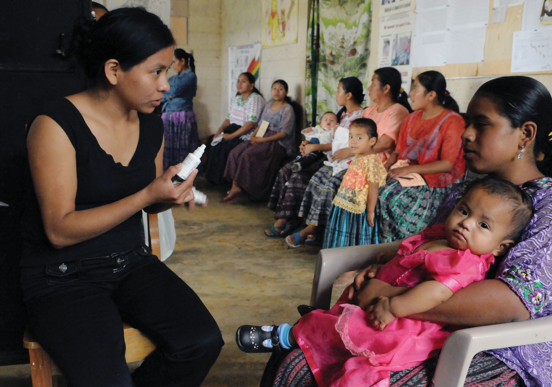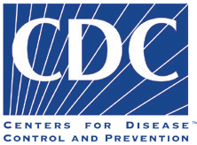

Adaptation Guidance & Needs Assessment - For Global IPCI 1
Adaptation Guidance & Needs Assessment - For IPC for Immunization Package 1

Adaptation Guidance & Needs Assessment

Interpersonal Communication for Immunization Package

©UNICEF/Markisz

This Resource
This resource is available on the Internet at: ipc.unicef.org
Copies of this document, as well as additional IPC materials on immunization, may be requested from UNICEF and partners:
UNICEF
3 United Nations Plaza New York, NY 10017 Tel: +1-212-326-7551
Email: IPC@unicef.org
© 2019 UNICEF
UNICEF and partners welcome requests for permission to use, reproduce or translate IPC for Immunization resources, in part or in full.
The content and the presentation of the material in this resource and the IPC package do not imply the expression of any opinion whatsoever on the part of UNICEF and partners.
Suggested citation: United Nations Children’s Fund, ‘IPC for Immunization Package’, UNICEF, New York, 2019.
For more information, or to provide feedback, please write to IPC@unicef.org

Adaptation Guidance & Needs Assessment - For IPC for Immunization Package
2
THIS RESOURCE

Acknowledgments

The Interpersonal Communication for Immunization (IPC/I) Package is the result of strenuous hard work and collaborative efforts of many institutions and individuals, without whose help, guidance and support, this would not have been possible.
UNICEF wishes to recognize their contributions to this important initiative and expresses gratitude to all those who supported the development of the package through their time and expertise.
Special thanks to the global advisory group and the frontline workers From various parts of the world who contributed to develop the package.

Global IPC Advisory Group Members

Molly Abbruzzese, BMGF Hardeep Sandhu CDC Susan Mackay, GAVI
Lisa Menning, WHO Jhilmil Bahl, WHO
Mike Favin, The Manoff Group Lora Shimp, John Snow Inc. Bill Glass, CCP
Saad Omer, Emory University
Dr. Stephen Hodgins, University of Alberta, Canada Nathan Pienkowski, Bull City Learning
Dr. Naveen Thacker, IPA Benjamin Hickler, UNICEF Ketan Chitnis, UNICEF Tommi Laulajainen, UNICEF Claudia Vivas, UNICEF

JHU Project Team

Sanjanthi Velu, Jvani Cabiness, Caitlin Loehr, Amrita Gill Bailey, Ron Hess, Guy Chalk, Michael Craven, and Bill Glass. Others who contributed include Rupali Limaye, Anne Ballard, Mark Beisser, Missy Eusebio, and Carol Hooks.

Acknowledging and thanks to the CCP field offices and sister organizations in Nigeria, Pakistan, Uganda, Ethiopia, India and CHIP Pakistan for their support during the formative research and pretesting stages of the package.

UNICEF Team

Attiya Qazi, Chikondi Khangamwa, Anisur Rehman, Rufus Eshuchi, Kennedy Ongwae, Ayesha Durrani, Robb Butler, Violeta Cojocaru, Jonathan David Shadid, Johary Randimbivololona, Natalie Fol, Deepa Risal Pokharel, Helena Ballester Mario Mosquera, Svetlana Stefanet, Sergiu Tomsa, Daniel Ngemera, Fazal Ather, Vincent Petit, Carolina Ramirez, Alona Volinsky, Hannah Sarah Dini, Benjamin Schreiber, Rafael Obregon, Diane Summer, Robin Nandy, Luwei Pearson and Stefan Peterson.

Suleman Malik, Communication for Development Specialist, UNICEF Headquarters, New York, USA. UNICEF Team Lead

Adaptation Guidance & Needs Assessment - For IPC for Immunization Package
3
ACKNOWLEDGMENTS

Foreword
In recent decades, child mortality has dropped dramatically. Vaccines have been a major contributor to improvements in health by protecting children and adults against diseases that once maimed and killed. The scourge of smallpox has been eradicated, the last mile of polio eradication is close, as is the elimination of maternal and neonatal tetanus. Yet, despite the availability of vaccines, many countries face continuing constraints to achieving universal vaccination. One of the key challenges is ensuring sustainable demand for vaccination at family and community levels. The value that community members place on vaccination is a major contributor towards good health. The Global Vaccine Action Plan (2011–2020) acknowledges the importance of community attitudes and practices, as reflected in one of its six strategic results: “Individuals and communities understand the value of vaccines and demand immunization as both their right
and responsibility.”
Although most children do receive the recommended vaccinations, too many still miss out: almost 20 million globally do not receive the full schedule of essential childhood vaccines. The reasons are complex. In some places, health services are not easily accessible – and when accessible, may not be convenient to users – and/or reliable. In some cases, health worker’s behaviors or attitudes may limit the uptake of vaccination services. Caregivers’ and children’s experiences with immunization services may be unpleasant for various reasons and this can explain why many children who receive the first dose of vaccines (e.g. BCG or DTP1), drop out. In other instances, children miss recommended vaccinations because their parents or guardians have concerns or misunderstandings about vaccines, lack information on the benefits of vaccines, or do not understand what they need to do to get their children vaccinated and protected.
Frontline Workers (FLWs), including facility-based professionals, community health workers (CHWs) and community volunteers (CVs), are a critical source of information about vaccination. Research shows that FLWs are the most influential source of information about vaccines for caregivers and families of children. Because of their critical role in providing essential information about vaccination services, FLWs must have effective interpersonal communication (IPC) skills. They also need positive attitudes towards the people they serve and their work, an understanding of the importance of communication, and an ability to operate in an environment that enables them to communicate effectively to build trust and confidence. When equipped with the relevant skills and supported by their supervisors, FLWs can be very effective in influencing attitudes and promoting uptake of vaccination services. Across countries, FLWs engage communities in dialogue, mobilize community leaders and provide communities with health services and knowledge about healthy practices. However, the limited IPC skills of FLWs remains
a challenge and requires focused efforts to enhance their capacity to communicate effectively with care givers and community members that they serve, and a system that supports and values the practice of these important competencies is vital.
UNICEF, together with Bill & Melinda Gates Foundation (BMGF), Centers for Disease Control and Prevention (CDC),
, Emory University, GAVI, the Vaccine Alliance (GAVI), International Pediatric Association (IPA), , John Snow Inc. (JSI), the United States Agency for International Development’s flagship Maternal and Child Survival Program, World Health Organization (WHO) and other partners, remain committed to closing the gap by facilitating a process of empowerment through the development and roll out of a comprehensive ‘IPC for Immunization’ package.
UNICEF and partners are pleased to introduce this IPC for Immunization package and invite national and sub- national programme managers, partners and FLWs to adapt it to their local context and use it to guide their work with caregivers and communities. A range of resources are in the package, including participant’s and facilitator’s manuals, an adaptation guide, a supportive supervision manual, FAQs, flash cards, videos, audio job aids, a mobile application, and a monitoring and evaluation (M&E) framework. These resources are available both online (IPC. UNICEF.Org) and offline in four global languages. It’s hoped that through this package and instructional-design approaches, FLWs will improve their capacity to effectively communicate and successfully promote demand for immunization and other health services; empathize with caregivers; address questions and concerns through counselling; and clearly communicate key messages regarding the timing and importance of further vaccinations and practical information on where and when they should be obtained.
UNICEF extends gratitude to partners, colleagues and the advisory group who contributed their time, expertise and experience to the preparation of this package. Special thanks to Johns Hopkins University Center for Communication Programs for helping to develop the package, to the UNICEF regional and country colleagues and the FLWs for their support, valuable feedback and collaboration in developing the package. Through this partnerships and support, UNICEF will continue to enhance the capacity of the immunization workforce,
institutions, and teams that will help communities to value, demand, trust and improved understanding to the right to immunization services.

Adaptation Guidance & Needs Assessment - For IPC for Immunization Package
4
FOREWORD

Overview
The Interpersonal Communication for Immunization Package provides a comprehensive array of resources and materials to train frontline health workers on knowledge, skills, and attitudes needed to engage in positive and meaningful interpersonal communication with caregivers. The package is designed to inform and motivate frontline workers about the importance of immunization for children, increasing demand for vaccination, and improving immunization coverage. The training package is designed to be delivered by training institutions, government or NGO staff, for pre-service or in-service training of frontline workers, to strengthen the capacity of the multiple cadres of frontline workers (FLWs) that support families and communities achieve full immunization coverage. The fundamental concepts and skills introduced, as well as the participatory approaches used across the package have global applicability. This applicability contributes to expanding equitable access and use of evidenced-based global health and behavior change content in a standardized format to achieve improved health outcomes. However, not all of the content, methodologies or tools will be appropriate for every country, training opportunity, or trainee audience. All materials within the package were developed for a global audience and intended for adaptation and local contextualization. Review and adaptation of the content, methodologies, delivery plan, and supporting resources are recommended to maximize the relevance and accessibility for local contexts, immunization priorities, and needs of health workers and care-givers1. This document provides a review of key principles and steps to guide the adaptation process, to conduct a needs assessment, and tailor the global package to individual needs and priorities.

Despite the well-recognized importance of training, the time and resources to plan and deliver quality training is often limited across government and partner organizations working in constrained resource environments and juggling several competing priorities. While adaptation of an existing resource alleviates the need to start from scratch, it can feel like a daunting exercise for a large and/or complex package such as this one. Thoughtful adaptation however, can increase the overall usefulness of the training for more successful outcomes and can be managed with a systematic approach. This document provides a review of key principles and steps to guide the adaptation process to tailor the global package to individual needs and priorities. The package contains the following resources:

The Interpersonal Communication for Immunization Trainers’ Facilitation Guide and Participants’ Manual

The Facilitator’s Guide and Participant’s Manual on Interpersonal Communication for Immunization are companion resources designed to help FLWs acquire and practice the knowledge, skills, and attitudes needed to communicate effectively with caregivers and communities about childhood immunization. The information and exercises they contain can be used in the context of pre-service training, training workshops, day-to-day supervision, supportive supervision visits, on-the-job training (including coaching, mentoring, and peer- to-peer mentoring), and self-study. The facilitator’s guide was developed for group training while the participant’s manual can be used in group training settings and for self-study.

Adaptation Guidance & Needs Assessment - For IPC for Immunization Package
5
OVERVIEW

Supportive Supervision
Intended to be used by supervisors of FLWs, the Supportive Supervision Manual includes various modules that cover an introduction to supportive supervision, as well as skills
and tips related to giving and receiving feedback, observation, mentoring and coaching, supporting FLWs in developing goals and action plans, and motivation.

Frequently Asked Questions
This reference document and job aid both consolidates and builds upon frequently asked questions around vaccines and vaccine-preventable diseases from around the world.
Responses to the questions include key messages and concise supporting messages that follow the principles of interpersonal communication.

Reference Cards
The Interpersonal Communication for Immunization Reference Cards have been created to provide an easy access to messages on vaccines and vaccine-preventable diseases. These cards can be used as self-learning tools; message guides for conversations with caregivers and community members; or information resources for education and training.

Audio Job Aids
A series of Audio Job Aids share with FLWs key messages that respond to some of the common, difficult questions they may encounter during their visits with caregivers. The Audio Job Aids will offer FLWs another channel for accessing key messages and they can serve as a quick refresher that FLWs can listen to while on-the-go, possibly en route to a caregiver visit or community meeting.

Animated Videos
A series of short, animated videos illustrating interpersonal communication-based challenges and solutions to improving immunization coverage. The videos are intended to be used a job aids to support FLWs as they address barriers to immunization in their communities.

Six key steps are outlined below to help facilitate the needs assessments and adaptation process. These steps should be considered within an overarching framework of three principles or concepts modified and drawn from a model developed by Dizon et al.

- ADOPTION: Not all content will require change or significant revision. Modules, sessions, activities, or tools that can be maintained in their entirety, can be adopted without change. This content will generally be comprised of sessions that are grounded in a solid, global evidence base that has applicability regardless of country or culture such as a review of how vaccines work, fundamental principles of interpersonal communication, or how to address common myths, biases and heuristics. Many of the approaches are grounded in adult learning principles or templates and overall presentation of materials, may also be suitable for adoption. While most of the content may be suitable for adoption, some of
it may not be suitable for inclusion in your context therefore it should be adapted based on the needs and parameters of the training you are delivering. This package has been designed in a modular format built on a number of individual sessions and activities to support tailoring of content for audience needs.

Adaptation Guidance & Needs Assessment - For IPC for Immunization Package
6
OVERVIEW

- CONTEXTUALIZATION Some content may be easily adopted by grounding it in details and examples that are culturally relevant. Think, for example, of some of the role-play or case study exercises introduced. You may be able to maintain the overall architecture and content of the session by contextualizing the activities and examples so that they better reflect your local environment and resonate with your participants. Contextualization may include but is not limited to:

  - Changing the names for local ones
  - Using common expressions or slang to better reflect common speech patterns
  - Using local images or popularly known character personalities
  - Substituting locally developed communication tools for examples or group work activities for those included in the package
  - Including popular activities or approaches for energizers, re-cap or quiz exercises
  - Translation into local languages

- REVISION Content, materials, or approaches that require significant change or revision require adaptation. This is generally content that references or draws on:

  - Local data or research (coverage data, immunization schedules, incidence of outbreaks, behavioral barriers to vaccine uptake or trust in health systems, for example)
  - Policies, laws, and power structures (consent or refusal forms, eligibility for school enrollment or travel, or religious edicts, for example)
  - Infrastructure and systems issues (stock-outs and supply issues, mechanisms for supportive supervision, roles and responsibilities, and available resources for cadres of health workers, for example)
  - Routine EPI schedules (recommended vaccines, recommended dosage, recommended age, recommended series)

Some materials may need to be adapted to reflect technological environments or logistical parameters of your training, as well:

  - Availability of electricity, equipment, or materials
  - Space for activities or other logistical concerns such as travel or weather
  - Access to media or mobile technology to access tools and materials after the training
  - Needs for printed, audiovisual, or other formats of materials during the training

Key Recommendation

In addition to the above framework, it is helpful to keep in mind that adapting a training is an iterative process. The package is comprised of many interconnected parts. As you make changes in one section or one component of the package, they will often have an effect in other sections or components. This will require you to go back and further revise as you strive to balance between introduction of content, practical application of skills and knowledge, and review and discussion. Allow time in the adaptation process to accommodate the need for more than one round of revision and review to maximize cohesiveness, clarity, and usefulness.

Adaptation Guidance & Needs Assessment - For IPC for Immunization Package
7
OVERVIEW

Steps In The Process

1. Define the audience

Health and immunization programs are comprised of several different types of FLWs that have unique yet complementary roles. Not only do roles vary, but key characteristics such as education levels, competencies,
access to previous training, compensation level and a host of other factors will also vary. The most critical step in adaptation is to identify and understand your audience. the intended audience for this global package is frontline workers (FLWs). Broadly defined, a frontline worker is a social worker or health provider
- facility- or community-based, professional or volunteer - who is tasked with delivering interpersonal communication and counseling, immunization, or education and outreach to caregivers, clients or community members. An immunization program may involve several different types of FLWs, each with unique yet complementary roles in ensuring communities achieve full vaccine coverage. The resources within the IPC/I package are intended to be used
by FLWs who serve in a health promotion and preventive care capacity. Their generic profile is as follows:

  - Completed secondary school
  - Trained in maternal and child health areas
  - Provides information and counseling with the aim of encouraging health behaviors
  - Provides preventive health care services, specifically vaccination

If your audience has a very different role or function, educational level, training experience, and competencies then you will want to clearly define your audience profile, their role and needs, and adapt the content to meet their specific needs.

2. Conduct a knowledge and needs assessment

The next critical step is to review the local evidence base and conduct a needs assessment to understand and prioritize the training needs of
your audience/trainees. Identifying and understanding the needs of the trainee audience is crucial in the adaptation process. You may not be able to address everything that you have identified as a need in the time or with the resources that you have available for the training, or the time period allocated for the adaptation. Ranking the needs in order of relevance or significance to the overall results helps ensure you address the most critical needs for your specific audience.
•

Adaptation Guidance & Needs Assessment - For IPC for Immunization Package
8
STEPS IN THE PROCESS

ELEMENTS TO CONSIDER FOR YOUR NEEDS ASSESSMENT INCLUDE BUT ARE NOT LIMITED TO THE FOLLOWING:

    - Clarify who the FLWs are (and how many of each type) and what are their roles and responsibilities in counseling, facilitating meetings and group talks, home visits, etc.
This is critical as different cadres of workers have distinct roles in immunization services.
    - Clarify the communication needs relevant to improving immunization coverage. What are the knowledge, attitudes and practices, of both caregivers and FLWs in your country and region with regard to immunization? How much vaccine hesitancy is there? Is it everywhere, not an issue, or only in one or
two small areas? How much do people know about the scientific aspects of immunization? How much do they want to know?
    - Are there any unique biases, barriers, and facilitators for the uptake of immunization in your country? If so, what are they? What has helped in the past to address them?
    - What is the local policy environment and in what ways does this impact FLWs in their day-to-day provision of services?
    - What are the existing immunization communication tools and resources available and used by FLWs at work and in their personal lives?
    - How are these tools applied on a day-to-day basis?
    - What are the challenges FLWs face with regard to utilization of immunization communication materials?
©UNICEF/Noorani

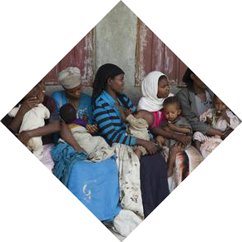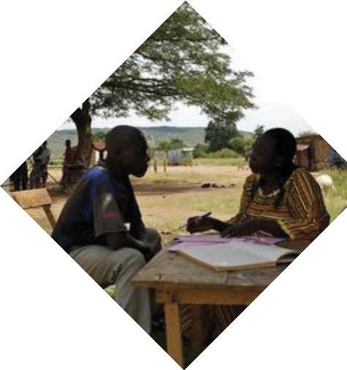©UNICEF/Getachew

Adaptation Guidance & Needs Assessment - For IPC for Immunization Package
9
STEPS IN THE PROCESS

- 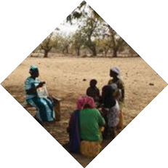What are the preferred learning styles of the FLWs in your training group?

- What are the most feasible delivery channels for your audience? Clarify what topics/ content should, in general, be covered in which communication forums (health talks
in facilities and outreach, counseling at the time of vaccination, home visits, etc.). If immunization sessions are very crowded, as occurs in many countries, such topics as common side effects can be covered
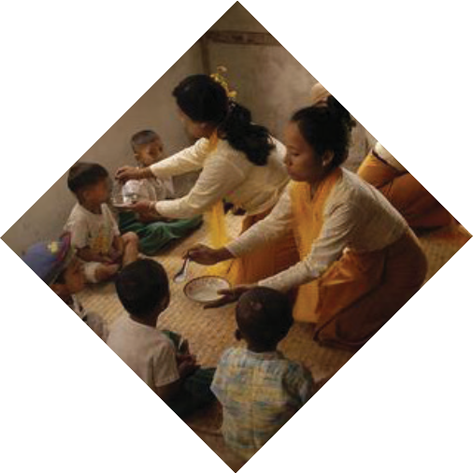in health talks and other opportunities, since there will be little chance during the vaccination session itself.
©UNICEF/Noorani
- What is the ideal time to conduct training (does the clinic shut down, for example, if they are in an all-day training, or is it best to bring trainees together for 3 days with
additional travel time if needed, or offer one module a month over several months during their monthly meetings)?
- What training formats are most appropriate for your audiences’ capabilities? Consider language needs and previous access to training, especially if you will have a mixed group of participants from different regions or different levels of expertise.
- What are the personnel, financial, and logistical resources available to commit to training? Consider availability of trainers who are skilled in conducting interactive training or availability of space to break into small groups comfortably for group activities, for example.

©UNICEF/Asselin

Adaptation Guidance & Needs Assessment - For IPC for Immunization Package
10
STEPS IN THE PROCESS

Conducting a review of the local evidence base may help you to answer many of these questions, or target areas for further exploration. Resources to consider in this review include but are not limited to:

- Literature reviews from the region or country, as well as of local immunization schedules, coverage data, and program reports
- Behavioral research that investigates the knowledge, attitudes and practices, of both caregivers and health workers in your country and region, including biases, barriers and facilitators to the uptake of promoted behaviors
- Feedback from any FLWs that have taken this or other similar trainings offered in the country or region before with respect to: clarity, usefulness, organization, layout, methodologies, as well as overall content of the training in terms of particular strengths and weaknesses and ability to meet stated objectives.
- Inventory and/or review other training materials currently used in country that cover related content. These may be helpful in identifying what exactly you need to improve or include in your process.
- Your own observations from delivering or attending related trainings in your country or region.
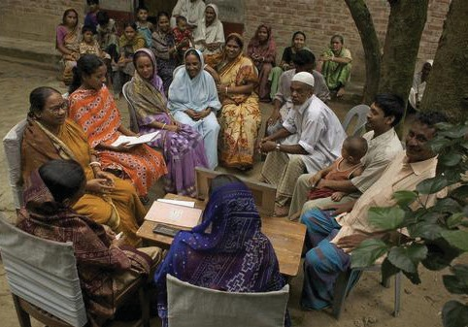Once you have reviewed your local evidence base, you may want to gather additional insight by conducting focus group discussions, interviews, or surveys among FLWs and their supervisors to gain further insight into your
©UNICEF/Noorani
audience and prioritize the needs of your audience. The results of this exercise need to be incorporated into the TOT and subsequent training. This will make the training much more relevant and specific for the learners and the program.

3. Determine the learning objectives

Once you have identified the needs of your audience and parameters of the training you will deliver, review the training package to identify any
learning objectives that do not speak directly to your identified needs or learning objectives that you may need to add. Is there content that you need to delete to make your training more relevant to the learning objectives? Is there content that you need to develop or adapt from other resources outside of this training package to better address learning objectives? Once you have determined
this, revise the learning objectives as needed so they speak to the needs you identified in your needs assessment.

Adaptation Guidance & Needs Assessment - For IPC for Immunization Package
11
STEPS IN THE PROCESS

4. Repurpose the Content

Review the training schedule and materials against your modified learning objectives and update the content and training agenda to reflect your
learning objectives. Reflect on how the individual module sessions, the activities and discussions, and the various components that comprise the package, work together to address each objective you have identified. Consider how the new or revised activities could be better integrated within the sessions, and how the sessions integrate or flow within the larger training program as a whole. Do the activities and sessions build on each other in a sequential process? Building up a foundation, step- by-step and allowing application of each new concept through focused sessions can facilitate the learning of new content.

Consider the time and materials required to address each objective, in terms of providing a balance of a) instruction or introduction of content, b) practice or application of skills and knowledge, and c) review and discussion. Reflect on the feasibility or practicability of the activities. Can you imagine yourself conducting the exercises
you are designing? Are the concepts, exercises, and language appropriate for your audience?

You may need to consult the ranked list of your needs from the results of your needs assessment to further prioritize the focus of the training. Modify the session content as needed, and reflect the changes in the overall training agenda. This step may require multiple reviews.

Adapting Training Schedules

Sample schedules for a five-day training, three-day training, and one-day training are appended.

Preservice Training

Integration of this training package into pre-service training will likely require a formal process that includes a stakeholder consultation to identify those interested in supporting implementation; which modules and sessions should be added to the IPC/I curriculum; content analysis of the program’s current IPC and IPC/I training resources; planning to adapt and introduce new content and prepare instructors; and developing a monitoring, evaluation, and learning plan.

In-Service Training

Assess participants’ training needs and modify the content to meet those needs. Adapt objectives, sessions, steps, timing, activities, role play scenarios and character/ place names, examples, vocabulary, key takeaways, and any other elements to

Adaptation Guidance & Needs Assessment - For IPC for Immunization Package
12
STEPS IN THE PROCESS

make the training more closely aligned with the needs and policies of the immunization program, the profile of the participants, and the barriers in the community. Enhance the content with local examples and country-level data for better contextualization. Modify the content according to the time available, focusing on the modules that align with the identified learning needs. In some health systems, it will be necessary to spread content over two or more mini- workshops of one to two days each. Or you might need to distil the content down to a single workshop of one to three days. If this is necessary, make every effort to maintain the highly participatory, practice-oriented nature of the
workshop as outlined. You will likely achieve the best result by covering a limited number of topics and sessions deeply.

On-the-Job Training

To use these modules for on-the-job training, focus the selected staff who you have identified as having the same training needs. Through supportive supervision and other needs assessments focus the training on the specific knowledge, attitudes, and skills. Allocate time to cover each competency on a
schedule that will allow the FLWs to learn, practice, and independently apply the new skills or approaches.
5. Review what tools, such as activity sheets or
visual aids are needed for each section
Once you have the main content of the sessions and activities
completed, go back to review if there are any supplemental or complementary materials such as activity sheets, video or audio clips, graphics, etc. that also require to be updated or created for delivery of the sessions. Update these
as needed to support your sessions. You may also want to consider if there are additional tools reminders, tips, or resources such as articles that would strengthen the session for your specific audience.

6. Reiterate

As mentioned previously, developing a training is an iterative process, all of the components (agenda, guides, manuals, activity sheets and
supporting materials) need to be properly aligned. Allow time to continue to revise and update across all of the interlocking components so that the different elements of the package are complementary and do not look like separate documents. Walking through the training, may allow you to identify areas
that need further attention and refinement. Additionally, after you deliver your adaptation, take note of feedback that will allow you to continuously update and improve the training and serve as a resource for others.

Adaptation Guidance & Needs Assessment - For IPC for Immunization Package
13
STEPS IN THE PROCESS

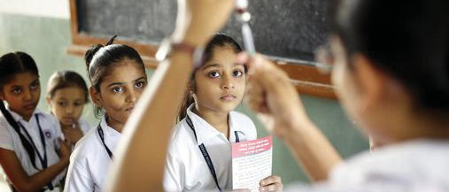Test and Validate your Content

Gather input from stakeholders on the content you have adapted or developed and pre-test it among the intended audience, if possible. Test the
adapted content and delivery method with your audience by simulating a real training scenario. Evaluate whether the learning objectives were met and revise the content and delivery methods based on pretest findings.

Ensure approval of the adapted package by relevant authorities, organizations, or entities, including but not limited to government officials at national and decentralized levels and supporting NGO partners.

A general checklist of broad content areas that may be helpful to review and cross- reference as you adapt this training package is provided below.
  - Title Page of all materials
  - Tailor training objectives to needs identified during needs assessment
  - Agenda, pre-and post-tests, activity sheets and scenarios, and evaluation to ensure alignment and consistency with changes to content
  - Substitute any generic visual aids with relevant country specific ones used in the country, or applicable examples from the region
  - Substitute relevant country timelines, local coverage, incidence of disease, and national immunization schedules for relevant group work activities
  - Update Vaccine Safety Processes and Protocols to reflect current policies for country or region

©UNICEF/Pietrasik

Adaptation Guidance & Needs Assessment - For IPC for Immunization Package
14
STEPS IN THE PROCESS

    - 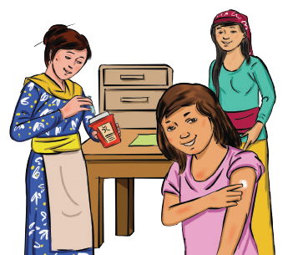Substitute relevant country data on fears, beliefs, biases, and side effects to make them more relevant to your context.
    - Substitute relevant country data on caregiver experience, barriers and facilitators, especially from specific ethnic or religious populations.
    - Review and contextualize example case studies and other examples as needed.
    - Review and contextualize role-play scripts, names, and scenarios as needed.
    - Expand or reduce the content in consideration of time. Adjust recommended session timing based on training length and pretest findings
    - Include locally relevant images
    - Add culturally appropriate icebreakers and refreshers
- Session on Vaccines: Since it’s detailed it should only be covered if there’s time and the FLWs specifically request for the information. Tailor the vaccine/ immunization facts module to the health-literacy level of the audience

- Include a session on supportive supervision if training FLW supervisors (see SS manual)
- Information on Immunity: You may decide that this information is not critical to cover during the training and ask trainees to refer to the information in the participant’s manual.

Adaptation Guidance & Needs Assessment - For IPC for Immunization Package
15
STEPS IN THE PROCESS

  - Profiling Caregiver: Consider eliminating this session if you think it is not relevant. The profiling tool may be useful in countries or regions where vaccine hesitancy is a known problem that blocks higher coverage. It is not recommended in countries or regions where vaccine hesitancy is not a major factor limiting coverage. Develop a contextually appropriate answer key from the caregiver profiling questions.
- Localize guidance and messages. For example, ask FLWs to outline what is done in-country to assure caregivers about vaccine safety to answer questions about how vaccine safety is ensured in particular countries. Include a description of local vaccine safety protocol
- Consider incorporating other RMNCH technical content
- Translate into appropriate language
- Add references to or links to relevant, validated training resources and job aids
- Incorporate other training videos:
  - Medical Aids Films has a collection of more than 200 downloadable video films in 20 languages, which cover topics in maternal, newborn, and child health. www.medicalaidfilms.org
  - Global Health Media has a collection of downloadable videos on a range of health topics, including newborn and child care and breastfeeding. https:// globalhealthmedia.org/videos/
  - HealthPhoneTM is a video reference library that includes over 2500 downloadable health videos available in a wide number of languages. www. healthphone.org

Guidance specific to Reference Cards
- Adapt the content to the program or local context (Language, Images, Vaccine information, Schedule, Myths, Card Size, Delivery Format, etc.)
- Substitute locally relevant images (photos or illustrations)
- Add the contraindications for specific vaccines, particularly to the Myths and Facts for Providers, “who should not receive vaccines?”
- Adapt the profiling caregiver audiences cards to reflect local caregiver audience segments
- Replace generic myths and rumors with locally relevant myths and rumors
- Add or remove cards based on their relevance

Adaptation Guidance & Needs Assessment - For IPC for Immunization Package
16
STEPS IN THE PROCESS

  - 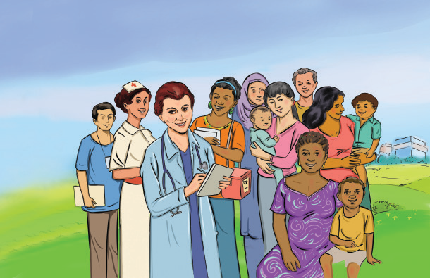Adjust the size of cards or formatting based on FLW preference
  - Add additional vaccine-preventable diseases or remove less relevant ones
  - Change the vaccine schedules to align with national or program-specific guidance
  - Add card(s) on reproductive, maternal and child health topics
  - Adjust the delivery format - Possible formats could include: PPT Presentation, Fold-out information chart, digital deck for a smartphone app, illustrated/pictorially presented information

Guidance specific to Videos
  - Localize the character names
  - Use voice over actors with relatable accents, pronunciation, and vocabulary
  - Translate into local language either through voice overs or subtitles
  - Be mindful of local sensitivities in relation to race, religion, tribal norms and politics in adapting videos

Adaptation Guidance & Needs Assessment - For IPC for Immunization Package
17
STEPS IN THE PROCESS

Guidance specific to Audio Job Aids
- Record using local voices and accents
- Translate into local Languages
- Change names of characters to reflect your context
- Format: Stop and Start, Drama to give audience time for feedback
- Adjust delivery mode: SIM Card, Radio Spot, IVR push or pull

This content is adaptable for in-service, pre-service and periodic capacity building initiatives. All the materials highlighted in this guide are also available and can be downloaded in English, French and Arabic at: (ipc.unicef.org). You are encouraged to share your experiences on this website and if you need additional guidance, feel free to contact UNICEF via email: smalik@unicef.org

Adaptation Guidance & Needs Assessment - For IPC for Immunization Package
18
STEPS IN THE PROCESS

Trainers’ Facilitation Guide Overview

Module 1 - Principles of Interpersonal Communication

Sessions
Key Concepts
Activities
Activity Session Module
Timing Timing Timing

1.1
Opening
Why interpersonal communication
is important to the immunization program
Set ground rules

Learning expectation
5 min.
5 min.
15 min.
4 hr.

1.2
Pre-test
Client- centred approach
Testing current
knowledge
Pretest
20 min.
30 min.

1.3

1.4

1.5
Interpersonal communication and a client- centred approach
Interpersonal communication skills

Appreciating the caregiver
Good customer service in health service

Empathy

Nonverbal communication; creating a welcoming environment; asking questions sensitively

Client experience role play

Persona exercise

Journey mapping the caregiver experience

Double ‘blind’ communication

15 min.

45 min.

1 hr.

10 min.

20 min.

2 hr.

20 min.

1.6
Appreciating the
caregiver
Photo review
15 min.
45 min.
Role play
25 min.

Adaptation Guidance & Needs Assessment - For IPC for Immunization Package
19
FACILITATOR’S GUIDE OVERVIEW

Module 2 - Exploring Provider Perspective and Barriers and Problem Solving
Sessions
Key Concepts
Activities
Activity Session Module
Timing Timing Timing

2.1 | Respect and | Discrimination, | Reflection on | 20 min. | 45 min. | 1 hr, 45
 | equity | diversity | experience |  |  | min.

Dimensions of diversity
15 min.

2.3
2.2 Provider Experiences of Agree-disagree 10 min. 15 min. barriers frontline workers
impacting client services
Problem solving
Problem solving
Problem solving
25 min.
45 min.

Module 3 - Immunization and Vaccines

Sessions
Key Concepts
Activities
Activity Session Module
Timing Timing Timing

3.1
Immunity
Active, passive, herd immunity
How vaccines work pop quiz
10 min.
45 min.
1 hr, 30 min.

3.2 Vaccines Types of vaccine Lecture 30 min. 30 min.

3.3
Vaccine- preventable childhood diseases
Vaccine- preventable diseases
Guess that vaccine- preventable disease
20 min.
45 min.

Adaptation Guidance & Needs Assessment - For IPC for Immunization Package
20
FACILITATOR’S GUIDE OVERVIEW

Module 4 - Profiling Types of Caregivers
Sessions
Key Concepts
Activities
Activity Session Module
Timing Timing Timing

4.1 | Understanding | Determinants of | Examples from | 15 min. | 45 min. | 1 hr, 30
 | vaccine  hesitancy | vaccine hesitancy; identifying parental concerns | the local context |  |  | min.

4.3
Communicating with caregivers
What to communicate during an immunization visit
Finding-the-right- message skits
10 min.
40 min.

Module 5 - Community Engagement

Sessions
Key Concepts
Activities
Activity Session Module
Timing Timing Timing

5.1
Conducting a needs assessment
Approaches for conducting a needs assessment
Lecture
45 min.
45 min.
2 hr, 15 min.

5.2 | Barrier | Common | Image review | 15 min. | 45 min.
 | analysis | caregiver barriers

5.3
Conducting a community conversation
Communicating immunization messages to the community
Story and brainstorm

Planning a community conversation
10 min.

10 min.
45 min.

4.2 Profiling
caregivers
Identifying parental
concerns; types of hesitant caregivers
Practice profiling
30 min.
1 hr.

Adaptation Guidance & Needs Assessment - For IPC for Immunization Package
21
FACILITATOR’S GUIDE OVERVIEW

Module 6 - Addressing Negative Rumors, Myths, and Misconceptions

Sessions
Key Concepts
Activities
Activity Session Module
Timing Timing Timing

6.1
What can be done about a negative rumor
Steps to addressing a negative rumor
Addressing rumors speed rounds
15 min.
30 min.
2 hr.

6.3 | Risk | Vaccine safety; |  | 20 min. | 45 min.
 | communication | essentials and  techniques for risk communication | Practice with difficult  conversations

Module 7 - Action Planning and Workshop Closing
6.2
Communicating
potential adverse events following immunization
Causes of adverse
events following immunization (AEFI)
20 min.
45 min.
AEFI case study
Sessions
Key Concepts
Activities
Activity Session Module
Timing Timing Timing

6.1 | Collecting | Why collect | Prototyping a | 1 hr. | 1 hr, 15 | 4 hr, 15
 | and using  community | community  feedback and how | feedback system |  | min. | min.
feedback

skills
7.2
Mobilization
Advocating with
influencers
Communication
campaign
15 min. 30 min.
7.3
Apply your
Skills application
Individual interactive
1 hr, 30
1 hr, 30

and practice

immunization education session

min.

min.

and certificates
7.4
Post-test and
workshop evaluation
Post-test,
workshop evaluation
Post-test
20 min.
40 min.
Workshop
evaluation
7.5
Commitments
Issue certificates
15 min.
25 min.
Post-training commitments
10 min.

Issue certificates
Adaptation Guidance & Needs Assessment - For IPC for Immunization Package
22
FACILITATOR’S GUIDE OVERVIEW

Annex A 5-Day Training

Day 1 Training Schedule

Greeting Announcements
9:00
9:15 - | Session 1.1
9:30
9:45 | Session 1.2
10:00 | Tea Break
10:15 | Session 1.3
10:30 - | Session 1.4 Part 1
11:00
11:15 | Energizer
11:30 -
12:15

12:30 - | Lunch
13:00
13:15 - | Session 1.5
13:30
13:45 - | Session 1.6
14:15
14:30 | Afternoon Break
14:45 - | Session 2.1
15:15
15:30
15:45

Session 1.4 Part 2

Closing and Feedback

Day 2 Training Schedule

Greeting Announcements
9:00
9:15 | Energizer
9:30 - | Session 2.2
9:45
10:00 | Tea Break
10:15 - | Session 2.3
10:45
11:00 | Energizer
11:15 - | Session 3.1
11:45
12:00 - | Lunch
12:15

12:30 | Lunch
12:45 | Group Bonding Activity
13:00
13:15 - | Session 3.2
13:30
13:45 - | Session 3.3
14:15
14:30 | Afternoon Break
14:45 - | Session 4.1
15:15
15:30 -
15:45

Closing and Feedback

Adaptation Guidance & Needs Assessment - For IPC for Immunization Package
23
ANNEX A

Day 3 Training Schedule

Greeting Announcements
9:00
9:15 | Energizer
9:30 - | Session 4.2
10:15
10:30 | Tea Break
10:45 - | Session 4.3
11: 15
11:30 | Energizer
11:45 -
12:15

12:30 - | Lunch
13:00
13:15 - | Group Bonding Activity
13:30
13:45 - | Session 5.2
14:15
14:30 | Afternoon Break
14:45 - | Session 5.3
15:15
15:30 -
15:45

Session 5.1

Closing and Feedback

Day 4 Training Schedule

Greeting Announcements
9:00
9:15 | Energizer
9:30 - | Session 6.1
10:00
10:15 | Tea Break
10:30 - | Session 6.2
11:15
11:30 | Energizer
11:45 -
12:15

12:30 - | Lunch
13:00
13:15 | Group Bonding Activity
13:30
13:45 - | Session 7.1
14:45
15:00 | Afternoon Break
15:15 - | Session 7.2
15:30
15:45

Session 6.3

Closing and Feedback

Adaptation Guidance & Needs Assessment - For IPC for Immunization Package
24
ANNEX A

Annex A Continued

Day 5 Training Schedule

Greeting Announcements
9:00
9:15 | Energizer
9:30 - | Session 7.3 Part 1
9:45
10:00 | Tea Break
10:15 -
10:45

11:00
11:15 - | Session 7.4
11:45
12:00 | Lunch
12:15
12:30 -
12:45

Session 7.3 Part 2

Session 7.3 Part 2

Session 7.5

Adaptation Guidance & Needs Assessment - For IPC for Immunization Package
25
ANNEX A

Annex B 3-Day Training

Day 1 Training Schedule

Greeting Announcements
9:00
9:15 | Session 1.1
9:30 - | Session 1.2
9:45
10:00 | Tea Break
10:15 | Session 1.3
10:30 - | Session 1.4 Part 1
11:00
11:15 | Energizer
11:30 -
12:15

12:30 - | Lunch
13:00
13:15 - | Session 1.5
13:30
13:45 - | Session 1.6
14:15
14:30 | Afternoon Break
14:45 - | Session 2.1
15:15
15:30 -
15:45

Session 1.4 Part 2

Closing/Feedback

Day 2 Training Schedule

Greeting Announcements
9:00
9:15 | Energizer
9:30 - | Session 2.2
9:45
10:00 | Tea Break
10:15 - | Session 2.3
10:45
11:00 | Energizer
11:15 - | Session 3.3
11:45
12:00 - | Lunch
12:15

12:30 | Lunch
12:45 - | Session 4.1
13:15
13:30 | Group Bonding Activity
13:45
14:00 - | Session 4.2
14:45
15:00 | Afternoon Break
15:15 -
15:45

Session 4.3

Adaptation Guidance & Needs Assessment - For IPC for Immunization Package
26
ANNEX B

Day 3 Training Schedule

Greeting Announcements
9:00
9:15 - | Session 5.1
9:45
10:00 | Tea Break
10:15 - | Session 5.2
10:45
11:00 | Energizer
11:15 - | Session 5.3
11:45
12:00 - | Lunch
12:15

12:30 | Lunch
12:45 - | Session 6.1
13:15
13:30 | Group Activity
13:45 - | Session 6.2
14:15
14:30 | Afternoon Break
14:45 - | Session 7.4
15:15
15:30 -
15:45

Session 7.5

Annex C 1-Day Training

Day 1 Training Schedule

Session 1.1
9:00
9:15 - | Session 1.2
9:30
9:45 | Session 1.3
10:00 | Tea Break
10:15 - | Session 1.4
11:00
11:15 | Session 1.5
11:30 - | Session 2.1
11:45
12:00 - | Lunch
12:15

Session 2.2

Session 7.5

Adaptation Guidance & Needs Assessment - For IPC for Immunization Package
27
12:30
12:45 - | Session 2.3
13:00
13:15 - | Session 4.1
13:30
13:45 - | Session 4.2
14:15
14:30 | Afternoon Break
14:45 - | Session 4.3
15:00
15:15 - | Session 7.4
15:45
16:00

ANNEX B, C

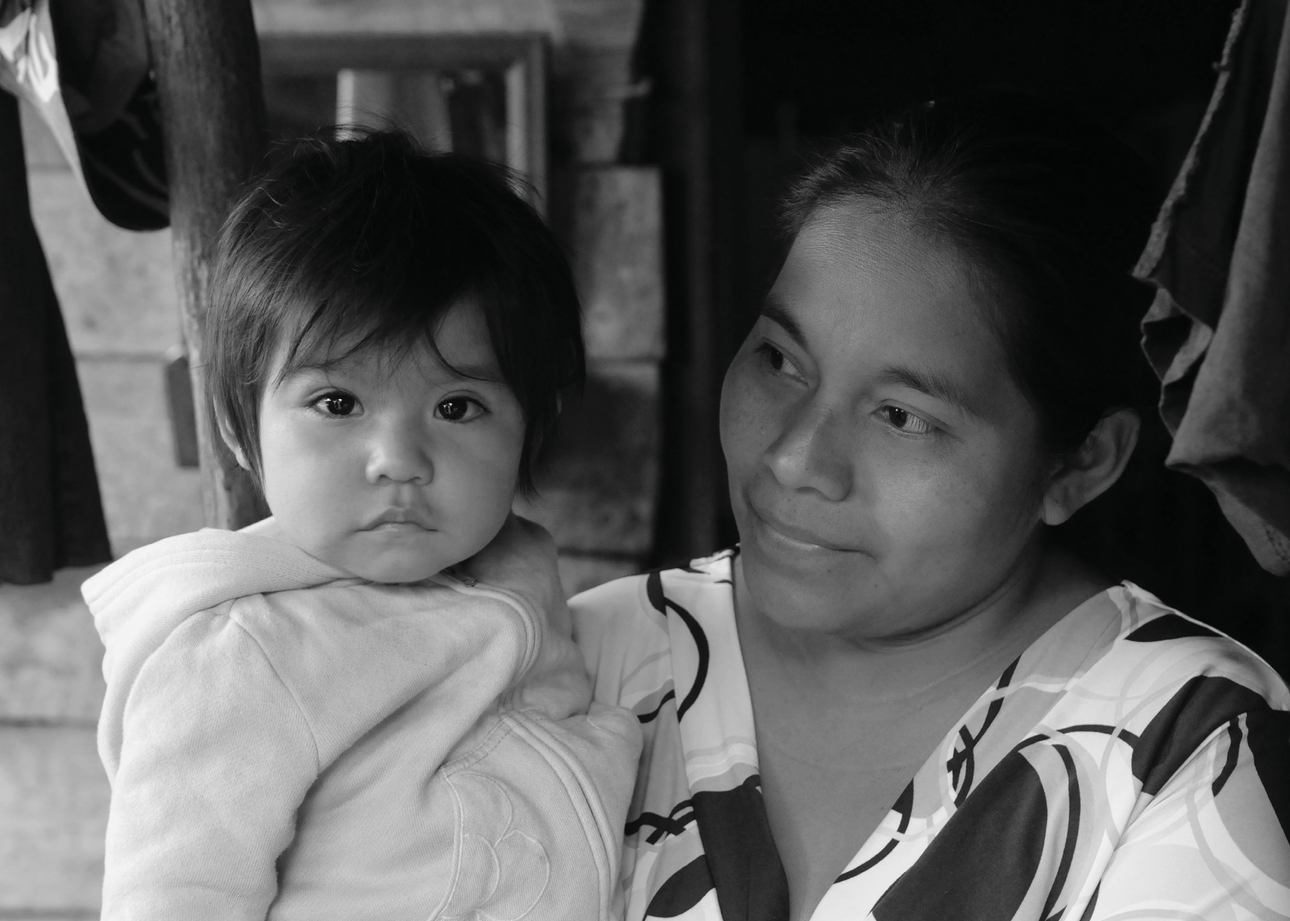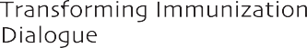

28 Adaptation Guidance & Needs Assessment - For IPC for Immunization Package

©UNICEF/Markisz

