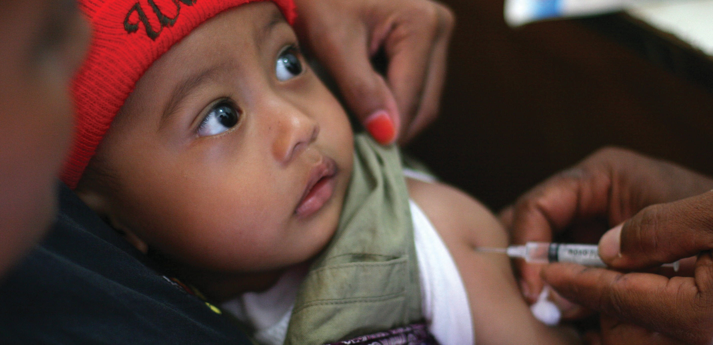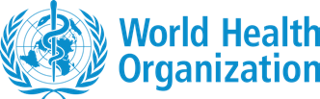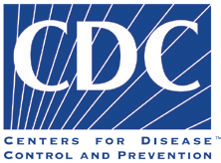

Routine Immunization – Frequently Asked Questions 1

Frequently Asked Questions Interpersonal Communication for
Immunization Package

©UNICEF/Estey

This Resource

This resource is available on the Internet at: ipc.unicef.org
Copies of this document, as well as additional IPC materials on immunization, may be requested from UNICEF and partners: UNICEF
3 United Nations Plaza New York, NY 10017 Tel: +1-212-326-7551
Email: IPC@unicef.org
© 2019 UNICEF
UNICEF and partners welcome requests for permission to use, reproduce or translate IPC for Immunization resources, in part or in full.
The content and the presentation of the material in this resource and the IPC package do not imply the expression of any opinion whatsoever on the part of UNICEF and partners.
Suggested citation: United Nations Children’s Fund, ‘IPC for Immunization Package’, UNICEF, New York, 2019. For more information, or to provide feedback, please write to IPC@unicef.org

Routine Immunization – Frequently Asked Questions
2
THIS RESOURCE

Acknowledgments
The Interpersonal Communication for Immunization (IPC/I) Package is the result of strenuous hard work and collaborative efforts of many institutions and individuals, without whose help, guidance and support, this would not have been possible.
UNICEF wishes to recognize their contributions to this important initiative and expresses gratitude to all those who supported the development of the package through their time and expertise. Special thanks to the global advisory group and the frontline workers From various parts of the world who contributed to develop the package.
Global IPC Advisory Group Members Molly Abbruzzese, BMGF
Hardeep Sandhu CDC Susan Mackay, GAVI Lisa Menning, WHO Jhilmil Bahl, WHO
Mike Favin, The Manoff Group Lora Shimp, John Snow Inc. Bill Glass, CCP
Saad Omer, Emory University
Dr. Stephen Hodgins, University of Alberta, Canada Nathan Pienkowski, Bull City Learning
Dr. Naveen Thacker, IPA Benjamin Hickler, UNICEF Ketan Chitnis, UNICEF Tommi Laulajainen, UNICEF Claudia Vivas, UNICEF
JHU Project Team
Sanjanthi Velu, Jvani Cabiness, Caitlin Loehr, Amrita Gill Bailey, Ron Hess, Guy Chalk, Michael Craven, and Bill Glass. Others who contributed include Rupali Limaye, Anne Ballard, Mark Beisser, Missy Eusebio, and Carol Hooks.
Acknowledging and thanks to the CCP field offices and sister organizations in Nigeria, Pakistan, Uganda, Ethiopia, India and CHIP Pakistan for their support during the formative research and pretesting stages of the package.
UNICEF Team
Attiya Qazi, Chikondi Khangamwa, Anisur Rehman, Rufus Eshuchi, Kennedy Ongwae, Ayesha Durrani, Robb Butler, Violeta Cojocaru, Jonathan David Shadid, Johary Randimbivololona, Natalie Fol, Deepa Risal Pokharel, Helena Ballester Mario Mosquera, Svetlana Stefanet, Sergiu Tomsa, Daniel Ngemera, Fazal Ather, Vincent Petit, Carolina Ramirez, Alona Volinsky, Hannah Sarah Dini, Benjamin Schreiber, Rafael Obregon, Diane Summer, Robin Nandy, Luwei Pearson and Stefan Peterson.
Suleman Malik, Communication for Development Specialist, UNICEF Headquarters, New York, USA. UNICEF Team Lead

Routine Immunization – Frequently Asked Questions
3
ACKNOWLEDGMENTS

Foreword
In recent decades, child mortality has dropped dramatically. Vaccines have been a major contributor to improvements in health by protecting children and adults against diseases that once maimed and killed. The scourge of smallpox has been eradicated, the last mile of polio eradication is close, as is the elimination of maternal and neonatal tetanus. Yet, despite the availability of vaccines, many countries face continuing constraints to achieving universal vaccination. One of the key challenges is ensuring sustainable demand for
vaccination at family and community levels. The value that community members place on vaccination is a major contributor towards good health. The Global Vaccine Action Plan (2011–2020) acknowledges the importance of community attitudes and practices, as reflected in one of its six strategic results: “Individuals and communities understand the value of vaccines and demand immunization as both their right
and responsibility.”
Although most children do receive the recommended vaccinations, too many still miss out: almost 20 million globally do not receive the full schedule of essential childhood vaccines. The reasons are complex. In some places, health services are not easily accessible – and when accessible, may not be convenient to users – and/or reliable. In some cases, health worker’s behaviors or attitudes may limit the uptake of vaccination services. Caregivers’ and children’s experiences with immunization services may be unpleasant for various
reasons and this can explain why many children who receive the first dose of vaccines (e.g. BCG or DTP1), drop out. In other instances, children miss recommended vaccinations because their parents or guardians have concerns or misunderstandings about vaccines, lack information on the benefits of vaccines, or do not understand what they need to do to get their children vaccinated and protected.
Frontline Workers (FLWs), including facility-based professionals, community health workers (CHWs) and community volunteers (CVs), are a critical source of information about vaccination. Research shows that FLWs are the most influential source of information about vaccines for caregivers and families of children. Because of their critical role in providing essential information about vaccination services,
FLWs must have effective interpersonal communication (IPC) skills. They also need positive attitudes towards the people they serve and their work, an understanding of the importance of communication, and an ability to operate in an environment that enables them to communicate effectively to build trust and confidence. When equipped with the relevant skills and supported by their supervisors, FLWs
can be very effective in influencing attitudes and promoting uptake of vaccination services. Across countries, FLWs engage communities in dialogue, mobilize community leaders and provide communities with health services and knowledge about healthy practices. However, the limited IPC skills of FLWs remains a challenge and requires focused efforts to enhance their capacity to communicate effectively with care givers and community members that they serve, and a system that supports and values the practice of these important competencies is vital.
UNICEF, together with Bill & Melinda Gates Foundation (BMGF), Centers for Disease Control and Prevention (CDC), , Emory University,

Routine Immunization – Frequently Asked Questions
4
FOREWORD

GAVI, the Vaccine Alliance (GAVI), International Pediatric Association (IPA), , John Snow Inc. (JSI), the United States Agency for International Development’s flagship Maternal and Child Survival Program, World Health Organization (WHO) and other partners, remain committed to closing the gap by facilitating a process of empowerment through the development and roll out of a comprehensive ‘IPC for Immunization’ package.
UNICEF and partners are pleased to introduce this IPC for Immunization package and invite national and sub-national programme managers, partners and FLWs to adapt it to their local context and use it to guide their work with caregivers and communities. A range of resources are in the package, including participant’s and facilitator’s manuals, an adaptation guide, a supportive supervision manual, FAQs, flash cards, videos, audio job aids, a mobile application, and a monitoring and evaluation (M&E) framework. These resources are available both online (IPC.UNICEF.Org) and offline in four global languages. It’s hoped that through this package and instructional-design approaches, FLWs will improve their capacity to effectively communicate and successfully promote demand for immunization and other
health services; empathize with caregivers; address questions and concerns through counselling; and clearly communicate key messages regarding the timing and importance of further vaccinations and practical information on where and when they should be obtained.
UNICEF extends gratitude to partners, colleagues and the advisory group who contributed their time, expertise and experience to the preparation of this package. Special thanks to Johns Hopkins University Center for Communication Programs for helping to develop the package, to the UNICEF regional and country colleagues and the FLWs for their support, valuable feedback and collaboration in developing the package. Through this partnerships and support, UNICEF will continue to enhance the capacity of the immunization workforce, institutions, and teams that will help communities to value, demand, trust and improved understanding to the right to immunization services.

Routine Immunization – Frequently Asked Questions
5
FOREWORD

Routine Immunization

Frequently asked questions

Introduction

As a frontline worker (FLW), you probably get a lot of questions about immunization. We developed this resource to help you respond to those questions using simple and concise language, following the principles of effective interpersonal communication (IPC). Effective IPC builds trust between the provider and caregiver, which can be the determining factor in whether a child gets fully vaccinated. Keep conversations with caregivers open, friendly, and respectful. Although caregivers are the focus, the tips shared here can also be used to communicate with other community members.

Before the Immunization Session

- Consult with mothers, fathers, grandparents, other types of caregivers and community leaders about what questions or concerns they have. There might be local issues not addressed in this FAQs and you will need to be prepared to address any concerns.

- Find out local names for the vaccine-preventable diseases, and any local cultural references for the diseases so that you can relate to the local context.

During the Immunization Session

- Respect the caregiver – They have a right to their beliefs, fears, and concerns, and they have the right to decide not to immunize. If a caregiver decides not to immunize, the FLW’s job is to help ensure that the caregiver understands the risks that decision brings and what to do during an outbreak of a vaccine-preventable disease or if the child shows symptoms of a serious disease. They should be treated well regardless of their ethnic group or religion, whether they are rich or poor, well-educated or not, and well-dressed or not. All are there because they love their children and want to protect them.

Routine Immunization – Frequently Asked Questions
6
INTRODUCTION

  - Listen to the caregiver – Give them your full attention. If appropriate in your culture, make eye contact with the caregiver and the child. Let the caregiver know you want to hear their questions and concerns. Restate any caregiver’s concerns (except rumours and misinformation, which you should avoid repeating or restating) to be sure that you understand what they mean.

  - Acknowledge the caregivers’ feelings, including their fears and their desire to protect their children.

  - Exercise empathy – Both you and the caregiver want to foster healthy children, families, and communities. Questions and reactions from caregivers come from a place of love and concern for the well-being of the child and the family.

  - Ask open-ended questions – Encourage caregivers to share their concerns by asking open-ended questions (questions that cannot be answered with “yes” or “no”).

  - Respond to actual concerns – Sometimes, the true question or concern is not being voiced. When listening and responding, try to identify and address the root of the problem.

  - Keep information simple – Caregivers may not have the precise knowledge or vocabulary to communicate their immunization-related concerns in a precise, technical way. Help them by using language, analogies, and examples that can be easily understood. Avoid overwhelming them with information that does not clearly address their concerns.

  - Acknowledge benefits and risks – Always discuss the known side effects of vaccines honestly.

  - Take your time – If you do not have the answer to a question right away, it is okay to give the best answer you can and ask the caregiver to ask the question again next time, so you can give a more complete response. You can then consult with colleagues or documents to help you prepare a more complete response.

  - Give caregivers time – They probably do not want to be rushed into a decision. If a caregiver is not ready to immunize, schedule a return visit for after they have had time to consider what you discussed together.

Routine Immunization – Frequently Asked Questions
7
INTRODUCTION

- Reassure the caregiver that you and the health system only want to help protect everyone from dangerous diseases.

- Reduce the stress of injections – Show caregivers ways to make immunization visits less stressful for their child. Reinforce that crying is a normal response. Suggest that caregivers stay calm themselves to help their child stay calm or calm down. Encourage caregivers to distract and soothe their child throughout the process.
- Provide take-home materials or direct caregivers to trusted immunization resources.

After the Immunization Session

Document caregivers’ questions and concerns. A record of what was discussed will be valuable for a child’s future visits and for developing health talks that are more relevant to the communities you serve.

Follow up. If caregivers express extreme worry or doubt, contact them a few days after the visit or ask a community liaison to check on them. A caring call will provide comfort and reinforce trust.

What If a Caregiver Refuses Immunization?

- Explain the risks of not immunizing, including risks to the child, to the other members of the household, and to the other members of their community.
- If appropriate and feasible, explain the responsibilities of caregivers of a child who is not fully vaccinated for his/her age.
- Show the caregiver photos of children with each vaccine-preventable disease and describe the early and late symptoms of the disease. Tell them what to do if the symptoms occur.
- If appropriate and feasible for your context, explain to caregivers what other actions they must also take, including always alerting health providers of their child’s immunization status to prevent the possible spread of vaccine-preventable diseases.
- Remember that not all caregivers want the same level of information about vaccines. Assess the level of information that a particular caregiver wants in order to communicate more effectively and build trust.

Routine Immunization – Frequently Asked Questions
8
INTRODUCTION

Practical Questions Whose Answers Will Vary by Country, Facility, Practice, or Community

FLWs should be prepared to answer questions such as:

  - Are vaccinations available in or near my community, and if so, when and where?
  - When are vaccinations available in this health facility?
  - Are all vaccinations available at these times, and if not, what is available when?
  - When do I need to bring my child back for more vaccinations?
  - If I cannot bring my child on that day, what should I do?
  - 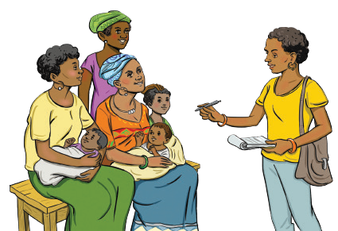When is the best time of day to bring my child so I do not have to wait for a long time?

Routine Immunization – Frequently Asked Questions
9
INTRODUCTION

Table Of Contents
Here are some commonly asked questions that will be answered in this document.

Vaccine Schedule 16
Vaccine Safety
13. If my child gets a fever after
20
immunization, should they still get more
vaccines?. 20
- Should I still bring my baby for the immunization appointment if they have a fever, a cold, or diarrhoea?. 20
- Do vaccines decrease a child’s natural ability to fight disease?. 21
- Why does my baby need so many vaccines?. 21
- Why does my baby need so many vaccines at once?. 21
- I heard that giving several vaccines in one day can overload the immune system. Can you give my child just one today?. 22
- What do you mean by ‘combination vaccine’?. 22
- Why do some children get very sick and even die after immunization?. 23
- What about vaccines and autism?. 23
- Can an immunization given to a woman affect her ability to have
children?. 23
The Need for Childhood Immunization 12
- Childhood diseases are part of the normal process of a child’s development. Why should I prevent this by having the baby immunized?. 12
- I have not seen these diseases you are talking about. Why should I vaccinate my child against something that does not affect people here?. 12
- Now that most of the old diseases are under control, am I putting my child at unnecessary risk by vaccinating them?. 13
- What happens if I do not immunize my child?. 13
- Do children get protection from diseases from their mother during pregnancy/through breastfeeding?. 14
- Should my child get vaccinated after being exposed to Measles, Mumps, or Rubella?. 15
    - What difference does it make if my baby misses one or two appointments? Will the vaccines not work?. 16
    - Why is the schedule so important? I cannot always make it here on time. 16
    - What should I do if I have to miss an immunization appointment?. 15

Side effects and complications 18
    - Can vaccines hurt my child?. 18
    - How common and serious are side effects that may come from immunizing my child?. 18
    - Why do some children have a fever and poor appetite after immunization, and what should caregivers do?. 19

Routine Immunization – Frequently Asked Questions
10
TABLE OF CONTENTS

Vaccine Effectiveness 24
- I have heard that some children get diseases that they have supposedly been immunized against. How can this be true?. 24
- Is natural infection better than immunization?. 24
Family/Community Resistance 25
- Traditional methods have protected my family for generations. Why should I believe immunization will be better for
my child?. 25
- My husband refused to let me bring the baby back for more immunizations because the last time the baby received an immunization, they fell sick. What can I do?. 25
- How can I convince my husband to give me transport money to bring our baby for the next immunization?. 26
- Do vaccines contain prohibited materials? I do not want such materials in my child. 26
Other Health System-Related Issues 31
- Why should I bring my child for immunization when it takes so much of my time?. 31
Questions about Specifi Antigens 27
- Why does the BCG vaccine cause a wound?. 27
- I have never heard of Hib. Why should I immunize my child against it?....
................................27
- Why does my child need to keep being immunized against polio?. 28
- What is this new injectable polio vaccine, and why does my child need both the new and the old one?. 28
Mistrust of the Health System/ Facility/Providers 29
- People say that vaccines cause sterility. What can you tell me about such things?. 29
- How do I know that immunization does not cause HIV/AIDS?. 29
- I do not know where the vaccines come from. How do I know they are safe?
...............................................30
- Why should I trust what you tell me about vaccines?. 30
- If I still have concerns about having my child vaccinated, where can I learn more?. 30
- Do I have to pay for immunization?. 31
- I lost my child’s immunization card. Can they still be immunized?. 32

Routine Immunization – Frequently Asked Questions
11
TABLE OF CONTENTS

The Need For Childhood Immunization

1. Childhood diseases are part of the normal process of a child’s development. Why should I prevent this by having the baby immunized?
?
2. I have not seen these diseases you are
talking about. Why should I vaccinate my child against something that does not affect people here?

- Some childhood diseases cause mild symptoms, but many can cause serious illness, disability, or even death in young children. Immunization protects your baby from several of these serious childhood diseases.

- Diseases like measles and whooping cough harm many children. Many children do not survive or are permanently harmed by these diseases. With childhood immunization, we do not have to lose our children to these diseases, and they do not have to suffer from them.

- Completing the immunization schedule gives your child a better chance to develop into a healthy adult.
- Vaccines save millions of children from illness and death, and the diseases they prevent still exist.
- We have seen time after time that these diseases start making children sick again once parents stop vaccinating their children or start delaying immunization.
- Sometimes, the germs that cause the diseases are still in the environment. Other times, newcomers or visitors bring them into the community. When children contract these diseases, they suffer. Some children even die.
- If you have any doubt about the need for vaccines, ask people in your parents’ or grandparents’ generation what it was like when so many children died or suffered permanent damage from diseases like measles and polio.
- Parents who fully vaccinate their children and vaccinate them on time help protect their children and all the other children around them.

Routine Immunization – Frequently Asked Questions
12
THE NEED FOR CHILDHOOD IMMUNIZATION

Building Trust: Science Versus Anecdote
Responding with too many scientific facts will frustrate some parents, while avoiding data, statistics and evidence may frustrate others. For some parents, too much anecdotal information won’t will not be useful. For others, a story from your experience about an unprotected child who became ill or knowing that children in your family have received all of their vaccinations, will be right on target. Which approach to use will depend on your knowledge of the caregiver and community. Be prepared to use a mix of science and personal stories that will be most effective in addressing caregivers’ questions.

3. Now that most of the old diseases are under control, am I putting my child at unnecessary risk by vaccinating them?

4. What happens if I do not immunize my child?

  - Continued vaccination is necessary to keep diseases under control.
  - Vaccines have been extensively tested by scientists and doctors and are extremely safe.
  - Very rarely, a child can experience a serious reaction. If this happens, the child should be checked by a health care provider as soon as possible to resolve the problem and report it. Reports are investigated to determine whether the vaccine might have caused the problem, which is rarely the case.
If your children are vaccinated, tell hesitant caregivers: I immunized my children because I know vaccines protect against many very serious diseases. Immunizing my children also protects my family and my community. Vaccinating is clearly the wise choice, given that the only downside is the possibility of mild discomforts that disappears in a day or two.
- If not immunized – or if immunized only once or twice with vaccines that need to be given three times – your child’s body will not be prepared to fight these diseases.

- If exposed to one of these diseases, your child could become seriously ill.

- If many children in the community do not get immunized, then a disease like measles could affect many children and there could be a devastating outbreak of the disease in the community.

Routine Immunization – Frequently Asked Questions
13
THE NEED FOR CHILDHOOD IMMUNIZATION

5. Do children get protection from diseases from their mother during pregnancy/through breastfeeding?

  - Mothers do pass on protection against some diseases to their baby during pregnancy and through breastfeeding (particularly in the thick, yellowish milk produced in the first few days after birth).
  - The immunization schedule was developed so that when the protection from the mother becomes weaker, the vaccinations will take over and protect the child.
The Dangerous Disease Most of Us Had Never Heard Of Here are 2 examples you can share of what can happen when children are not fully immunized: In the United States, Hib used to be the main cause of bacterial meningitis and other diseases such as pneumonia in children under 5: 20,000 cases occurred every year. Every year more than 1000 children died from Hib, and more than 6000 children were left deaf, blind, or brain damaged. By 2009 there were only 40 reported cases of Hib disease in children under 5. Most of these children were unimmunized or had not completed the vaccine schedule. So, in less than 10 years, Hib vaccine nearly wiped out Hib disease in young children in the U.S., preventing many, many cases of deafness, blindness, and brain damage. Source: U.S. National Institutes of Health A newly established national surveillance system showed a decrease in Hib disease among South African children after Hib conjugate vaccine introduction. The number of Hib cases (reported to the national surveillance system) among children below one year of age decreased by 65%, from 55 cases in 1999–2000 to 19 cases in 2003–04. Enhanced surveillance begun in 2003, identified HIV infection and incomplete vaccination as contributing factors for Hib transmission.

Source: Bulletin of the World Health Organization 2006;84:811- 818.

Assuming your children are vaccinated, tell hesitant caregivers: I immunized my children because I know vaccines protect against many very serious diseases. Immunizing my children also protects my family and my community. Vaccinating is clearly the wise choice, given that the only downside is the possibility of mild discomforts that disappear in a day or two.

Routine Immunization – Frequently Asked Questions
14
THE NEED FOR CHILDHOOD IMMUNIZATION

The Dangerous Disease Most of Us Had Never Heard Of

6. Should my child get vaccinated after being exposed to Measles, Mumps, or Rubella?

Here are two examples you can share of what can happen when children are not fully immunized:

    - If your child does not have immunity against measles, mumps, or rubella and are exposed to someone with one of these diseases, talk to a health professional about getting the relevant vaccine (s).

    - It is not harmful to get MMR vaccine after being exposed to measles, mumps, or rubella, and doing so may possibly prevent later disease.

    - During outbreaks, everyone without evidence of immunity should be brought up to date on their MMR vaccination. Sometimes during measles and mumps outbreaks, an additional dose of MMR may be given.
In the United States, Haemophilus influenzae type B (Hib) used to be the main cause of bacterial meningitis and other diseases such as pneumonia in children under five – 20,000 cases occurred every year. Among those cases, more than 1,000 children died from Hib, and more than 6,000 children were left deaf , blind, or had brain damage. By 2009 there were only 40 reported cases of Hib disease in children under five. Most of these children were unimmunized or had not completed the vaccine schedule. So, in less than 10 years, Hib vaccine nearly wiped out Hib disease in young children in the United States, preventing many deaths, and many cases of deafness, blindness, and brain damage.

Source: U.S. National Institutes of Health (n.d.)

A newly established national surveillance system showed a decrease in Hib disease among South African children after Hib conjugate vaccine introduction. The number of Hib cases (reported to the national surveillance system) among children below one year of age decreased by 65%, from 55 cases in 1999–2000 to 19 cases in 2003–2004. Enhanced surveillance that began in 2003, identified HIV infection and incomplete vaccination as contributing factors for Hib transmission.

Source: von Gottberg et al. (2006)Bulletin of the World Health Organization 2006;84:811-818.

Routine Immunization – Frequently Asked Questions
15
THE NEED FOR CHILDHOOD IMMUNIZATION

Vaccine Schedule

23
7. What difference does it make if my
baby misses one or two appointments? Will the vaccines not work?

8. Why is the schedule so important? I cannot always make it here on time

  - To be fully immunized, your child needs all doses of all vaccines in the recommended schedule. If your child does not receive the full number of doses, they are at risk for serious diseases.

  - It is highly recommended to stay as close as possible to the recommended schedule to prevent that risk.

  - Until the entire vaccine series is received, the child does not have the maximum protection against the diseases.

  - If a child is behind on the immunization schedule, a vaccinator can determine the proper catch-up schedule.

  - An interruption in the schedule does not require a child to start the series over for any vaccines.
- I understand how hard it can be to follow the schedule.
- The immunization schedule has been designed so that each vaccine is given at the age that provides the best protection for children.
- They are scheduled so the infant will be protected when the protection from the mother wears off. They are also scheduled for when each particular vaccine will work best, according to the tests done before the vaccine is approved for public use (and sometimes again based on experience implementing the vaccine).
- Please try your best to bring the child for immunization on time. The more days your child is eligible for immunizations but does not receive them, the more days they are at unnecessary risk for serious diseases.

Routine Immunization – Frequently Asked Questions
16
VACCINE SCHEDULE

9. What should I do if I have to miss an immunization appointment?

  - If you miss a scheduled immunization, bring your child to the next immunization session to catch up.

  - Every day that your child is late for an immunization is another day that your child is at risk for a preventable disease.

Routine Immunization – Frequently Asked Questions
17
VACCINE SCHEDULE

Side Effects And Complications

10. Can vaccines hurt my child?
- You understandably do not want your child to be hurt.
- Vaccines actually spare your child the pain and danger of many serious childhood diseases. However, vaccines can cause slight discomfort and/or a fever. Both go away within a day or two.

11. How common and serious are side effects that may come from immunizing my child?

- Some pain when the needle goes in is normal and lasts only briefly.
- Some children get a slight fever or maybe redness or swelling at the injection site, but that is normal. Those reactions go away by themselves. A lukewarm bath or paracetamol to lower the fever
- can help in the meantime.
- The BCG (bacille Calmette–Guérin) vaccine will leave a small sore that heals quickly.
- Discomfort, tenderness or soreness at the injection site is minor compared to the serious diseases that these vaccines can prevent.
Soothing a Child During the Vaccination
Before bringing your child for immunization, try to ensure that
they is are fed and well- rested. During the immunization, stay calm, talk softly, smile, and make eye contact with the children. Mothers may wish to cuddle or breastfeed infants after the injections. For toddlers, distract from the pain of the injection by telling a favorite story, singing, or taking deep breaths and blowing out the pain. After the injections, praise toddlers for getting through the injections and reassure them that everything is okay.
Source: U.S. CDCCenters for Disease Control and
Prevention (2012).

Routine Immunization – Frequently Asked Questions
18
SIDE EFFECTS AND COMPLICATIONS

12. Why do some children have a fever and poor appetite after immunization, and what should caregivers do?

  - 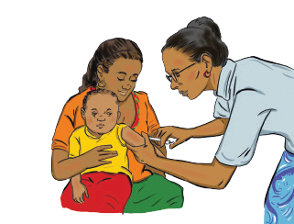A child who has a fever or feels sore may be irritable and not eat as well as normally.

  - Feed patiently and give favourite foods (especially breast milk).

  - If the fever does not go away within three days, take the child to a health worker. The fever might be due to another problem, not the immunization.

Routine Immunization – Frequently Asked Questions
19
SIDE EFFECTS AND COMPLICATIONS

Vaccine Safety

13. If my child gets a fever after immunization, should they still get more vaccines?

14. Should I still bring my baby for the immunization appointment if they have a fever, a cold, or diarrhoea?

- Yes, your child should receive all immunizations on the basic schedule.
- Fever following the DTP-Hep B (diphtheria, pertussis, and tetanus; hepatitis B) vaccine in particular, but other vaccines as well, is normal.
- Fever is a sign that the body is preparing to fight the diseases.
- Fever after immunization usually begins within 24 hours after the injection and lasts one or two days.
- If the fever is very high or lasts more than two days, please bring the child back because they might have something wrong that is not related to the vaccines.

Strong Ability to Respond
- Yes! If you are very concerned, you can contact a doctor ahead of the scheduled vaccination, or when you bring your baby for the visit, the nurse or doctor will examine them and let you know if immunization should be postponed.
- Immunizing a child who is not seriously ill will not harm the child and will not make the illness worse. Children with a cold, an earache, a mild fever, or diarrhoea, for example, can be safely immunized.
- In fact, a child who is malnourished or ill with a cough, a cold, diarrhoea, or a fever is weakened and particularly vulnerable to disease. Therefore, it is very important to keep to the immunization schedule as long as the child does not have a high fever (>38.5°C/101.3°F) or is not so sick that they need to be hospitalized.

The immune system can manage and respond to literally millions of antigens (foreign substances) at the same time. Take for example, as you walk outside on a spring day with flowers and trees in bloom, you are exposed to multiple antigens in pollen and dust via your mouth, nose, and lungs. Your immune system will constantly respond to the multiple antigens (like pollen and dust).

In the same way, in daily interactions, you may be exposed to multiple cold viruses and your body will respond successfully. Source:
Children’s Vaccine Program at PATH (2004).PATH

Routine Immunization – Frequently Asked Questions
20
VACCINE SAFETY

15. Do vaccines decrease a child’s natural ability to fight disease?
  - 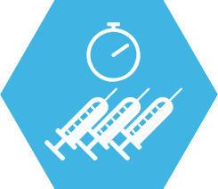No! Vaccines do not decrease a child’s natural ability to fight diseases.

17. Why does my baby need so many vaccines at once?
  - Vaccines teach the body to fight specific diseases without having to actually experience those diseases.
- The vaccines your child gets will protect them from these dangerous illnesses. Most vaccines require more than one dose to provide the best protection.
- Not too long ago, we had few vaccines to protect our children. Many more children got very sick or even died from diseases that can now be prevented with vaccines.

  - Vaccine schedules are designed to provide maximum benefit from the vaccines. Young children are more vulnerable to more diseases than adults and older children. The sooner they can be safely immunized, the better.

16. Why does my baby need so many vaccines?

- It can seem like there are a lot of vaccines but thank goodness our children can be protected from so many illnesses!
- The moment a baby is born, they are exposed to illnesses that pass from one person to another.
- Doctors and scientists develop vaccines to teach the body to fight off several illnesses.
- Every day, all over the world, babies safely receive multiple immunizations.

- It takes time to bring the baby in, and other life problems can make visiting the clinic difficult. Giving several vaccines at once avoids extra trips to the clinic and also ensures more children get all the vaccines they need to be protected against the diseases the vaccines prevent.

Routine Immunization – Frequently Asked Questions
21
VACCINE SAFETY

18. I heard that giving several vaccines in one day can overload the immune system. Can you give my child just one today?
1+1=
19. What do you mean by
‘combination vaccine’?

  - I can see why you might think that but consider how many germs your child’s body fights off every day. Everything they put in their mouths has germs, but the body fights off the vast majority of them. Otherwise, your child would be always sick (or worse).
  - Vaccines only have killed or extremely weak versions of germs (to teach the body how to fight the real thing). Your child’s body has no trouble handling them.
  - We have immunized many, many children at this facility and have not seen any problem from giving several vaccines during the same visit. In the same visit, we always give different injections in different spots on the child’s body. This avoids the child getting too sore in one area.

Vaccine Fears
Some people have incorrectly blamed vaccines for causing illness due to the timing of vaccines and when their child started to show symptoms of illness.

The health and science communities take these concerns very seriously and look hard for possible links. No one wants to give our children vaccines that will harm them.
  - Your child is actually more likely to be harmed by delaying a vaccine, since they might be exposed to the disease and become sick during that delay.
  - Before vaccines are introduced together, medical research is done to be sure they are safe when given together.
- Two or more different vaccines are sometimes combined into a single injection. These combination vaccines offer protection for your child against more than one disease with a single injection.
- They reduce the number of injections your child needs, as well as the number of visits to the health centre. This is easier on your child and saves you time and effort.

Routine Immunization – Frequently Asked Questions
22
VACCINE SAFETY

  - Unfortunately, the article set off a panic that led to dropping immunization rates, resulting in outbreaks of diseases.

20. Why do some children get very sick and even die after immunization?
  - There is no evidence of a link between the MMR vaccine and autism or autistic disorders.

- This may occur in extremely rare cases, but most likely the immunization did not cause the sickness. Instead another disease probably caused the sickness or death, and it was very likely that the child got sick around the time of the vaccination by chance. After all, young children get sick fairly often.
- Scientists and governments investigate such cases thoroughly to understand the cause of the problem.

21. What about vaccines and autism?

- The 1998 study that raised concerns about a possible link between the MMR (measles-mumps-rubella) vaccine and autism was later found to have very serious mistakes and made-up data.
- The paper was later retracted by the journal that published it. Ten of the 12 authors on the paper endorsed the retraction and rejected the original interpretation.

22. Can an immunization given to a woman affect her ability to have children?

- Immunizations given to women (most commonly, tetanus toxoid is given to pregnant women) protects them and their newborn children from disease such as those for tetanus, diphtheria or influenza.

- Vaccines do not affect women’s ability to have children or carry any risk for the health of newborn children.

- You probably know many women in your community who have been immunized and later have more children.

Routine Immunization – Frequently Asked Questions
23
VACCINE SAFETY

Vaccine Effectiveness

23. I have heard that some children get diseases that they have supposedly been immunized against. How can this be true?

24. Is natural infection better than immunization?

  - Unfortunately, no medical intervention works perfectly.

  - The vaccines we provide are extremely effective when the child receives all of the doses needed.

  - Nevertheless, since vaccines are not 100% effective, a small number of vaccinated children will still get the disease. Their bodies do not respond strongly enough to the vaccine.

  - The vaccine still helps them though. They will get less sick than if they had not been vaccinated, because their bodies are at least partially prepared for the disease.

Infection usually does cause better immunity than vaccination. However, the price paid for natural disease can include:
  - Paralysis
  - Permanent brain damage
  - Liver cirrhosis/cancer
  - Deafness
  - Blindness
  - Pneumonia
  - Death

Herd immunity
Because most vaccine-preventable diseases move from person to person, the more people in a community who are immunized, the lower the likelihood that disease will be around and “find” the few who are unprotected.

Routine Immunization – Frequently Asked Questions
24
VACCINE EFFECTIVENESS

Family/Community Resistance

25. TTraditional methods have protected my family for generations. Why should I believe immunization will be better for my child?
26. My husband refused to let me bring the baby back for more immunizations because the last time the baby received an immunization, they fell sick. What can I do?

    - It might seem hard to believe that immunization makes a difference because we do not often see the harmful effects of these diseases anymore.

    - Before immunization was widely adopted, families expected one or more of their children to die before reaching the age of five years. Many of these children died from measles, polio, tuberculosis, whooping cough (pertussis), and tetanus.

    - Today, immunization protects children from these and other diseases, so more children grow well and survive.
- It is true that sometimes a baby develops a mild fever after receiving a vaccine. This is a side effect of immunization rather than a real sickness.

- Side effects are milder and not as serious as the diseases that immunization prevents.

- Side effects typically disappear in a short time. A lukewarm bath or paracetamol can bring down a child’s temperature.

- If your husband is still concerned, I can come talk to him or he can visit the clinic to learn more about vaccines and their safety.

Routine Immunization – Frequently Asked Questions
25
FAMILY/COMMUNITY RESISTANCE

27. How can I convince my husband to give me transport money to bring our baby for the next immunization?

28. Do vaccines contain prohibited materials? I do not want such materials in my child.

  - You are not alone in having this problem.

  - You might start by reminding your husband that the baby depends on both of you for their security, growth, and development.

  - Explain that immunization can save the family money by preventing diseases that would need to be treated – sometimes with expensive medicines or many visits to the clinic or hospital.

  - If your husband does not change his mind, please try very hard to set aside enough money to bring your child in – for their sake and for your family’s sake.
- Vaccines are designed to be acceptable to people of all religions. This is important because for immunization to protect the most people, as many people as possible need to be immunized.
- Islamic scholars determined that the transformation of pork products into gelatin alters them sufficiently to make it permissible for observant Muslims to receive vaccines containing pork gelatin.
- Vaccines are made mainly from germs, or pieces of them, that cause the diseases. However, the germs in vaccines have been weakened or killed so they are no longer harmful to the child.
- To ensure that vaccines remain sterile, effective, and safe, they also contain very small amounts of chemicals that have been tested extensively and found to be safe.

Routine Immunization – Frequently Asked Questions
26
FAMILY/COMMUNITY RESISTANCE

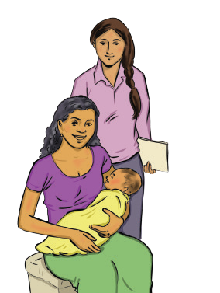Questions About Specific Antigens

29. Why does the BCG vaccine cause a wound?
  - BCG causes a reaction in the skin where it is given. This shows that the vaccine has worked and the child’s body is becoming protected from some serious forms of tuberculosis.

30. I have never heard of Hib. Why should I immunize my child against it?

  - I did not always know what Hib was either. Then I learned that it is a dangerous germ that causes many of the pneumonia and meningitis cases we see – or used to see!
  - The Hib vaccine prevents serious types of pneumonia and meningitis and saves thousands of lives every year.
  - If the caregiver wants to know, Hib stands for Haemophilus influenzae type B.

Routine Immunization – Frequently Asked Questions
27
QUESTIONS ABOUT SPECIFIC ANTIGENS

31. Why does my child need to keep being immunized against polio?

32. What is this new injectable polio vaccine, and why does my child need both the new and the old one?

- Oral polio vaccine (OPV) is safe and effective, and every dose brings a child closer to being fully protected against polio. It takes multiple doses of OPV to achieve full immunity against polio.

- Although wild polio disease has been eliminated from many countries, it still exists in others, so unprotected children could be infected.

- When the virus is eradicated worldwide, we will be able to stop using polio vaccine. However, as long as polio exists in the world, our children need protection against it.
- Injectable polio vaccine (IPV) is an effective vaccine used to help protect children from and ultimately eradicate polio. It has been used all over the world for more than 50 years.

- IPV does not replace OPV. Rather, IPV is used as well as OPV because they work together to best strengthen a child’s immune system against polio.

Routine Immunization – Frequently Asked Questions
28
QUESTIONS ABOUT SPECIFIC ANTIGENS

Mistrust Of The Health System/Facility/Providers

33. People say that vaccines cause sterility. What can you tell me about such things?

34. How do I know that immunization does not cause HIV/ AIDS?

  - There is nothing in vaccines that prevents future pregnancy.

  - I am sure that many women in your community who were immunized as children or while pregnant later got pregnant and had babies.

  - And of course, many men who were immunized as boys later became fathers.

  - Immunization is a safe and effective way to reduce deaths from vaccine-preventable diseases and has been in use worldwide for many years.
- Sharing needles with someone who has HIV can possibly spread HIV, but we do not reuse needles for immunization or any injections.

- If non-reusable syringes are used, show the caregiver how they work.

- Unfortunately, pregnant women with HIV can pass the virus to their babies. This is not related to immunization. It can happen whether or not the mother or child is immunized since there is not yet an AIDS vaccine.

Routine Immunization – Frequently Asked Questions
29
MISTRUST OF THE HEALTH SYSTEM/FACILITY/PROVIDERS

  - I would like you to trust me because I have your child’s best interests at heart. But if you would like to speak with another healthcare professional, I will try to arrange it.

35. I do not know where the vaccines come from. How do I know they are safe?
  - I make sure my own children have all recommended vaccinations, so clearly, I am very confident in vaccinations.

37. If I still have concerns about having my child vaccinated, where can I learn more?

- Vaccines are among the safest health products in the world.
- They are extensively tested for safety before being accepted into immunization programs, and they are made in specialized manufacturing plants all over the world.
- They generally are made from killed or weakened pieces of the germs that cause the diseases.
- Every vaccine is tested and approved by the World Health Organization before it reaches any country.

36. Why should I trust what you tell me about vaccines?

- I regret that you might not trust me, but please know that the recommendations I am making are made all over the world. Some countries are lucky to give even more vaccines to their children.

- I can see if a doctor is available to speak with you, or you can make an appointment to speak to one later.
- Here are some links to information on vaccine safety:
  - World Health Organization http://www.who.int/vaccine_ safety/en/
  - U.S. Centres for Disease Control and Prevention https:// www.cdc.gov/vaccinesafety/index.html
  - Immunization Action Coalition http://immunize.org
  - Other credible websites, especially in the national language(s), including the Ministry of Health
  - Any well-done national publications that provide solid information on immunization.
  - There is a lot of false information about vaccination on the Internet. It is best for people to use only web sites from reputable organizations such as the ones above.

Routine Immunization – Frequently Asked Questions
30
MISTRUST OF THE HEALTH SYSTEM/FACILITY/PROVIDERS

Other Health System-Related Issues

38. Why should I bring my child for immunization when it takes so much of my time?

39. Do I have to pay for immunization? Note: This depends on the country, and perhaps on the facility.

    - We are sorry that sometimes it takes a long time to have your child immunized.
    - You did the right thing by staying until your child could be seen, and they will be better protected from disease because you did.
    - It may seem like a long time to wait for your child to be vaccinated, but if your child fell ill from one of the vaccine- preventable diseases, you would have to spend much more time and resources getting care for them.
    - If true, say: If you bring the child later in the day, there will be a much shorter wait.
    - If true, say: We are working to reduce waiting times and hope you will see a difference next time.
- Explain any official immunization-related costs and say that caregivers should not have to pay any “unofficial” costs.

- Emphasize that despite costs, having a child protected from vaccine-preventable disease is priceless.

- Reiterate the benefits of immunization.

- If appropriate, help the caregiver identify resources for the vaccine-related expenses.

- In settings where vaccination does not involve any cost, tell the mother that it is provided free of cost by the government.

Routine Immunization – Frequently Asked Questions
31
OTHER HEALTH SYSTEM-RELATED ISSUES

40. I lost my child’s immunization card. Can they still be immunized?

  - 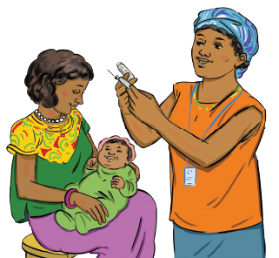Yes, and I am very glad you have asked.

  - If this is true, say: Just tell a health worker that the card is lost, and they will give you a new one free of charge. Please keep the card in a safe place and always bring it when the child is going to see a health worker.

  - The card is important for you and the health worker to know for sure what vaccines your child has had or needs.

Routine Immunization – Frequently Asked Questions
32
OTHER HEALTH SYSTEM-RELATED ISSUES

Sources

    - Basic Support for Institutionalizing Child Survival (BASICS) and Federal Ministry of Health (FMOH). (2002). Communicating with clients/parents and communities for improved routine immunization coverage. Nigeria: BASICS and FMOH.
    - Children’s Vaccine Program at PATH. (2004). Childhood immunization: What you need to know. A handbook for health workers and parents. Available from: https://www.path.org/resources/childhood-immunization-what-you-need-to-know-a-handbook-for-health- workers-and-parents/
    - 1. Communicating with clients/parents and communities for improved routine immunization coverage (Prepared in 2002 in Nigeria by BASICS and FMOH)
    - How to Answer Parents’ Tough Questions about Their Children’s Vaccinations, draft.Immunization Action Coalition. (n.d.). Website. Available from: http://www.immunize.org/
    - Questions and Answers about Immunization: A guide to assist vaccinators and other health professionals answer questions about immunization in Timor-Leste.
    - UNICEF. (n.d.). Training curriculum. Interpersonal communication skills; Introduction of inactivated polio vaccine (IPV).
    - USAID Maternal and Child Health Integrated Program (MCHIP) for Ukraine Ministry of Health. (n.d.) answer parents’ tough questions about their children’s vaccinations [draft].
    - U.S. Centers for Disease Control and Prevention. (2012). Talking with parents about vaccines for infants: Strategies for health care professionals. Available from: https://www.cdc.gov/vaccines/hcp/patient-ed/conversations/downloads/talk-infants-color-office.pdf
    - U.S. National Institutes of Health. (n.d.). Childhood Hib vaccines: Nearly eliminating the threat of bacterial meningitis. Available from: https://www.nih.gov/sites/default/files/about-nih/impact/childhood-hib-vaccines-case-study.pdf
    - von Gottberg, A., de Gouveia, L., Madhi, S. A., et al. (2006). Impact of conjugate Haemophilus influenzae type b (Hib) vaccine introduction in South Africa. Bulletin of the World Health Organization, 84, 811-818.
    - World Health Organization. (2017). Questions and answers on immunization and vaccine safety: Online Q&A – March 2017. Available from: https://www.who.int/features/qa/84/en/

Routine Immunization – Frequently Asked Questions
33
SOURCES

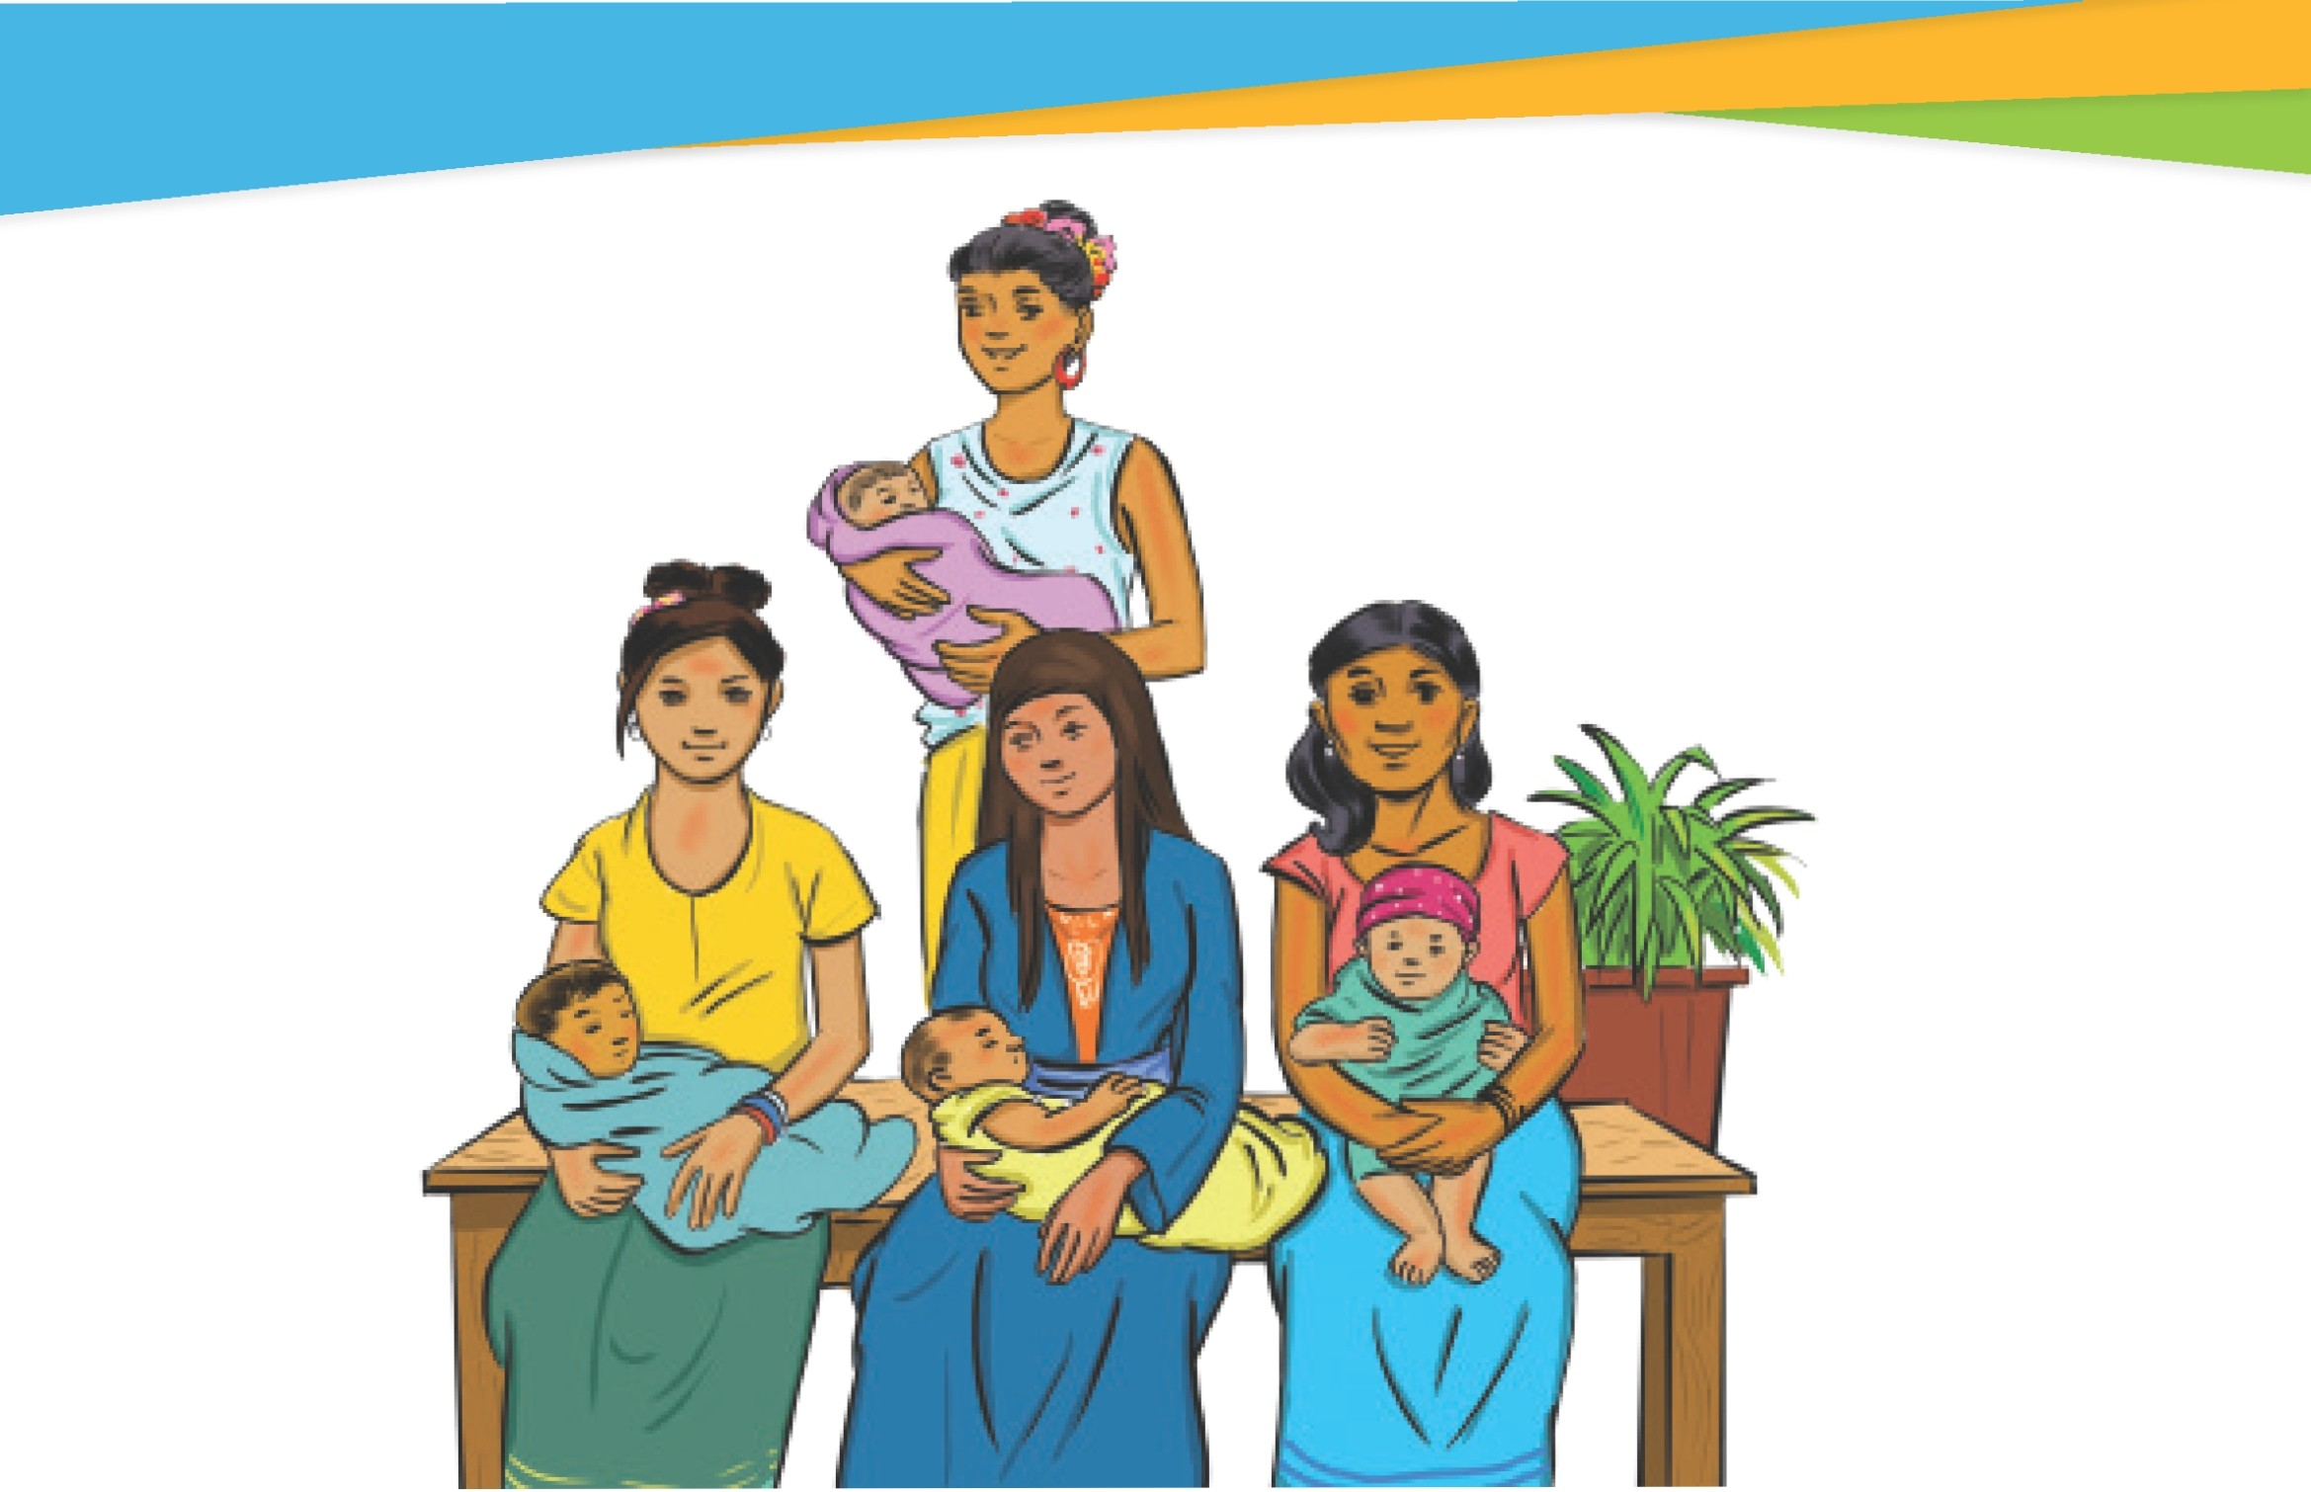

Routine lmmun1zat 1on - Frequently Asked Questions
34
NOTES

Notes

Routine Immunization – Frequently Asked Questions
35
NOTES

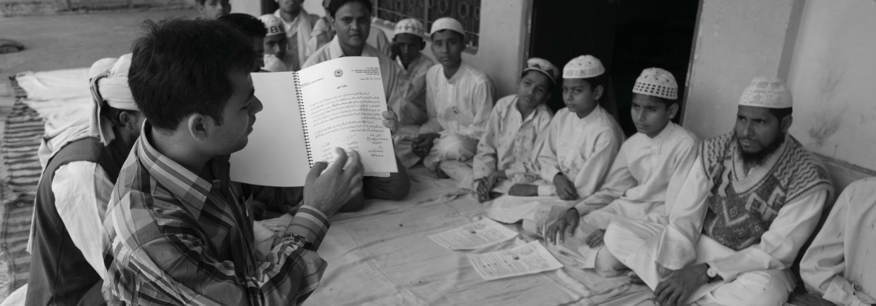

36 Routine Immunization – Frequently Asked Questions

©UNICEF/Pietrasik

