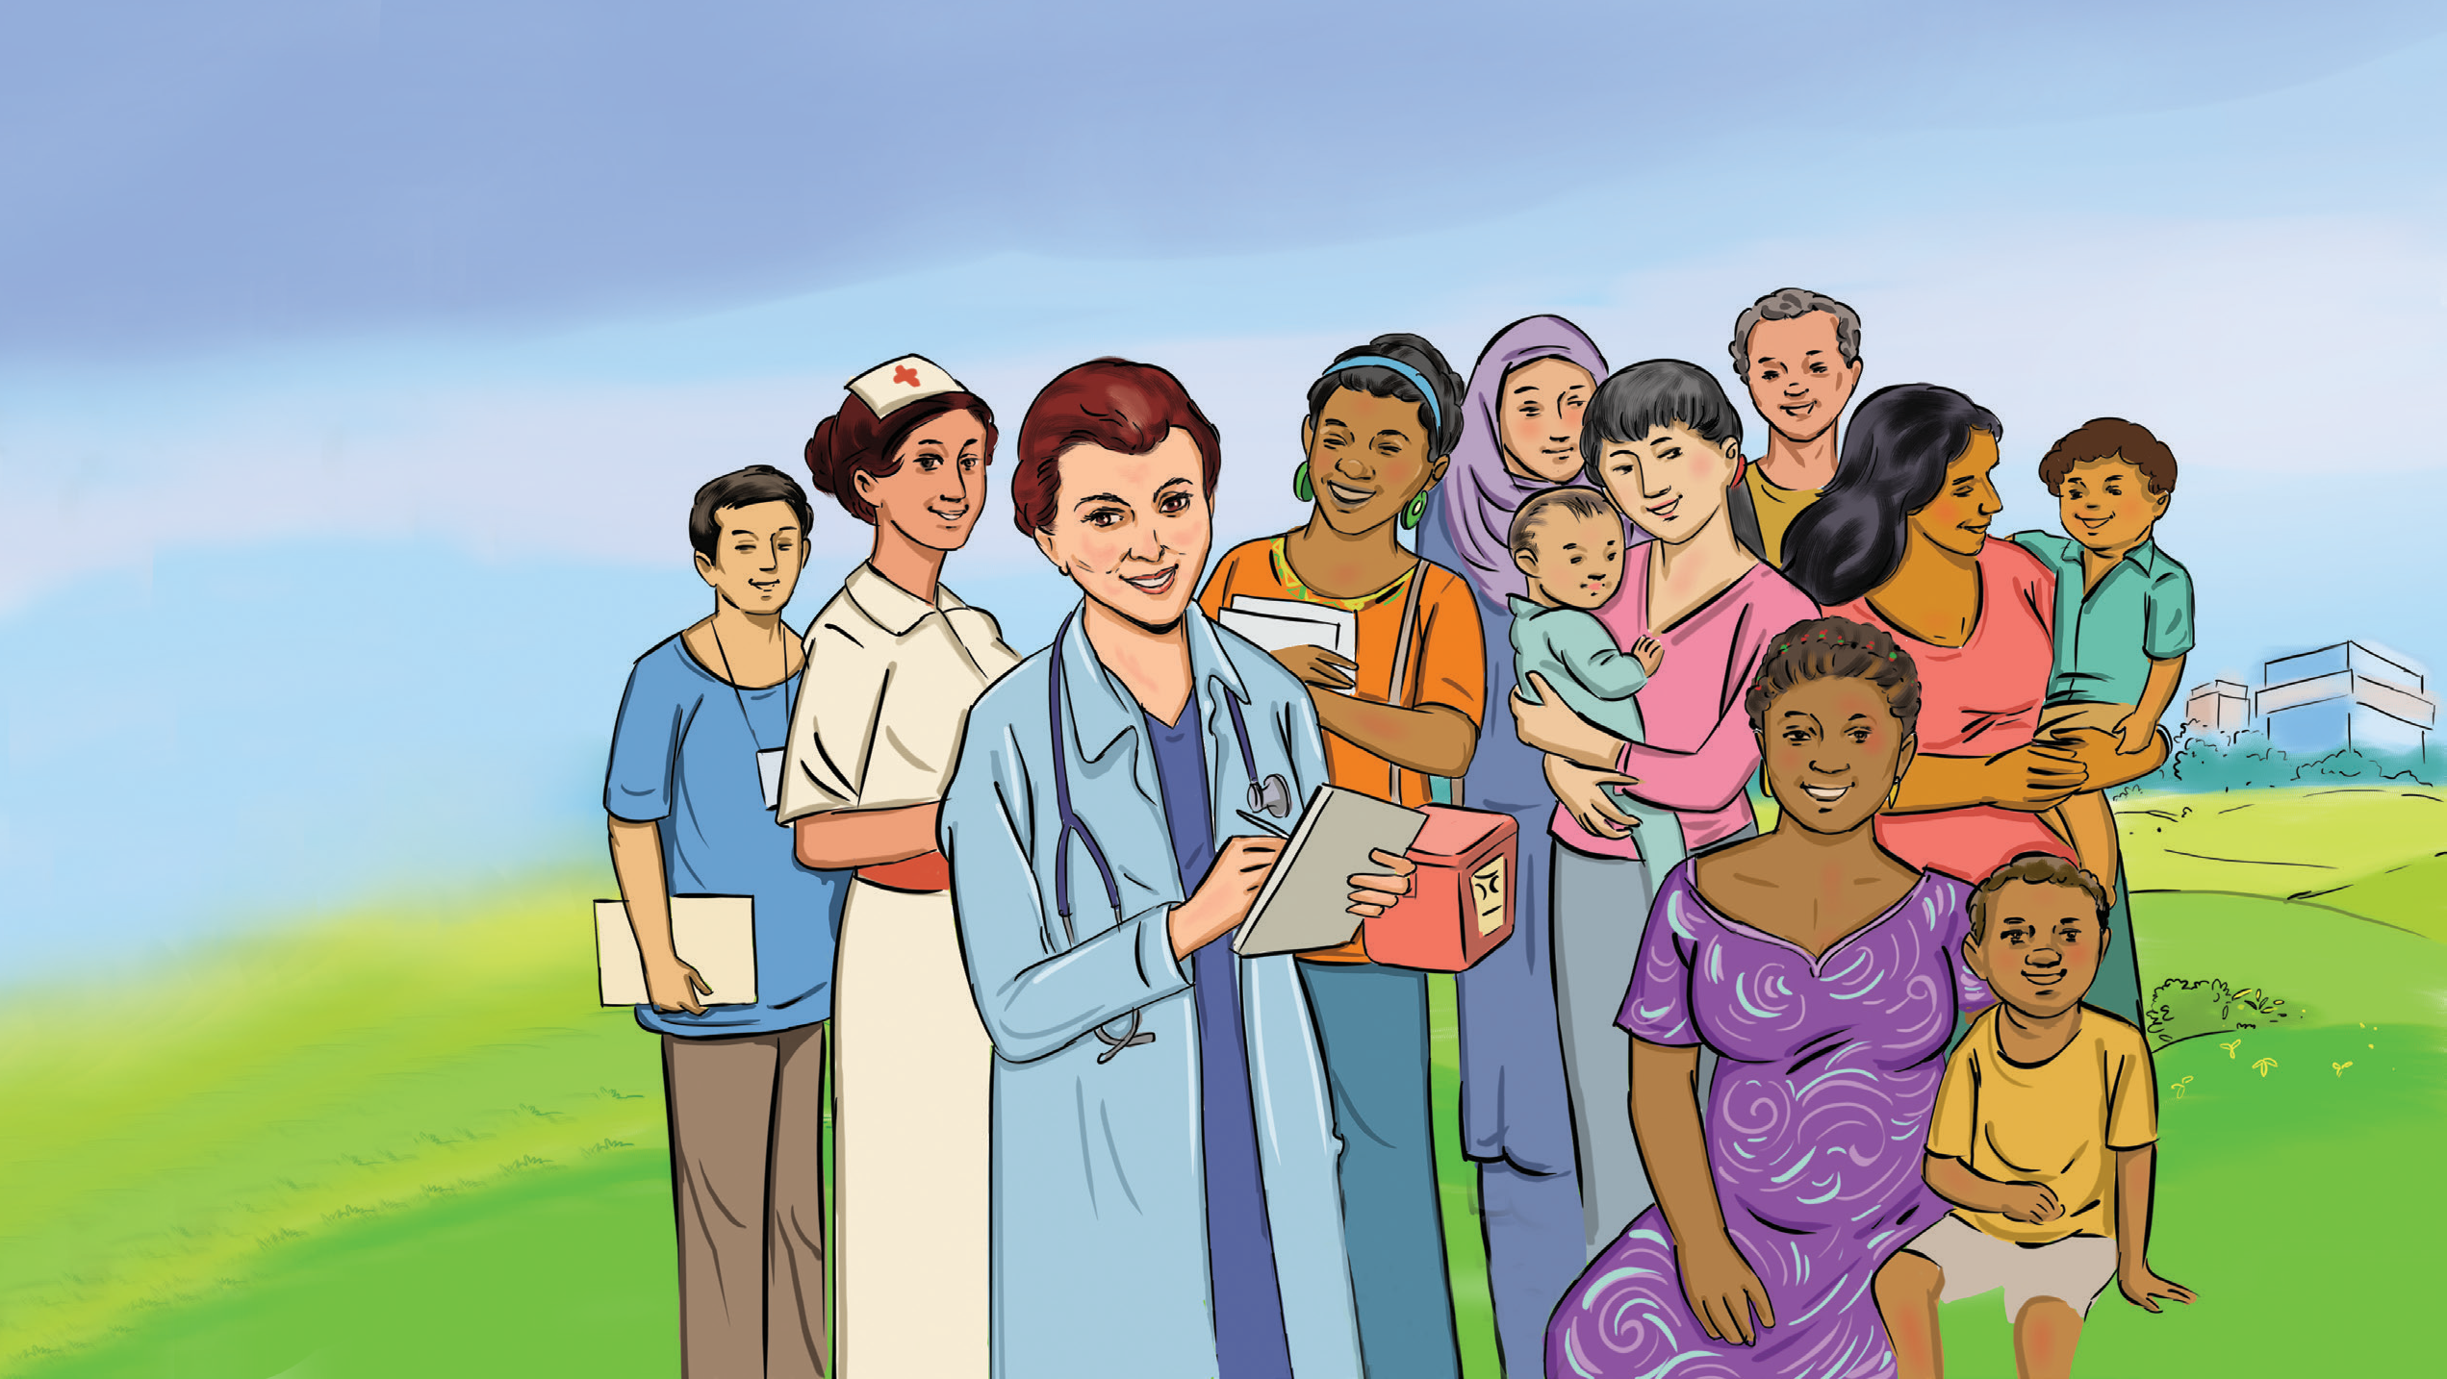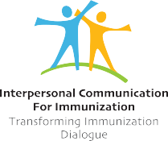INTERPERSONAL COMMUNICATION FOR IMMUNIZATION
REFERENCE CARDS

About

The Interpersonal Communication for Immunization Reference Cards were created to provide easy access to information about vaccines and vaccine-preventable diseases. These cards can be used as self-learning tools, guides for conversations with caregivers and community members, and information resources for education and training.
This resource was developed for a global audience of front line workers who interact and communicate with caregivers and clients about immunization. Immunization programmes can adapt these cards to reflect their own specific priorities, guidance, and messages. We recommend considering the needs of the programme and community, adapting the cards to reflect those needs and priorities, and then pretesting the cards with community members. Factors to consider include:
Images
Vaccine schedule
Contraindications for specific vaccines
Caregiver profiles
Add or remove cards according to their relevance Size of cards or formatting
We recommend that pretesting be conducted with the various types of frontline workers and caregiversin each area or country. The pretesting process will help the programme to understand how the frontline workers react to the cards themselves and how well the cards assist conversations with caregivers. The feedback will help inform further revision the cards, if needed. The goal of this process is to make the cards and their content appropriate for the programme and the communities they serve.
These cards are one component of the UNICEF Interpersonal Immunization for Communication Training and Supervision Resource Kit. The kit also contains a Frequently Asked Questions booklet, which provides additional messages and detailed responses to the questions and topics discussed in the Reference Cards.
url: ipc.unicef.org, E-mail: smalik@unicef.org

B PROFILING CAREGIVER AUDIENCES
B1 Caregiver Audience: Confident Acceptors
Caregiver Audience: Cautious Acceptors B2 Caregiver Audience: Partial Acceptors
Caregiver Audience: Rejectors
C FREQUENTLY ASKED QUESTIONS
C1 Frequently Asked Questions: The Importance of Vaccines C2 Frequently Asked Questions: Vaccine Safety
C3 Frequently Asked Questions: Vaccine Safety Continued C4 Frequently Asked Questions: Vaccine Schedule
C5 Frequently Asked Questions: Vaccine Effectiveness
C6 Frequently Asked Questions: Vaccination During Pregnancy C7 Frequently Asked Questions: Who Should Not Get Vaccinated?
E DISEASE KNOWLEDGE CHECK
E1 Disease Knowledge Check: Questions 1–9 Disease Knowledge Check: Answers 1–9
E2 Disease Knowledge Check: Questions 10–18 Disease Knowledge Check: Answers 10–18

Content Overview
A GUIDING AN INTERPERSONAL COMMUNICATION FOR IMMUNIZATION SESSION
A1 Importance of Interpersonal Communication for Immunization A2 Effective Interpersonal Communication Practices
A3 Key Messages in an Immunization Session A4 Immunization Key Messages for Caregivers
A5 Communicating About Discomforts Following Vaccination
A6 Communicating Potential Adverse Events Following Vaccination
D VACCINES-PREVENTABLE DISEASES
D1 Diphtheria
D2 Haemophilus influenzae Type B
D3 Hepatitis B
D4 Human Papillomavirus (HPV)
D5 Influenza
D6 Measles
D7 Meningococcal D8 Mumps
D9 Pertussis (Whooping Cough) D10 Pneumococcal
D11 Polio
D12 Rotavirus Disease D13 Rubella
D14 Tetanus D15 Tuberculosis
D16 Varicella (Chicken Pox)

Guiding an Interpersonal Communication for Immunization Session

A

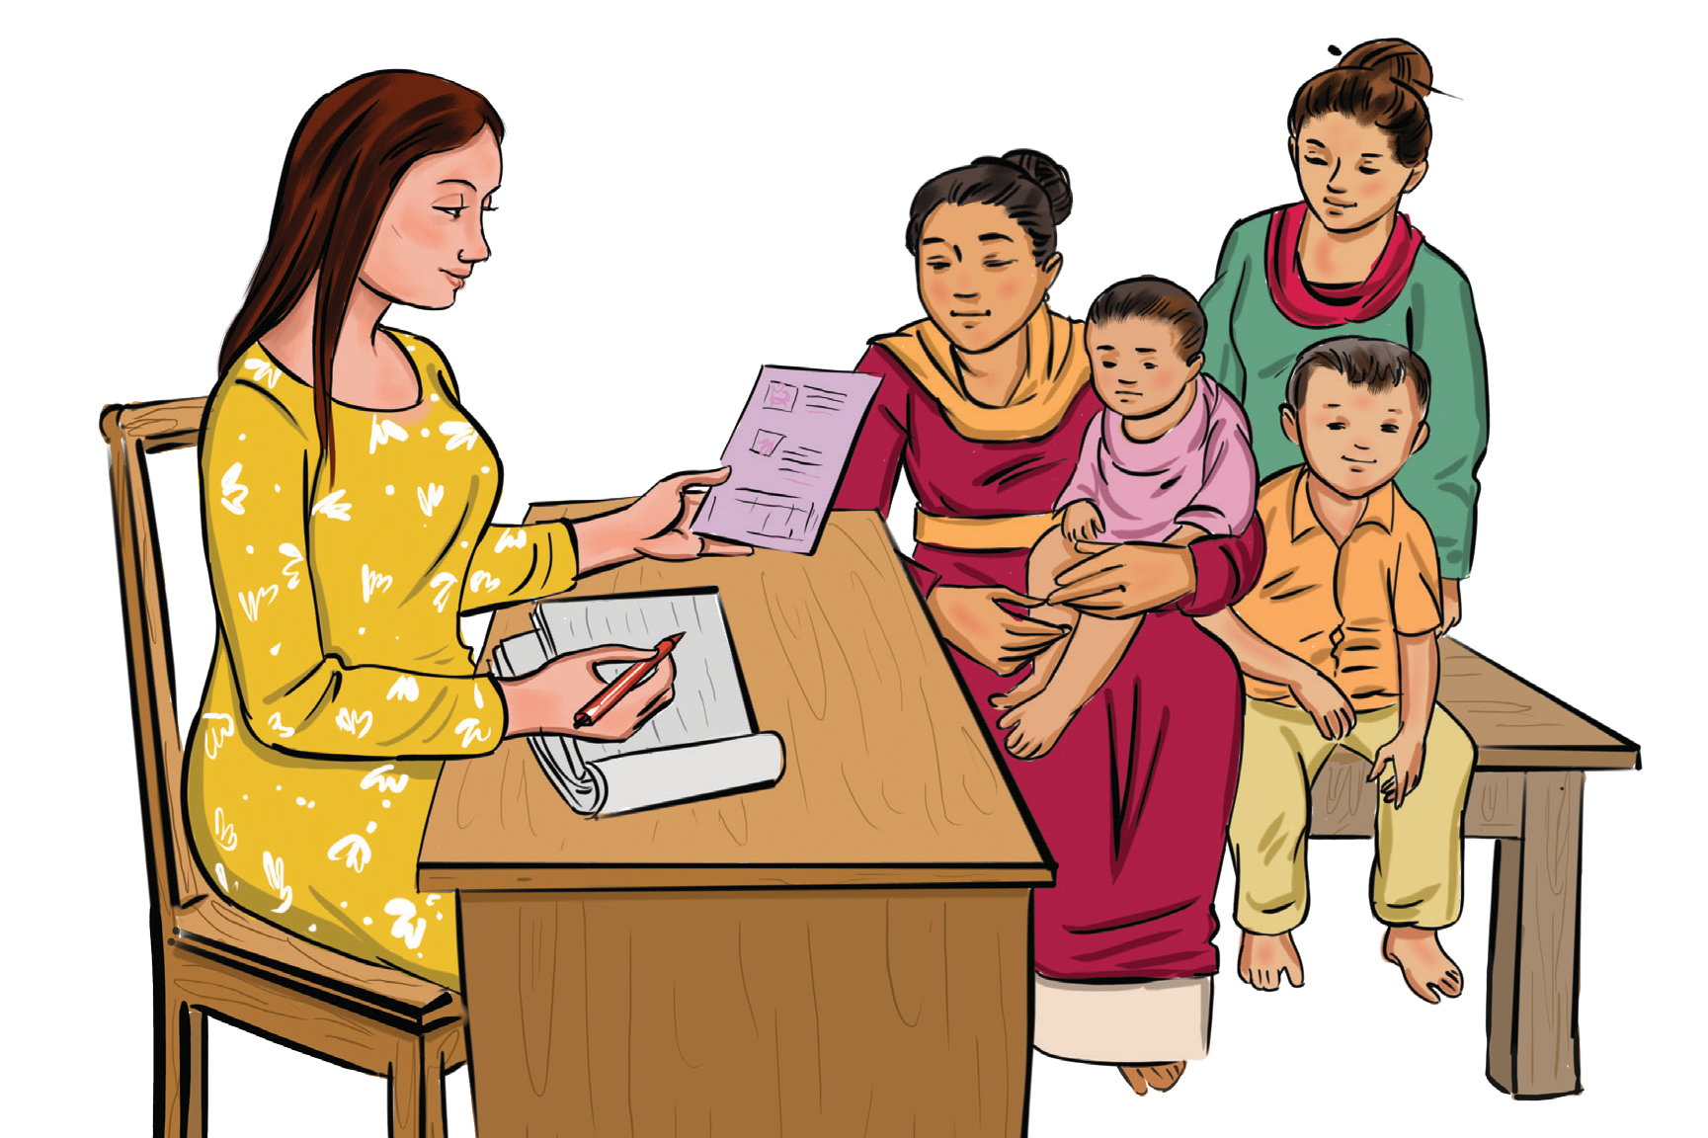
Importance of Interpersonal Communication for Immunization

A1

Strengthening Interpersonal communication can help front line workers to:
Understand different perspectives and knowledge gaps on immunization
Maintain confidence in their ability to discuss vaccination
and the diseases vaccines prevent
Engage with caregivers and listen to their challenges and concerns with genuine interest
Check that the caregiver or client understands the information given, including when to return for the next vaccinations and services
Build trust with the caregiver Remain kind and patient

How can interpersonal communication support improved immunization coverage?
When a front line worker practices good interpersonal communication, this helps to ensure that a caregiver has the correct information and confidence they need to commit and maintain a commitment to continue to bring their child for all vaccinations on schedule. Good interpersonal communication includes the following:
Acknowledging the caregiver’s feelings, including their concerns and desire to protect the child
Emphasizing a shared desire to ensure the child’s health
Correcting any myths or misperceptions about vaccine risks
Explaining that vaccines are extremely safe Answering any questions accurately and respectfully

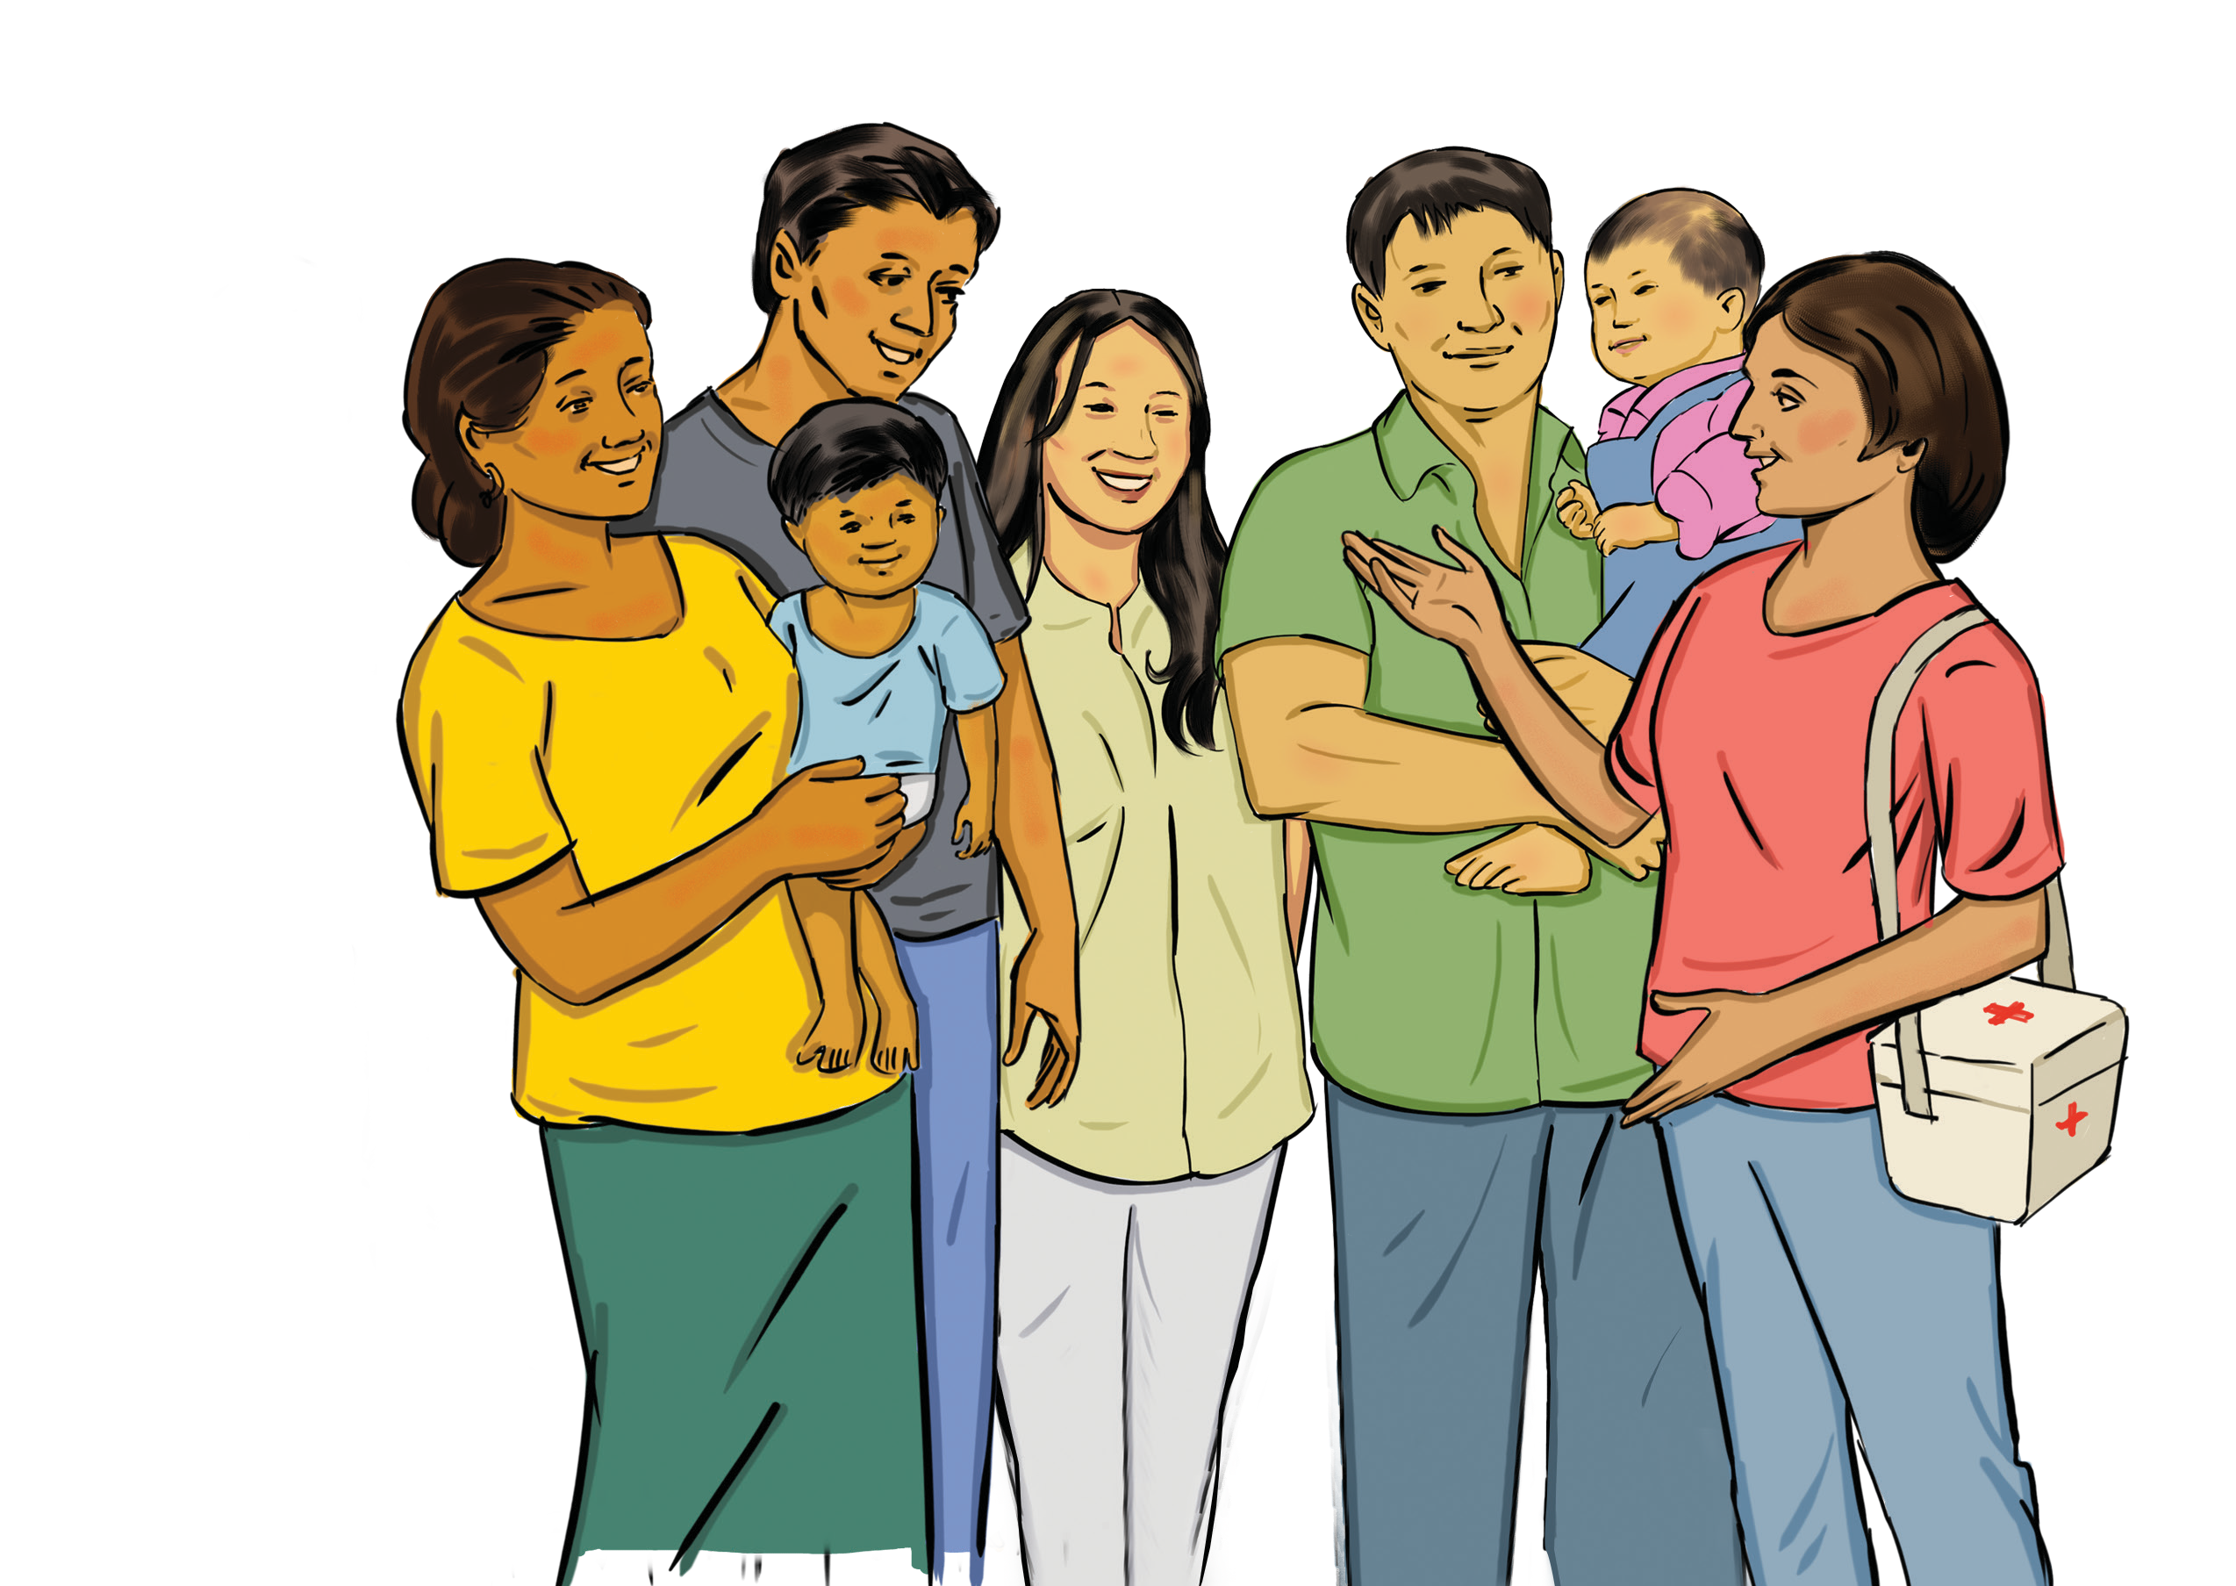

Good Interpersonal Communication Practices

When starting a conversation about immunization with a caregiver, it is important to have strong interpersonal communication skills.
Good interpersonal communication practices are fundamental to having positive and productive discussion. This card will discuss a few vital practices to keep in mind while working with caregivers in your community.
A2

Two-Way Dialogue
Good interpersonal interaction with a caregiver is a two- way dialogue. Both participants must speak and listen to the other without interrupting, ask questions, and exchange information.

Atmosphere of Caring
Caregivers need to believe that their provider cares about them and is committed to their health and wellbeing. Being attentive, making eye contact, listening and questioning thoughtfully, and demonstrating understanding and empathy will make caregivers feel important and show them that you are interested and concerned.

Encourage Dialogue
Do not forget that, in addition to asking yes or no questions, you should ask caregivers open-ended questions to encourage them share any concerns. Once caregivers describe their situation, you might have a better idea of how to best advise them.

Present Information
It is essential to present information in a way that the caregiver can easily absorb and understand. It may be beneficial to use visual aids when possible or available.

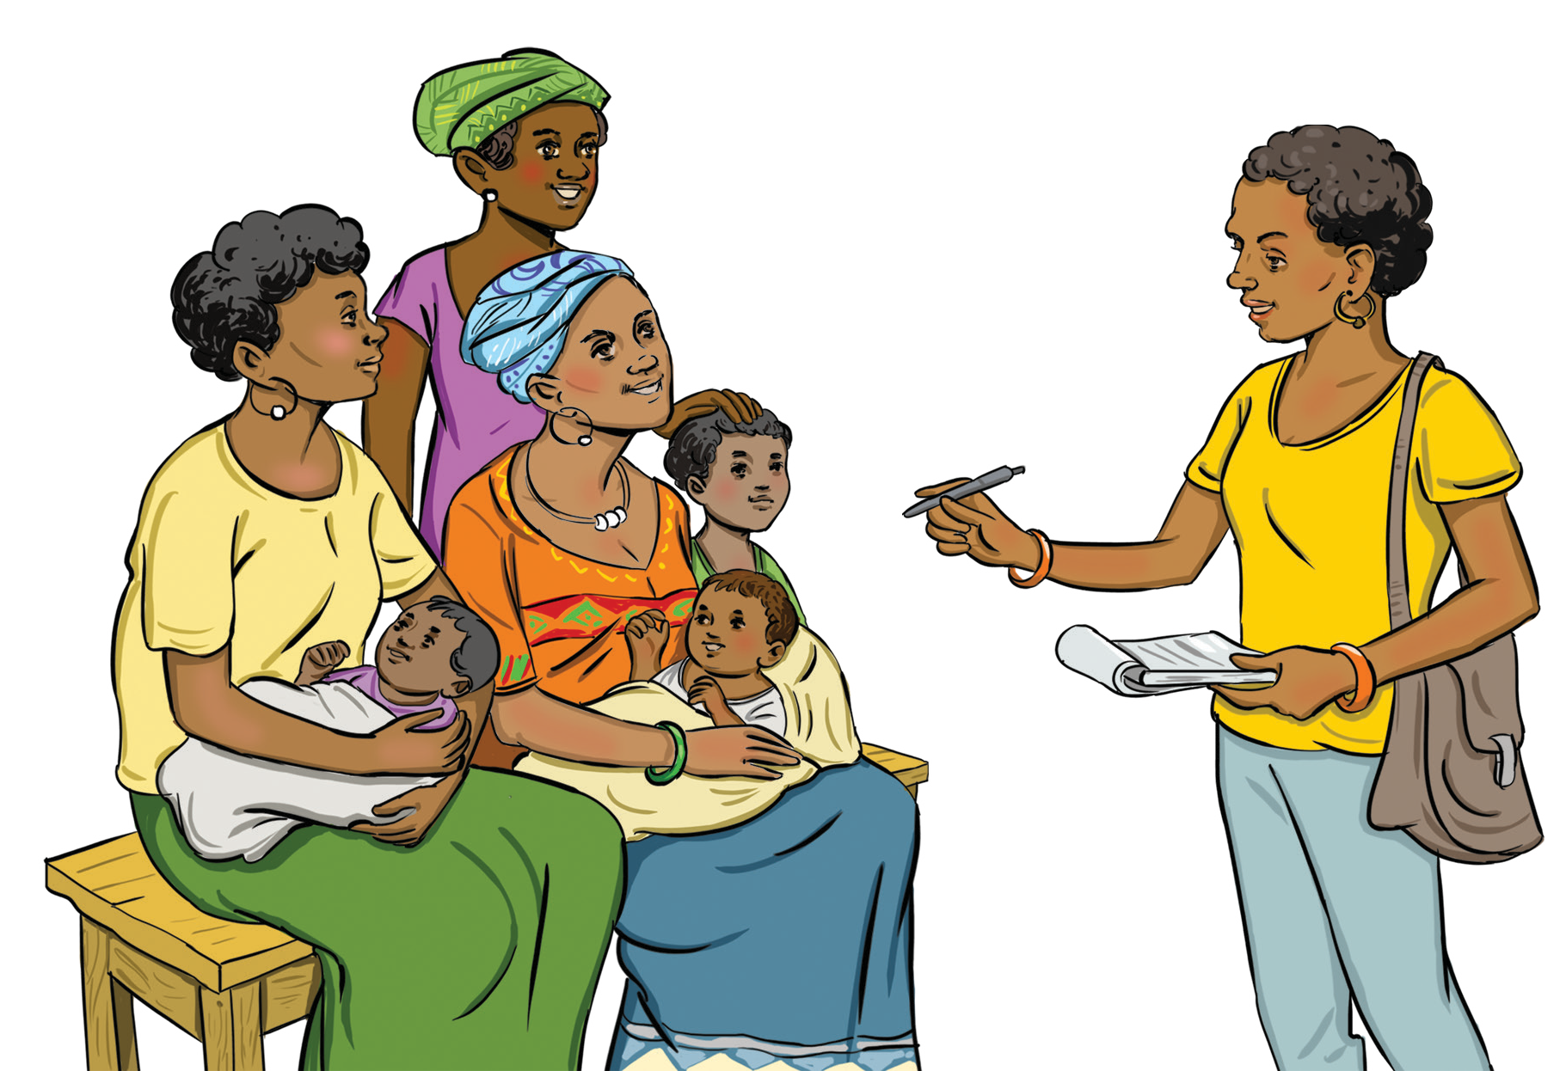

Key Messages in an Immunization Session

A3

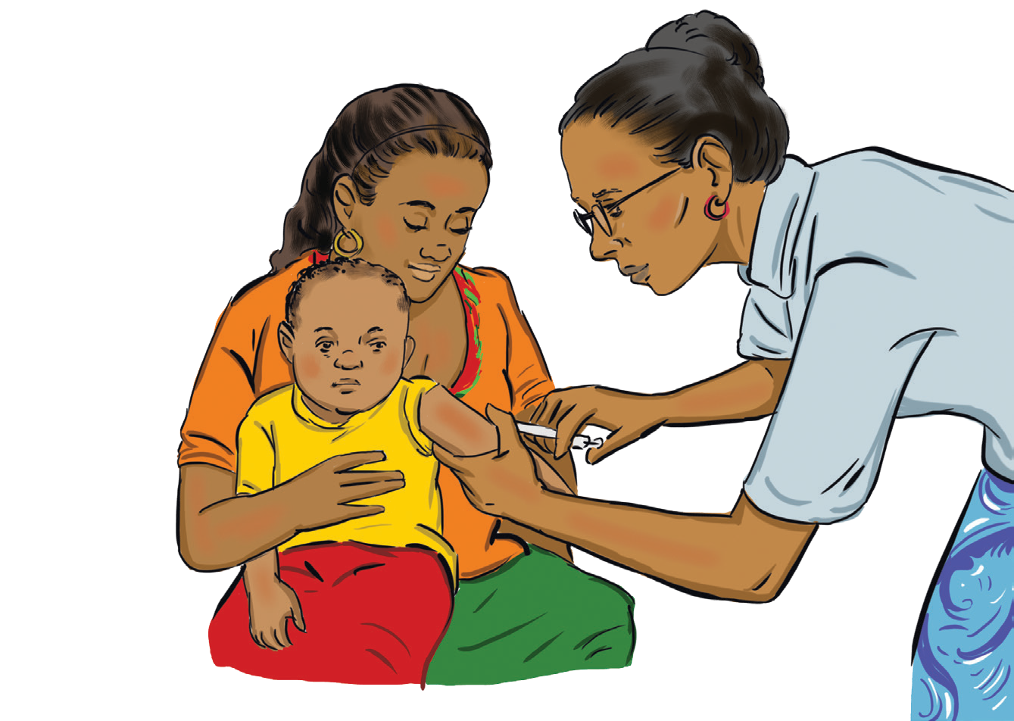The following issues may need to be covered, depending on the individual needs and level of understanding of the caregiver or client:
Why vaccination is important for children’s health
The number and timing of vaccines and their doses, including the diseases they prevent
The routine immunization schedule and the importance of completing the series
The important of being aware of and complying with the date(s) to return for the next dose(s)
Potential discomforts after vaccination and what to do if they occur
Explanation and reassurance in response to inaccurate information
Importance of immunization cards and the need to keep them in a safe place and always bring them when you bring your child to health services
Immunization session locations and times, especially for the next visit
In many situations, it may be more feasible to discuss these topics with groups of caregivers, rather than each caregiver individually.

What four key messages should be shared with a caregiver during an immunization session?
- The vaccine given, and the disease prevented
- Common discomforts following vaccination and how to manage them
3. Immunization Card benefits and to bring it to each visit
4. Next vaccination date, time, location and importance

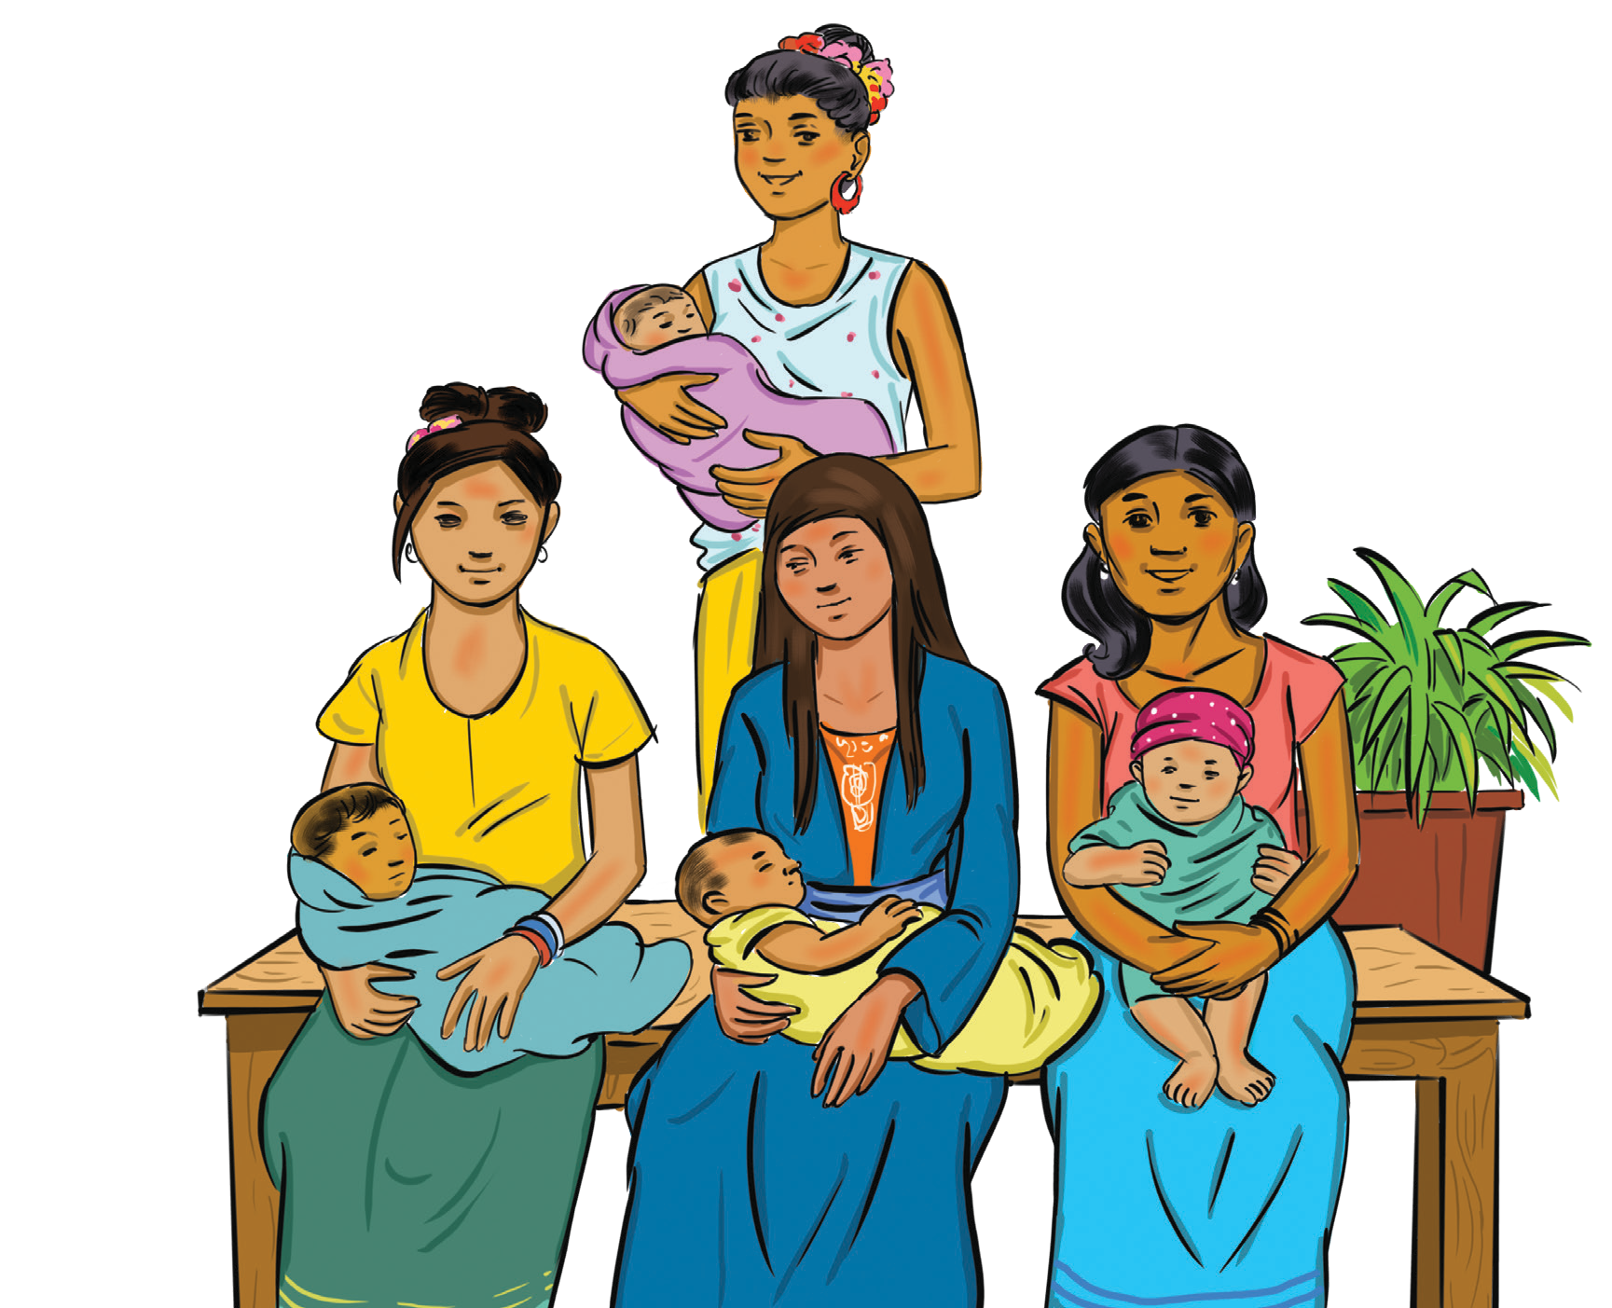

Key Messages for Caregivers

A4

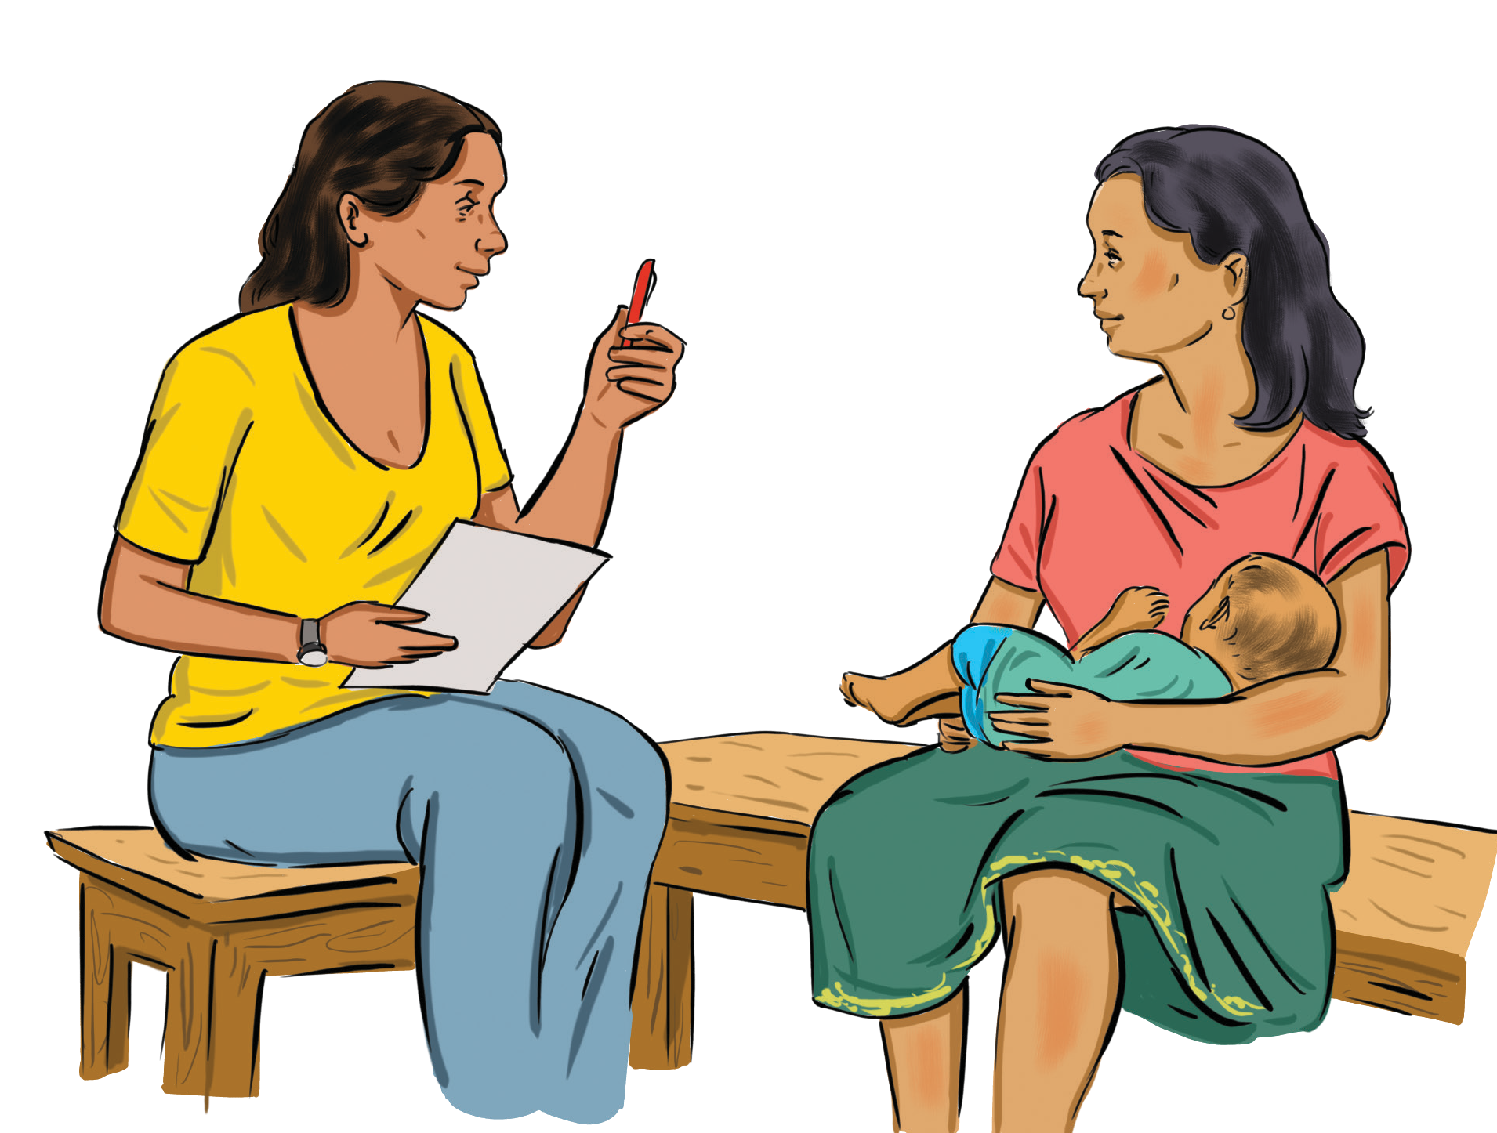The following information may help a caregiver understand the importance of immunization:
Immunizing a child on time protects the child and others from diseases
It is especially important for children under five years of age to receive their immunizations on time because their immune systems have not built up the necessary defences to fight these vaccine-preventable infections
If a child misses a scheduled vaccine, the vaccine should be given as soon as possible, and the parent or caregiver informed about when to return for the next vaccines(s)
Tracking vaccines on the Immunization Card is especially important to:
Enable the health worker to see the child’s vaccination history and determine which vaccinations should be given today or in the near future
Prevent a child from receiving unnecessary vaccinations
Keep immunizations up to date
Increase awareness of what vaccine is due next

Why is it important for infants and young children to be vaccinated?
Vaccinations provide protection for young children against many dangerous diseases. They are most effective when given at the ages when protection inherited from the mother is not enough to protect the child.

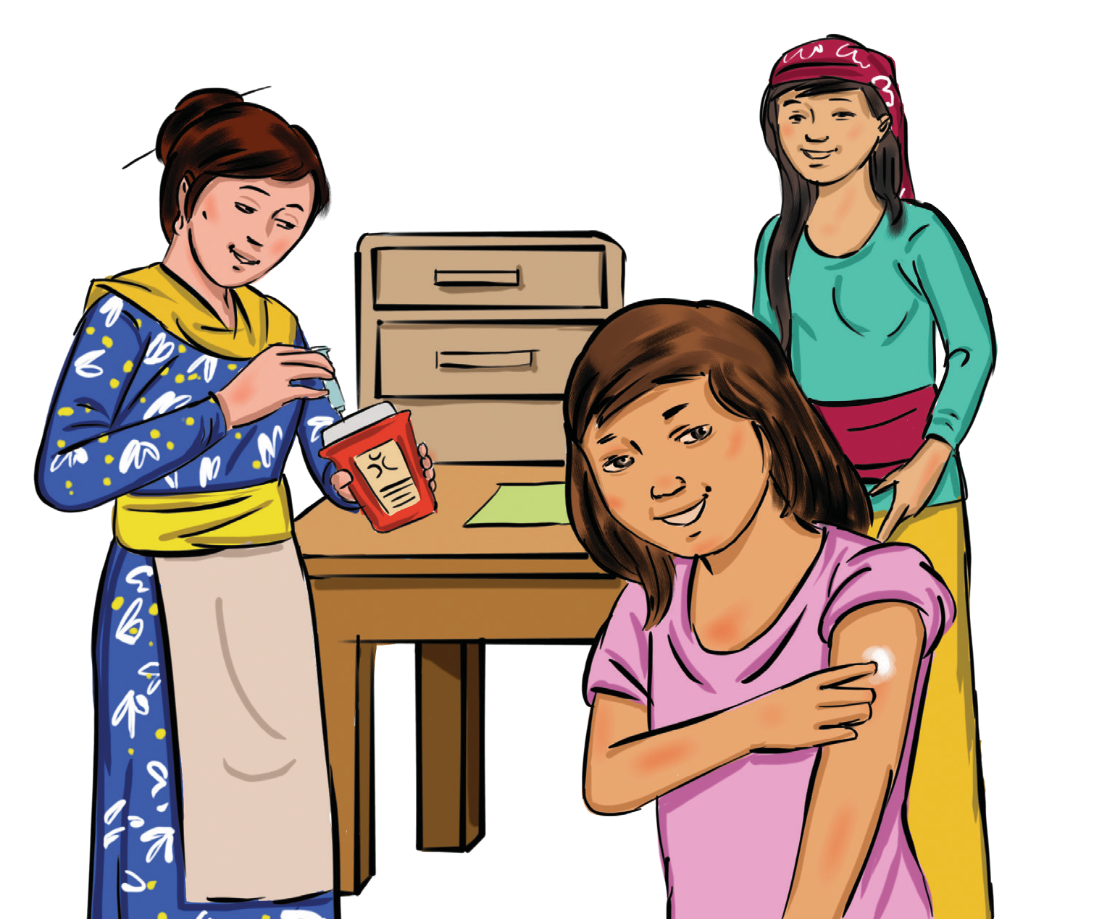

Communicating About Discomforts After Vaccination

A5

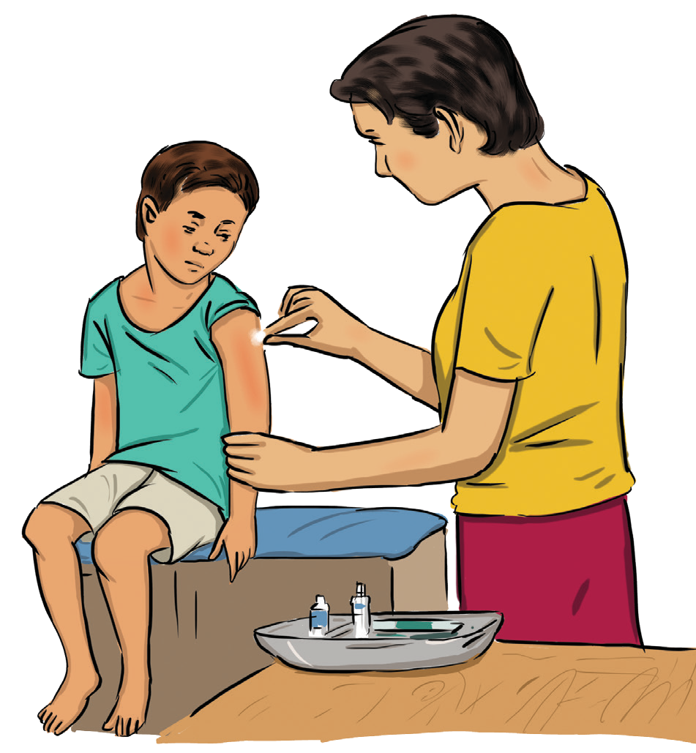A side effect is a common reaction (redness, swelling, and fever) to a vaccination or vaccine. The vast majority of side effects are not serious and go away on their own within a few days. It is an expected and known effect of the vaccine.

The following points are important when discussing common side effects following vaccination:
Reassure the caregiver that discomforts, such as mild fever, pain, or swelling at the injection site, and changes, such as the child being irritable or their colouring off, are common and indicate that the vaccine is working
Instruct the caregiver that if fever persists, paracetamol (not aspirin) may be given; specify the appropriate dose and timing for the child
Remind the caregiver to give extra hugs and attention, but to avoid pressure to the injection site(s)
Tell the caregiver to bring the infant/child to the health centre if the child’s fever persists or elevates, the condition worsens, or the reaction continues for more than a day or two

Is discomfort after receiving a vaccine normal?
Yes, it is very common for children to experience mild discomfort after receiving a vaccine.
Effective vaccines may produce some undesirable side effects, most of which are mild and clear up quickly.
These discomforts are common and usually disappear after one or two days

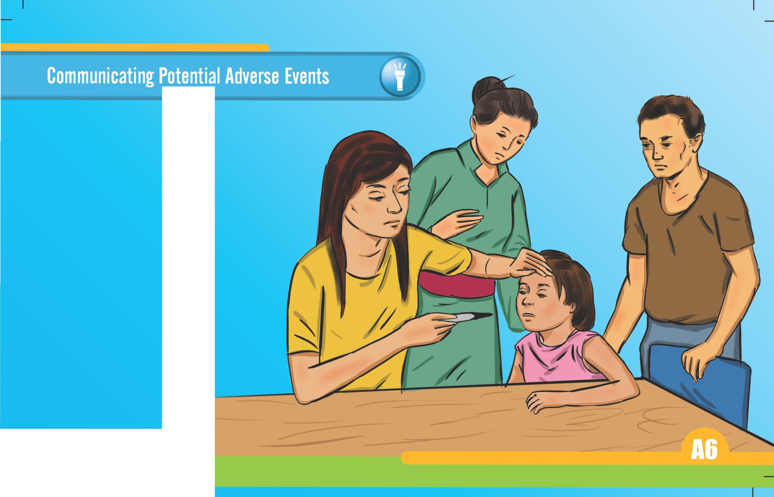

I

An adverse event following immunization is any unexpected medical occurrence that follows immunization. The adverse event may be any unfavourable or unintended sign, symptom, or disease. Adverse events following immunization can be either a result of the vaccine or immunization process or coincidental events that are not due to the vaccine or immunization process but happen to occur shortly after a vaccination.

The following points are important to communicate when discussing the potential adverse events following a vaccine: Adverse side effects following vaccination are very rare
If a child has high fever or becomes severely sick immediately following vaccination, the child should be brought to a health worker for advice and/or treatment
If a child experiences an adverse event, write down what happened and the date and time it happened. Your doctor, nurse, or health department should file a Vaccine Adverse Event Report

Why do adverse events sometimes follow vaccination?
The majority of adverse events following immunization are actually not due to the vaccine itself—many are coincidental events, while others are due to human or programme error.

The following details do not need to be communicated to caregivers but are for your information:
Vaccine product-related reaction: An adverse event following immunization that is caused or precipitated by a vaccine due to one or more of the inherent properties of the vaccine product.
Vaccine quality defect- related reaction: An adverse event following immunization that is caused or precipitated by a vaccine that is due to one or more quality defects of the vaccine product, including its administration device as provided by the manufacturer.
Immunization error-related reaction: An adverse event following immunization that is caused by inappropriate vaccine handling, prescribing, or administration and, thus, by its nature is preventable.
Immunization anxiety-related reaction: An adverse event following immunization arising from anxiety about the immunization.
Coincidental event: An adverse event following immunization that is caused by something other than the vaccine product, immunization error, or immunization anxiety.

Profiling Caregiver Audiences

B

A caregiver’s attitude toward immunization is driven by many factors. The immunization experience includes caregivers’ perceptions of how long and how comfortably they waited; how well they felt they were treated; if their child received all of the vaccinations due, if the front line worker communicated clearly essential practical information, such as the return date; and if the child developed worrying side effects that the front line worker did not prepare the family for. Caregivers may express different beliefs and concerns about vaccination. The following cards provide a sample of four general categories of caregivers and their basic behaviours and attitudes. Note that the Participants Manual provides alternative caregiver profiles based on level of vaccine knowledge.
Caregiver Type | Beliefs About Vaccines
Confident  Acceptors | Strongly agree that vaccines are necessary and may not  express concerns.
Cautious Acceptors | Agree that vaccines are necessary but have some reservations about vaccinating their children.
Partial Acceptors | They accept certain vaccinations but not others, or they insist on their own schedule rather than the nationally recommended one.
Rejectors | Disagree that vaccines are necessary.

Caregiver Audience: Confident Acceptors

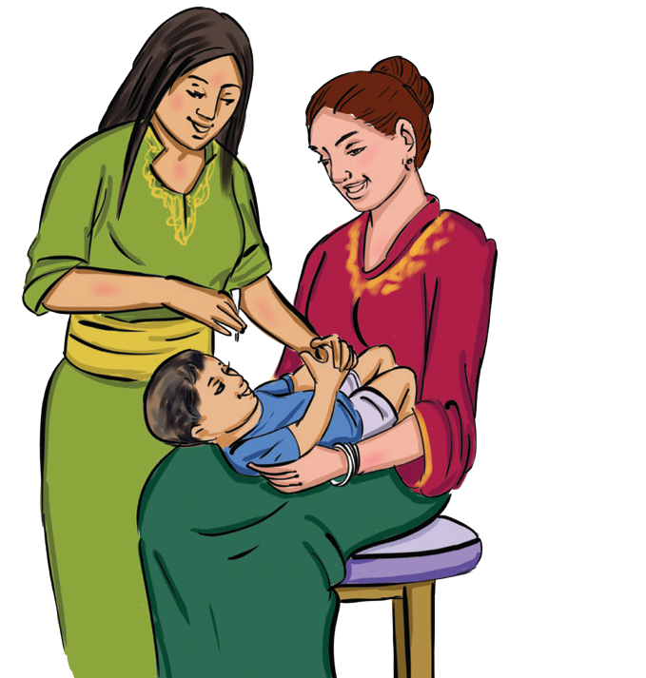Confident Acceptors strongly agree that vaccines are
necessary and may not express concerns.

How to Identify Confident Acceptors
Caregivers who fall into the category of Confident Acceptors will readily agree to receive the vaccines recommended for their children or themselves. They may even ask for you to check that they and their children are up to date on vaccinations.

What Questions You Should Ask
Although caregivers have already agreed to receive vaccines, you should still solicit and welcome any questions they may have.

How to Best Guide Your Responses
It is important to congratulate the caregivers for taking the time to come to the clinic and bring their children to get fully vaccinated. Remind them how important this decision was for the health of their children and community.
Summary Discussion Steps: Welcome caregiver Appreciate caregiver
Explain vaccine to be given and disease it prevents
Explain expected discomforts (side effects) following vaccination
Ask caregiver whether they have questions or concerns Respond to any questions or
concerns
Administer vaccine
Thank caregiver and provide date of next appointment

B1

Caregiver Audience: Cautious Acceptors

Cautious Acceptors agree that vaccines are necessary but have some reservations about vaccinating their children.

How to Identify Cautious Acceptors
Caregivers who fall into the category of Cautious Acceptors will agree that receiving vaccines is recommended but will still have concerns. Many of these concerns arise from not fully understanding the process of how or why vaccines keep children protected from vaccine-preventable diseases.

What Questions You Should Ask
Although caregivers have already agreed to receive vaccines, you should still solicit and welcome any questions they may have. Reassure them of the benefits that vaccines provide for the health of their children. Ask if they would like you to explain the process of how vaccines work and why they are beneficial.

How to Best Guide Your Responses
Similar to Confident Acceptors, it is important to congratulate the caregivers for taking the time to come to the clinic and bring their children to get fully vaccinated. Remind them how important this decision was for the health of their children and community.

Summary Discussion Steps: Welcome Caregiver Appreciate Caregiver
Explain vaccine to be given and disease it prevents
Explain expected discomforts (side effects) following vaccination
Ask caregiver whether they have questions or concerns Respond to any questions or concerns
Administer vaccine
Thank caregiver and provide date of next appointment

Caregiver Audience: Partial Acceptors

Partial Acceptors accept certain vaccinations but not others or insist on their own schedule rather than the nationally recommended one. They probably require individual counselling, either in communities or health facilities, but they may also be reached via group leaders, including physicians who share their concerns.

How to Identify Partial Acceptors
Caregivers who fall into the category of Partial Acceptors are perhaps the most important because they have the potential to either leave the facility being fully immunized or not. They will ask questions such as:
What are all these vaccines for? Are they necessary?
What are the side effects of vaccines?

What Questions You Should Ask
Although concerns vary according to each person’s knowledge and experience, most reasons revolve around the fear of vaccines being unsafe for their children. You should ask questions such as:
What are your concerns about receiving vaccines today?
Is there a part of the safety or process of vaccination that I can explain today?

How to Best Guide Your Responses
When responding to an uncertain caregiver, the main goal should be to address the caregivers’ specific concerns. Not all caregivers have the same concerns, and those who are already uncertain will need reassurance and the appropriate information to feel comfortable getting vaccinated and allowing their children to be vaccinated. In this situation, it is important to discuss vaccines from multiple perspectives, such as the benefits of being fully vaccinated and the risks of not vaccinating.
Summary Discussion Steps: Welcome Caregiver Appreciate Caregiver
Explain vaccine to be given and disease it prevents
Ask caregiver whether they have questions or concerns Respond to any questions or concerns
Provide a strong recommendation for vaccination
Listen and respond to additional concerns with evidence or personal stories
Explain expected discomforts (side effects) following vaccination Administer vaccine
Thank caregiver and provide date of next appointment

B2

Caregiver Profile: Rejectors

Rejectors disagree that vaccines are necessary or safe. Some will never be convinced, but patient advocacy with the group leaders can work.

How to Identify Rejectors
They may say that they are not comfortable with their child receiving so many vaccines at once or that they have heard that vaccines are unsafe and do not want their child to receive them.

What Questions You Should Ask
Caregivers who fall into the Rejectors category will have a reason why they reject vaccines. Presenting them with only the positive benefits of the vaccines will not be sufficient. You must ask questions to discover the underlying thoughts behind their decision, and then address their specific concerns. Here are a couple questions you should begin with:
What are your concerns about receiving vaccines?
Is there a part of the vaccine process or issues about vaccine safety that I can talk with you about today?

How to Best Guide Your Responses
Acknowledge the benefits and risks (known side effects) of vaccines. Emphasize the overwhelming benefits of preventing serious diseases. Assure the caregiver that crying is a normal response but that distracting an infant or young child will help reduce the stress of receiving a vaccine.

If their final decision is to not accept any form of vaccine, it
is important to communicate the following points:
Your child will be at greater risk of acquiring and suffering from the diseases
If your child has not been vaccinated and is around someone who has childhood diseases, they will probably get sick, too
Summary Discussion Steps: Welcome Caregiver Appreciate Caregiver
Explain vaccine to be given and disease it prevents
Ask caregiver whether they have questions or concerns Respond to any questions or concerns
Provide a strong recommendation for vaccination
Listen and respond to additional concerns with evidence or personal stories
Explain expected discomforts (side effects) following vaccination If they choose not to vaccinate, explain the risks of not vaccinating Refer the caregiver to additional resources
Thank caregiver and plan a follow-up appointment

Frequently Asked Questions

C

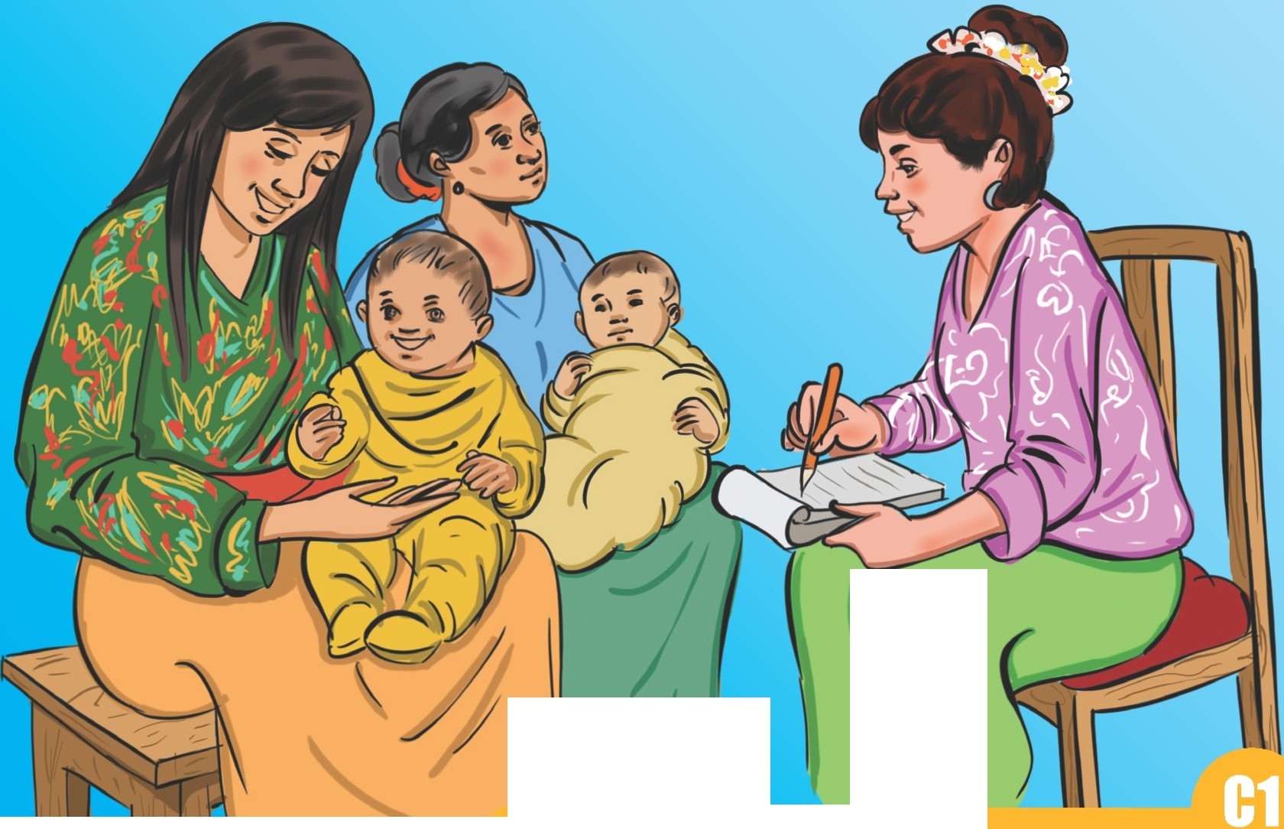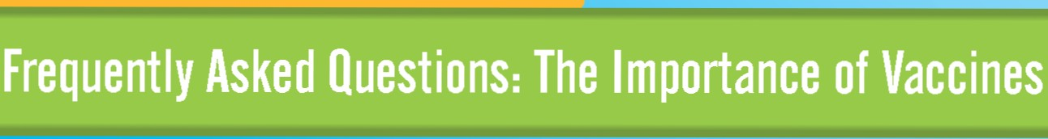

\
. I I I J

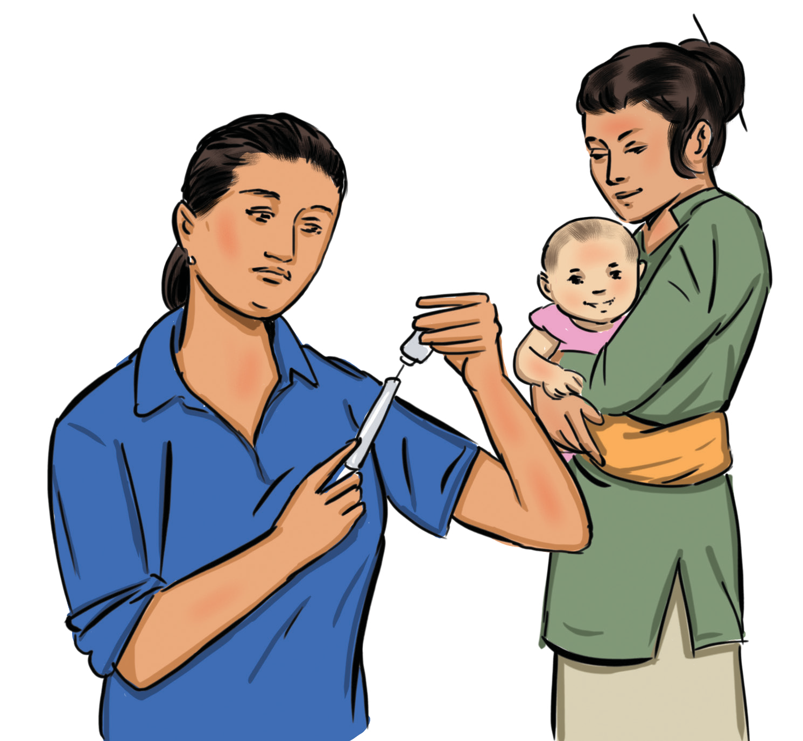How does vaccination work?
Vaccination works by preparing a child’s body to fight illness. Each immunization contains either a dead or live bacteria or virus (or parts of it) that causes a particular disease. When a child receives the recommended vaccinations for particular diseases,they are considered to be immunized and, therefore, protected from those particular diseases.

Why should my child be immunized?
Children need vaccination to protect them from vaccine- preventable childhood diseases. These diseases have serious complications that can even kill children. Unvaccinated children can spread these diseases to other unvaccinated children.

Why are vaccinations important?
Vaccinations protect children against serious diseases by stimulating the immune system to create antibodies against certain bacteria or viruses.

What diseases do vaccines protect against?
Immunizing a child with vaccines protects them against serious diseases like measles, whooping cough, polio, meningococcal disease, tetanus, rotavirus, hepatitis A, hepatitis B, chickenpox, and influenza. We do not yet have vaccines against malaria and HIV/AIDS, but they are being
developed and tested now, so they should be available in the coming years.

Why is it important for even healthy children and adults to be vaccinated?
Immunization not only protects the individual but also prevents the spread of disease between individuals. Immunization of everyone ensures that the diseases do not have hosts to reproduce and survive, indirectly protecting even those who are unimmunized.

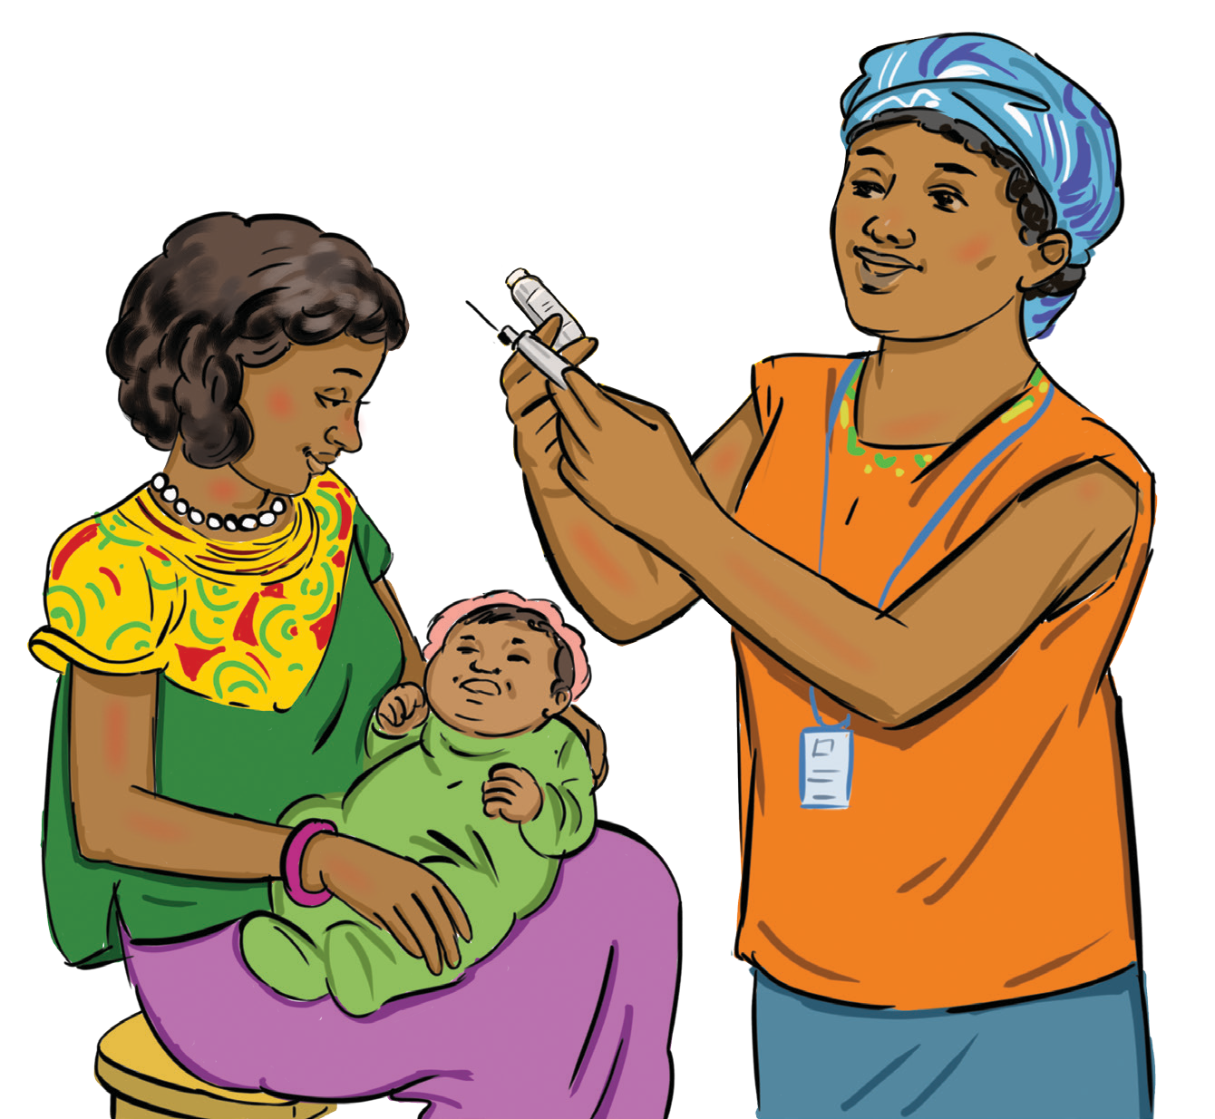
Frequently Asked Questions: Vaccine Safety

C2

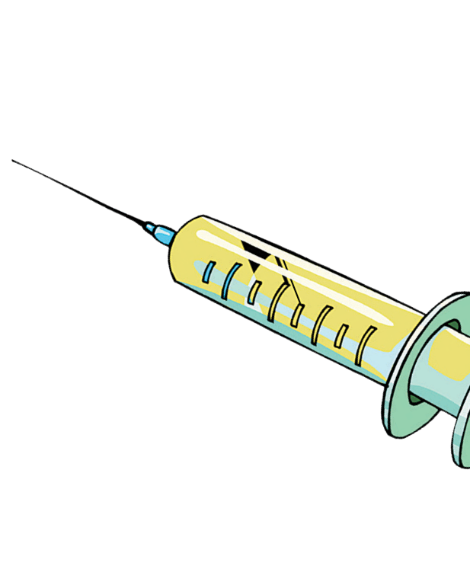Are vaccines safe?
Yes. Vaccines are very safe. The vaccine safety system starts with extensive testing and trials of vaccines when they are being developed. Manufacturers make sure to they maintain a high level of quality control throughout the manufacturing and transportation of the vaccines to the health facilities. In [country], there is a quality assurance system in place to ensure that vaccines are as safe as possible and are closely monitored throughout the immunization delivery system.

What are the side effects of the vaccines?
Vaccines, like any medication, may cause some side effects. Most of these side effects are very minor, like soreness where the shot was given, mild discomfort or fatigue, or a low-grade fever. These side effects typically disappear within one to two days.

Are there better ways to protect my baby against these diseases?
No. Maternal antibodies and breastfeeding offer temporary immunity against some infections, but this protection becomes weaker as a baby grows.

Is getting the “natural” disease preferable?
It is true that, for some diseases, getting infected will lead to immunity, but natural disease also brings risks that include paralysis, brain injury, liver cancer, deafness, blindness, or death.

How do we know if vaccines are safe?
Because vaccines are given to millions of people, they are held to very high safety standards. They are tested and evaluated before being recommended and are continuously monitored. Every batch is tested for: potency (that it works effectively to protect against the specific disease), purity (that certain ingredients used during production have been removed), and sterility (that it does not contain any outside germs).

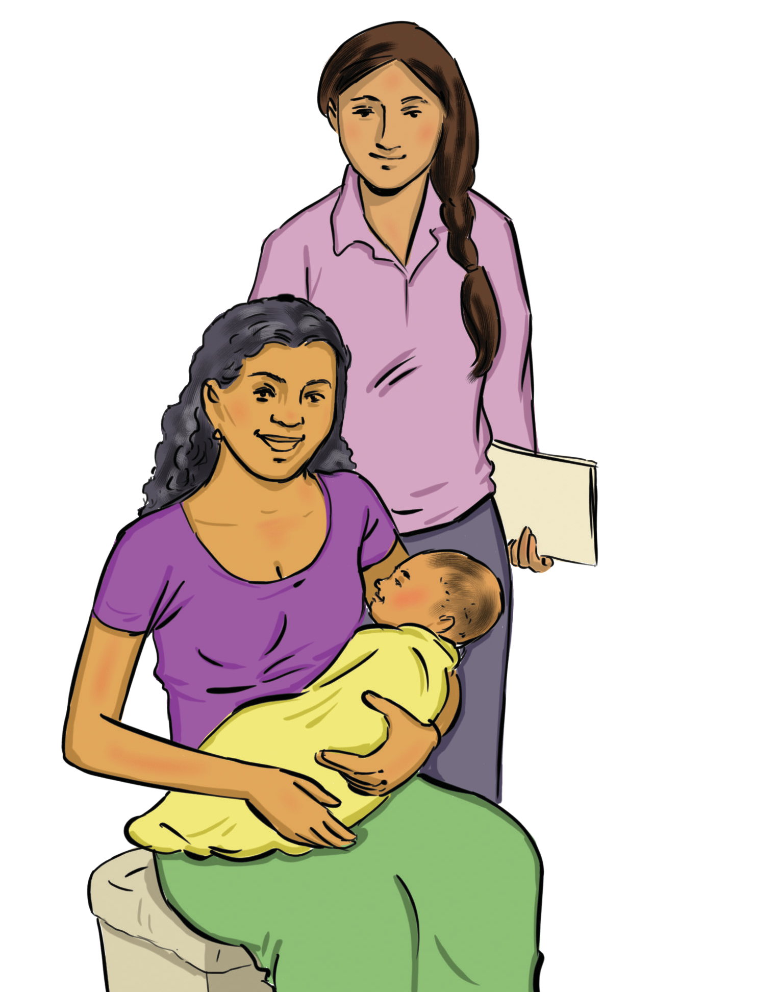

Frequently Asked Questions: Vaccine Safety Continued

Vaccines are safe and effective. They are held to high safety standards and carefully monitored from the
start of the development process to the time they reach the child.

C3

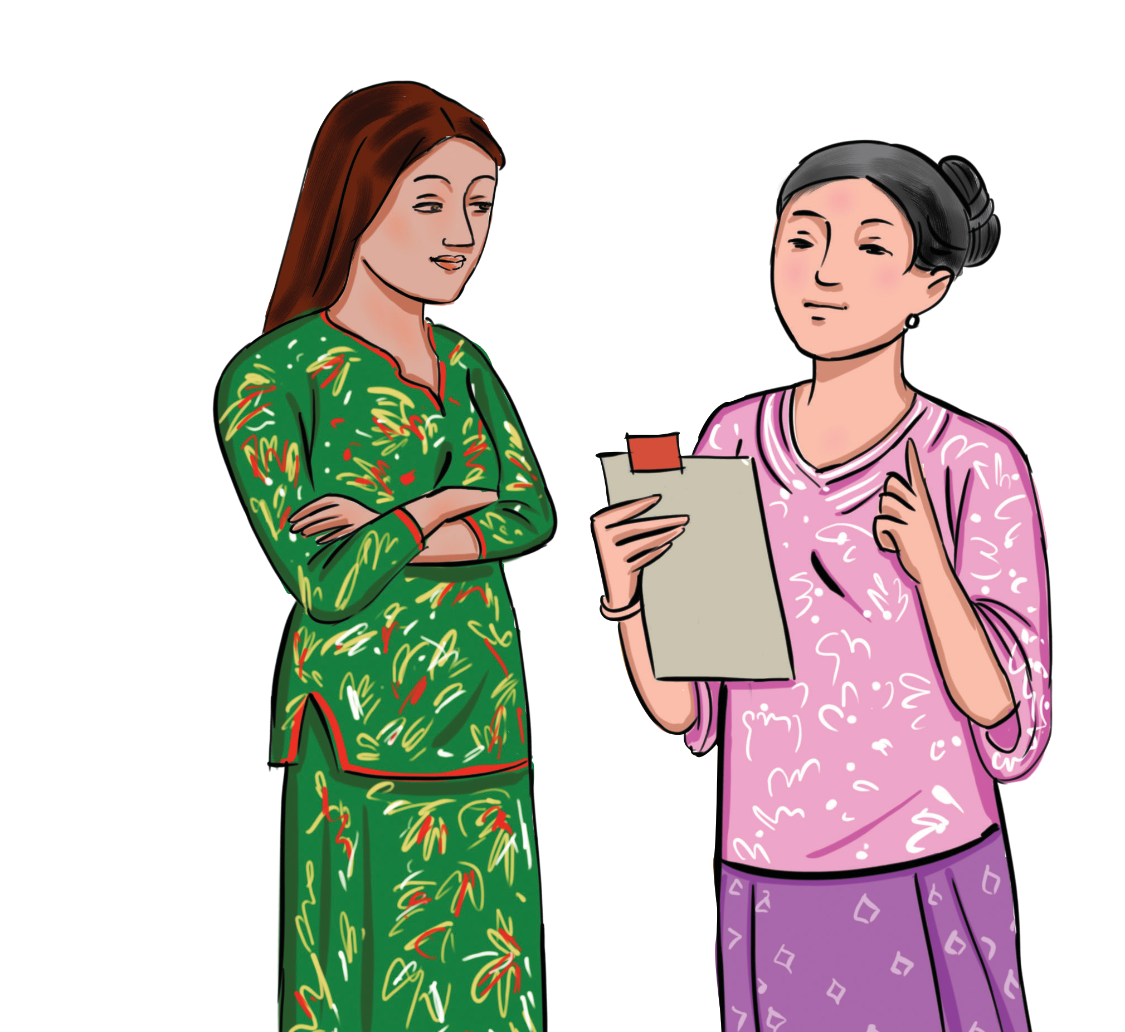Quality and Safety
The World Health Organization works closely with national experts and authorities to ensure and support the quality, safety, and effectiveness of all vaccines. They, along with partner countries and organisations, establish a set of safety standards. The process for ensuring vaccine safety includes:
A thorough review of the evidence on the efficacy and
safety of the vaccine
Establishment of quality standards for specific vaccines
Every batch is tested for: potency (that it works effectively to protect against the specific disease); purity (that certain ingredients used during production have been removed); and sterility (that it does not have any outside germs)
Establish a vaccine monitoring system for detecting and investigating adverse events following immunization

Effectiveness
Vaccines are produced and distributed with the goal of preventing and protecting against serious diseases. The efficacy of vaccines is seen all over the world. Many diseases that were once common, such as polio, measles, mumps, and tetanus, are now rare and under control. However, this does not mean that there is no longer a need for vaccines; in fact, when immunization levels have dropped in countries, dramatic and immediate spikes in the appearance of diseases have occurred.

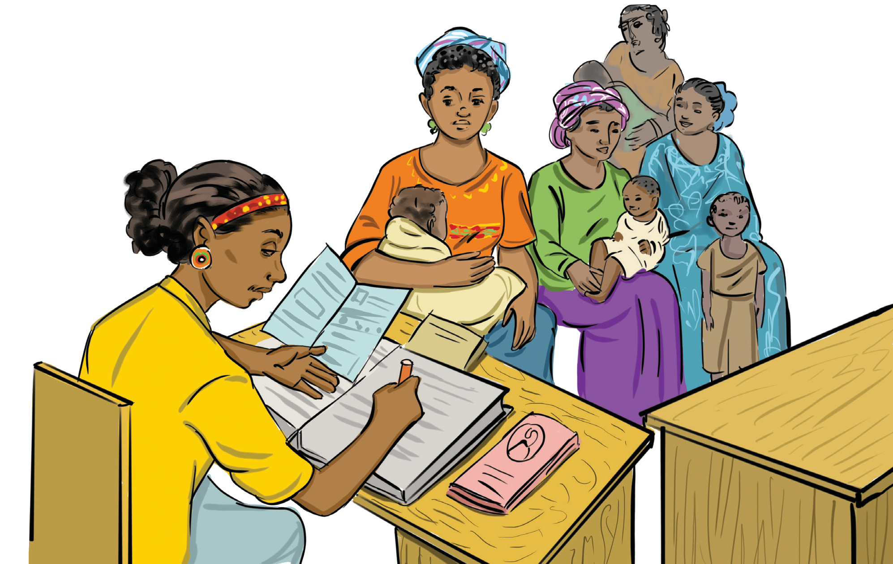

Frequently Asked Questions: Vaccine Schedule

C4

When should my child receive immunizations?
Consult the country’s specific schedule for the most up-to-date guidance. It is important to begin and continue vaccinations on time and according to the recommended schedule, from birth onwards, for maximum benefit and protection.

Why does my child need multiple vaccinations for one disease?
Most vaccines require more than one dose to provide the best protection. Multiple vaccines do not weaken a child’s immune system. Vaccinators should avoid giving two injections in the same area of a person’s body during the same visit.

Why does vaccination start when my child is so young?
The recommended schedule is designed to protect infants and children by providing immunity early in life, before they are exposed to life-threatening diseases and when their immune system is most responsive.
Children are immunized early because they are otherwise
unprotected against diseases at a young age, and the consequences of these diseases can be very serious, even life-threatening.

What if my child did not get their vaccine when they were supposed to, or they have gotten behind schedule?
Although it is important to immunize on time, it is never too late to start getting immunizations. If your child has had some of their shots but then fell behind in their schedule, they do not have to start over. The shots already given are important. You will need to continue the vaccination schedule based on the vaccines your child still needs, which your health care provider can determine and explain.

Why are vaccines given at specific ages and with a certain
time period between doses?
Newborns have protection through the transfer of maternal antibodies and breastfeeding. However, that protection is weakened after six to nine months, resulting in higher risk of disease exposure of the child is not vaccinated.

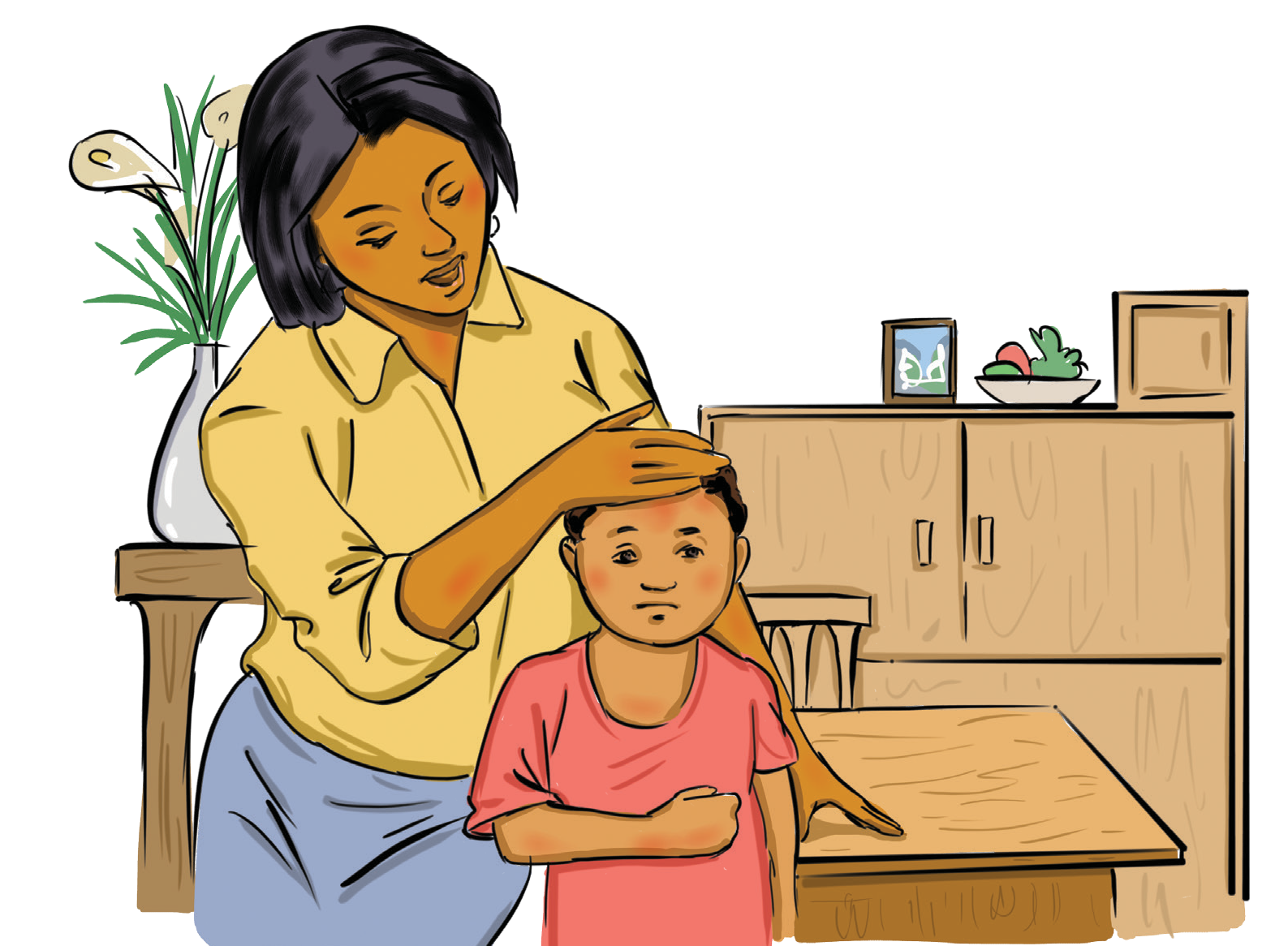

Frequently Asked Questions: Vaccine Effectiveness

C5

What could happen if my child does not get the vaccines? Your child will be at greater risk of acquiring and suffering from vaccine-preventable diseases, and for the disease to make the child very sick or even kill the child
All but one of the vaccine-preventable diseases (tetanus) are spread easily from person to person
A sick child could pass on the illness to other children

Can my child be immunized if he or she is sick?
Even if your child has a slight fever, cold or runny nose, upset stomach, ear infection, or is taking antibiotics, they can still be immunized safely
There is no greater risk of harmful events when immunizations are given during a minor illness
However, if a fever or other symptoms that suggests a moderate or serious illness, it is important to discuss these with the health worker, who may then decide to delay vaccination until the symptoms improve

How do I treat the side effects of vaccines?
These mild side effects typically only last a couple of days and go away on their own. However, you can make your child more comfortable by, for example, applying a clean, cool, wet washcloth on the sore area

Is it possible to still acquire a disease after receiving vaccination(s)?
The likelihood of acquiring a disease after receiving vaccination(s) is very low. Vaccines are extremely effective in preventing disease when the child receives all necessary the doses per the recommended schedule. However, a small number of vaccinated children may still acquire the disease if exposed. If this happens, the vaccination will still provide partial protection, so the illness is likely to be milder that it would have been without vaccination

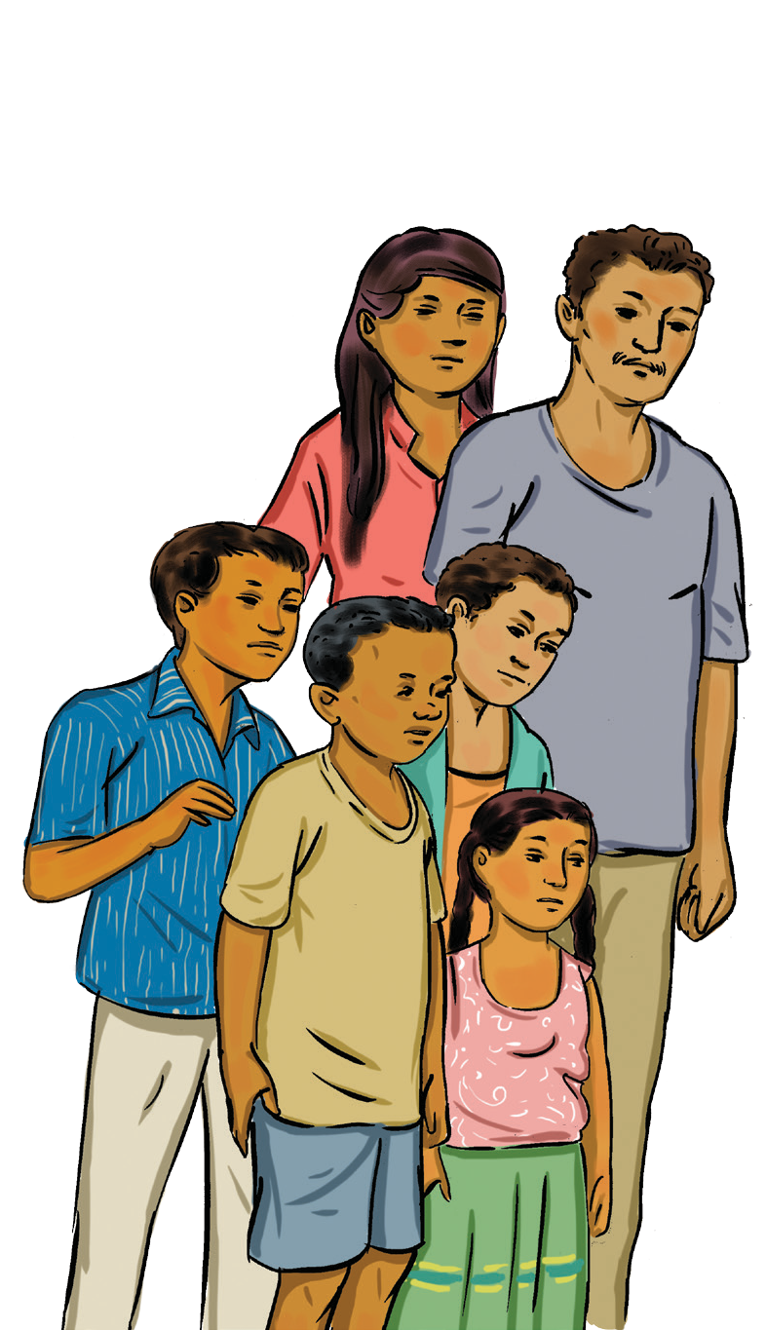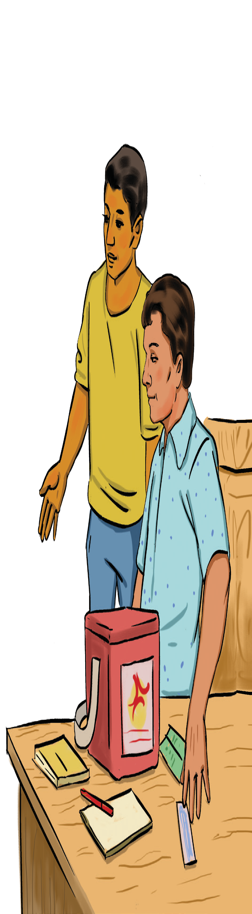

Frequently Asked Questions: Who Should Not Get Vaccinated?

C6

Can vaccines be given to those who are not severely ill?
Yes. Mild acute illness with or without fever is not a contraindication to vaccination; neither is antibiotic treatment, recent exposure to an infectious disease, or recovering from an illness.

Can vaccines be given to those who have some immune
deficiencies?
Severely immuno compromised people, such as those with low HIV CD4 count or symptoms of HIV, should not receive live vaccines.

Are there certain people who should not receive vaccines?
There are precautions and contraindications providers should be aware of, with lists available from the Expanded Programme on Immunization. Always check the latest best- practices guidance.
People who experienced encephalopathy within seven days after administration of a previous dose of pertussis- containing vaccine (not attributable to another identifiable cause) should not receive additional doses of a vaccine that contains pertussis.
Because of potential risk to the foetus, women known to be pregnant should not receive live attenuated virus vaccines.

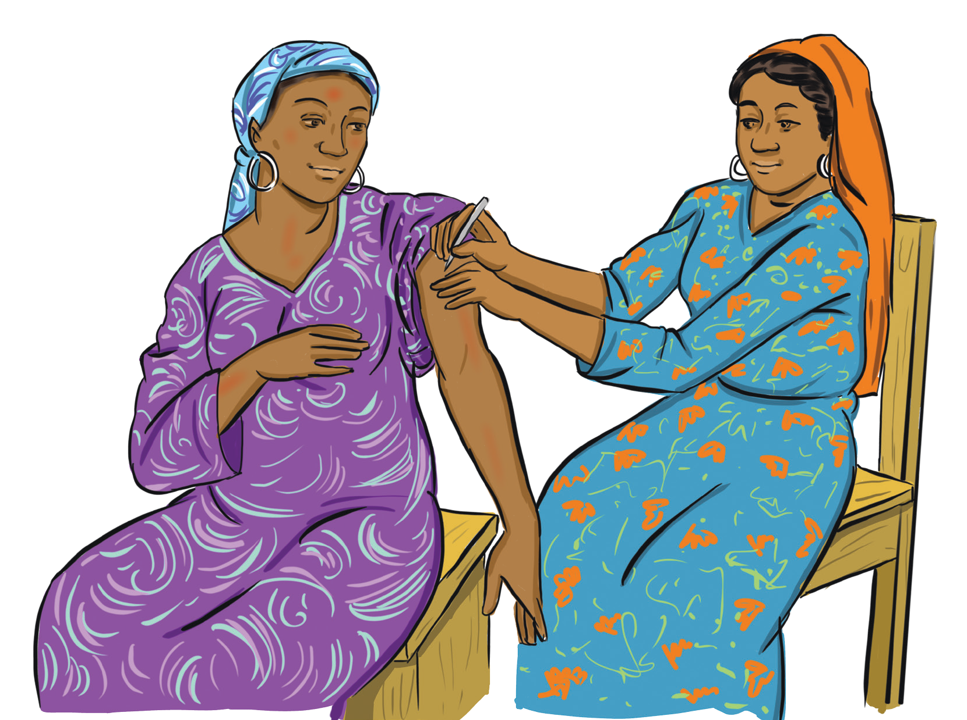

Frequently Asked Questions: Vaccination During Pregnancy

C7

Shouldpregnant women receive vaccines?
Although pregnant women should not receive live vaccines, influenza and Tdap (tetanus, diphtheria, and pertussis) vaccines are recommended during pregnancy. Other inactivated vaccines may or may not be administered, depending on the mother’s risk factors and vaccination status.
The human papilloma virus (HPV) vaccine is recommended for women and men before they are sexually active. It is not recommended to administer HPV vaccine during pregnancy.

Can vaccines be given to women who are breastfeeding? All vaccines can be given to women who are breastfeeding (even live vaccines).

Can Tdap be administered if a person has received Td
(tetanus and diphtheria) vaccine in the last five years? There is no minimum interval one needs to wait between receiving a Td and Tdap vaccine.
Are vaccines safe for pregnant and breastfeeding women? The majority of vaccines are safe for pregnant and breastfeeding women. However, pregnant women should not receive live vaccines such as influenza and Tdap. The risk to a developing foetus from vaccination during pregnancy is not
proven. Some vaccines, such as the MMR (measles, mumps, and rubella) vaccine, should be given before pregnancy, while the Tdap vaccine should be given during pregnancy. Other vaccines, like the influenza shot, can be given before or during pregnancy. It is safe for a mother to receive vaccines right after giving birth, even while breastfeeding. However, the HPV vaccine has not been sufficiently studied and should not be given during pregnancy.

Vaccines-Preventable Diseases

D

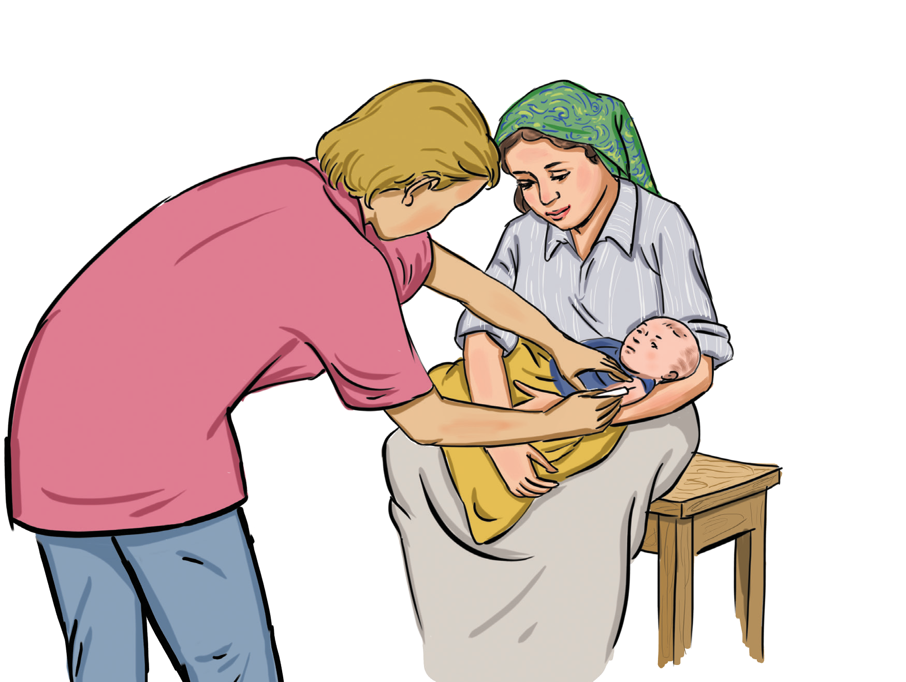

Diphtheria

Diphtheria, Tetanus and Acellular Pertussis (DTaP) vaccine requires a five-dose series given at:
2 months
4 months
6 months
15 to 18 months
4 to 6 years

D1

What is diphtheria?
A disease caused by bacteria spread through the air when an infected person breaths, coughs, or sneezes
Usually affects the lungs and breathing tubes

What are the symptoms of diphtheria?
Starts like a cold, with sore throat, mild fever and chills Thick covering forms on the back of the throat and nose

What vaccine is used to prevent diphtheria?
The DTaP or DT (diphtheria and tetanus) vaccine is used to prevent diphtheria
DTaP is included in a pentavalent vaccine, which commonly includes Haemophilus influenzae type B(Hib) and hepatitis B or Hib and polio (IPV)
A primary series of three doses of DTaP-containing vaccine is recommended, with the first dose administered as early as six weeks of age. In many countries, this is administered as part of a pentavalent vaccine that includes hepatitis B, Hib, and/or IPV. Subsequent doses should be given with an interval of at least four weeks between doses. The third dose of the primary series should be completed by six months of age, if possible

Why is it important to prevent diphtheria?
The bacteria produce a toxin that can harm or destroy human body tissues and organs

What is the impact of diphtheria?
Patients may develop abnormal heartbeats, which can result in heart failure. Some patients with diphtheria experience inflammation of the heart muscle and valves, leading after many years to chronic heart disease and heart failure. The most severe complication of diphtheria is respiratory obstruction followed by death

What are the potential side effects for the diphtheria vaccine?
Redness, swelling and pain from injection site Fever
Vomiting

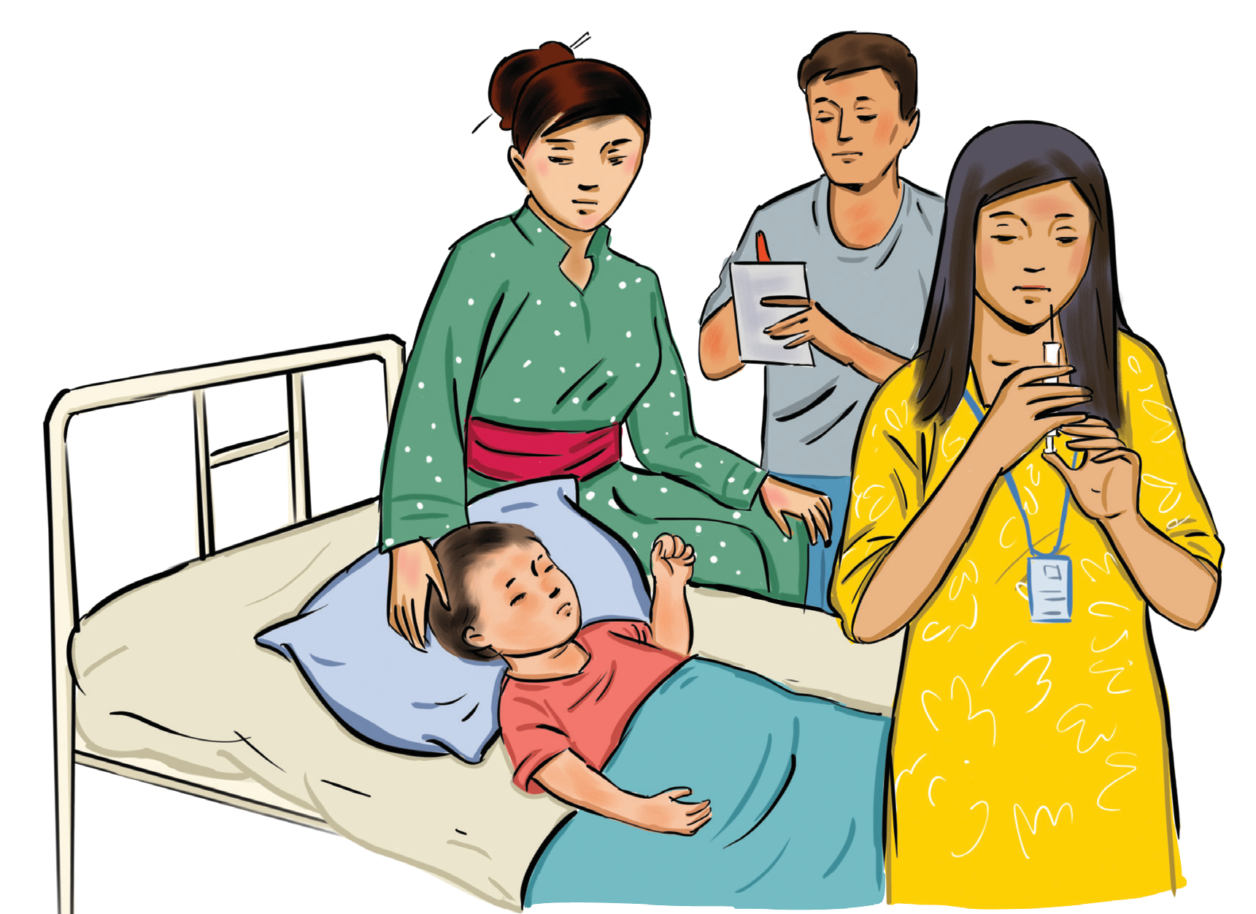

Haemophilus Influenzae Type B

Haemophilus influenzae type
B vaccine requires a four-dose series given at:
2 months
4 months
6 months
12 to 15 months

D2

What is Haemophilus influenzae type B(Hib) disease?
A serious disease caused by bacteria usually affecting children under five years old. If the germs stay in the child’s nose and throat, the child probably will not get sick. But sometimes the germs spread into the lungs or the bloodstream, and then Hib can cause serious problems

What are the symptoms of Hib?
Symptoms of Hib meningitis include fever, decreased mental status, and stiff neck

What vaccine is used to prevent Hib?
The Hib vaccine is given as an injection. The interval between doses should be at least four weeks if three primary doses are given, and eight weeks if two primary doses. In many countries, this is administered as part of a pentavalent vaccine that includes DTP and hepatitis B

Why is it important to prevent Hib?
Hib is a serious disease that can cause infections of the blood, joints, bones, and covering of the heart
Even with treatment, as many as one out of 20 children with Hib meningitis dies.

What is the impact of Hib?
Survivors suffer some permanent neurologic damage, including blindness, deafness, and mental retardation.
As many as one out of five children who survive Hib
meningitis will have brain damage or become deaf

What are the potential side effects for the Hib vaccine?
Side effects are usually mild and go away own their own Redness
Fever

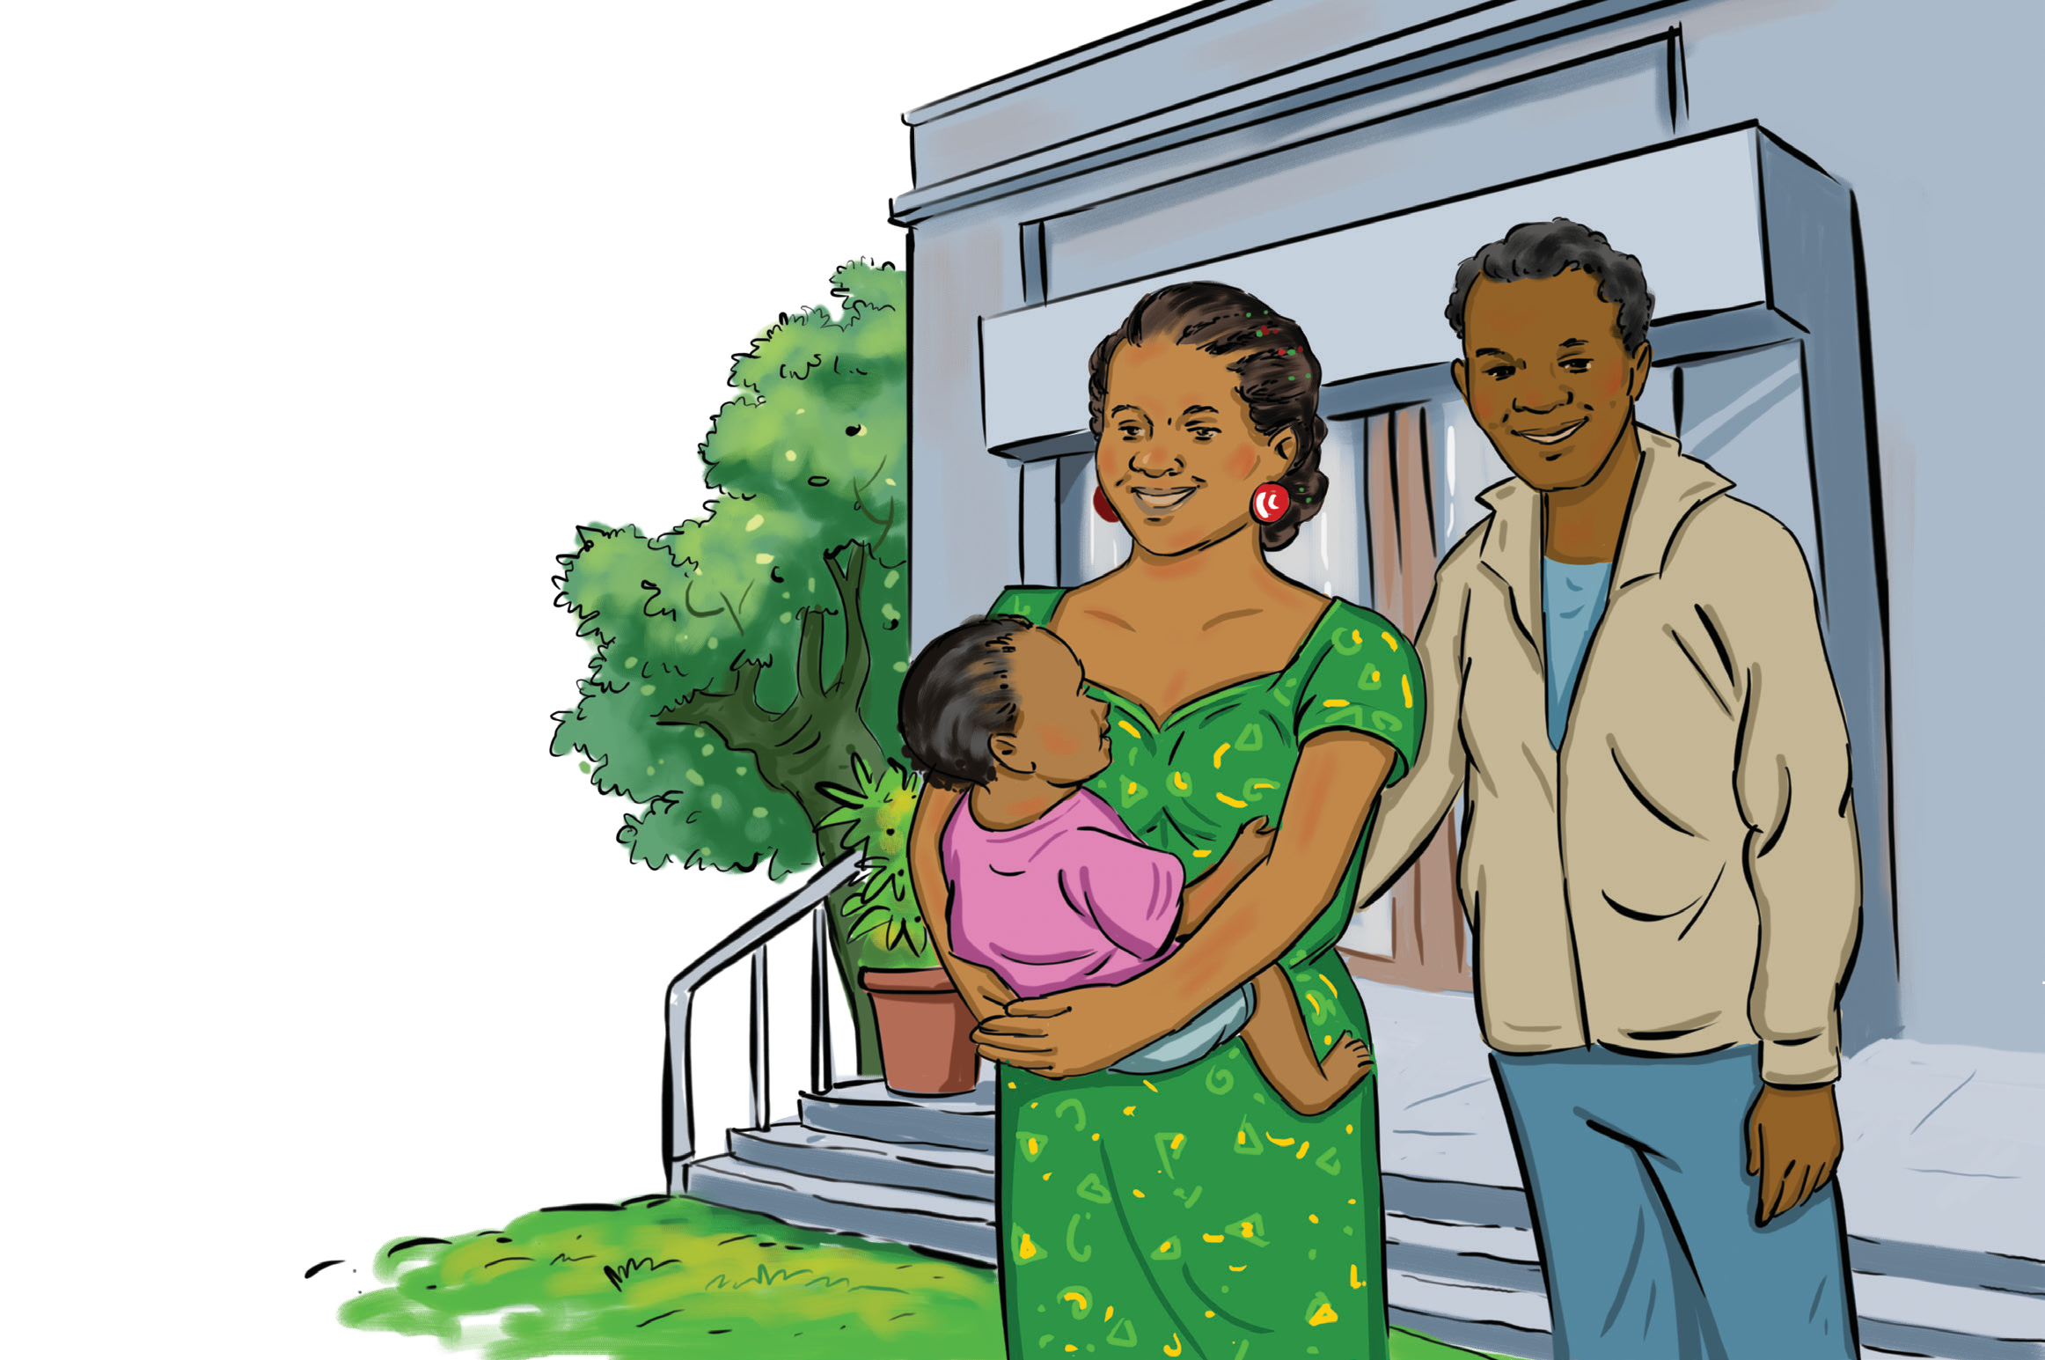

Hepatitis B

Hepatitis B vaccine requires a three-dose series given at:
Birth
1 to 2 months
6 to 18 months

D3

What is hepatitis B?
Hepatitis B is a liver infection caused by the hepatitis B virus. It can range from a mild illness lasting a few weeks to a serious lifelong illness
Hepatitis B virus is most commonly spread from mother to child at birth, or through exposure to infected blood

What are the symptoms of hepatitis B?
Children under five years of age usually have no symptoms
Loss of appetite Fever Tiredness
Pain in muscles, joints, or stomach Nausea, vomiting, or diarrhoea Jaundice

What vaccine is used to prevent hepatitis B?
The hepatitis B vaccine is used to prevent hepatitis B
At least three doses of the hepatitis B vaccination are recommended for all children worldwide. In many countries, this is administered as part of a pentavalent
vaccine which includes DTP (diphtheria, tetanus, and pertussis), Haemophilus influenzae type B (Hib), and/or polio (IPV)
In some countries, it is recommended that all infants (including low birth weight and premature infants) should receive their first dose of hepatitis B vaccine as soon as possible after birth, ideally within 24 hours

Why is it important to prevent hepatitis B?
Hepatitis B is a serious liver infection. While there is no cure for the condition, the vaccine can prevent hepatitis B

What is the impact of hepatitis B?
Infants and children who are infected with hepatitis B virus are more likely to develop chronic infection, which could lead to liver damage, liver cancer and death

What are the potential side effects for the hepatitis vaccine?
Sore leg Fever Tiredness

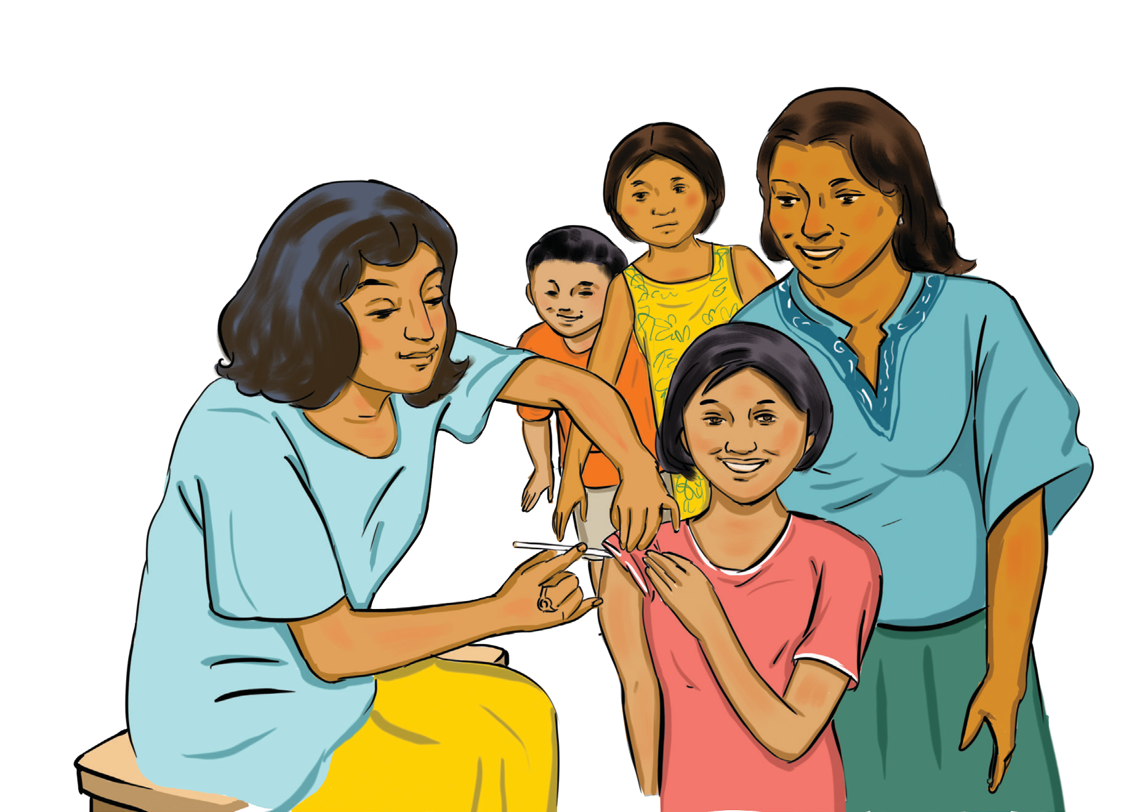

Human Papillomavirus

Human Papilloma Virus (HPV) vaccine is recommended for girls and boys aged 9 to 14 years.

Ages 9 to 14 years:
A two-dose series with a minimum of 6 month interval

Ages 15 years or older:
A three-dose series at 0 months, 1 to 2 months
and 6 to 12 months

D4

What is human papilloma virus (HPV)?
HPV infection, often referred to as HPV, is a group of viruses that are spread through sexual contact and can develop into cancer in women and men
Rarely, a pregnant woman passes HPV to her baby during vaginal delivery
What are the symptoms of HPV?
Most people who become infected with HPV have no symptoms.
Some people develop visible genital warts or precancerous changes in the cervix, vulva, anus, or penis.

What vaccine is used to prevent HPV?
The HPV vaccine is given as an injection to boys and girls; with girls aged 9 to 14 years—ideally, before the start of sexual encounters—being the recommended primary target population.
The schedule for the HPV vaccine depends on the age at
which the first dose is given.
A 2-dose schedule with a 6-month interval between doses is recommended for individuals receiving the first dose before 15 years of age.
Why is it important to prevent HPV?
HPV is very common and carried by the majority of sexually active adults. However, the vaccine can help protect again cancer-causing strains of HPV
What is the impact of HPV?
Low-risk HPV infection can result in warts, while high-risk infection can lead to the following types of cancer: cervical, anal, oral and throat, vulvar, vaginal, and penile
What are the potential side effects of the HPV vaccine?
Soreness, redness, or swelling where the injection was given Mild or moderate fever
Why is the vaccine often only given to girls?
Cervical cancer is the most common disease caused by HPV. Protecting women from this potentially fatal disease is the primary aim of HPV vaccination programmes. WHO and most national authorities recommend that vaccination against HPV be offered to girls and women as the first priority. Protecting women from HPV also indirectly protects their partners, and this community protection or herd immunity has shown to be very effective in stopping the spread of the virus.

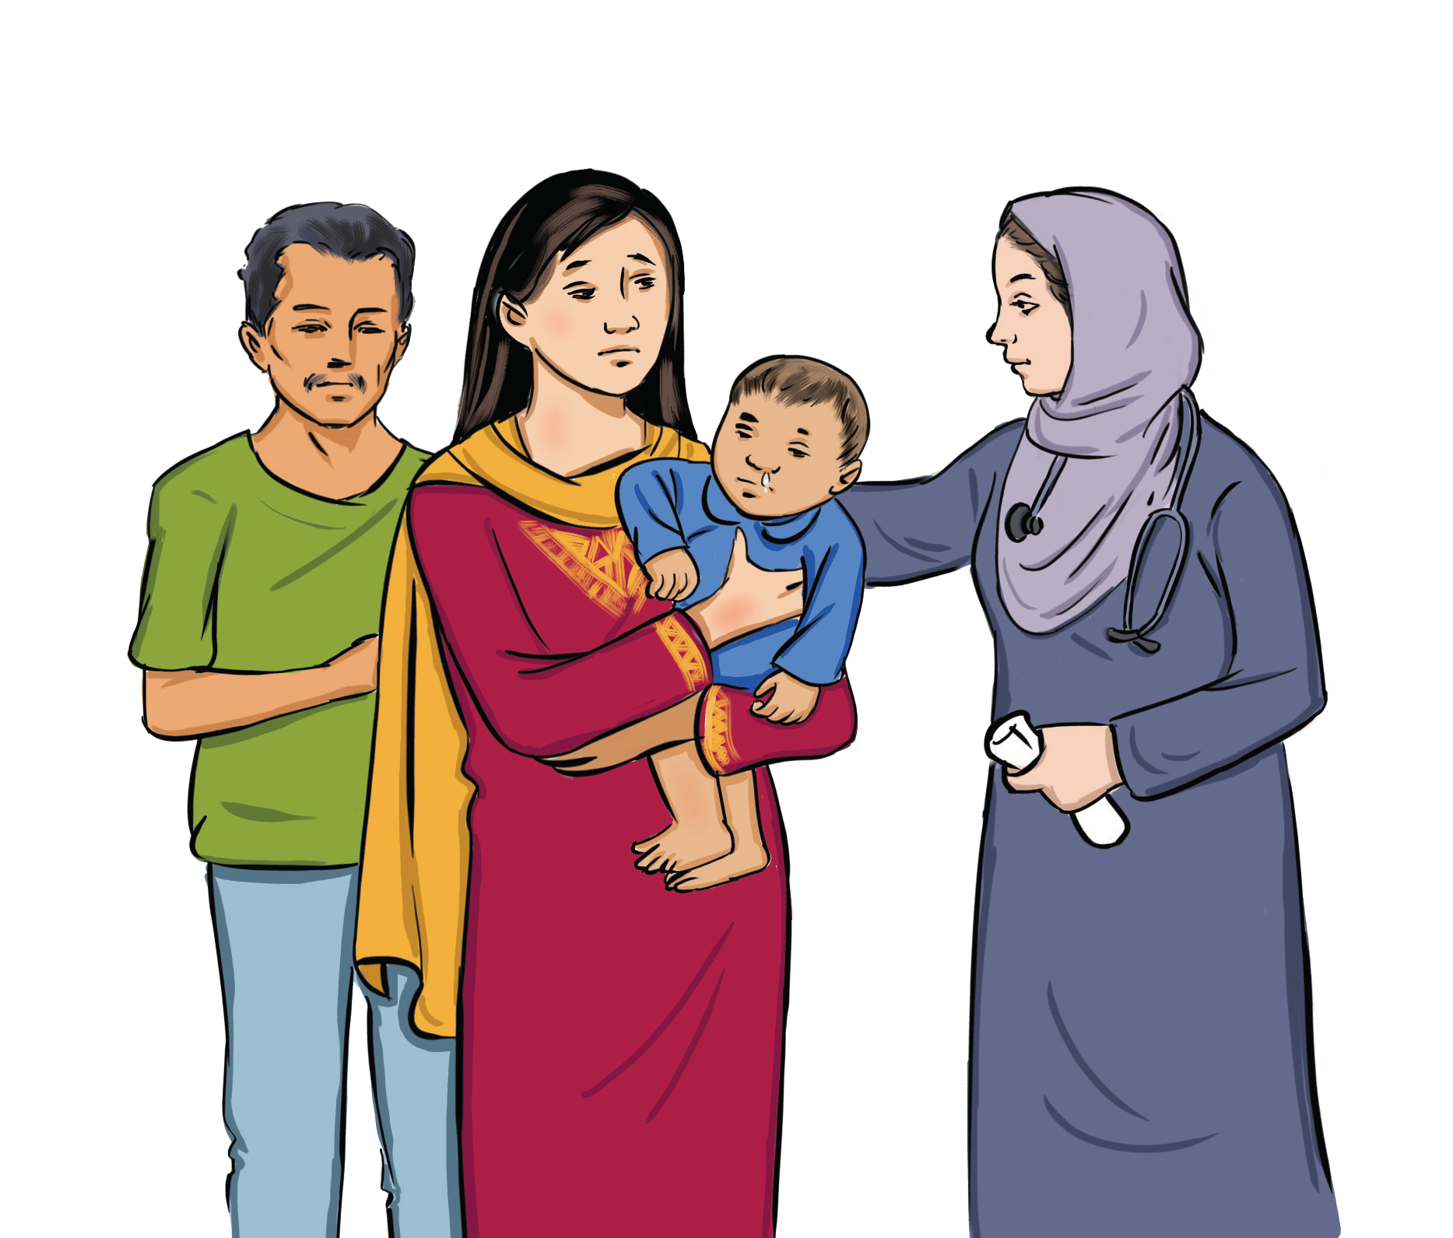

Influenza

Influenza vaccine requires
frequent doses.

For children six months to eight years of age:
Two doses given at least four weeks apart

For children eight years and older:
Annual vaccination dose

D5

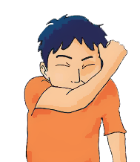What is the flu?
Flu—short for influenza—is caused by influenza viruses
Flu viruses infects the nose, upper airways, throat, and lungs

What are the symptoms of the flu?
Fever, chills, muscle or body aches, fatigue, malaise, headache, dry cough, runny or stuffy nose, vomiting and/ or diarrhoea

What vaccine is used to prevent the flu?
Flu vaccines are used to prevent the flu
The vaccine composition is modified each year to address the expected mix of flu strain

Why is it important to prevent the flu?
Flu spreads easily and can cause serious illness, especially for young children
Some of the more serious complications from flu include
pneumonia and dehydration

What is the impact of the flu?
The flu typically does not have long-term consequences,
but in rare cases it can be fatal

What are the potential side effects of the influenza vaccine? Soreness, redness, or swelling where the shot was given Hoarseness
Sore, red, or itchy eyes
Cough, fever, fatigue, aches, headache and itching

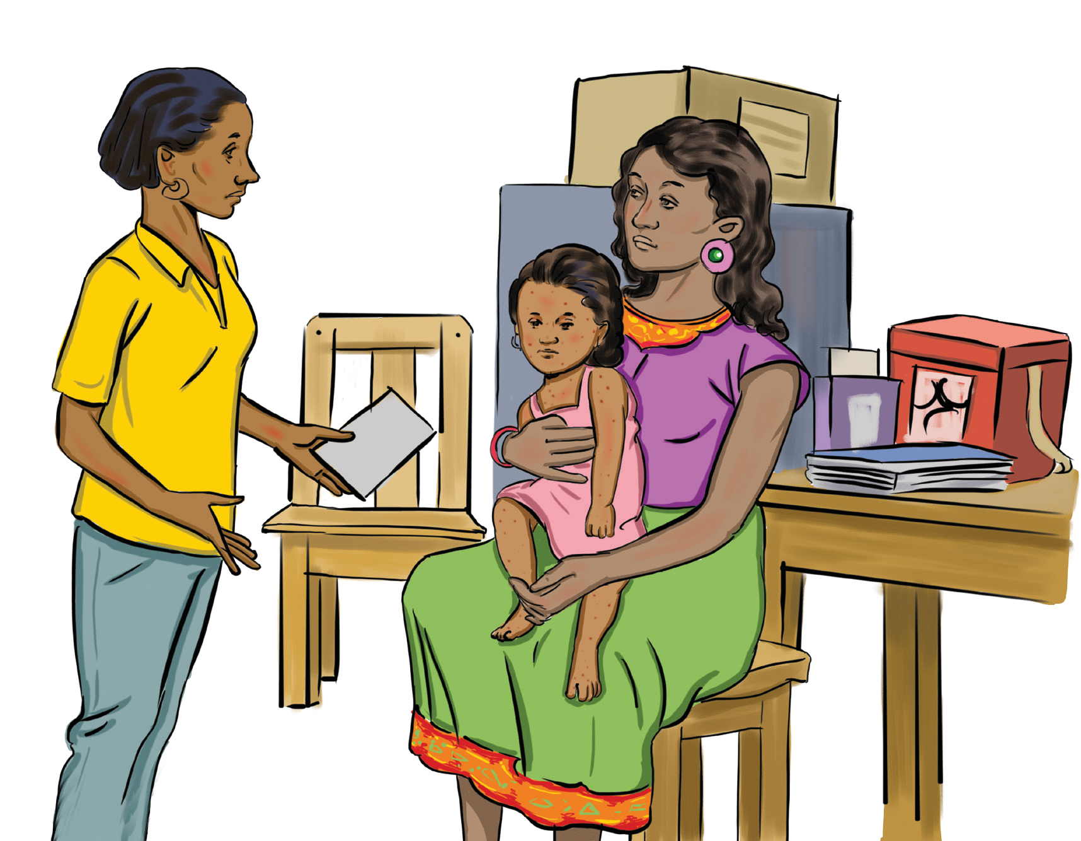

Measles

Measles, Mumps and Rubella (MMR) vaccine requires a two-dose series given at:
12 to 15 months
4 to 6 years

D6

What is measles?
A disease caused by germs spread through the air when an infected person breaths, coughs, or sneezes
Affects the lungs and breathing tubes

What are the symptoms of measles?
Starts with fever and causes cough, runny nose, and red eyes soon after
Rash of tiny, red spots will form at the head and spread to the rest of the body

What vaccine is used to prevent measles?
The measles vaccine is used to prevent measles
It is often presented in the combination vaccine MR (measles and rubella) or MMR

Why is it important to prevent measles?
Measles weakens a child’s ability to fight other diseases. It directly causes some deaths and, particularly in poor countries where children are malnourished and frequently ill, contributes to further deaths after the disease episode

What is the impact of the measles?
Measles can cause severe diarrhoea, pneumonia, blindness, and ear infection. The virus infection can lead to a rare disease of the central nervous system called subacute sclerosing panencephalitis, which leads to chronic brain inflammation and eventually death

What are the side effects for the measles vaccine?
Fever Mild rash

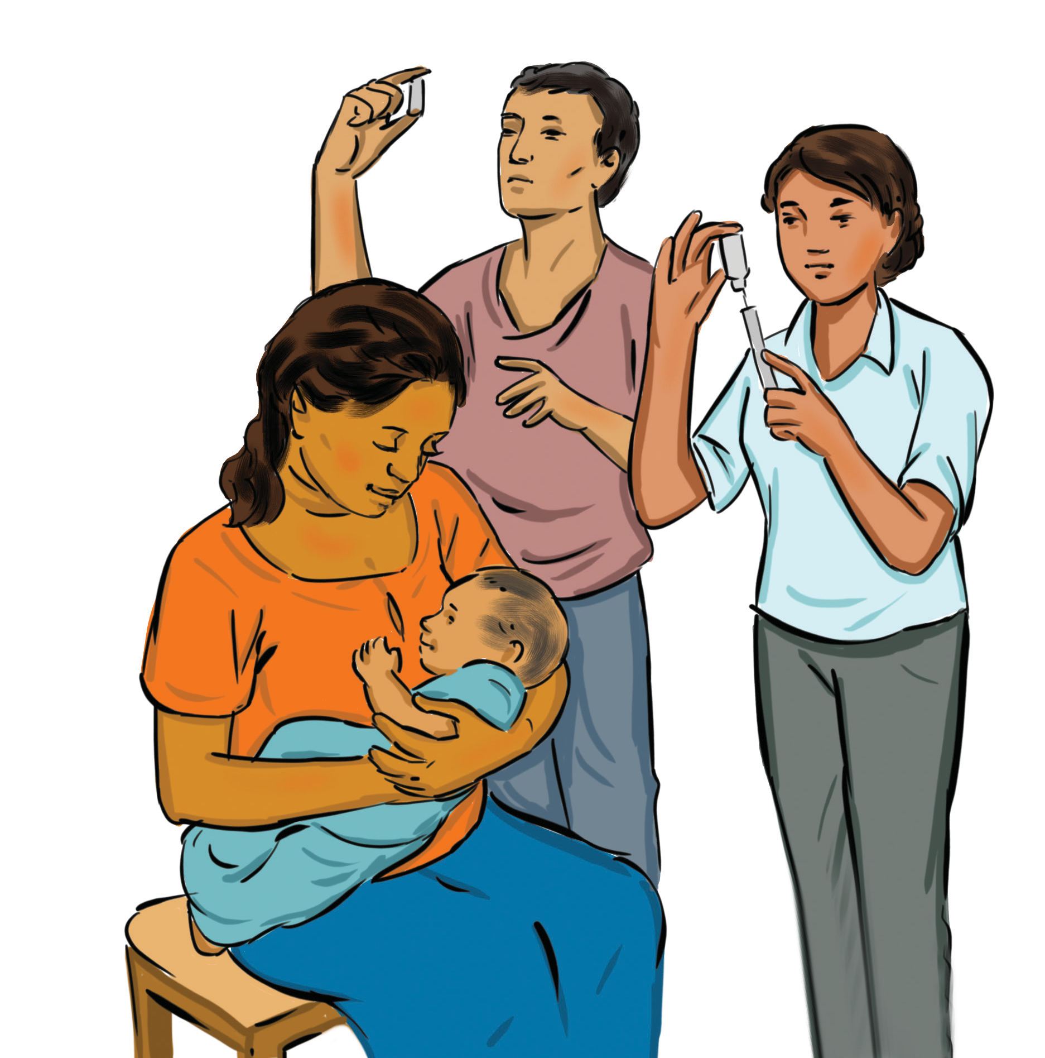

Meningitis

MenA conjugate requires:
- dose at 9 to 18 months

MenC conjugate requires:
- doses with booster 1 year
after 1 dose

Quadrivalent conjugate requires:
2 doses at 9 to 23 months
1 dose at 2 years or younger

D7

What is meningitis?
Meningitis can be caused by different groups of the meningococcal bacterium
The disease is spread person to person through the exchange of respiratory and throat secretions—such as by coughing, kissing, or sharing eating utensils—or close or lengthy contact with an infected person

What are the symptoms of meningitis?
Common symptoms are high fever, chills, lethargy, and a rash
If meningitis is present, the symptoms will also include headache and neck stiffness, which may not be present in infants; seizures may also occur

What vaccine is used to prevent meningitis?
A number of meningococcal vaccines are available. Refer to your country Expanded Programme on Immunisation guidelines

Why is it important to prevent meningitis?
In severe meningococcal infections, shock, coma, and death can follow within several hours, even with appropriate medical treatment

What is the impact of meningitis?
About 10% to 15% of those who get sick with the disease will die, even with appropriate treatment. As many as 20% will have permanent side effects, such as hearing loss or brain damage

What are the side effects for the meningitis vaccine?
Redness or pain where the injection was given Allergic reaction
Mild fever

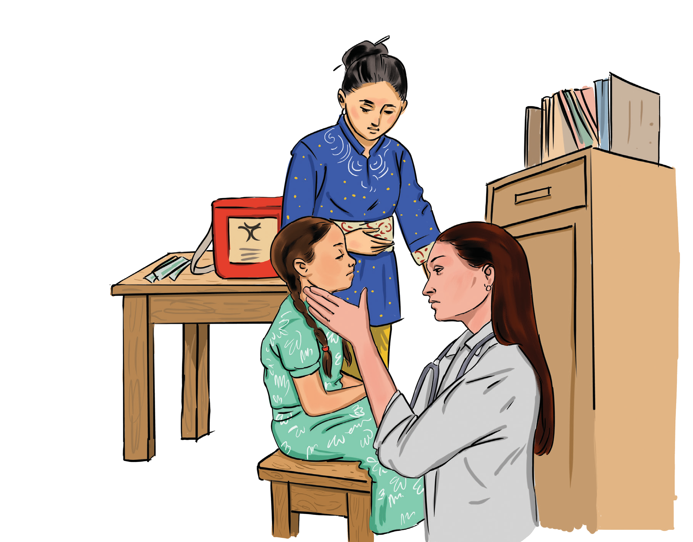

Mumps

Measles, mumps and rubella (MMR) vaccine requires a two-dose series given at:
12 to 15 months
4 to 6 years

D8

What is the mumps?
Mumps is a contagious viral infection of the salivary glands
Mumps spreads from person to person via droplets of saliva or mucus from the mouth of an infected person, usually when the person coughs, sneezes, or talks
The virus may also be spread indirectly when someone with mumps touches items or surfaces without washing their hands

What are the symptoms of mumps?
Individuals with mumps usually first feel sick with nonspecific symptoms like headache, loss of appetite, and low-grade fever
The most well-known sign of mumps is swelling of the salivary glands below the ear
Respiratory or only nonspecific symptoms such as
headache, loss of appetite, and low-grade fever

What vaccine is used to prevent mumps?
The vaccine is typically combined with the measles and rubella in the MMR vaccine
It is given as a shot in two doses:
The first dose of MMR should be given on or after the child’s first birthday; the recommended age range is from 12 to 15 months (9 months in developing countries)
The second dose is usually given when the child is 4 to 6 years old, although it can be given earlier (15 to 18 months in developing countries)

Why is it important to prevent the mumps?
Mumps spreads easily from person to person and can lead to serious complications, like hearing loss

What is the impact of the mumps?
Mumps can cause meningitis (in up to 15% of cases), orchitis (inflammation of one or both testicles), and deafness. Very rarely, mumps can cause encephalitis and permanent neurological damage
Mumps in adults may cause serious complications such
as inflammation of testes, ovaries, and/or breasts

What are the side effects for the mumps vaccine?
Fever is the most common side effect Some people may develop a mild rash

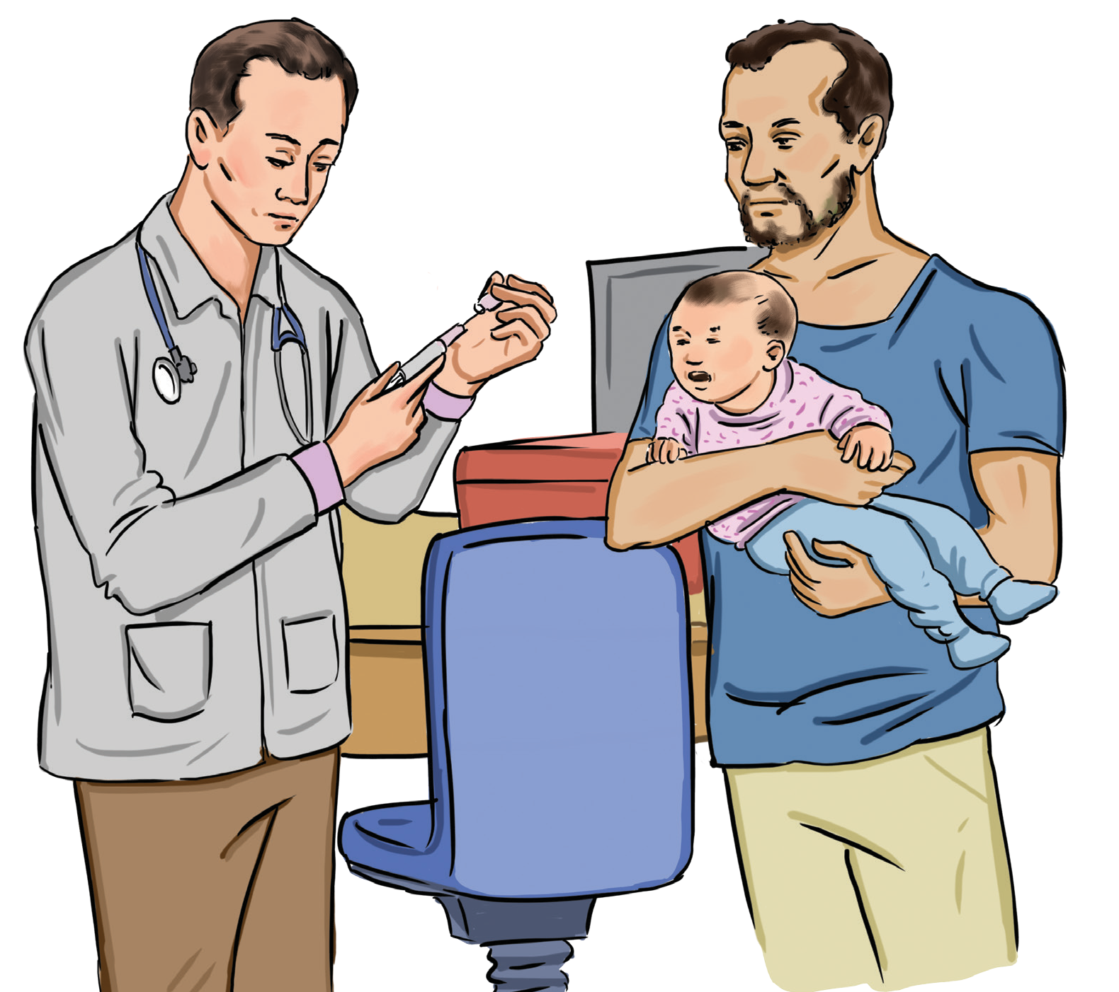

Pertussis (Whooping Cough)

Diphtheria, Tetanus and Acellular Pertussis (DTaP) vaccine requires a five-dose series given at:
2 months
4 months
6 months
15 to 18 months
4 to 6 years

D9

What is pertussis?
It is a disease known commonly as whooping cough, which is caused by bacteria that spread through the air when an infected person breaths, coughs, or sneezes

What are the symptoms of pertussis?
Starts with runny nose, sneezing, mild cough, and pauses in breathing in infants
Coughing becomes violent after one to two weeks, and the child will begin to make the whooping noise as they gasp for breath
Babies and young children may turn blue while coughing from lack of oxygen

Why is it important to prevent pertussis?
The DTaP vaccine is used to prevent pertussis. DTaP is a single vaccine that fights against diphtheria, pertussis, and tetanus. It is especially important for pregnant women to get vaccinated

Why is it important to prevent pertussis?
Babies who get whooping cough can have dangerous complications, like pneumonia, convulsions, and brain damage

What is the impact of pertussis?
The uncontrollable, violent coughing can create severe breathing difficulties and can cut off the oxygen flow to the brain, causing brain damage and seizures. In teens and adults, the cough may cause complications such as passing out or fracturing a rib

What are the side effects for the pertussis vaccine? Redness, swelling and pain at the injection site Fever
Vomiting

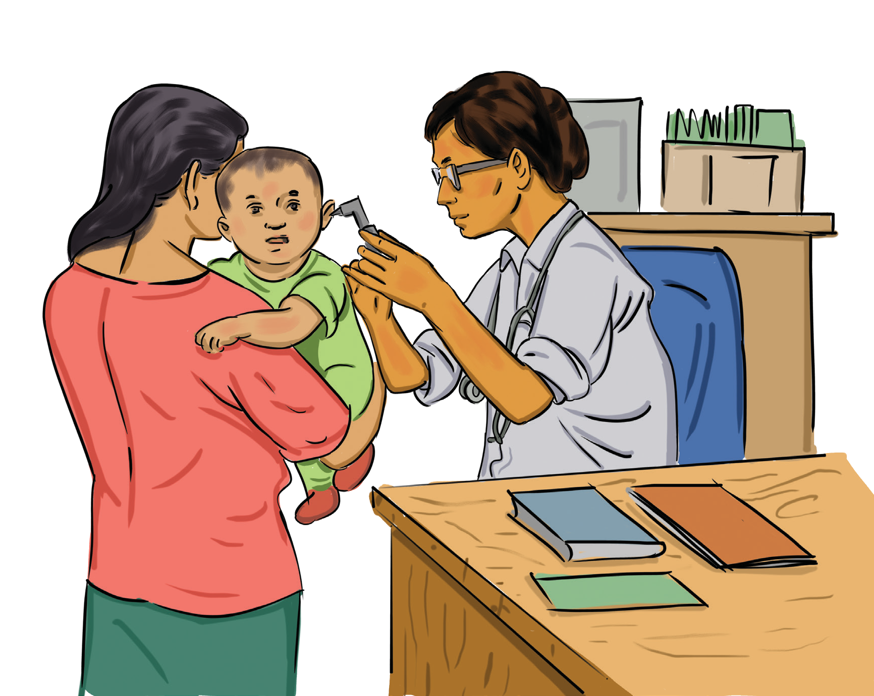

Pneumococcal Diseases

Pneumococcal vaccine (PCV13) requires a four-dose series given at:
2 months
4 months
6 months
12 to 15 months

D10

What is pneumococcal disease?
Pneumococcal diseasesare caused by the pneumococcus bacteria. There are many types of pneumococcal disease. The disease spreads when an infected person coughs or sneezes. These illnesses can lead to disabilities like deafness, brain damage, or loss of arms or legs

What are the symptoms of pneumococcal diseases?
Symptoms depends on which part of the body it affects Pneumococcal pneumonia causes fever or chills, cough,
rapid or difficulty breathing, and chest pain. It is one of
the main types of pneumonia
Pneumococcal meningitis causes stiff neck, headache, high fever, pain from bright lights, and confusion
In babies, symptoms include poor eating and drinking, low alertness, or vomiting
Middle-ear infection symptoms include ear pain, a red swollen ear drum, and fever or sleepiness
Blood infection symptoms include fever, chills, or low alertness

What vaccine is used to prevent pneumococcal?
There are more than 90 types of pneumococcal bacteria and the vaccine protects against the types that cause most of the serious illnesses in children

Why is it important to prevent pneumococcal diseases?
Some children may not even feel sick, but they could have the bacteria in their noses and throats. These children can still spread pneumococcal disease

What is the impact of pneumococcal diseases?
Pneumococcal infections can lead to potentially serious, and even deadly infections like pneumococcal meningitis and pneumonia

What are the side effects for the pneumococcal vaccine?
Fussiness Sleepiness
Loss of appetite (not wanting to eat)
Redness, swelling or soreness at the injection site Fever

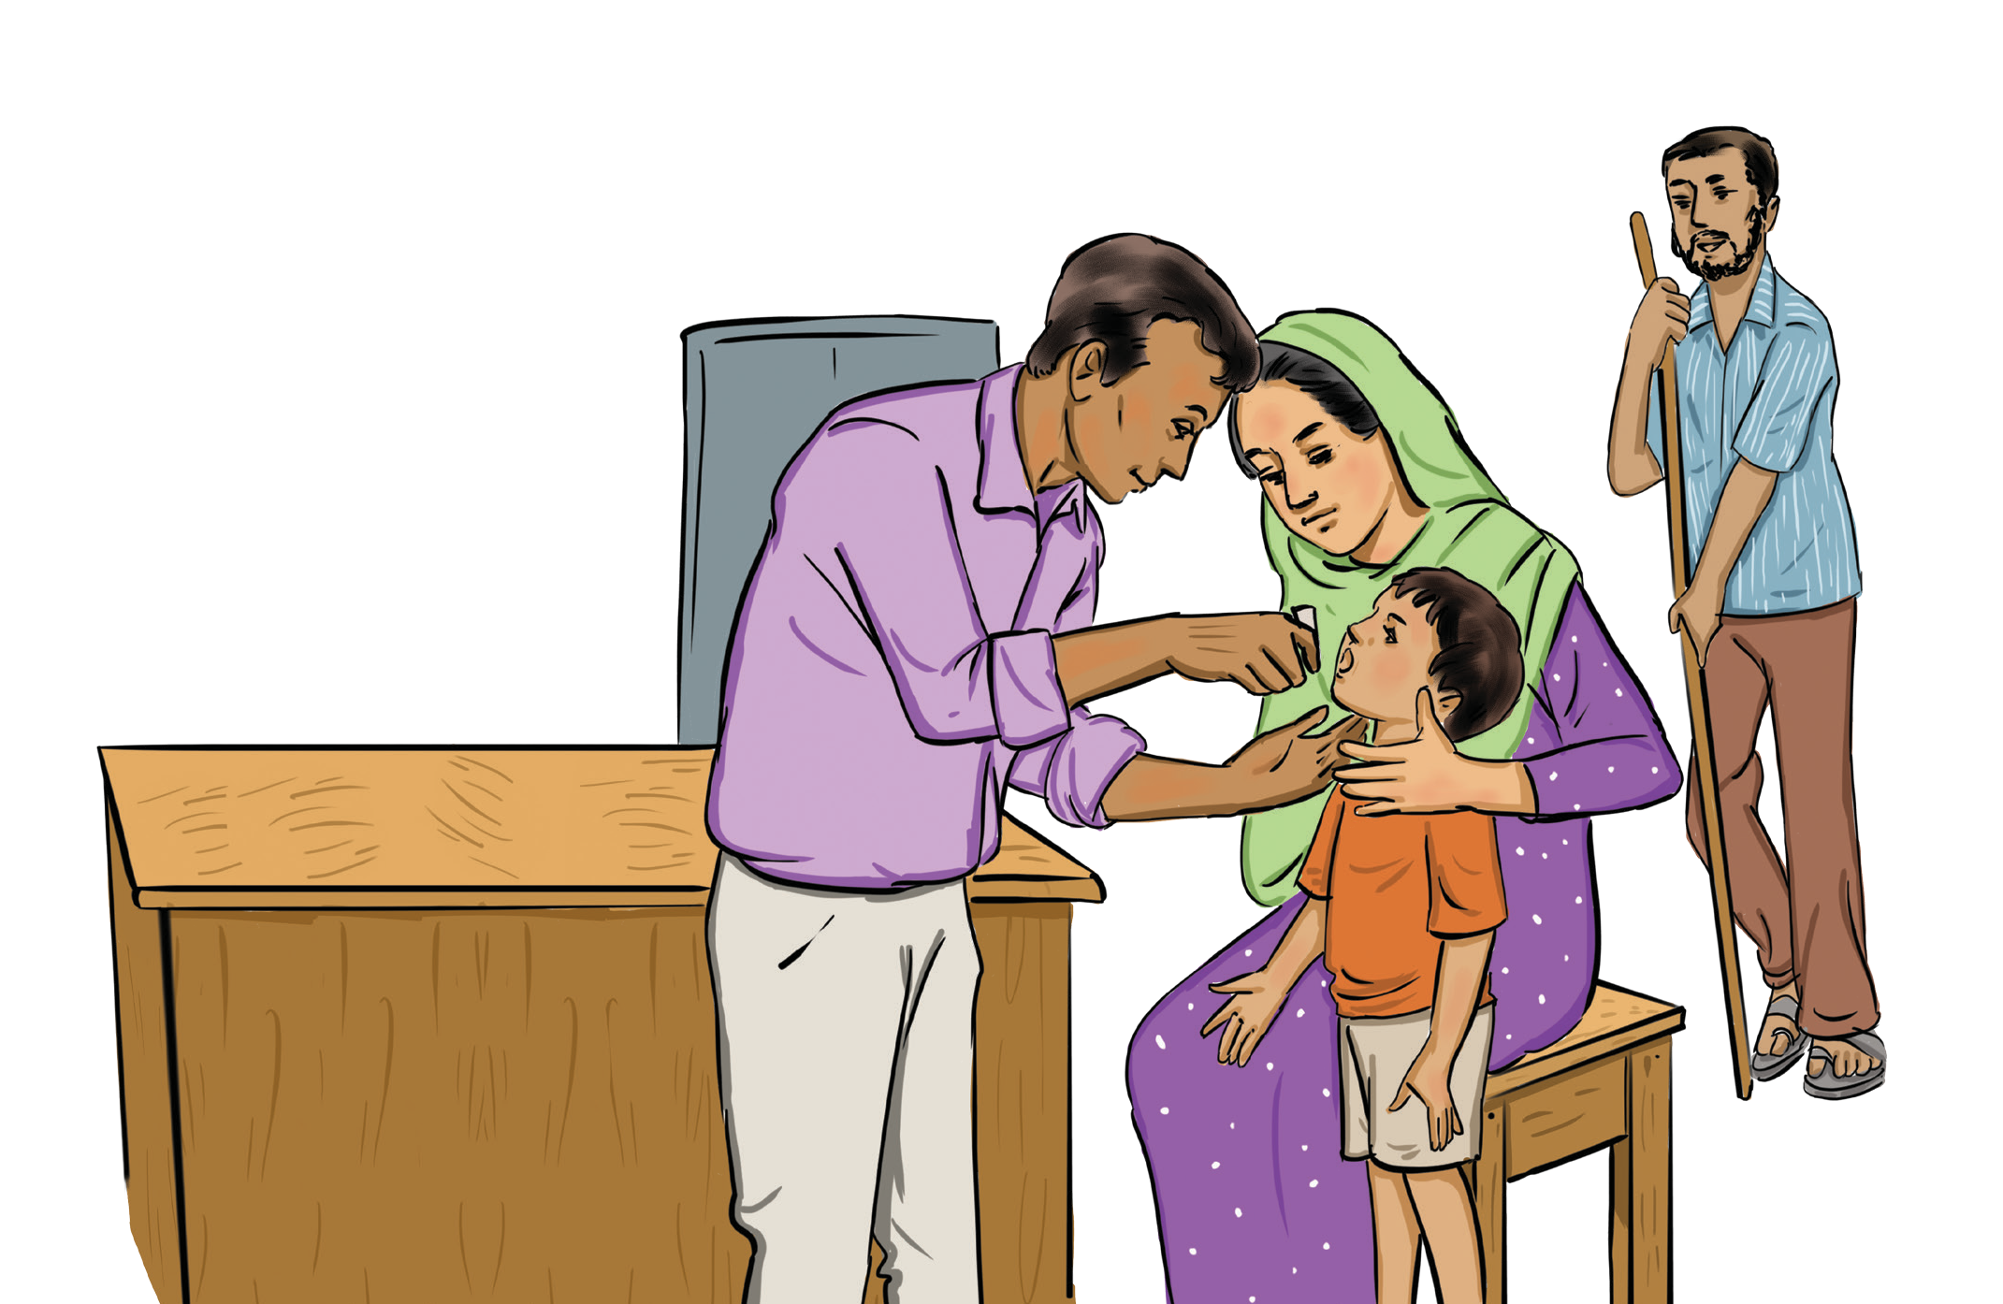

Polio

Polio vaccine (bOPV, IPV) requires a four-dose series given at:
2 months
4 months
6 to 18 months
4 to 6 years

D11

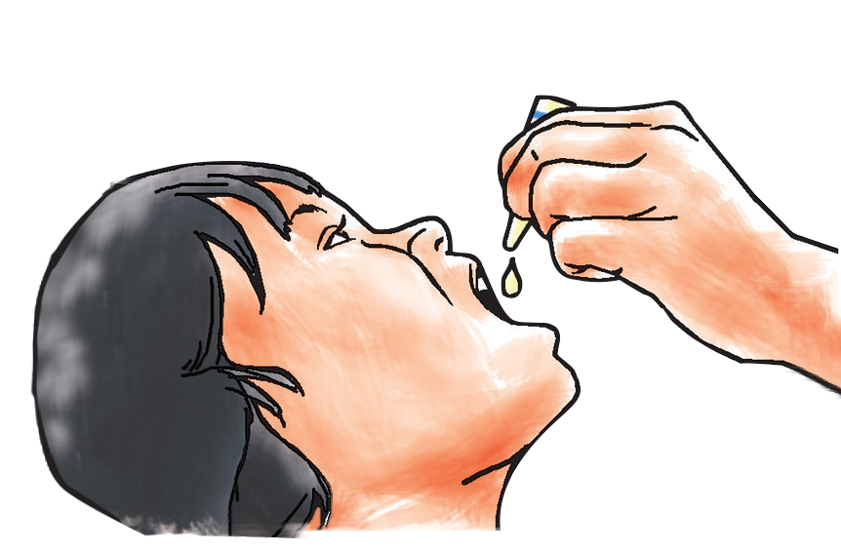What is polio?
Polio disease is caused when the polio virus is transmitted through direct contact with someone infected with the virus or, less commonly, through contaminated food and water.

What are the symptoms of polio?
95% of polio cases are asymptomatic; however, if symptoms do appear, they are typically very minor and include fever, tiredness, headache, nausea and vomiting, sore throat, stiff neck and back, and pain in arms and legs. A small percentage of cases develop acute flaccid paralysis (most commonly loss of control over one or more limbs) and, in some of these cases, can lead to respiratory distress and death.

What vaccine is used to prevent polio?
IPV and bOPV

Why is it important to prevent polio?
Polio virus is highly infectious. People carrying the polio virus can spread the virus for weeks in their faeces. People who have the virus, but do not have symptoms, can pass the virus to others

What is the impact of polio?
Paralysis, which can lead to permanent disability and death

What are the side effects for the polio vaccine?
The bOPV vaccine has no common side effects. However, in rare cases, where coverage is low, bOPV can mutate and cause vaccine-derived polio cases. For this reason, national immunization programs will be eliminating bOPV from their schedules, as the IPV supply becomes sufficient and countries secure financing
IPV side effects include redness, pain, swelling, or a lump at the injection site;low fever; joint pain or body aches; drowsiness; or vomiting

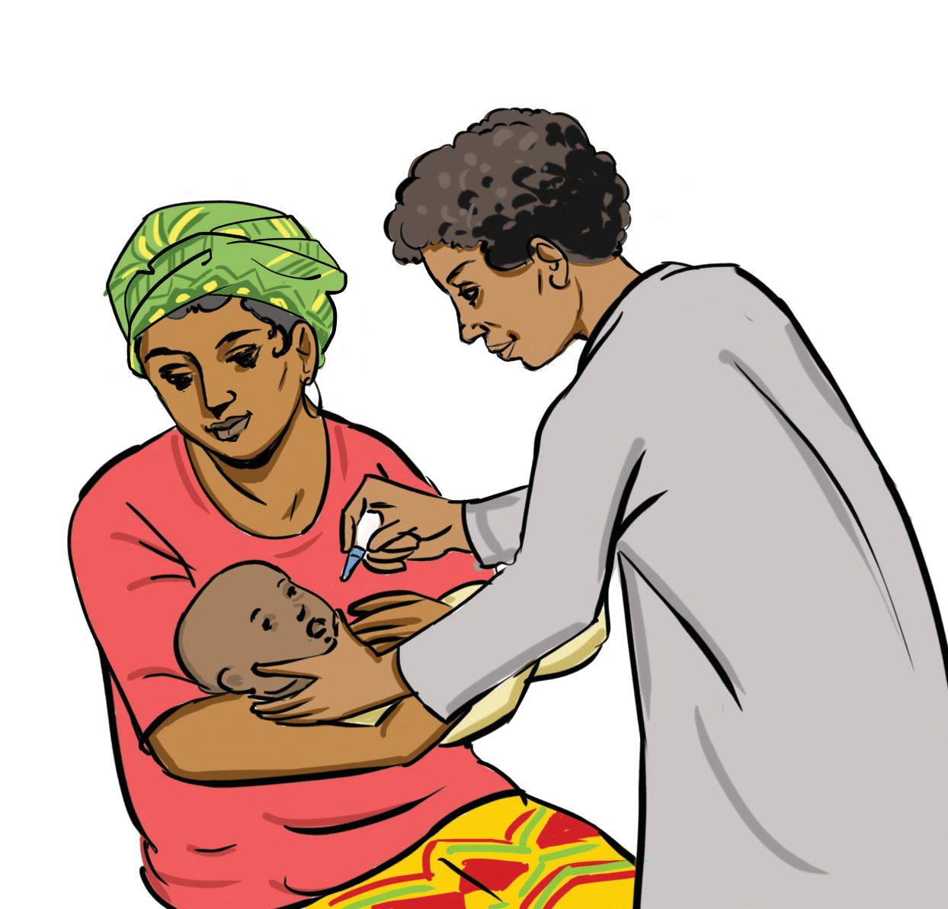

Rotavirus

Rotavirus vaccine requires a two- or three-dose series given at:
2 months
4 months
6 months

D12

What is Rotavirus?
Rotavirus is a contagious virus that can cause gastroenteritis, which is an inflammation of the stomach and intestines

What are the symptoms of Rotavirus?
Fever
Watery diarrhoea Vomiting Stomach pain

What vaccine is used to prevent Rotavirus?
The rotavirus vaccine is used to prevent rotavirus
Children get two or three doses of the vaccine, depending on the brand of vaccine
The first dose of rotavirus vaccine is to be administered from six weeks of age. For optimal protection and timeliness, it is recommended for infants to receive the

complete course of rotavirus vaccine before or by six months of age. However, the rotavirus vaccine can be administered to infants over six months of age

Why is it important to prevent rotavirus?
Rotaviruses are the most common cause of severe diarrhoeal disease in young children throughout the world. Each year over 200,000 children under five years of age die from vaccine-preventable rotavirus infections

What is the impact of rotavirus?
Rotavirus leads to dehydration, which can be very dangerous, especially for babies and young children

What are the side effects for the rotavirus vaccine?
Side effects are rare, usually mild, and may include fussiness, diarrhoea, and vomiting

Rubella

Measles, mumps and rubella (MMR) vaccine requires a
two-dose series given at:
12 to 15 months
4 to 6 years

D13

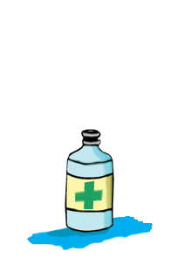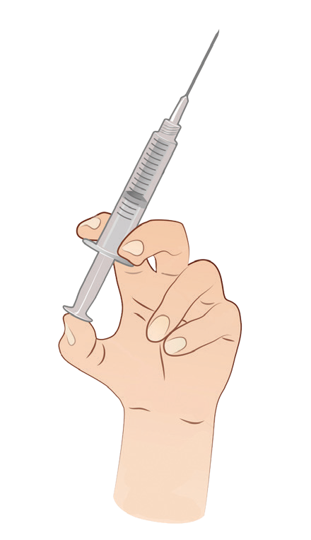What is rubella?
Rubella is a contagious viral infection best known by its distinctive red rash. The infection is usually accompanied by a mild fever

What are the symptoms of rubella?
In children, the following symptoms that last two or three days:
Rash that starts on the face and spreads to the rest of the body
Low fever (less than 101 degrees)
Before the rash appears, older children and adults may also have swollen glands, cough, runny nose, and aching joints (especially in young women)

What vaccine is used to prevent rubella?
The best way to protect against rubella is to get the measles, mumps, and rubella (MMR) shot
The first dose of rubella-containing vaccine can be delivered at 9 or 12 months depending on the measles vaccination schedule

Why is it important to prevent rubella?
Infection during pregnancy can cause birth defects, such as deafness, blindness, intellectual disability, heart defects, and liver or spleen damage

What is the impact of rubella?
Up to 70% of women who get rubella may experience arthritis. In rare cases, rubella can cause brain infections and bleeding problems

What are the side effects for the MMR vaccine?
Most children do not get side effects from the vaccine.
The side effects that do occur are usually very mild, such as a fever, rash, soreness, or swelling at
the injection site

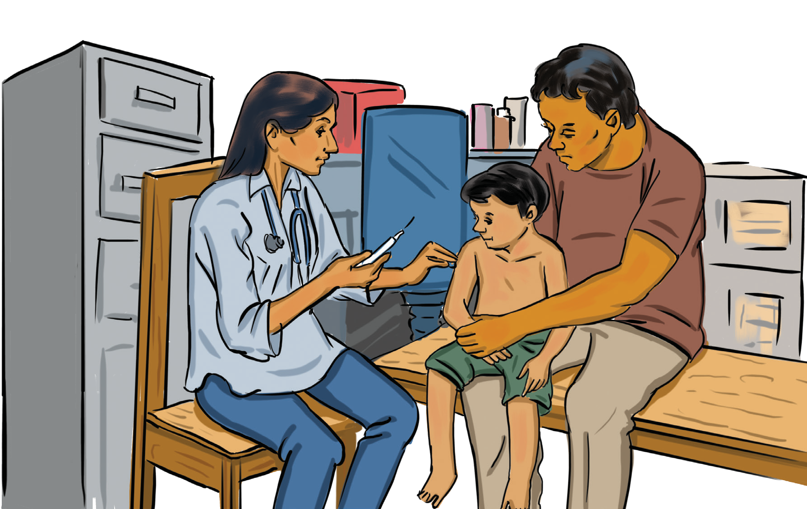

Tetanus

Diphtheria, tetanus and acellular pertussis (DTaP) vaccine requires
a five-dose series
given at:
2 months
4 months
6 months
15 to 18 months
4 to 6 years

D14

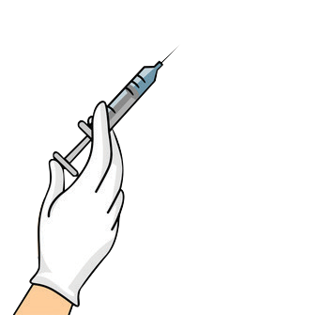What is tetanus?
Tetanus is a serious disease caused by a toxin (poison) made by bacteria. It causes painful muscle stiffness and is usually fatal

What are the symptoms of tetanus?
Tetanus in children starts with headache, jaw cramping, and muscle spasms (sudden involuntary muscle tightening)
It also causes the following: painful muscle stiffness all over the body, trouble swallowing, seizures, fever and sweating, high blood pressure, and fast heart rate

What vaccine is used to prevent tetanus?
The best way to protect against tetanus in babies is for the mother to have received five properly spaced doses of tetanus vaccine before she gives birth
Babies should receive their first doses as infants

Why is it important to prevent tetanus?
Tetanus is very dangerous; most babies who contract tetanus die

What is the impact of tetanus?
It can cause breathing problems, muscle spasms, and paralysis. Muscle spasms can be strong enough to break a child’s spine or other bones
It can take months to recover fully from tetanus. A child might need weeks of medical care

What are the side effects for the DTaP vaccine?
Most children do not get side effects
Side effects that do occur are usually mild: redness, swelling, or pain at the injection site; fever; or vomiting

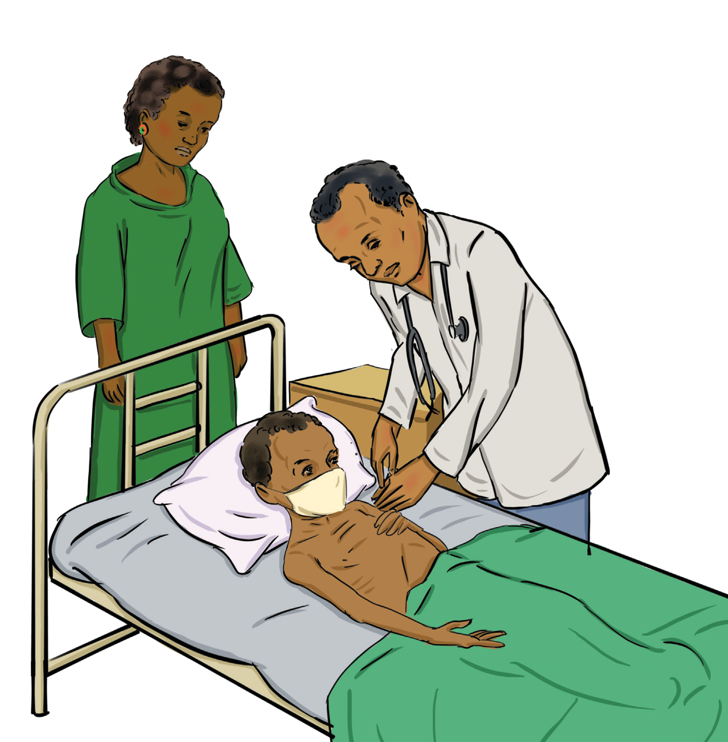

Tuberculosis

Bacille Calmette-Guerin (BCG) vaccine requires only one dose, ideally, within one week of birth

D15

What is tuberculosis?
It is disease caused by germs spread through the air when an infected person breathes, coughs, or sneezes
It usually affects the lungs, but can also affect the kidneys, spine, and brain

What are the symptoms of tuberculosis?
Weakness, coughing blood, night sweat, chest pain, and weight loss

What vaccine is used to prevent tuberculosis?
The bacille Calmette-Guerin (BCG) vaccine is used to prevent specific strain of tuberculosis that causes meningitis in children
A single dose of BCG vaccine should be given to all healthy new borns at birth, ideally together with hepatitis B birth dose

Why is it important to prevent tuberculosis?
If not treated properly, tuberculosis can be fatal. The tuberculosis bacteria can attack the lungs, kidneys, spine, and brain, and can lead to organ failure and ultimately death

What is the impact of tuberculosis?
Many strains of tuberculosis resist the drugs most used to treat the disease. People with active tuberculosis must take several types of medications for many months to eradicate the infection and prevent development of antibiotic resistance

What are the side effects for the tuberculosis vaccine?
A raised blister will form over the site almost immediately after injection
A small, red spot may appear at the injection site two to six weeks after vaccination; this red spot will eventually heal but may form a scar

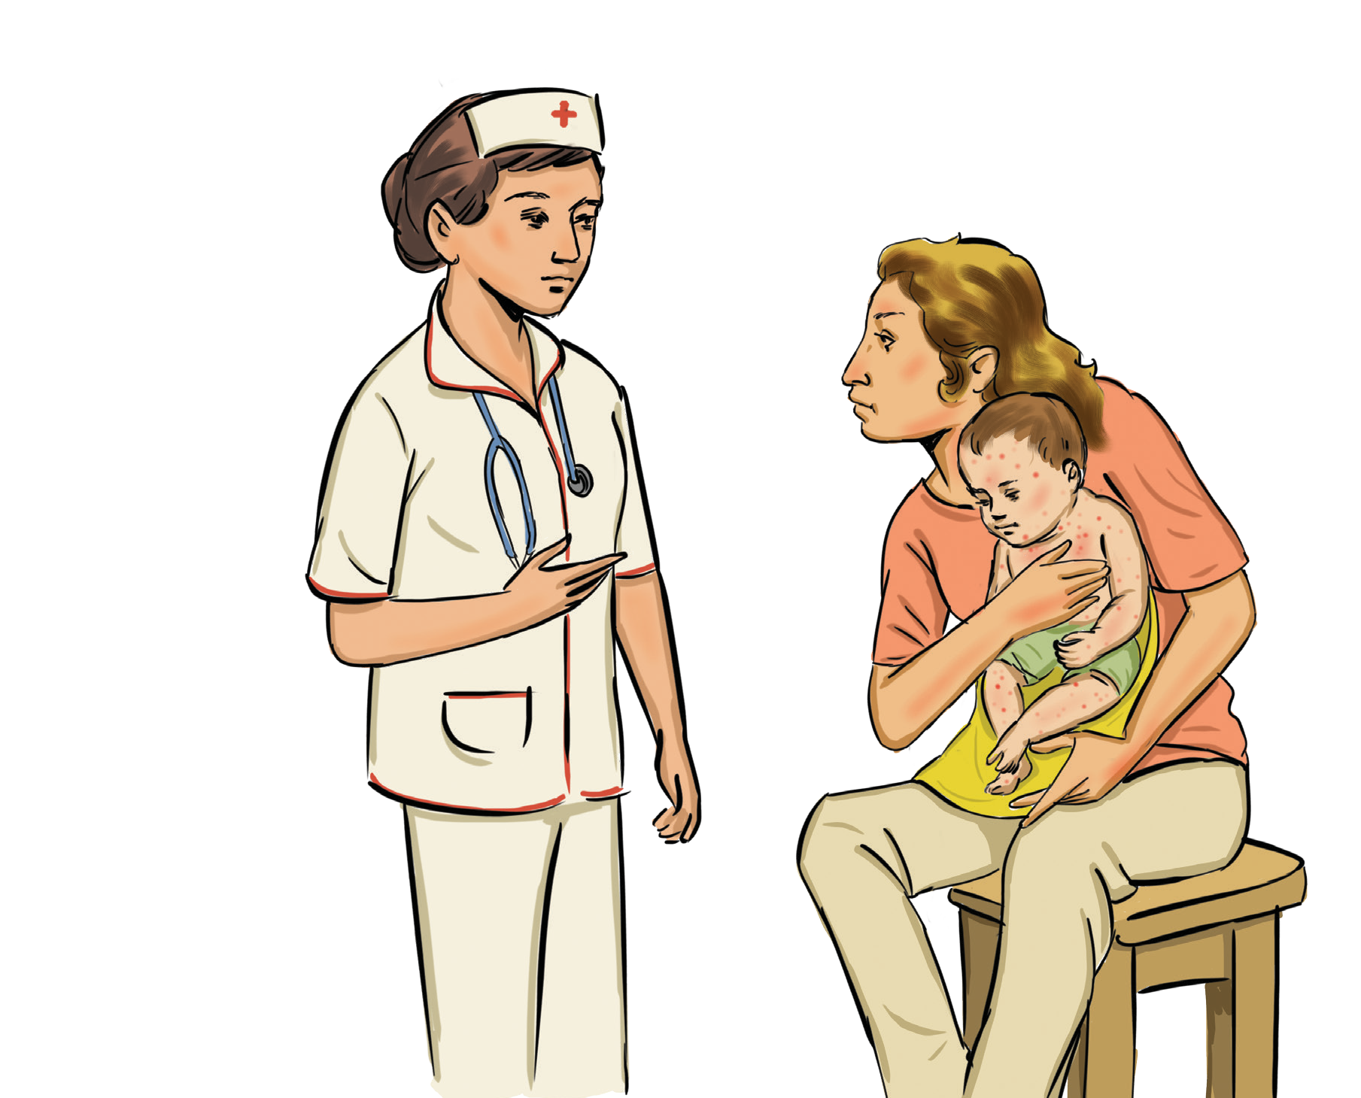

Varicella (Chicken Pox)

Varicella vaccine requires a two-dose series given at:
12 to 15 months
4 to 6 years

D16

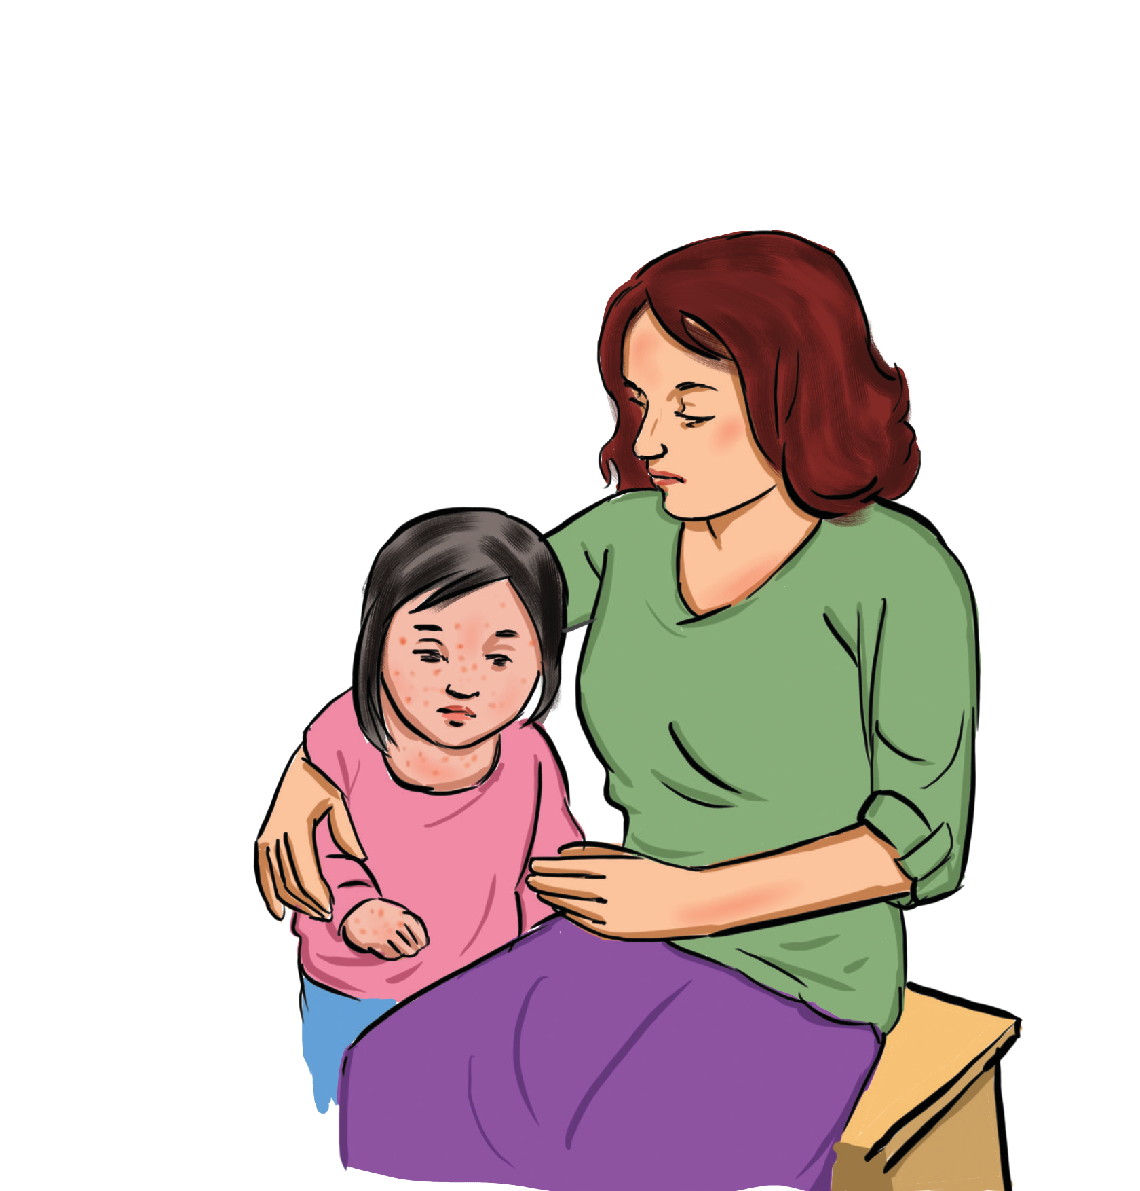What is chickenpox?
An infectious disease causing a mild fever and a rash of
itchy inflamed blisters
Caused by the herpes zoster virus, it mainly affects children, who are usually immune afterward

What are the symptoms of chickenpox?
The most common symptoms of chickenpox are rash, fever, coughing, fussiness, headache, and loss of appetite
The rash usually develops on the scalp and body, and then spreads to the face, arms, and legs
The rash usually forms 200 to 500 itchy blisters The illness lasts about 5 to 10 days

What vaccine is used to prevent chickenpox?
The chickenpox vaccine is used to prevent chickenpox.
Almost all (more than 99%) children develop immunity to the disease after two doses of vaccine

Why is it important to prevent chickenpox?
Chickenpox is very contagious and, while it is usually mild, it can cause serious complications like pneumonia

What is the impact of the chickenpox?
Besides the discomforts during the infection, the chickenpox virus can cause a very painful shingles infection later in life

What are the side effects for the chickenpox vaccine?
About 1% of people who received the vaccine develop a mild form of the disease, consisting of a limited rash of as little as only five to six blisters

Diseases Knowledge Check

E

Diseases Knowledge Check: Questions 1 – 9

Q1. Which disease is characterized by a bacterium that releases a toxin causing membrane formation and tissue damage, most commonly in the throat?
Q2. How does diphtheria spread?

Q3. Measles infection during pregnancy is associated with increased risk of what?

Q4. What is the most significant complication of rubella?

Q5. If a child misses one in a series of immunizations do they have to start over? Q6. What are some of the symptoms of a mild case of polio?
Q7. Can tetanus spread from person to person?

Q8. What are some of the early symptoms of tetanus? Q9. What is tetanus commonly known as?

E1

Diseases Knowledge Check: Answers 1 – 9

A1. Diphtheria

A2. The bacteria live in the mouth, throat, and nose of an infected person. The bacteria spread when an infected person coughs or sneezes; they occasionally can transfer from skin sores or through articles contaminated with discharge for sores of an infected person.
A3. Premature labour, spontaneous abortion, and low birth-weight baby.

A4. Infection in pregnant women can lead to foetal death, spontaneous abortion, or preterm delivery in addition to a variety of congenital defects.
A5. No. The child does not have to start over if the schedule was not followed.

A6. Symptoms include fever, sore throat, nausea, and head or stomachaches; it may also cause neck and back pain or stiffness
A7. No. Spores of the bacteria are found in soil and intestines or faeces of many household and farm animals. It usually enters the body through a puncture.
A8. Headache, irritability, and stiffness in the jaw and neck A9. Lockjaw

Diseases Knowledge Check: Questions 10 – 18

Q10. How long does it take so show signs of pertussis (whooping cough) after being exposed? Q11. How is pertussis spread?
Q12. What are some of the signs of measles infection?

Q13. What are some of the signs and symptoms of mumps infection? Q14. True or false: The pertussis vaccine is unsafe in pregnancy.
Q15. Varicella is also known as what?

Q16. Which of the vaccine-preventable diseases are infectious but not contagious?

Q17. Which disease can cause painful spasms, lasting for several minutes at a time and can cause bone fractures? Q18. What severe complication can rotavirus cause?

E2

Diseases Knowledge Check: Answers 10 – 18

A10. Typically, 5 to 10 days, with an upper limit of 21 days. A11. Through infectious droplets and is highly contagious.
A12. After 10 to 12 days from exposure; usually a fever appears and then a rash 2 to 3 days after the fever. A13. Fever, headache, and swelling of one or both cheeks or sides of the jaw.
A14. False. It is safe and should be administered at 26-weeks’ gestation or shortly afterwards. A15. Chickenpox. The virus also causes shingles in adults.
A16. Tetanus A17. Tetanus.
A18. Inflammation of the stomach and intestines (gastroenteritis)

