Supportive Supervision

Supportive Supervision

A Manual for Supervisors of Frontline Workers in Immunization

Contents

II CONTENTS

- ACKNOWLEDGMENTS

- ABBREVIATIONS

1 INTRODUCTION

- SUPPORTIVE SUPERVISION SYSTEM
- PURPOSE AND INTENDED USE OF THIS MANUAL
- OBJECTIVES OF THIS MANUAL
- HOW TO USE THE SUPPORTIVE SUPERVISION MANUAL

5 CHAPTER 1: IMPROVING THE QUALITY OF ROUTINE IMMUNIZATION SERVICES

- IMMUNIZATION PROGRAM OVERVIEW
- PROVIDING HIGH-QUALITY IMMUNIZATION SERVICES
7 ROLES AND PERSPECTIVES OF FRONTLINE WORKERS, CAREGIVERS, AND SUPERVISORS
9 CHAPTER 1 KEY TAKEAWAYS

10 CHAPTER 2: WHY SUPPORTIVE SUPERVISION

11 ASSESSING YOUR SUPERVISION STYLE
- WHAT IS SUPPORTIVE SUPERVISION?
- PURPOSE OF A SUPPORTIVE SUPERVISION VISIT
14 TRADITIONAL VS. SUPPORTIVE SUPERVISION
- BENEFITS OF SUPPORTIVE SUPERVISION
- CHARACTERISTICS OF A SUCCESSFUL SUPPORTIVE SUPERVISOR
- THE FIVE W’S OF INTERPERSONAL COMMUNICATION FOR IMMUNIZATION FOR SUPPORTIVE SUPERVISION
20 CHAPTER 2 KEY TAKEAWAYS

21 CHAPTER 3: COMMUNICATION SKILLS IN SUPPORTIVE SUPERVISION

22 INTERPERSONAL COMMUNICATION SKILLS FOR SUPPORTIVE SUPERVISION
26 GIVING CONSTRUCTIVE FEEDBACK
29 CHAPTER 3 KEY TAKEAWAYS

Supportive Supervision
II
TABLE OF CONTENTS

30 CHAPTER 4: SUPPORTIVELY SUPERVISING IPC/I

- THE IMPORTANCE OF IPC
- SUPPORTIVE SUPERVISION OF COMMUNITY-BASED FLWS
- DAILY SUPPORTIVE SUPERVISION OF IPC/I (FACILITY-BASED STAFF)
- IPC/I SUPPORTIVE SUPERVISION IN THE CONTEXT OF INTEGRATED SUPERVISION
- SUPERVISION VISITS AND ASSESSING IPC/I
40 CHAPTER 4 KEY TAKEAWAYS

41 CHAPTER 5: COACHING AND MENTORING

42 WHAT IS COACHING?
44 WHAT IS MENTORING?
44 PEER-TO-PEER SUPPORT AND MENTORING
45 CHAPTER 5 KEY TAKEAWAYS

46 CHAPTER 6: ENHANCING MOTIVATION

- WHAT IS MOTIVATION?
- INDICATORS OF LOW MOTIVATION AND PERFORMANCE
48 STRATEGIES FOR MOTIVATING FLWS
51 HEALTH SYSTEM AND COMMUNITY-BASED RECOGNITION
54 AVOIDING DEMOTIVATORS
55 CHAPTER 6 KEY TAKEAWAYS

56 SUPPLEMENTAL RESOURCES

- APPENDIX A. TIPS FOR LEADING STAFF IN QUALITY IMPROVEMENT

- APPENDIX B. IMPROVING THE CLIMATE IN YOUR WORKPLACE THROUGH GOOD LEADERSHIP

- APPENDIX C. SIX TIPS FOR FRONTLINE WORKER SUPERVISION SUCCESS

62 APPENDIX D. SAMPLE EPI SUPPORTIVE SUPERVISION CHECKLIST

68 APPENDIX E. SUPPORTIVE SUPERVISION SELF- ASSESSMENT CHECKLIST FOR SUPERVISORS

Supportive Supervision
TABLE OF CONTENTS
III

This Resource

This resource is available on the Internet at: ipc.unicef.org
Copies of this document, as well as additional IPC materials on immunization, may be requested from UNICEF and partners:
UNICEF
3 United Nations Plaza New York, NY 10017 Tel: +1-212-326-7551
Email: IPC@unicef.org
© 2019 UNICEF
UNICEF and partners welcome requests for permission to use, reproduce or translate IPC for Immunization resources, in part or in full.
The content and the presentation of the material in this resource and the IPC package do not imply the expression of any opinion whatsoever on the part of UNICEF and partners.
Suggested citation: United Nations Children’s Fund, ‘IPC for Immunization Package’, UNICEF, New York, 2019.
For more information, or to provide feedback, please write to IPC@unicef.org

Supportive Supervision
IV
THIS RESOURCE

Acknowledgments

The Interpersonal Communication for Immunization (IPC/I) Package is the result of strenuous hard work and collaborative efforts of many institutions and individuals, without whose help, guidance and support, this would not have been possible.
UNICEF wishes to recognize their contributions to this important initiative and expresses gratitude to all those who supported the development of the package through their time and expertise.
Special thanks to the global advisory group and the frontline workers From various parts of the world who contributed to develop the package.

Global IPC Advisory Group Members

Molly Abbruzzese, BMGF Hardeep Sandhu CDC Susan Mackay, GAVI
Lisa Menning, WHO Jhilmil Bahl, WHO
Mike Favin, The Manoff Group Lora Shimp, John Snow Inc. Bill Glass, CCP
Saad Omer, Emory University
Dr. Stephen Hodgins, University of Alberta, Canada Nathan Pienkowski, Bull City Learning
Dr. Naveen Thacker, IPA Benjamin Hickler, UNICEF Ketan Chitnis, UNICEF Tommi Laulajainen, UNICEF Claudia Vivas, UNICEF

JHU Project Team

Sanjanthi Velu, Jvani Cabiness, Caitlin Loehr, Amrita Gill Bailey, Ron Hess, Guy Chalk, Michael Craven, and Bill Glass. Others who contributed include Rupali Limaye, Anne Ballard, Mark Beisser, Missy Eusebio, and Carol Hooks.

Acknowledging and thanks to the CCP field offices and sister organizations in Nigeria, Pakistan, Uganda, Ethiopia, India and CHIP Pakistan for their support during the formative research and pretesting stages of the package.

UNICEF Team

Attiya Qazi, Chikondi Khangamwa, Anisur Rehman, Rufus Eshuchi, Kennedy Ongwae, Ayesha Durrani, Robb Butler, Violeta Cojocaru, Jonathan David Shadid, Johary Randimbivololona, Natalie Fol, Deepa Risal Pokharel, Helena Ballester Mario Mosquera, Svetlana Stefanet, Sergiu Tomsa, Daniel Ngemera, Fazal Ather, Vincent Petit, Carolina Ramirez, Alona Volinsky, Hannah Sarah Dini, Benjamin Schreiber, Rafael Obregon, Diane Summer, Robin Nandy, Luwei Pearson and Stefan Peterson.

Suleman Malik, Communication for Development Specialist, UNICEF Headquarters, New York, USA. UNICEF Team Lead

Supportive Supervision
V
ACKNOWLEDGMENTS

Foreword
In recent decades, child mortality has dropped dramatically. Vaccines have been a major contributor to improvements in health by protecting children and adults against diseases that once maimed and killed. The scourge of smallpox has been eradicated, the last mile of polio eradication is close, as is the elimination of maternal and neonatal tetanus. Yet, despite the availability of vaccines, many countries face continuing constraints to achieving universal vaccination. One of the key challenges is ensuring sustainable demand for vaccination at family and community levels. The value that community members place on vaccination is a major contributor towards good health. The Global Vaccine Action Plan (2011–2020) acknowledges the importance of community attitudes and practices, as reflected in one of its six strategic results: “Individuals and communities understand the value of vaccines and demand immunization as both their right and responsibility.”
Although most children do receive the recommended vaccinations, too many still miss out: almost 20 million globally do not receive the full schedule of essential childhood vaccines. The reasons are complex. In some places, health services are not easily accessible – and when accessible, may not be convenient to users – and/or reliable. In some cases, health worker’s behaviors or attitudes may limit the uptake of vaccination services. Caregivers’ and children’s experiences with immunization services may be unpleasant for various reasons and this can explain why many children who receive the first dose of vaccines (e.g. BCG or DTP1), drop out. In other instances, children miss recommended vaccinations because their parents or guardians have concerns or misunderstandings about vaccines, lack information on the benefits of vaccines, or do not understand what they need to do to get their children vaccinated and protected.
Frontline Workers (FLWs), including facility-based professionals, community health workers (CHWs) and community volunteers (CVs), are a critical source of information about vaccination. Research shows that FLWs are the most influential source of information about vaccines for caregivers and families of children. Because of their critical role in providing essential information about vaccination services, FLWs must have effective interpersonal communication (IPC) skills. They also need positive attitudes towards the people they serve and their work, an understanding of the importance of communication, and an ability to operate in an environment that enables them to communicate effectively to build trust and confidence. When equipped with the relevant skills and supported by their supervisors, FLWs can be very effective in influencing attitudes and promoting uptake of vaccination services. Across countries, FLWs engage communities in dialogue, mobilize community leaders and provide communities with health services and knowledge about healthy practices. However, the limited IPC skills of FLWs remains a challenge and requires focused efforts to enhance their capacity to communicate effectively with care givers and community members that they serve, and a system that supports and values the practice of these important competencies is vital.
UNICEF, together with Bill & Melinda Gates Foundation (BMGF), Centers for Disease Control and Prevention (CDC),
, Emory University, GAVI, the Vaccine Alliance (GAVI), International Pediatric Association (IPA), , John Snow Inc. (JSI), the United States Agency for International Development’s flagship Maternal and Child Survival Program, World Health Organization (WHO) and other partners, remain committed to closing the gap by facilitating a process of empowerment through the development and roll out of a comprehensive ‘IPC for Immunization’ package.
UNICEF and partners are pleased to introduce this IPC for Immunization package and invite national and sub-national programme managers, partners and FLWs to adapt it to their local context and use it to guide their work with caregivers and communities. A range of resources are in the package, including participant’s and facilitator’s manuals, an adaptation guide, a supportive supervision manual, FAQs, flash cards, videos, audio job aids, a mobile application, and a monitoring and evaluation (M&E) framework. These resources are available both online (IPC.UNICEF.Org) and offline in four global languages. It’s hoped that through this package and instructional-design approaches, FLWs will improve their capacity to effectively communicate and successfully promote demand for immunization and other health services; empathize with caregivers; address questions and concerns through counselling; and clearly communicate key messages regarding the timing and importance of further vaccinations and practical information on where and when they should be obtained.
UNICEF extends gratitude to partners, colleagues and the advisory group who contributed their time, expertise and experience to the preparation of this package. Special thanks to Johns Hopkins University Center for Communication Programs for helping to develop the package, to the UNICEF regional and country colleagues and the FLWs for their support, valuable feedback and collaboration in developing the package. Through this partnerships and support, UNICEF will continue to enhance the capacity of the immunization workforce, institutions, and teams that will help communities to value, demand, trust and improved understanding to the right to immunization services.

Supportive Supervision
VI
FOREWORD

Abbreviations

EPI Expanded Programme on Immunization
- FLW frontline worker
- HRM human resources management
- IPC interpersonal communication
- IPC/I interpersonal communication in immunization
- WHO World Health Organization

Supportive Supervision
VII
ABBREVIATIONS

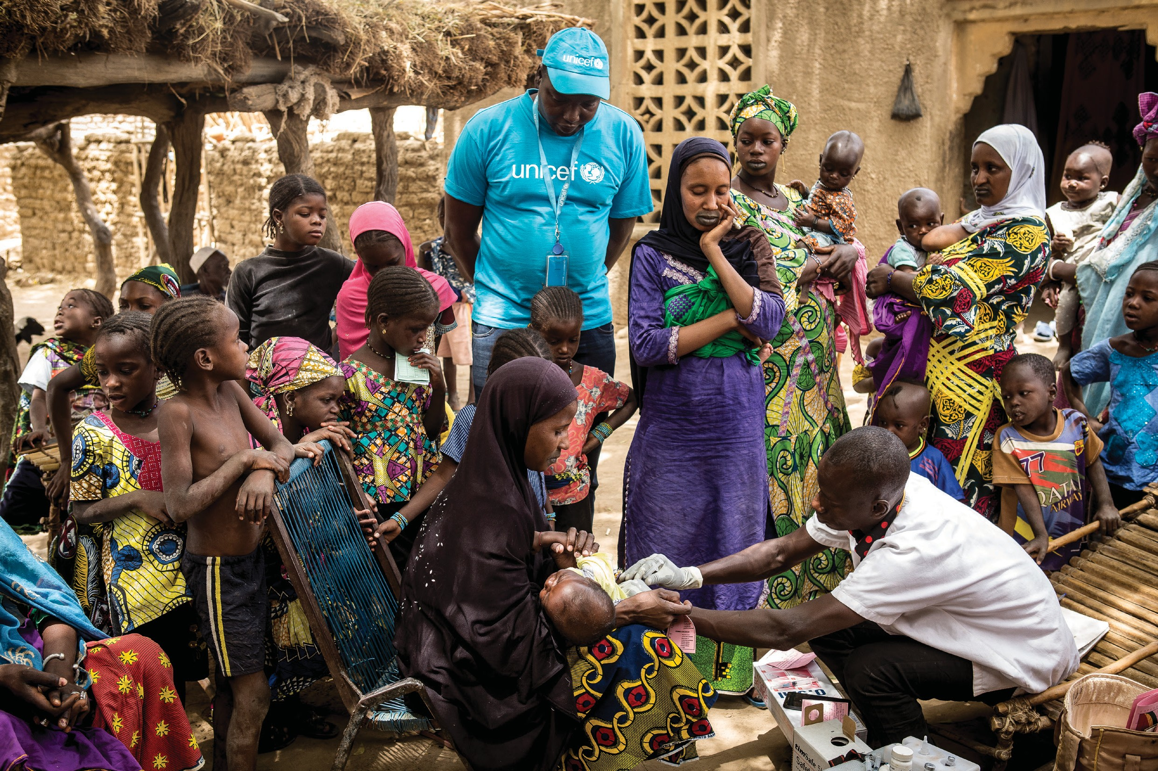Introduction

Supportive Supervision
INTRODUCTION

©UNICEF/Keïta

Introduction

Supervisors are responsible for many aspects of immunization programs, including ensuring a productive, safe, and healthful work environment. Supervisors often plan and monitor activities; implement and enforce systems, policies, and procedures; and assign tasks. Supervisors also conduct training, coach, counsel, mentor, and appraise staff performance. They may perform these roles either in their home worksites, or through dedicated visits to any sites in the outside health system.

Interpersonal communication (IPC) is person-to-person, two-way, verbal and nonverbal interaction that includes the sharing of information and feelings between individuals or in groups. IPC is founded on cooperative dialogue and exchange, and through them, it is used to create and maintain good relationships.

This manual is designed to help supervisors of frontline workers (FLWs) in immunization add to their set of skills and resources to ensure the important contribution of FLW IPC to immunization uptake and completion. For the purposes of this manual, FLWs are outreach workers, vaccinators, and clinical health workers who have direct contact with caregivers or community members on the topic of immunization. The concepts presented here
FLWs use IPC during vaccination,
promotion, community mobilization, advocacy, and other routine immunization
activities.
interaction
Good
provider–caregiver
is
shown
to
improve
immunization uptake and completion.
Supervisors play a key role in ensuring that FLWs consistently use good IPC in these interactions.
will support supervisors in their efforts to address persistent challenges to good IPC as well as other aspects of immunization. The content focuses on IPC in immunization (IPC/I) and using supportive supervision to overcome challenges that can be addressed by creating a more supportive, staff- centred work environment. In particular, the content emphasizes the important “soft” skills that expert supervisors need to manage people successfully and to achieve vital, high-quality service delivery outcomes. The skills, knowledge, attitudes, and ideas presented in this manual are
based on principles of IPC and supportive supervision. The manual will show creative ways to resolve problems through supportive supervision, using approaches such as positive reinforcement and capacity development to support and motivate FLWs, thus leading to improved FLW performance and job satisfaction, as well as higher achievement of program targets.

Supportive supervision can be defined as a process of guiding, monitoring, and coaching workers to promote compliance with standards of practice and to ensure the delivery of quality health services. The supervisory process permits supervisors and supervisees the opportunity to work as a team to meet common goals and objectives.

Key findings from recent research – literature review, observation, and interviews – highlight the role that supportive supervision can or should play in immunization:

- Improving supportive supervision is a critical opportunity to improve FLW capacity to increase immunization uptake.
- Supportive supervision structures should be adaptive and feedback should be immediate.
- Supportive supervision should be integrated into routine supervision.
- Supportive supervision is a critical factor in the recognition of FLWs.

INTRODUCTION
Supportive Supervision 1

Supportive Supervision System

A supportive supervision system should include, at a minimum, the following concepts: a clear understanding of roles and expected contributions, teaching with praise, recognition of positive contributions, guidance on how to handle difficult situations, and an approach that uses a circular feedback loop to provide skills, tools, and solutions to overcome problems.

Good IPC is essential for building community and caregiver trust in immunization and ensuring full adherence to the immunization schedule. Yet, FLWs often cite a lack of management and supervisory support for IPC as a reason they are not able to effectively practice good IPC skills in interactions with caregivers around childhood immunization.

FLWs have cited the following issues as challenges to providing good IPC/I:

  - Not enough time. During routine immunization, FLWs have very little time to spend with each caregiver while vaccinating. A high-volume immunization session can create a lot of stress for all involved.
  - Too much work. Because of chronic understaffing in many health and immunization programs, FLWs can feel like they are being asked to do too much. This can create not only stress, but also resentment. Both may then be projected onto caregivers.
  - Not enough or not the right kind of IPC training. FLWs often lack special skills that can improve their interactions with caregivers and/or they undervalue the importance of IPC. Immunization training typically devotes little time, if any, to IPC, and any training time devoted to IPC often includes insufficient or no practice and feedback on using the skills discussed.
  - Does not seem important, especially if supervisors only ask about logistics, coverage, and proper vaccination technique. If IPC is not assessed during supervision, FLWs are unlikely to consider IPC a critical component of immunization services. In addition, FLWs are often not aware of how using good IPC skills can benefit them personally and professionally.
  - Lack of appropriate support materials. Appropriate materials could help FLWs provide caregivers with the information they want and need in a way that is meaningful to them.
  - Language barriers. FLWs might not speak the language of the community where they work, or they might not know how to relay technical concepts in a way that caregivers can understand or relate to.
  - Insufficient knowledge about vaccines and vaccine-preventable diseases. Some FLWs have not been adequately informed about Expanded Programme on Immunization (EPI) vaccines and the diseases they prevent, and/or the information has not been adequately reviewed, reinforced, and assimilated.

Supportive supervision of IPC/I can make a real difference in FLW–caregiver interactions, and this difference can improve the health of families, communities, and nations – and save lives.

INTRODUCTION
2 Supportive Supervision

Purpose And Intended Use Of This Manual

This manual is designed to help supervisors support FLWs to improve IPC in immunization services. It takes into account common supervision practices, obstacles to supervision, and IPC/I-specific needs and information. Because not all supervisors are familiar with or feel competent to practice supportive supervision, the manual includes supportive supervision information and advice that translates across immunization program components and across health services.

Additional and more detailed information on supportive supervision of immunization programs can be found in Mid-Level Management Course for EPI Managers, Module 16: Supportive Supervision by EPI Managers

This manual is intended for self-study by subnational supervisors of FLWs who interact with caregivers and communities regarding immunization. Regional, district, and facility-based supervisors can all benefit from its content. While many references are made to supervision visits, onsite supervisors should implement the same supportive supervision strategies.

Trainers of supervisors (preservice or in-service) may choose to adapt and integrate Chapter 4: Supportively Supervising IPC/I and other content as appropriate into EPI or integrated health supportive supervision training.

Objectives Of This Manual
The objectives of this manual are to provide supervisors with:

Information about:

- Principles of effective IPC
- Effective communication between FLWs, caregivers, and communities
- Effective communication between supervisors and FLWs
- Effective communication of vaccine safety and how vaccines prevent disease
- Creative ways of implementing supportive supervision of FLWs by supervisors

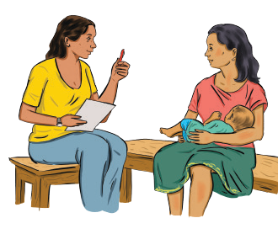Support for developing and reinforcing the following beliefs:

- Caregivers and communities are entitled to respect, empathy, and equitable service
regardless of religion, ethnicity, national origin, gender, education, or socioeconomic status.
- FLWs play a key role in supporting positive community health outcomes.
- FLWs play a key role in ensuring that every child is vaccinated according to the World Health Organization (WHO)-recommended schedule.

continued

INTRODUCTION
Supportive Supervision 3

- Caregivers and communities accept that vaccines are safe and prevent disease (the risks of adverse reactions are extremely rare and much lower than the risks of serious illness and death from the diseases).

Techniques to be able to:

- Effectively support and monitor the IPC/I of FLWs, with emphasis on improving staff motivation and skills
- Treat FLWs with respect and dignity
- Encourage FLWs to ask questions and solve problems
- Plan and conduct regular supportive supervision visits that include adequate attention to IPC/I
- Creatively undertake supportive supervision even in the context of time and resource limitations.

How To Use The Supportive Supervision Manual

Supervisors of FLWs are invited to work through this manual chapter by chapter, pausing as appropriate to implement what they have learned. Supervisors may also choose to focus on specific areas of supportive supervision they wish to adopt or improve.

This Supportive Supervision Manual is one component of an IPC/I package developed to support routine immunization program efforts to improve immunization coverage and maintain high coverage rates.
Since the interaction between the caregiver and service provider can be a key determinant in caregivers’ immunization decisions, IPC/I focuses specifically on helping programs ensure those interactions encourage immunization.

Exercise: Self-Assessment: ‘Where am I now?’
This exercise will help you make a quick record of your current practice of supportive supervision. It is intended to be for your own use, serving as an informal self-assessment tool –like a kind of snapshot, diary, or “selfie”. By answering the questions below based on your own current experience, you may capture a baseline picture of where your practice of supportive supervision is now. Later, in Chapter 4 of this manual, as you develop a detailed IPC/I supportive supervision checklist, you may wish to refer back to your answers here, to see how your perspective has changed in response to new ideas and tools presented in this self-study manual.

- What does supportive supervision mean to you?
- What were the main purposes of your last supervisory visit?
- What are a few things you do to prepare for a supervisory visit?
- List at least five things that you, as a supportive supervisor, observed in your last supervision of an immunization session, including IPC and service delivery practices.
- How did you review your last visit with staff upon completion? (Please give an example.)
- What steps do you take to plan a return visit?

Supportive Supervision
4
INTRODUCTION

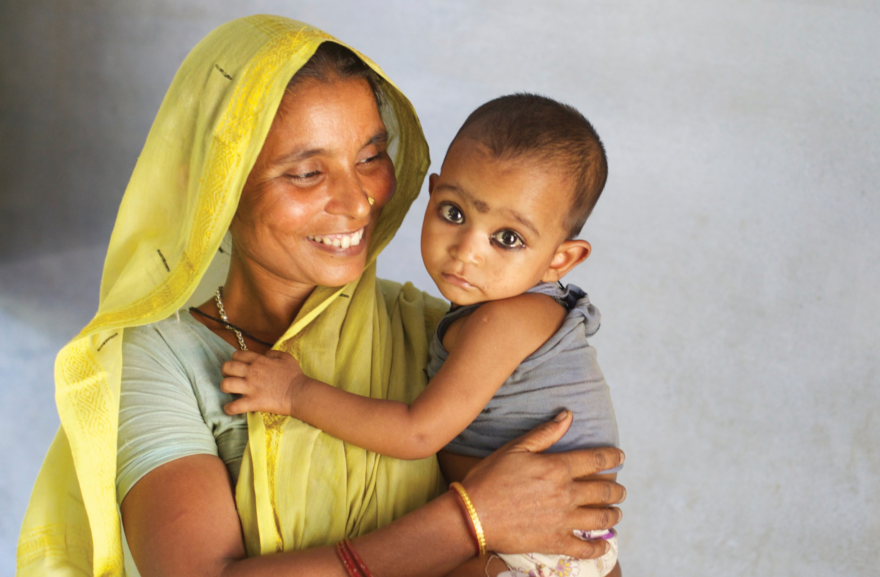Improving

Supportive Supervision 5
CHAPTER 1
The Quality Of Routine Immunization Services

©UNICEF/Pietrasik

Learning Objectives
By the end of this chapter, supervisors should be able to:

- State the value of vaccines for disease prevention
- Define high-quality routine immunization
- List at least three ways they can use supportive supervision to help improve the quality of routine immunization services.

Immunization Program Overview
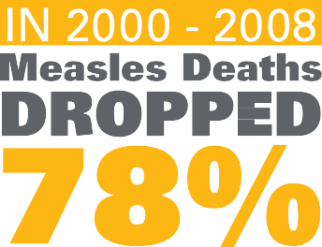An immunization initiative carried out by governments, WHO, and other partners from 1967 to 1977 resulted in the eradication of smallpox. When the program began, the disease still threatened 60% of the world’s population and killed one-fourth of all people infected. Resolved to build on the success of the smallpox eradication program, the 27th World Health Assembly established the EPI in May 1974 to ensure that all children, in all countries, could receive life-saving vaccines.

At its launch, EPI recommended the use of vaccines to protect against
six diseases: tuberculosis (Bacille Calmette–Guérin); diphtheria, tetanus, and pertussis (DTP); measles; and poliomyelitis. Immunization has proven its ability to control infectious diseases. Eradication of polio is now within reach – infections have fallen

According to WHO recommendations, most countries, including the majority of low-income countries, have added hepatitis B and Haemophilus influenzae type b (Hib) to their routine infant immunization schedules, and an increasing number are in the process of adding pneumococcal conjugate and rotavirus vaccines to their schedules. (See Ghana Case Study http:// www.who.int/immunization/diseases/ poliomyelitis/inactivated_polio_vaccine/ case_study_ghana_en.pdf)
by 99% since 1988, and some five million people have been protected from paralysis. Between 2000 and 2008, measles deaths dropped worldwide by over 78%, and some regions are on track to eliminate the disease as a major public health problem. Immunization programs have eliminated maternal and neonatal tetanus in 20 of the 58 high-risk countries.

Recent decades have included the push for universal childhood immunization in the 1980s, the last stages of the polio eradication effort, and intensified efforts in all regions to introduce new vaccines, eliminate measles and rubella, and eliminate maternal and neonatal tetanus.
These efforts have catalysed the availability of other health services to previously unreached children.

Thanks to countries’ progress, immunization is today one of the safest and most cost-effective and powerful means of preventing deaths and improving lives. Immunization programs now routinely reach over 80% of children under one year of age.

Supportive Supervision
6
CHAPTER 1 - IMPROVING THE QUALITY OF ROUTINE IMMUNIZATION SERVICES

Question for Reflection

  - What difference has EPI made in your life and the life of your community? Compare the immunization coverage in your country or region today with what is known about the coverage when you were a child (or during a previous period).
What was the decline in one of the immunization-preventable illnesses over that same period? Do you have any personal experience of that decline?

Providing High-Quality Immunization Services
While your country’s national immunization program may have its own definition of high-quality immunization services, you are invited to consider what you as a parent or caregiver might expect when you have your child immunized. Consider, for example, how you would want to be treated, what information you would want, what concerns you might have, what constraints you might face, and your expectations of the availability and quality of supplies, materials, and equipment. When (day and time) would you like to go for immunization services, and how long should you need to be there?

Now consider what high-quality immunization services might mean for the FLWs charged with motivating and providing immunization information and services to caregivers and communities. What do these FLWs need in order to be able to provide the high-quality services that you have just imagined?
Quality means providing caregivers and their young children with safe, competent, reliable and timely immunization services in a welcoming, informative, affirming manner. It also means avoiding any missed opportunities, such as those resulting from the non-availability of supplies, or the lack of referral of caregivers for appropriate immunizations or combination of immunization services.

Ensuring quality routine immunization services not only benefits caregivers and children, but also can reduce the workload of supervisors because they will have fewer problems to address. Supporting FLWs to improve service quality can help them stay motivated – especially if they are learning new things and being recognized for their achievements.

Roles And Perspectives Of Frontline Workers, Caregivers, And Supervisors

Children’s and their caregivers’ rights
Children and caregivers seeking immunization services have certain rights. Respecting these rights can create a positive perception in the minds of caregivers of the quality of care their children receive.

Children, through their caregivers, have the right to:

- Safe and effective vaccination
- Respect
- Honesty
- Correct and clear information
- Immunization free of unofficial charges
- Choice as to where to have immunization services and/or advice
- Privacy and confidentiality
- Encouragement

Supportive Supervision
7
CHAPTER 1 - IMPROVING THE QUALITY OF ROUTINE IMMUNIZATION SERVICES

FLWs can provide quality services and reach or surpass immunization targets when they are clear about what they are supposed to do and have the motivation, knowledge, skills, resources, and support they need to do their jobs well.

Role of frontline workers in immunization

The role of FLWs in immunization varies by country and by type of FLW. As mentioned above, for the purposes of this manual, immunization FLWs are lay and professional health workers who have direct contact with caregivers or community members on the topic of immunization. This can include vaccine administration; immunization promotion, education, and outreach; social mobilization; advocacy; and other areas. In most health systems, immunization is one of several health issues for which FLWs are responsible.

FLWs need the following to fully implement their role:

- Clear job description
- Fair compensation in the local context
- 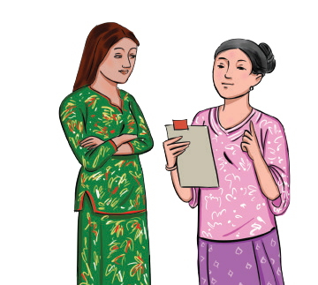Adequate training, information, and job aids, such as key messages, scripts, and other conversation aids that can assist
with delivery of key messages
- Consistent supply of vaccines
- Basic supplies and materials such as cold chain, syringes, sharps disposal box, and tracking and reporting forms
- Physical conditions that allow carrying out tasks as expected
- Acknowledgement and appreciation
- Constructive feedback and mentoring
- Community support – at least moral support, if not also material support

Role of the supportive supervisor

The key roles of a supportive supervisor are to encourage good practices and to identify and address areas for improvement. These include, but are not limited to, assessing the performance of FLWs under their supervision and helping to ensure that they are motivated to provide quality immunization services, including IPC. That is the focus of this manual.

Onsite supervisors do this every day. Regional and district supervisors might do this in person only once per quarter per facility, but they can work behind the scenes and by phone, text message, and email.

A key role of supportive supervisors, in addition to monitoring and assessing immunization services, is to help ensure that FLW work- related needs are met so that they can always provide quality care.

Exercise: List below some aspects you feel need improvement in the immunization program, and how you can improve or help improve them. Refer to this list as you work your way through this manual and even
afterward. Add to it when you see opportunities for improving immunization quality or spot problems that you can help overcome.

Supportive Supervision
8
CHAPTER 1 - IMPROVING THE QUALITY OF ROUTINE IMMUNIZATION SERVICES

Helping Improve the Quality of Routine Immunization
Things to improve | What I can do about them

Qestions for Reflection

  - How does the national immunization program define quality services from a technical point of view?
  - How would you define quality immunization services from a caregiver’s point of view?
  - What does it mean to be an immunization FLW in your context? In particular, what are their roles, motivations, and results?
  - What are some of the steps you are already taking to ensure quality immunization services?
  - What are some of the challenges limiting the ability of FLWs to provide quality immunization services?

- EPI has proven to be a very safe and effective way to prevent disease, saving millions of lives.
Chapter 1 Key Takeaways
- As the word “frontline” implies, FLWs are at the forefront of immunization services and can mean the difference between progress and stagnation or decline.
- High-quality immunization services provide caregivers and their young children with safe, effective, and timely immunization services in a welcoming, informative, affirming manner and require attention to caregiver, community, and FLW needs.
- Supervisors have the power to improve immunization services by supporting FLWs in their work. They can assess performance, provide helpful feedback, organize or facilitate training, and assist with problem solving.

Supplemental Resources
- Supportive Supervision in Immunization (video) https:// www.youtube.com/watch?v=yQuiQN-r7kk
- World Health Organization. (2015). Immunization in practice: A practical guide for health staff. Geneva: WHO.
- https://apps.who.int/iris/bitstream/handle/10665/193412/9789241549097_eng. pdf;jsessionid=64B9721163975B8C705B1C3691A0772A?sequence=1

Supportive Supervision
9
CHAPTER 1 - IMPROVING THE QUALITY OF ROUTINE IMMUNIZATION SERVICES

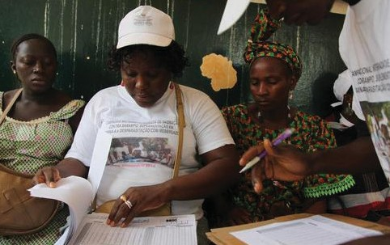

10 Supportive Supervision
CHAPTER 2

Why Supportive
Supervision

©UNICEF/LeMoyne

Learning Objectives

By the end of this chapter, supervisors should be able to:

- Define supportive supervision
- Explain the benefits of supportive supervision
- Identify what they feel are their strengths as a supervisor
- Identify things they might want to change about their supervisory style

Assessing Your Supervision Style

Supervision can be defined as the process of directing and supporting people so that they can do their work effectively. How supervision takes place directly impacts how FLWs do their work and how well they do it. Before attempting to change or improve your supervision style, it helps to identify it. Complete the Supportive Supervision Self-Assessment below to help you make this identification.

Supportive Supervision Self-Assessment

Use this checklist to better understand your supervision style. It is not a test. It is a tool to help you reflect on your way of supervising. Carefully read each statement and respond honestly. Completing this self-assessment can help you identify areas you need to strengthen.

Instructions: Place a tick mark in the appropriate column next to each of the statements below, according to how often you hold the attitude or perform the behaviour. Then add the total score for each column.

Statement | Frequently | Sometimes | Never
Job Expectations
1. I discuss work expectations with each FLW I supervise.
2. I discuss the FLW job description with the FLWs I supervise
3. I ensure that FLWs have current immunization program information and standards.
Performance Feedback | Frequently | Sometimes | Never
4. I provide FLWs with constructive feedback on their performance, focus on solutions to problems, and offer help.
5. I believe in helping improve rather than criticizing.
6. I work with the FLWs to ensure that they have ways to receive feedback from caregivers and the community.

Supportive Supervision
11
CHAPTER 2: WHY SUPPORTIVE SUPERVISION

Statement | Frequently | Sometimes | Never
7. I practice active listening and other good communication skills when supervising and providing feedback.
Motivation
8. I ask FLWs what encourages them, and I use this information to motivate them.
9. I listen to specific challenges they face and promptly support them to resolve these, if possible.
10. I recognize good FLW performance by telling the FLW personally.
11. I treat FLWs with respect, and I encourage FLWs to treat others respectfully.
Tools and Information
12.I make sure the FLWs I supervise have the necessary materials, equipment, supplies, tools, and information to provide quality immunization services.
13. I make sure that the necessary materials are being used or distributed as intended.
Knowledge and Skills
14. I help the FLWs I supervise to assess their skill level and learning needs.
15. I provide FLWs with the information they need to do their jobs well.
16. I provide on-the-job training to FLWs when appropriate.
17. I provide information on FLW training needs to the appropriate district, regional, and/or national management structure, that has training decision- making authority, and to the onsite manager if I am a district or regional supervisor.
18. I provide opportunities for FLWs to practice their skills and get feedback from me or others in a position to provide it.

Supportive Supervision
12
CHAPTER 2: WHY SUPPORTIVE SUPERVISION

Statement | Frequently | Sometimes | Never
Organizational Support
19. I see myself as part of the immunization team.
20. I visit all the FLWs I supervise at least once every three months.
21. My primary objective is to improve the quality of services.
22. I create a relationship based on trust and openness so that the FLWs feel free to discuss any problems with me.
23. I encourage and help FLWs to identify their own solutions to the problems they face.
24. I have a plan for my supervision activities.
25. I use a supervision checklist that encourages me to give feedback and work with the FLWs to analyse problems and plan solutions.
Total

The statements in this self-assessment represent a variety of behaviours, attitudes, and tasks involved in supervising FLWs. Every “sometime” or “never” that you marked a tick next to represents an opportunity to improve the way you supervise FLWs. It does not mean you are a bad supervisor, and you might never be able to tick “frequently” for every statement due to the limited resources and support you receive from the immunization program and from your own supervisors. A goal of this manual is to help enable you to honestly tick “frequently” on more of the statements and to increase the frequency with which you exhibit the supportive supervision attitudes and behaviours that the statements indicate. The totals in each column can help you track your overall progress over time. Ideally, the column 1 total will grow, while the column 2 and 3 totals diminish.
Questions for Reflection
  - What did you learn about yourself?
  - How can your behaviour affect an FLW’s performance?
  - Which statements surprised you? Why?
  - What would you most like to improve?

What Is Supportive Supervision
Supportive supervision can be defined as a process of guiding, monitoring, and coaching workers to promote compliance with standards of practice, ensure the delivery of quality health services (as defined in Chapter 1), and support the professional development of those supervised.

Supportive Supervision
13
CHAPTER 2: WHY SUPPORTIVE SUPERVISION

In the context of the immunization program, supportive supervision involves helping FLWs provide high-quality immunization services by ensuring that they have the information, training, supplies, constructive feedback, positive reinforcement, and advice/guidance they need and appreciate. Specific to IPC/I, it means paying attention to and supporting FLWs’ ability to practice good IPC/I in every interaction with a caregiver or community member so that effective IPC becomes the norm in immunization services. The skills and attitudes developed to improve routine immunization services apply to other health services as well.
Supportive supervision can look different in every case, but some basic elements include:

- Visiting FLWs regularly to learn their needs
- Observing and listening attentively
- Providing coaching and on-the-job training
- Helping FLWs identify and resolve problems
- Highlighting what FLWs do well

While supportive supervision focuses primarily on FLWs and health facilities, it is important to also pay attention to the needs of caregivers and communities since all of these groups play important roles in improving immunization coverage.

Purpose Of A Supportive Supervision Visit
Supportive supervision visits are meant to help FLWs perform better, even if they are already performing well. To this end, supervision visits should focus on improving the quality of immunization services FLW provide, including IPC/I, and on improving the quality of information FLWs feed back to the program.

Supportive supervision visits should encourage FLWs. Visits can sometimes feel intimidating to FLWs, so it is important to conduct the visits in a way that feels comfortable and supportive, to show that someone cares about and is paying attention to FLWs and what they do. Supportive supervision visits allow the supervisor to interact with community members, even if the supervisor interacts with only one or two caregivers during a particular supervision visit. Supportive supervision visits help the supervisor learn about any needs the FLW has in relation to immunization work.

Before, during, and after the supervision visit

To best support FLWs and health services, plan regular supervision visits for times when you can observe the FLW at work in the health facility (preferably performing routine immunization tasks, including group discussion and vaccination) and in the community (home visit, mobile services, community meeting). Since it will not always be possible to observe all of these functions in a single visit, try to schedule visits where, over the course of a year, for example, you have observed each at least once or twice.

If for any reason a supportive supervision is cancelled, inform those to be visited as soon as possible, as a courtesy and to allow them to adjust their plans if needed. This can go a long way towards improving FLW-supervisor relationships.

Traditional Vs. Supportive Supervision
The table below highlights differences between traditional and supportive supervision, illustrating the major limitation of traditional supervision: that it tends to focus on inspection and finding fault rather than on problem solving or providing positive motivation.

Supportive Supervision
14
CHAPTER 2: WHY SUPPORTIVE SUPERVISION

Comparison of Traditional and Supportive Supervision
Action | Traditional supervision Supportive supervision
Who performs supervision | External supervisors designated by the service delivery organization | External supervisors designated by the service delivery organisation, staff from other facilities, colleagues from the same facility (internal supervision), facility or community health committees, peer supervisors, staff themselves through self- assessment
When supervision happens | During periodic visits by external supervisors | Continuously: during routine work, team meetings, visits by external supervisors
What happens during supervision encounters | Inspection of facility, review of records and supplies, supervisor makes most of the decisions, reactive problem solving by supervisor, little feedback or discussion of supervisor observations | Observation of performance and comparison to standards,  acknowledgement of what is going well, provision of constructive feedback on performance, discussion with clients, provision of technical updates or guidelines, on-the-job training, use of data and client input to identify opportunities for improvement, joint problem solving, follow-up on previously identified problems
What happens after supervision encounters | No or irregular follow-up | Actions and decisions recorded, ongoing monitoring of weak areas and improvements, follow-up on prior visits and problems
Adapted from Marquez, L., & Kean, L. (2002). Making supervision supportive and sustainable: New approaches to old problems. MAQ Paper No. 4. Washington, DC: USAID.
Exercise: Thinking about your experience of being supervised or acting as a supervisor, please reflect on the ideal supportive supervision behaviours and traits, instances of how they were put into practice, and what effects these practices had on FLWs:

  - Add a few items to this list of behaviours and traits that demonstrate supportive supervision.
  - Note how were these behaviours and traits practiced in the field using specific instances based on your experience or imagination.
  - Finally, assess the effect of these behaviours on the FLWs supervised using specific instances based on your experience or imagination.

Supportive Supervision
15
CHAPTER 2: WHY SUPPORTIVE SUPERVISION

Supportive Supervision Behaviors/Traits
Behaviors | How Practiced (use examples) | Effect on FLWs (use examples)
- Listening
- Empowering FLWs by engaging them in planning,
organizing, and reporting on their work
- Helping FLWs identify and solve problems
- Providing constructive feedback
- Helping make sure FLWs have what they needed to
be effective
- Finding ways to motivate FLWs
•
•
•
Traits
- Helpful
- Encouraging
- Respectful
- Knowledgeable
- Reliable
- A good role model
•
•
•

Benefits Of Supportive Supervision
Being a supportive supervisor benefits you, the FLWs you supervise, caregivers and their children, and communities as a whole.

The potential benefits of supportive supervision include:

- FLW and facility performance will improve.
- Health services will run more smoothly.
- Users of services should enjoy more pleasant and satisfactory experiences, increasing the likelihood of continued use of services.
- Caregivers will “waste” less time when seeking services.
- Caregivers and communities, if visited for feedback during supervision visits, will feel they have input into the services.
(Continued on next page)

Supportive Supervision
16
CHAPTER 2: WHY SUPPORTIVE SUPERVISION

  - More children will be better protected as services, uptake, and immunization completion rates improve.
  - Your work might be less stressful and more professionally satisfying.
  - You might gain personal satisfaction from seeing the performance of FLWs improve.
  - You might gain professional satisfaction from seeing the performance of FLWs improve.
  - Your job will be easier as FLWs improve immunization services, make fewer mistakes, and show more initiative.
  - You will feel proud knowing that supporting FLWs helps save children’s lives.
  - There might be reduced tension between you and the FLWs you supervise.
  - You and the FLWs might experience a feeling of collective effort and teamwork.

List other ways being a supportive supervisor might benefit you, the FLWs you supervise, caregivers and their children and communities as whole:
•
•
•

Characteristics Of A Successful Supportive Supervisor

A successful supportive supervisor:

Is committed to the organization’s mission and goals
- Demonstrates leadership qualities
  - Inspires others
  - Communicates the vision of what the organization can and should accomplish
  - Communicates the strategic approaches to achieve that vision
  - Establishes trust and promotes teamwork
  - Mobilizes financial and human resources
  - Has an advocacy plan
- Has good communication skills, especially active listening and constructive feedback
- Respects caregivers, community members, FLWs, and colleagues
- Shows empathy
- Empowers others and provides opportunities for growth
- Works well in teams
- Understands the nature of routine immunization work
- Has immunization and maternal and child health technical knowledge and experience
- Is flexible
- Is open to new ideas
- Trains and conveys information to others effectively
- Expects and manages change
- Focuses on improving services
- Recognizes the influence of the external environment
- Serves as a liaison with the larger system

Supportive Supervision
17
CHAPTER 2: WHY SUPPORTIVE SUPERVISION

The Five W’s Of Interpersonal Communication For Immunization For Supportive Supervision

WHO can provide it
- Trainers and supervisors of FLWs who have completed training in both IPC/I and supportive supervision
- FLW peers, for mutual support
In addition, FLWs can periodically assess themselves to track their own progress and initiate an improvement process that a formal supervisor can then support.

WHY conduct it (objectives)
- Motivate and support FLWs to build their knowledge, skills, and confidence
- Facilitate improved quality of IPC in immunization services
- Work towards high performance of all FLWs over time
- Contribute to strengthened health/immunization programs and systems: improved quality of services, implementation of outreach activities, and coverage and completion rates

WHEN to conduct it
- Within a few weeks after FLW IPC/I training (to help reinforce learning)
- Regularly scheduled (at least twice per year per FLW if external supervisor)
- During refresher training
- On a day when immunization services (including group discussion on immunization, if feasible) are being provided
- On a day when outreach and/or mobile immunization services can be observed
- When the FLWs to be supervised will be available (not on leave, in meetings, in training, or picking up supplies)

Supportive Supervision
18
CHAPTER 2: WHY SUPPORTIVE SUPERVISION

WHERE to conduct it
- At health facilities (immunization sessions, group discussions)
- In communities (mobile and outreach immunization sessions, home visits, community meetings)

WHAT to look for when conducting it
Competencies in the following skills (discussed further in Chapter 3):
- Shows concern/care for the child and caregiver
- Demonstrates empathy and respect
- Listens actively
- Communicates key information that caregivers need to obtain scheduled vaccination services for their children
- Uses support materials, including the health card, to caregivers’ benefi
- Responds to caregiver questions with correct information
- Verifies caregivers’ understanding of messages and responses
- Solicits caregiver and community feedback and takes feedback into consideration to improve quality of care
Knowledge and profi in the following areas:
- Vaccines available through EPI
- Vaccine-preventable diseases
- Correct decisions on what vaccinations a particular child should receive at the time of a contact
- Locally common rumors and misinformation (and how to address them)
Chapter 3 begins the discussion of how to supportively supervise immunization FLWs

Supportive Supervision
19
CHAPTER 2: WHY SUPPORTIVE SUPERVISION

Chapter 2 Key Takeaways

- Supportive supervisors assess and continually improve their supervision techniques.

- Supportive supervision in immunization is guiding, monitoring, and coaching FLWs to provide quality immunization services.

- Supportive supervision benefits caregivers, communities, FLWs, and supervisors by improving services and relationships, reducing stress, and increasing job satisfaction.

- Supportive supervision uses constructive feedback, joint problem solving, and real-time coaching to improve the quality of services provided by FLWs.

- Supportive supervision requires active listening, attentive observation, effective communication, and consistency.

- Supportive supervision of IPC means paying attention to and supporting FLWs’ ability to practice good IPC in every interaction with a caregiver or community member.

Additional Resources

- Good vs. Bad Supervisor (video) https://www.youtube.com/watch?v=Hf8mjMU5aJk (good example of supportive supervision in the last four minutes)

- Good and Bad Supervision in Social Work (video) https://www.youtube.com/ watch?v=S9iDB_9njMw (brief, showing good and bad supervision)

Supportive Supervision
20
CHAPTER 2: WHY SUPPORTIVE SUPERVISION

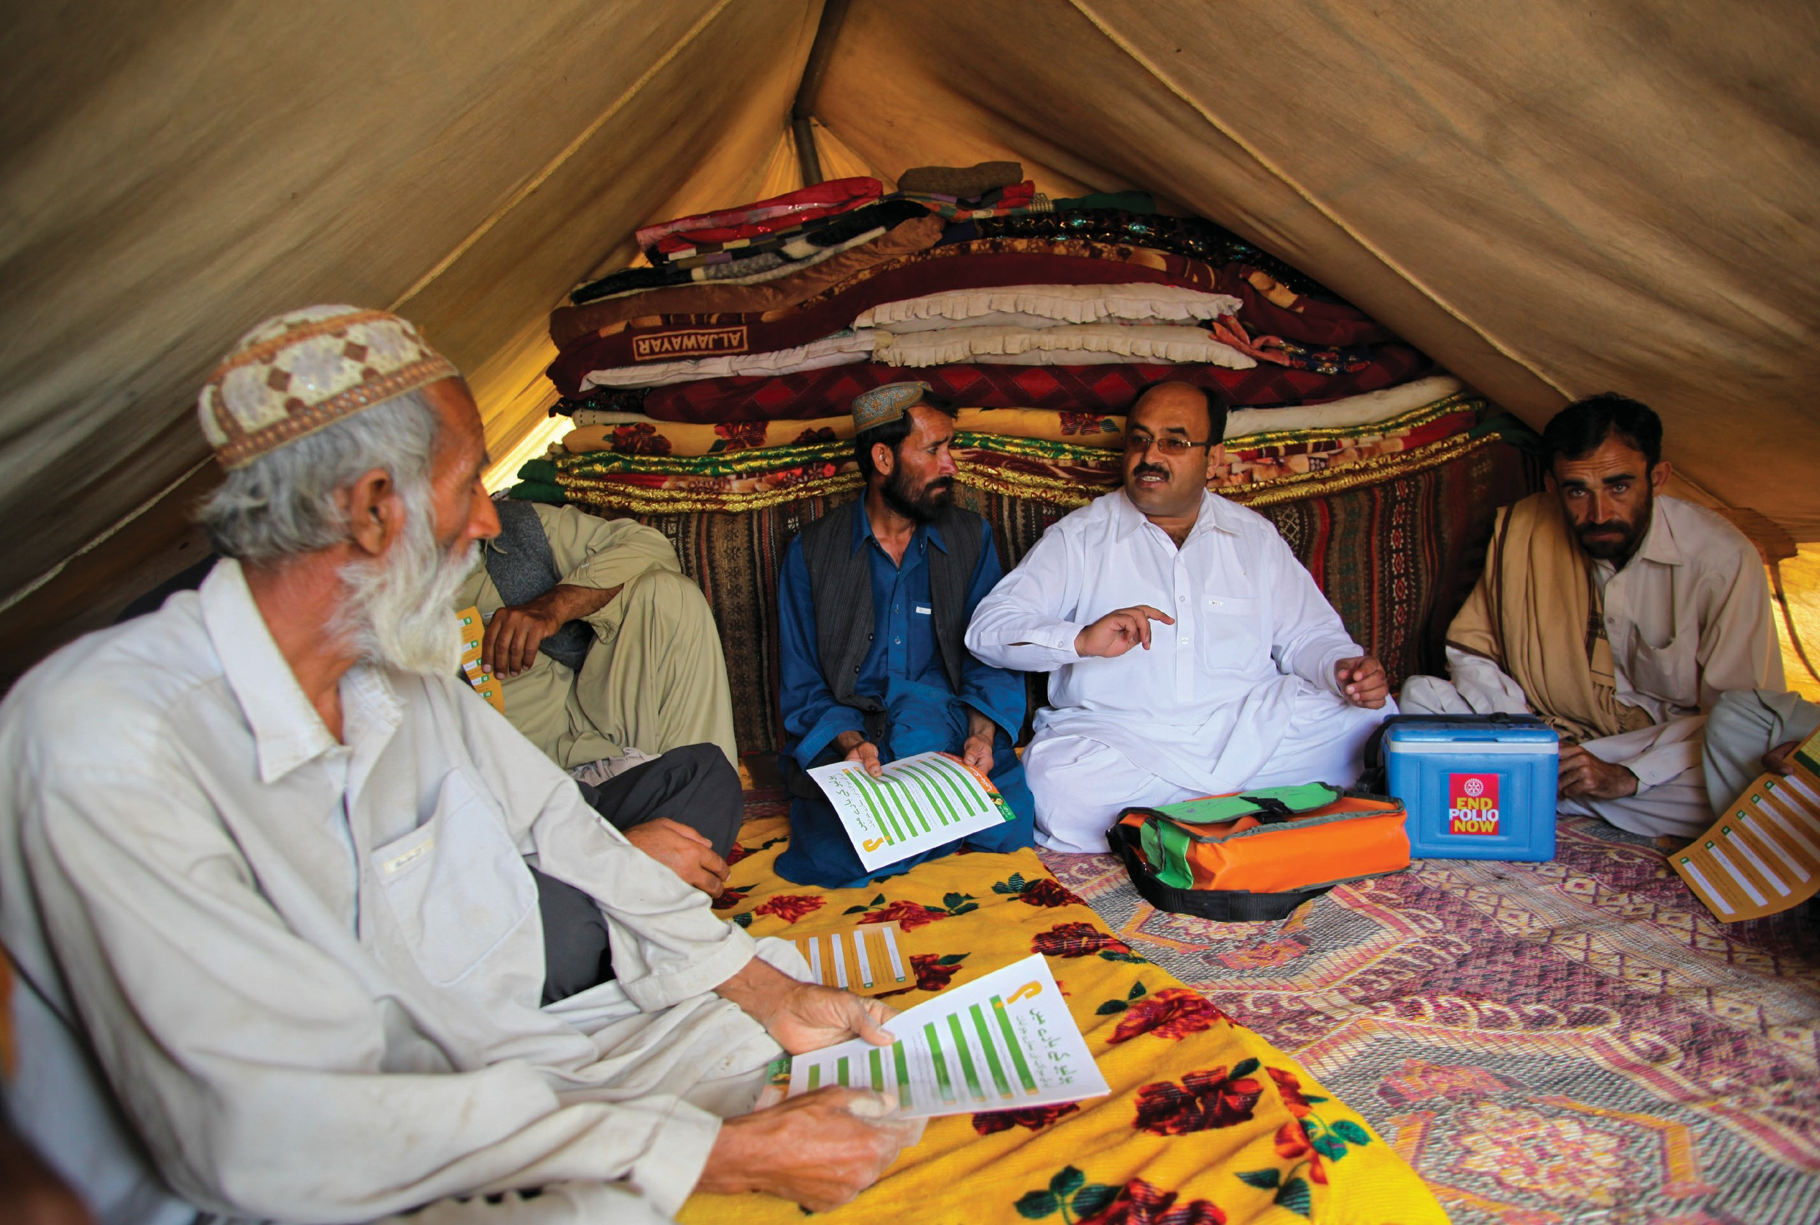Communication

Supportive Supervision 21
CHAPTER 3
Skills In Supportive Supervision

©UNICEF/Zaidi

Learning Objectives
By the end of this chapter, supervisors should be able to:

  - Explain the importance of using effective communication skills during supervision
  - Describe active listening techniques and the importance of using them in supervision
  - Describe the importance of body language in IPC
  - Define constructive feedback
  - Describe the steps in constructive feedback

Interpersonal Communication Skills For Supportive Supervision
IPC includes skills that are used every day at work, at home, and with families and friends. FLWs use IPC/I every time they interact with a caregiver, community member, or each other. Supervisors use IPC every time they interact with the FLWs they supervise, other staff, and caregivers and community members they meet during supervision visits. To be supportive, supervisors have to use effective IPC skills. Those skills are similar to the IPC skills used in effective FLW–caregiver interactions. The essential benefit of good IPC, both in supportive supervision and FLW–caregiver interactions, is that it creates trust and establishes a spirit of cooperation.

Supportive supervisors use these basic IPC techniques:
  - Active listening
  - Body language
  - Open-ended questions
  - Clarification

Active Listening
Active listening is listening to another person in a way that communicates understanding, empathy, and interest. Active listening is different from just hearing. When done well, it makes the speaker feel important, acknowledged, and empowered. It encourages the speaker to communicate openly. Supportive supervisors want FLWs to feel free to discuss any issue or problem so they can work together to find solutions.

Active listening requires effort, skill, and commitment – and is much easier to do in an environment that is not stressful. One way to listen actively is to restate, or paraphrase, what the person said, using different words. This shows that you are paying attention and understanding.

  - Example of paraphrasing
    - Statement: We really did not expect that adding one new vaccine would create all of the problems that it did.
    - Paraphrase: So, adding a new vaccine to the schedule was more difficult than you thought it would be.

  - Guidelines for paraphrasing
    - Listen to the speaker’s basic message.
    - Give the speaker a simple summary of what you believe is the message. Do not add any new ideas.

Supportive Supervision
22
CHAPTER 3: COMMUNICATION SKILLS IN SUPPORTIVE SUPERVISION

    - Look for a sign or response that confirms or rejects the correctness of your restatement.
    - Do not paraphrase negative statements that people make about themselves in a way that confirms this perception. If someone says, ‘I really acted foolishly in this situation,’ it is not good to say, ‘So, you feel foolish.’ Instead say, ‘You feel you made a mistake.’
    - Paraphrase once in a while, not often. You want to encourage the person to continue speaking, and constant interruption to restate what they are saying might discourage them. Try to paraphrase only when the speaker hesitates or stops speaking.

Exercise: Paraphrase these imagined comments from FLWs in a way that shows you have understood or want them to say more.

FLW Statement | Supportive Supervisor Paraphrase
I do not have time to be nice to every caregiver.
We never have all the supplies we need to conduct our outreach sessions.
We know we are supposed to open a vial even if there is only one child who needs it, but how can we do that when we never know when we will get more vaccine?
Reflecting back is similar to paraphrasing but places more emphasis on the feeling and idea and letting the speaker know they were heard.

    - Example of reflecting back

      - Statement: Are you calling again for a meeting to discuss cold chain? How many times can we discuss the same issues?
      - Reflecting back: It sounds like you would like to vary what we discuss in our meetings.

Verbal and nonverbal encouragement is using words, phrases, and gestures to show that you are paying attention and want the person to keep talking. Verbal and nonverbal encouragement is another way to make someone feel comfortable expressing their opinions, asking questions, and sharing their experiences.

Some examples of verbal encouragement include:

      - “I see.”
      - “I understand.”
      - “I get you.”
      - “That is clear.”

Some examples of nonverbal encouragement include:

      - Nodding your head
      - Smiling when the speaker smiles

Supportive Supervision
23
CHAPTER 3: COMMUNICATION SKILLS IN SUPPORTIVE SUPERVISION

Dos and Do Nots of Active Listening

Do | Do not
Concentrate on what the speaker is saying. | Do other things (for example, look through papers) when the speaker is talking.  Daydream or get distracted by surrounding events.
Allow the speaker to express himself or herself. | Interrupt the speaker.  Finish the speaker’s sentences.
Allow the speaker to control the conversation. | Ask questions that change the subject.
Respect the speaker’s opinion | Contradict, criticize, or judge.
Pay attention not only to the words, but also to gestures and behavior. | Anticipate what the speaker is going to say next.  Ignore the emotional contex
Prevent emotions from getting in the way of active listening no matter what the speaker is saying. | Become angry, defensive, or upset
Adapted from: Harper, A., & Harper, B. 1996. Team barriers: Action for overcoming the blocks to empowerment involvement and high performance. New York: MW Corporation.

Body Language
Body language is expressed through the face, posture of the body, the position of the arms, legs, and eyes, as well as gestures, space, and seating. The way we use our bodies, often without thinking, says a great deal about how we are feeling and what we are thinking. In fact, what we call “body language” usually says more than our words or our tone of voice as a way to communicate. Most of what people “hear” from us has to do with much more than our words!

Three Parts of Interaction between People

When you communicate, three things are important. Body language has the most impact on how the other person interprets what is being said. Words tend to have the least impact.

  - Body language – most
  - Tone of voice – some
  - Actual words – very little

Because your body communicates what you believe and think, changing what you are thinking can be important for making positive body language authentic. If you believe you are superior to the FLWs you supervise, consider focusing your mind instead on the value they bring to the immunization

Supportive Supervision
24
CHAPTER 3: COMMUNICATION SKILLS IN SUPPORTIVE SUPERVISION

program or anything else you appreciate about them.
Body language that might be encouraging:
    - Looking the FLW in the eye
    - Sitting at the same level as the FLW
    - Leaning towards the FLW
    - Sitting next to the FLW
    - Sitting close enough to the FLW

Examples of body language mean different things in different cultures. In many Western cultures, looking people in the eye and leaning towards them with an open posture (arms and legs uncrossed) indicates attention to what they are saying, but in other cultures such actions are considered impolite.

Also, body language might have a different meaning depending on whether one is in a group setting or communicating one on one and whether one is communicating with an elder or a person of another gender

      - Matching the FLW’s facial expressions (such as frowning when FLW frowns Exercise: Indicate whether the body language listed in the table below would be considered positive, negative, or neutral in your culture if you were speaking to an FLW.
Behavior | How is this behaviour perceived in your culture (positive, negative, or neutral)? | For any behaviour perceived as negative, what would be the opposite positive behaviour in your culture?
Making eye contact
Avoiding eye contact
Prolonged eye contact
Standing with hands on hips
Looking down while speaking to someone older
Smiling

Open-ended Questions

Open-ended questions are the questions that cannot be answered with one word (such as “yes,” “no,” or a number). If you phrase your questions in a way that invites FLWs to explain a situation in more detail, you will have a better understanding of the issue and be able to help them better. Usually, open-ended questions start with such words as “how,” “why,” and “what.” In addition, the FLW can be encouraged to explain through stories and examples.

Supportive Supervision
25
CHAPTER 3: COMMUNICATION SKILLS IN SUPPORTIVE SUPERVISION

Examples of open-ended questions

  - · What questions do you have?
  - · What problems have you noticed with answering caregivers’ questions?
  - · Why do you think FLW morale is low?
  - · How do you conduct your home visits?
  - · What do you think of the amount of time clients must wait to be helped?

Clarification involves asking questions in order to better understand what the speaker said Some guidelines on clarification:
- Admit that you do not understand exactly what the person is telling you.
- Restate the message as you understand it, asking if your interpretation is correct. Use phrases such as ‘Do you mean that…?’ or ‘Are you saying that…?’
- Do not overuse clarification. People might resent being interrupted if it happens too often.

Questions for Reflection
  - How do you think a supportive supervisor communicates? What communication styles or techniques do they use?
  - Why is it important for someone using supportive supervision to communicate effectively?
  - Think of an example of when your supervisor’s body language contradicted their words. Which did you believe – their words or their body language? How did it make you feel? How did it affect your perception of that person?

Giving Constructive Feedback
A key role of supervisors is to assess staff performance and the quality of the services provided. As part of assessment, they should discuss the findings with the staff. This is called feedback. There are at least four types of feedback.

Types of Feedback

Negative — critical without providing actionable steps for improvement
Positive — supportive of current actions Punitive — focused on assigning blame Constructive — focused on solving a problem

Supportive Supervision
26
CHAPTER 3: COMMUNICATION SKILLS IN SUPPORTIVE SUPERVISION

Negative and punitive feedback are ineffective if your goal is to improve performance and to help solve problems. They can:

    - Result in the employee making excuses for their performance rather than identifying challenges and solutions
    - Cause hurt feelings, depression, or anger leading to a contentious work environment
    - Decrease confidence and self-esteem making the employee less willing to take initiative or request support
    - Cause the employee to avoid the supervisor and/or work

Supportive supervisors keep in mind that the people they supervise are the front line of immunization services and must always be treated with respect, just as caregivers should be treated with respect. Therefore, supportive supervisors always try to provide feedback that is positive and constructive and ensures two-way communication.

Constructive feedback is the best way to improve FLW performance and help solve problems. This type of feedback:

    - Focuses on the issue, not the person
    - Is based on observation
    - Is thoughtful and honest
    - Clarifies problems and their various causes
    - Encourages the person receiving the feedback
    - Promotes joint problem solving
    - Improves relationships

The Steps in Constructive Feedback

Step 1. Choose an appropriate time.
Generally, supervisors should give immediate feedback, but this is not always appropriate (e.g., in front of a caregiver or when the FLW is extremely agitated and not likely to be receptive). Choose a private moment as soon as you think the person is ready to listen. Avoid times when the person is busy, tired, or upset. Do not give feedback in public, or the FLW might feel overly defensive or humiliated. Avoid waiting too long, or the impact will be weakened. Providing feedback may include, in a supportive and private way, the FLW and their day-to-day supervisor. Positive and negative feedback can address causes and priorities and make and record commitments to action. Some of those commitments may belong to the supervisor as well as the FLW.

Step 2. Convey your positive intent.
Conveying intent requires some preparation.

    - Begin with a neutral statement about what you want to talk about (e.g., ‘I have some thoughts about ...’ ‘Let’s take a look at ...,’ or ‘I would like to discuss ...’).
    - Point to a common goal. This helps the person understand the importance of the feedback and encourages team spirit. Use “we” when stating the problem, to highlight your common goal.

Supportive Supervision
27
CHAPTER 3: COMMUNICATION SKILLS IN SUPPORTIVE SUPERVISION

For example, ‘Mr Kumar, we need to ensure that caregivers trust us with the health of their children, and I am afraid that we cannot do that unless we treat them with care and respect.’ Or, ‘Mrs Seye, it is important to use our immunization support materials so that we can ensure caregivers understand our messages about the vaccines their children are getting.’

Step 3. Describe specifically what you have observed.
- Focus on the behaviour or action, not on the person.
- Avoid “you” statements. Instead of saying ‘You did a poor job of explaining side effects to those parents,’ say ‘The explanation about potential side effect and what to do about them was incomplete.’
- Avoid labelling. Instead of saying ‘You are careless and never ask caregivers for their questions,’ say ‘It is important to ask if caregivers have any questions, so we can ensure they understand the information.’
- Be specific, brief, and to the point. For example, ‘the average client waiting time is now one and a half hours, which is an increase of 30 minutes.’
- As much as possible, limit feedback to one to three behaviours or actions. Covering many topics at once will usually lead to a defensive response from the person.
- Remain calm and unemotional.

Step 4. State the impact of the behaviour or action.
Link the undesired behaviour or action to caregiver satisfaction or program goals. For example, ‘if we do not ask caregivers for questions, they might miss important information and might not understand the importance of returning for the next doses.’

Step 5. Ask the FLW to respond.
- Invite a response: ‘What do you think?’ ‘What is your view of this situation?’ ‘How do you see things?’
- Listen attentively (paraphrase, reflect back, and use verbal and nonverbal encouragement), use appropriate body language, and clarify.

Step 6. Focus the discussion on solutions (the constructive part of constructive feedback) and offer your help.
- Examples of solutions include clarifying expectations, giving advice, providing training or coaching (see Chapter 5, ‘Coaching and Mentoring’), developing new approaches to the problem, changing behaviour, and improving coordination.
- Choose solutions that are practical for you and the FLW to implement.
- If possible, explore solutions jointly. Try to avoid imposing the solution but suggest one or more solutions if the FLW cannot.

Occasionally, the FLWs you supervise will not respond to constructive feedback. Being a supportive supervisor does not mean that you never have the option of reprimanding FLWs who refuse to cooperate or are intentionally negligent in the performance of their work. Reprimanding might be an appropriate action for addressing an FLW who is unwilling to make the effort to improve.

Supportive Supervision
28
CHAPTER 3: COMMUNICATION SKILLS IN SUPPORTIVE SUPERVISION

Exercise:
  - Remember a time when you provided feedback to one of your supervisees and they did not respond in a way that met your expectation.

  - Think of other approaches you might use to help improve the outcome if a similar situation were to happen in the future.improve the outcome if a similar situation were to happen in the future.

- Consistent use of effective IPC skills creates trust, establishes a spirit of cooperation, and is essential to supportive supervision.

Chapter 3 Key Takeaways
- Active listening means using verbal and nonverbal cues, paraphrasing, and reflecting back what you hear in order to confirm your understanding of what was said and encourage the speaker to talk.
- Body language tends to carry more weight than words or tone of voice, so it is a critical part of communication and worth paying attention to in your interactions with FLWs, caregivers, and communities.
- Providing constructive feedback – feedback that builds up instead of tearing down – is the best way to improve FLW performance and help solve problems.
- To provide constructive feedback, choose an appropriate time, convey positive intent, describe what you have observed, state the impact of the behaviour or action, and focus the discussion on solutions.

Supportive Supervision
29
CHAPTER 3: COMMUNICATION SKILLS IN SUPPORTIVE SUPERVISION

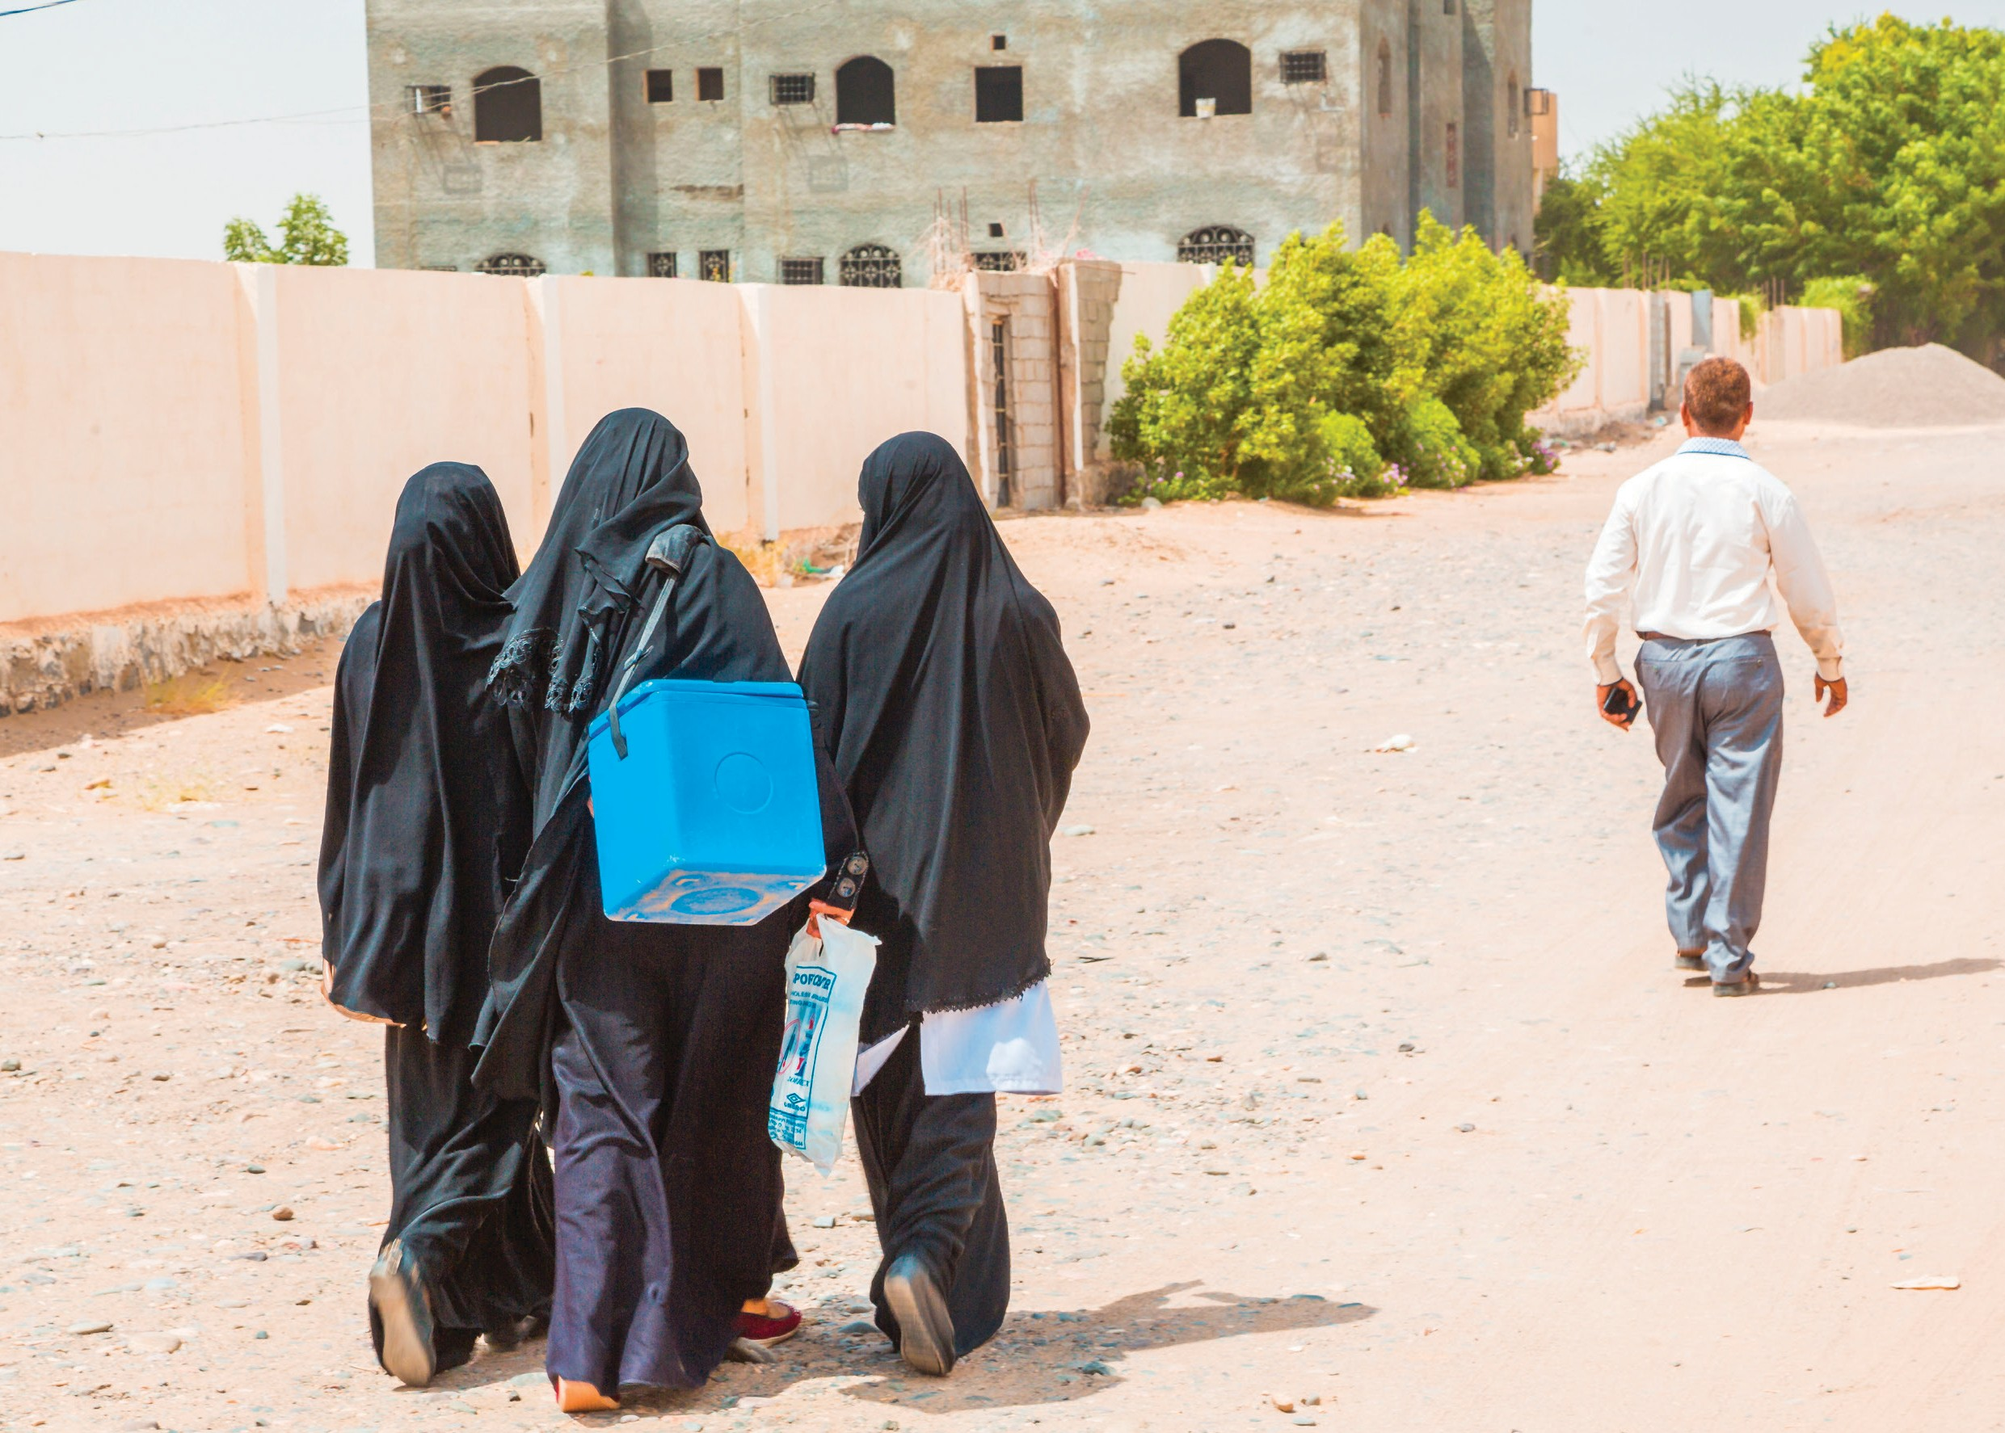

30 Supportive Supervision
CHAPTER 4

Supportively
Supervising Ipc/I

©UNICEF/Alhariri

Learning Objectives
By the end of this chapter, supervisors should be able to:

- Define IPC
- Describe why focusing on IPC/I during supervision is important
- List five things supportive supervisors must do on supervision visits
- Use IPC checklists to observe and give FLWs feedback on their IPC/I

The Importance Of IPC
As noted in the introduction to this manual, IPC is a person-to-person, two-way verbal and nonverbal interaction that includes the sharing of

Key characteristics of effective IPC/I
- Showing respect
- Showing empathy
- Listening actively
- Using language and words the caregiver easily understands
- Using body language that reinforces the words and conveys caring
information and feelings between individuals or in groups. IPC is founded on shared dialogue and exchange, through which, it seeks to develop and maintain good relationships.

Supervisors can play a key role in determining whether FLW IPC/I is good, fair, or poor. When carrying out routine immunization duties such as immunization sessions, group discussions, and community outreach, good IPC/I can help caregivers and communities recognize the value of immunization and decide to fully immunize their children. Mediocre
or poor IPC/I can leave caregivers and communities feeling disrespected, uninformed, confused, and resistant to immunization.

Here are some of the ways FLWs use good IPC/I in their work:

- Understanding the caregiver’s situation by asking questions and listening
- Learning about the caregiver’s obstacles to immunization and the context in which they occur
- Motivating, assisting (teach skills, counsel), encouraging, and providing information
- Promoting, encouraging, and reinforcing behaviour change (e.g., completing the childhood immunization schedule) at all levels – personal/family, community/societal, and institutional

Here are some ways supportive supervisors use good IPC in their work:

- Learning about the routine immunization successes and challenges of the FLW
- Exploring problems and identifying solutions
- Providing positive and constructive feedback to FLWs
- Coaching and training FLWs to improve their performance
- Recognizing FLWs for their positive contributions to routine immunization

Evaluation: Supportive supervisors should evaluate each FLW’s IPC using three basic methods:

- Observe the FLW-caregiver interaction (which may provide an example of the FLW’s best IPC and a caregiver’s response, but may not indicate how consistently IPC is practiced)
- Ask the FLW questions in the supervision checklist (trying to use a conversational, open- ended approach to explore further issues raised by these questions)
- Engage with caregivers, using both exit interviews (to assess what key information caregivers

Supportive Supervision
31
CHAPTER 4: SUPPORTIVELY SUPERVISING IPC/I

capture, such as return date, side effects, etc.) and group discussions in communities (which can reveal caregivers’ feelings and perceptions of their interactions with FLWs)

Good IPC/I benefits the people receiving immunization services, particularly pregnant women and the caregivers of children who need to be vaccinated. It can help relieve their concerns about vaccine safety, make them feel important, help them understand key practical information such as when the next dose(s) is due, and reassure them that they are being a good parent/caregiver by adhering to the immunization schedule.

LESS STRESS

BUILDS RELATIONSHIPS
IMPROVING QUALITY OF LIFE
&
JOB SATISFACTION
MORE TRUST

Good IPC/I also benefits communities. It can help communities understand that the overall health of their community will improve if all children are fully immunized. It can also increase trust in and use of health services, which is important both for achieving high immunization coverage routinely and for minimizing the effects of rumours, an incident (e.g., adverse event following immunization), or a safety concern that people are talking about.

Finally, good IPC/I benefits FLWs and supervisors. It can reduce stress, increase trust and confidence, and build relationships, thereby improving overall quality of life and job satisfaction.
Exercise: Write down additional ways IPC/I benefits you, FLWs, caregivers, and communities.

Supportive Supervision Of Community-Based Flws
FLWs, whether paid or volunteers, have special supervision needs. Their formal FLW training may last only a few weeks or months, varying by country and context. To ensure their credibility in the community and build trust, it is therefore especially important to ensure that their basic technical understanding of immunization and immunization services is sound. FLWs often work alone and must reach out to families, some of whom might not want their help and might perceive them as not being real health workers. This isolation, stress, and low level of skills can result in high levels of burnout, absenteeism, and attrition.3 Thus, FLWs can benefit greatly from supportive supervision, whether it boosts FLW and community confidence in FLW immunization knowledge during the supervisor’s visit, or whether it comes in the form of other psychosocial support, for example, through a weekly supportive supervision check-in call.

Because supervisors are unlikely to have served as FLWs, occasionally spending a day with FLWs can provide key insights and help supervisors provide more effective support. To get the most benefit from such opportunities, the supervisor can become the trainee for that day and work as an FLW instead of acting as and introducing themself as a supervisor. They can truthfully be introduced as someone who is learning about being an FLW, for example.

Supportive Supervision
32
CHAPTER 4: SUPPORTIVELY SUPERVISING IPC/I

Other supportive supervision visits should take place much like supervision of facility-based staff, but with even more attention and planning to ensure the right time and enough time and resources (including transportation to and within the community) to visit communities, observe home visits, and meet with community leaders. Early mornings are often the best time for such visits, but supervisors should verify timing with the FLWs they supervise. Meetings with community leaders and members should solicit community feedback on FLW performance and the overall value of the FLW program, community recommendations for improvement, and ways communities can support their FLWs. Where communities have a functional community health structure, such as a village health committee, supervisors should plan to attend at least one of their meetings per year. FLWs might also be more likely than facility-based staff to need replenishment of supplies and materials.

In addition to (or sometimes in place of) regular visits to FLWs in their communities, some programs bring FLWs together (at the health facility or other central location) for monthly supportive supervision, report submission, and replenishment of supplies.

Specific to IPC/I, FLWs might feel inadequately informed about vaccines and immunization. This can lead to feelings of shame for not being able to respond to caregiver and community member questions or a tendency to provide incorrect information (rather than saying ‘I do not know but will find out for you’) in order to save face. Supportive supervisors are well-placed to gauge and help build individual FLWs’ capacity to respond to more than basic questions.

For more advice, see the appendix C: ‘Six Tips for FLW Supportive Supervision Success’.
Questions for Reflection
  - If you supervise FLWs, how can you ensure their needs are met so that
they can consistently practice good IPC/I and feel successful?
  - What can and should you do to build FLW capacity to respond appropriately to questions about vaccines and immunization?

Daily Supportive Supervision Of IPC/I (Facility- Based Staff)
For onsite supervisors, every work day presents opportunities to support good IPC/I by facility-based FLWs. Some supportive supervisors begin or end each week with a brief meeting to review, for example, plans, expectations, results, and challenges. Such meetings can include discussions of FLW insights on getting caregivers to fully vaccinate on time, recent challenging interactions with caregivers or community members, new or persistent caregiver barriers to immunization and how to help solve them, review of newly arrived immunization support materials, and other topics related to IPC/I.

Supportive onsite supervisors can demonstrate their interest in staff by stopping by to observe an immunization session or by telling an FLW what a great job they are doing. If an FLW is having

trouble handling difficult questions, a supervisor can practice with them, offering advice and resources as needed. Supervisors can coach FLWs through such trial sessions or conduct occasional caregiver interactions themselves to model good practices. If an FLW seems too stressed to provide good IPC, a peer or supervisor can relieve them for the amount of time necessary to allow them to refocus.

Onsite supervisors should occasionally sit in on group discussions on immunization and accompany FLWs on outreach visits (mobile services, home visits, community mobilization), getting and giving

Supportive Supervision
33
CHAPTER 4: SUPPORTIVELY SUPERVISING IPC/I

Caregiver, client, and community feedback |  | Do supervisors need multi-topic discussion guides to get input and feedback from those for whom services are developed?
Do separate meetings need to be held to engage
different types of community stakeholders?

feedback on them to support and encourage the FLW as well as to improve IPC during such services. Onsite supervisors can use or adapt supportive supervision checklists developed for supervision visits or develop their own.

While much of the day-to-day supportive supervision will be informal, onsite supervisors should document FLW progress and issues over time, even if there is not a formal performance review process in place at or for the facility. This can inform staff development plans, provide justification for awards or recognition, and provide learning to share during monthly, quarterly, and annual reviews and in planning meetings.

IPC/I Supportive Supervision In The Context Of Integrated Supervision
As the integration of health services advances, supervisors and supervision teams will need to
adjust how they staff for, plan, implement, and follow up supportive supervision. Several aspects of supervision merit consideration/rethinking.
Team building
What kind of team building among FLWs and among supervisors does service integration require?
What role do supervisors and managers play, and how is overlap handled?

Degree of Integration
Do FLWs in integrated services handle multiple health issues or specialize in one or two?
Are all services provided daily?
If not, which are available when?
How do the answers to such questions impact the timing, scope, and duration of supervision visits?
How do they impact the content of supervision training and the composition of the supervision team (are subject matter experts needed, and if so, for which disciplines)?
How do they impact costs and logistics?
How do they impact the job descriptions that should
be a basis for supportive supervision, and what is the supervisor’s role in revising job descriptions?
How do they impact on-the- job training, coaching, and mentoring of FLWs?

Supervision checklists
Are multiple checklists needed for all or some FLWs?
Which, if any, supervision checklists can and should be integrated?

Variation in IPC content that FLWs need to communicate
While IPC skills are fairly universal, FLWs will need to offer different information depending on the type of service and client (e.g., a caregiver of a child to be immunized vs. a couple seeking fertility assistance).

Supportive Supervision
Performance improvement and service quality

Supervisors might notice that FLWs intensify their efforts in the areas supervisors purposely or inadvertently emphasize and decrease their efforts in areas that are overlooked. How can supervisors ensure overall performance and service quality improvement? Also, a potential benefit of integration and integrated supervision should be more crossover services and more effective referrals. Supervisors can promote this by training and encouraging FLWs to provide or refer for needed services based on their review of the health card (e.g., immunizing children who are due for vaccinations even if they are present for another reason and providing breastfeeding support to mothers who bring an infant for immunization and complain of poor feeding).
34
CHAPTER 4: SUPPORTIVELY SUPERVISING IPC/I

Question for Reflection

    - What has or will integrated supervision mean for you and the FLWs you supervise?

Supervision Visits And Assessing IPC/I
Here is a detailed checklist of what supportive supervision of IPC/I should entail. Use this checklist as you prepare for your visit, look at it during the visit as needed to ensure you are doing everything you planned, review it at the end of visit, and return to it as needed after the visit and while planning the next visit. Appendix D contains a Sample EPI Supportive Supervision Checklist that includes IPC/I.
Exercise: If you are an onsite supervisor, review the IPC/I supervision checklist below. Then adapt it to use monthly with immunization FLWs.

Sample IPC/I Supportive Supervision Checklist

FLWs to be visited: Expected Date of Visit:

Activity | Progress | Comments
Part 1. Before the visit
1. Schedule a time for your visit with the FLWs in advance.
2. Ensure all of the logistics required (notifications up and down the hierarchy, transportation, fuel, per diem, anticipating scheduling conflicts, etc.) to reduce the chances of cancellation.
3. Review the FLWs’ records and activities conducted since your last supervision visit.
4. Set visit objectives and tell the FLWs what you want to achieve during the visit.
5. If appropriate, gather and transport supplies and materials that the FLWs need (registers, health cards, support materials, etc.)
6. Provide those to be visited with an expected time of arrival. Text updates as needed.
Part 2. Once on site
1. Follow up on action items and recommendations from the previous supervision visit.
2. Ask how the FLWs feel about their work: What is going well? Are they experiencing any difficulties? Praise what is going well.

Supportive Supervision
35
CHAPTER 4: SUPPORTIVELY SUPERVISING IPC/I

Activity | Progress | Comments
3. Observe immunization IPC activities (caregiver-
FLW interactions during immunization, health talk on immunization, home visits, or other outreach). For each encounter, ask the FLW to introduce you to the
caregiver(s) and explain briefly why you are there. Then ask permission from the caregiver(s) to observe. Explain that you will record no names and that all personal information will remain confidential.
4. Sit so that you can observe the FLW and caregiver, but not distract either.
5. As the FLW talks with the caregiver, make notes on the Observation Checklist so that you can provide feedback to the FLW once the session has ended and the caregiver has left. (You will not have to complete
the checklist or submit it to anyone; rather, it is for your guidance in observing and mentoring the FLW.)
Note: In any one immunization session, there will not be an opportunity for the FLW to use all of the skills in the checklist; therefore, make brief notes to help you remember the skills that were used, and just as importantly, those that were not used when there was an appropriate opportunity.
If you are observing more than one FLW, make additional copies of this checklist.
Part 3. Basic IPC/I Skills Observation
FLW Facility/Site
Supervisor Date

Below are key elements supervisors should observe to assess an FLW’s strengths in communicating effectively and appropriately with caregivers during an immunization encounter. Use this checklist when observing FLWs during supportive supervision visits, especially when the focus of the supervision visit is IPC/I.

Insert a tick mark indicating whether the FLW exhibited the skill sufficiently or not. Use the Comments/Notes column for examples, specific kudos or concerns, and anything else you as the supervisor will find helpful when you review the completed checklist with the FLW.

IPC/I Skill | Sufficiently | Insufficiently | Comments/Notes
Showed concern/care for the child and caregiver
Demonstrated empathy and respect
Listened actively (nonverbal, reflecting back, open-ended questions, gestures, and short responses)

Supportive Supervision
36
CHAPTER 4: SUPPORTIVELY SUPERVISING IPC/I

IPC/I Skill Sufficiently Insufficiently Comments/Notes
Communicated the key immunization messages
- Vaccines given to the child that day
- Possible side effects and how to manage them
- When to return for next doses
- Importance of bringing health card
- · (Other key messages depending on the context)
If a group discussion or general session with caregiver,
communicated about the following:
- Benefits of immunization such as protects children from vaccine preventable diseases
- Importance of completing immunization in first year of life for best protection
- Safety and effectiveness of immnization, and free availability at government health facilities
- Where and when available
Used support materials, including the health card, to the caregiver’s benefit (including providing or referring for other needed services)
Responded to caregiver/community questions with correct information
Verified the caregiver’s/community’s understanding

Activity Progress
Part 4. End of immunization session, group discussion, or community/home visit
- If an FLW gives wrong information or fails to correct misinformation provided by a caregiver, find a way to present the correct information to the caregiver without offending FLW and without making the FLW lose credibility in their role in the community.
- Seek feedback from caregivers who attend the immunization session or a group discussion and from community members.
- After you have observed the FLW and most (if not all) caregivers have left with their children, discuss your observations with the FLW, acknowledge what the FLW is doing well, and what might be strengthened, using positive references to the FLW’s own work, experience, or training.

Supportive Supervision
37
CHAPTER 4: SUPPORTIVELY SUPERVISING IPC/I

4. Ask each FLW to self-assess their IPC/I (and other Routine Immunization aspects as appropriate). If FLWs have completed IPC/I self-assessment checklists since the last supervision visit, ask if they would like to share and discuss them (privately or as a group).
5. Assist with problem solving as needed.
6. Provide immediate on-the-job training, if appropriate, demonstrating and having the FLWs practice skills needing improvement.
7. With each FLW, decide on at least one change – a ‘small, do-able action’ – that the FLW can improve before the next supervision visit. Work with them to develop an achievable individual and team performance improvement plan, putting the shared plan into writing for all parties. Note agreed follow-up actions in an FLW supervision notebook.
8. Gather monitoring data. A supervision visit may be an opportunity for the supportive supervisor to talk with caregivers about their experiences around immunization, and to periodically collect data from a small number of caregivers to help track progress towards results.
9. End the visit by going over any action items with both the FLWs and their onsit manager/supervisor
10. Remind FLWs and onsite manger/supervisor of the timing of next supervision visit.
Part 5. After the supervision visit
1. Follow up as needed and agreed.
2. Plan and schedule new or refresher training as needed.
3. Share nonconfidential findings with other supervisors/managers during monthly/ quarterly review meetings and consult the health facility manager on issues needing resolution. (Note: Results collected systematically over time from multiple facilities will enable the supervisory team to assess overall progress against goals and to identify any sites or practices in need of strengthening and corrective action.)
4. Support problem solving as needed.
5. Follow up by phone, text, and email as appropriate. This conveys interest and can encourage FLWs to stay on track with their performance improvement plans.

Supportive Supervision
38
CHAPTER 4: SUPPORTIVELY SUPERVISING IPC/I

Questions for Reflection

- How can you ensure that IPC/I becomes an important component of every supervision visit?
- Why are planning and follow-up so important to supportive supervision of immunization?

Exercise: Write down practical ways you can improve your planning, conduct, and follow-up of supervision visits.

•

•

•

Assessing Facility-Based Immunization Discussions (Health Talks)
FLWs should continually assess the immunization discussions they and their coworkers facilitate (usually with caregivers in the waiting room) and use the results to improve their practice. FLWs can assess their discussions by seeking feedback from a sample of caregivers themselves, trying to keep their inquiry friendly and objective – perhaps by involving an FLW coworker or a friend of the caregiver in the assessment. They may ask such questions such as ‘How important was the information we just talked about?’ ‘How much of it did you already know before the talk?’ ‘What other questions or topics would you like to cover in these talks?’ ‘Do you have any other suggestions for making these talks more useful for you?’ FLWs should share their findings with the supervisor during supervision visits, especially if they recognize they need help improving the discussions.

When feasible during supportive supervision visits, supervisors also should assess an immunization (or other health topic) discussion. Reasons to assess health/immunization discussions include:

  - To know if FLWs leading the discussions are achieving appropriate objectives
  - To help identify ways to make the discussions more relevant
  - To help identify ways to make the discussions more interesting for participants
  - To help identify ways to better schedule the discussions if, for example, caregivers find themselves waiting for a discussion to begin when they would rather be having their child immunized
  - To assess their effectiveness in stimulating positive interest in immunization Here are 10 indicators to consider for assessing immunization talks:
- Purpose and objectives clear and appropriate
- Purpose and objectives achieved
- Participants’ prior knowledge assessed
- Highly interactive discussion
- Immunization promoted and benefits discussed
- Participants’ barriers to immunization discussed
- Appropriate duration
- FLW asked for and responded appropriately to questions
- Participants’ understanding assessed
- Key points summarized

Supportive Supervision
39
CHAPTER 4: SUPPORTIVELY SUPERVISING IPC/I

Supervisors can add such indicators to supervision checklists or use this list more informally, noting feedback on the supervision checklist in the “comments” or “other” section. Assessment does not have to be formal or complicated. Any positive and constructive feedback you give can be useful.

Exercise: Adapt the IPC/I Supportive Supervision Checklist and/or EPI Supportive Supervision Checklist for your next supervision visit. After the visit, make further adaptations based on the experience. Also, to assess your progress in using this manual, please compare the answers that you gave in the Introductory Chapter of this manual with your newly adapted checklist.

Chapter 4 Key Takeaways

- IPC – a person-to-person, two-way verbal and nonverbal interaction that includes the sharing of information and feelings between individuals or in groups – is about creating and building/maintaining a good relationship.

- Because good IPC is essential for high immunization coverage, supervisors must regularly assess IPC/I and support FLWs in consistently practicing good IPC.

- To be most effective, supportive supervisors should plan supervision visits in advance, conduct them regularly, and follow up with check-ins and agreed-upon actions.

- During supportive supervision, supervisors should follow up on previous action items, observe caregiver-FLW interactions, seek feedback from caregivers
and community members, provide constructive feedback and training, assist with problem solving, and document progress and issues over time.

- A supervision checklist that includes IPC/I indicators will help supportive supervisors improve this important aspect of routine immunization services.

Additional Resources

- Crigler, L., Gergen, J., & Perry, H. (2014). Supervision of community health workers. In Developing and strengthening community health worker programs at scale: A reference guide and case studies for program managers and policymakers. Maternal and Child Health Integrated Program, Jhpiego.
- https://www.mchip.net/sites/default/files/mchipfiles/CHW_ReferenceGuide_sm.pdf

- MHP Salud, http://www.mhpsalud.org (search “Supervision”)

Supportive Supervision
40
CHAPTER 4: SUPPORTIVELY SUPERVISING IPC/I

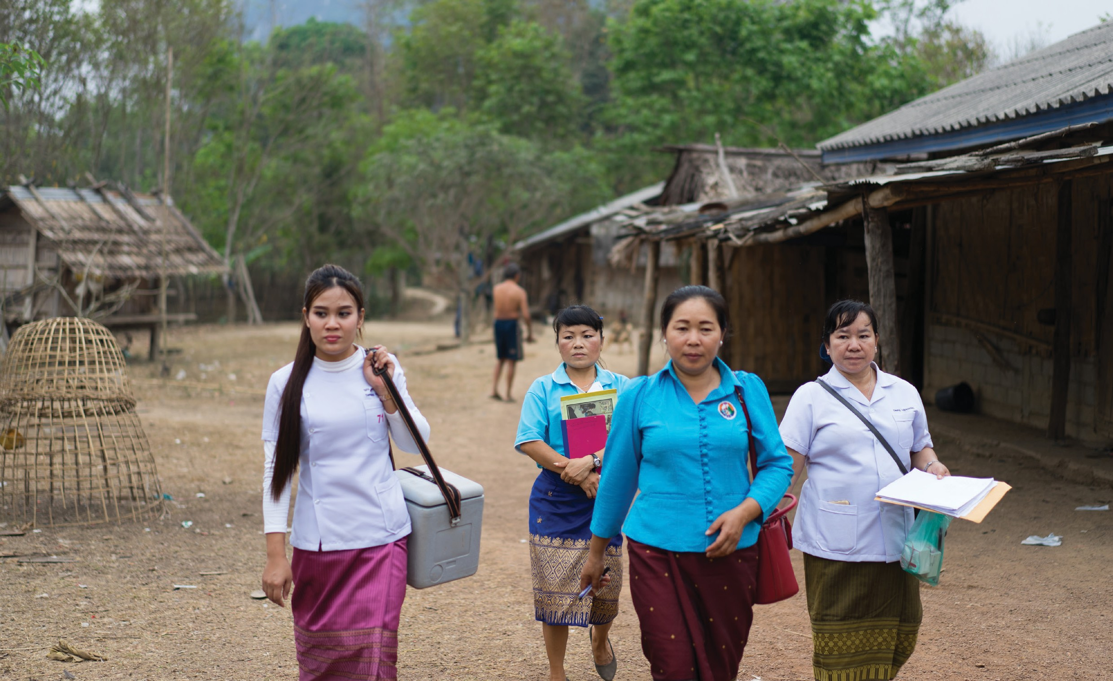COACHING

Supportive Supervision 41
CHAPTER 5
AND MENTORING

©UNICEF/Nazer

Learning Objectives
By the end of this chapter, supervisors should be able to:

  - Define coaching
  - Describe characteristics of coaching
  - List the steps involved in coaching
  - Describe the benefits of peer-to-peer mentoring

What Is Coaching

Coaching is a training approach that seeks to achieve continuous improvement in performance through motivation, modelling, practice, constructive feedback, and the gradual transfer of skills and complementary attitudes. Coaching is a key task of supportive supervision and allows FLWs to learn on the job and immediately apply what they are learning and see how well it works.

Characteristics of Coaching

Coaching should be:

  - Balanced: Give-and-take, two-way communication; mutual questioning; sharing of ideas and information
  - Concrete: Focused on objective aspects of performance, on what can be improved or learned in terms of new skills. Performance can be improved only when it can be described precisely, so that both the coach and those being coached understand what is being discussed. The skills should be described as behaviours, so they can be observed and verified.
  - Respectful: Based on behaviours that convey that the other person is a valued and fully accepted counterpart

Advantages of Coaching
A supervisor might notice a performance problem and say: ‘Here is what you did wrong, and here is what you should do next time.’ Often, the FLW does not know how to do the task correctly and needs more guidance. A supportive supervisor is different. They not only help FLWs to identify problems, but also actively help them to solve those problems. The best way to achieve this goal is by coaching FLWs during routine supervision activities.
This coaching:

  - Allows FLWs to learn on the job
  - Allows FLWs to immediately apply what they are learning and see how well it works
  - Fosters a positive working relationship with FLWs, who previously may have considered the supervisor a critic
  - Makes FLWs feel supported and valued

Supportive Supervision
42
CHAPTER 5: COACHING AND MENTORING

Coaching Steps

Step 1
Motivation

Motivation (ensuring the person to be coached is committed to acquiring the new behaviour). Seek the FLW’s agreement for the need to develop the skill, attitude, or knowledge you want to teach through coaching. How will the FLW, caregivers, facility, or others benefit from what the FLW learns?

Step 2
Modeling

Modelling. Demonstrate the attitude or skill. If appropriate, explain each step as you demonstrate, or ask the FLW being coached to explain what they see you doing. Allow and even encourage the FLW to ask questions as you proceed. These might be questions about what you are doing or why you are doing it. This will support the learning process.

Step 3
Practice

Practice. Give the FLW being coached the opportunity to demonstrate their ability to perform the new skill or to demonstrate the new attitude or knowledge. They might first practice with the coach and then with others (e.g., coworkers or caregivers), while you as the coach observe.

Step 4
Constructive Feedback

Constructive feedback. Share your evaluation of the FLW being coached in a concrete, respectful, two-way interchange of observations and ideas.

Step 5
Skill Building
Skill building. Set goals with the FLW, then continue to build skills gradually, as you allow the FLW being coached the opportunity to undertake and demonstrate an increasing number of the specific skills involved in the new behaviour, after which they become competent to carry out the new skill without supervision.

Supportive Supervision
43
CHAPTER 5: COACHING AND MENTORING

Coaching involves the following steps:

What Is Mentoring
Mentoring can overlap with coaching. Mentoring means giving help, advice, and support over an extended period of time. To serve as a mentor, supervisors must have solid technical knowledge for duties they perform and must know how and where to gain access to additional support, when needed. They must get to know and understand the FLWs whom they are mentoring. Mentoring in many contexts can also involve helping FLWs define and follow a career path that maximizes their contributions and job satisfaction.

Mentoring involves the following steps:

  - Getting to know one another: The mentor and mentee develop a relationship.
  - Establishing goals for the mentoring relationship: What does the mentee want to achieve?
  - Establishing a plan to reach the goals: What are the steps, resources, and timeline needed to reach the goal?
  - Regular meetings to share knowledge, develop skills, and review progress: This includes teaching, coaching, encouraging, assessing progress, and re-planning.

Supportive supervisors can build mentoring into their regular supportive supervision duties or work with one or more FLWs in a mentoring relationship focused on the FLWs’ career development or the implementation of a specific immunization quality improvement project, for example.

Peer-To-Peer Support And Mentoring
FLWs need not depend solely on supervisors for support and mentoring. This is especially important when the supervisor and supervisees do not work in the same facility or the ratio of FLWs to supervisors is high.

Fellow FLWs, or peers, often have complementary strengths. One FLW may have mastered communicating with caregivers about vaccine-preventable diseases, while another might be exceptionally good at encouraging caregivers to complete the immunization schedule on time. Peers can also share their successes and challenges in responding to difficult questions and situations. This encourages joint problem solving and promotes wider understanding of best practices and correct information.

Supervisors should encourage formal or informal peer-to-peer support and mentoring. To do so, take one or more of the following steps:

- Help ensure FLW colleagues are aware of their own and each other’s strengths.
- Explicitly recommend and suggest ways peer FLWs can support one another. This can also help foster a collaborative work environment.
- Match peer mentors with appropriate mentees based on skills, experience, interest, compatibility, and other relevant factors.
- Set aside time during the work week for mentoring activities.
- Allow mentors and mentees to report on their mentoring experiences during monthly

Supportive Supervision
44
CHAPTER 5: COACHING AND MENTORING

review meetings.
Exercise: Ask FLWs or supervisors acting as FLWs to form pairs and to practice peer-to-peer mentoring skills with their partners.

  - Each member should identify a few of their partner’s strengths.
  - Each member should list specific ways they can offer support to the other.
  - The partners should identify times during the normal work cycle that would be most suitable to work together supportively.
  - Peer partners should share their own peer-to-peer mentoring experience with the larger group

- Coaching – a key component of supportive supervision – is a training approach that seeks to achieve continuous improvement in performance through motivation, modelling, practice, constructive feedback, and the gradual transfer of skills and attitudes.

Chapter 5 Key Takeaways

- Coaching should be balanced, concrete, and respectful.

- Mentoring overlaps with coaching and in some contexts emphasizes clinical skills or assisting the mentee with career development.

- Supervisors can facilitate peer-to-peer mentoring to take advantage of FLWs’ complementary strengths, motivate FLWs, and improve the quality of immunization services.

Supplemental Resources

- Center for Health Leadership & Practice (CHLP). (2003). Mentoring guide: A guide for mentors. Oakland, CA: The Public Health Institute.

Supportive Supervision
45
CHAPTER 5: COACHING AND MENTORING

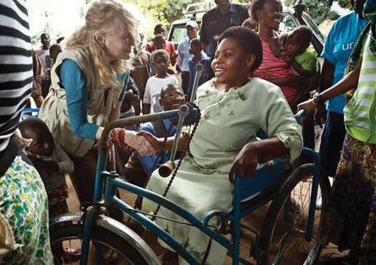

46 Supportive Supervision
CHAPTER 6

ENHANCING
MOTIVATION

©UNICEF/Asselin

Learning Objectives
By the end of this chapter, supervisors should be able to:

- Define motivation
- Describe internal and external motivation
- List at least three signs of low motivation and performance
- List or describe at least four ways to increase FLW motivation
- Describe how to create and support a community recognition system

What Is Motivation
Motivation can be defined as the general willingness or desire to do something. FLW motivation generally involves the reasons the person became an FLW and the reasons they continue to function as one. Motivation to carry out effective IPC is often enhanced by an appreciation of the importance of good IPC for immunization results, attention to IPC in job descriptions and from supervisors, and positive feedback from interactions with caregivers that they appreciate good IPC.

When FLWs feel unmotivated while providing services and unhappy with their work climate, poor- quality services and poor performance are the results. While such low motivation may affect the FLWs’ work environment, it is the caregivers and their children who suffer the greatest impact. Caregivers are highly invested in their children’s well-being, and they may reject immunization services if faced with provider tardiness, indifference, low-quality care, or other signs of low FLW motivation. If caregivers reject services, immunization coverage declines and children ultimately suffer the greatest risk.

Internal Motivation

Internal motivation comes from within an FLW. It can stem from how they perceive the importance of their work, how well they feel they can perform their tasks, and any expectation they have for professional gratification. It can be influenced by the feeling that a supervisor cares about them as a person and by opportunities for growth, advancement, recognition, and responsibility.

Think back for a moment to your own first service-related job experiences. What were some of your internal motivators? Were they related to the satisfaction of helping people, solving problems, innovating and creating a new approach, making a contribution, surpassing established standards and goals, or learning and working with a dynamic group of people? Most health workers have many of the same internal motivators, but different motivators inspire each individual health worker to a greater or lesser extent. Do you know what motivates each member of your team? Health workers tend to be strongly guided by a desire to help people. To be effective, they need to be able to work to professional standards. Once you get to know the FLWs you supervise and what motivates each of them, you can create a work climate that offers opportunities that will motivate them and encourage

Supportive Supervision
47
CHAPTER 6: ENHANCING MOTIVATION

excellent performance.

External Motivation

External motivation involves using incentives that come with or are added to a job – for example, pay, benefits, office space, safety, and training opportunities. A dangerous worksite or pay at survival level demotivates many employees. External motivation can also include supportive supervisors and others giving FLWs positive feedback and recognition.

Indicators Of Low Motivation And Performance
FLWs may show specific signs of low motivation or performance, such as:

  - Absenteeism and tardiness (delay beyond the expected or proper time)
  - Decreased productivity
  - Disengagement and inflexibility of work habits
  - Dissatisfaction among clients
  - Failure of a work group to meet specific performance targets
  - Frequent or unresolved conflict among staff
  - Poor communication among group members and with you
  - Resistance to new processes and ideas

FLWs may also complain. The following are some common complaints that supervisors worldwide have heard:

  - ‘This place is so disorganized. We don’t know what direction we are going in. Today, one task has high priority, but tomorrow a different task has priority.’
  - ‘We are asked to produce results, but we don’t have support or necessary resources.’
  - ‘No one appreciates our work. No one says thank you.’
  - ‘We get plenty of criticism when things go wrong, but rarely any positive feedback.’
  - ‘Things are tense and unpleasant. Our manager just barks at us. Sometimes I wish I didn’t have to go to work.’
  - ‘If our work is so important, why do they pay us so little?’

Strategies For Motivating Flws
Since different people have different motivations for being FLWs, developing a system to motivate FLWs must take into account a variety of different incentives. Programs often struggle to find ways to incentivize good work when offering new financial incentives is not feasible. Experience and evidence suggest that any comprehensive strategy to maximize health worker motivation in a developing country context must include nonfinancial incentives.5 In fact, financial incentives are not sufficient to obtain the performance levels required
for sustained high-quality services and can skew high performance to the areas or tasks incentivized. Performance-based financing, a mechanism by which health providers are at least partially funded on the basis of their performance, has shown mixed results in terms of improving maternal and child health outcomes, including immunization.
HRM tools that can affect motivation

- Supervision schemes
- Recognition schemes
- Performance management
- Training and professional development
- Leadership
- Participation mechanisms
- Intra-organizational communication processes

Supportive Supervision
48
CHAPTER 6: ENHANCING MOTIVATION

Nonfinancial incentives and human resource management (HRM) tools such as supportive supervision play an important role in motivating FLWs. Adequate incentives and appropriately applied HRM tools can strengthen FLW motivation and performance. Supportive supervisors should acknowledge FLWs’ performance and address professional goals such as recognition, career development, and training.

To learn what might be the best strategies to motivate the FLWs you supervise, ask them what would help them enjoy their work more and perform it better. If you as a supervisor are not in a position to authorize financial incentives, make that clear at the beginning of the discussion. Collaborate with FLWs and management to devise a flexible, comprehensive incentive scheme. Flexibility allows for the various motivations of different FLWs to be addressed. Flexibility can also allow programs to adapt to the potentially waning effect of particular incentives over time. Having a comprehensive strategy that combines an array of incentives allows the program to address the multiplicity of needs and motivations of each individual FLW – a full package should help reduce FLW dissatisfaction and increase FLW motivation.

The incentive system should take into account:

    - The wishes of the FLWs
    - The need to set appropriate goals and performance standards, especially if incentives will be tied to performance
    - The ability of the health facility, health system, and/or community to maintain the incentive system (preferably without external funding since the loss of agreed-upon incentives can demotivate FLWs)
    - The capacity to manage the incentive system fairly and implement it consistently over time
    - The need to assess the incentive package annually to determine its impact and identify any changes that might be necessary to increase the effectiveness of the package

The literature on incentives for health workers offers the following ideas

    - Performance-based incentives such as bonuses or funding to make changes that will make FLWs’ work easier. Such changes might include new supplies or equipment, infrastructure improvements, or additional full- or part-time staff, for example.
    - Promotions and pay increases where feasible and appropriate
    - Priority selection of trainings to attend
    - Recognition of FLWs for the work they do through scholarships, permanent employment, prizes, or awards (e.g., Vaccinator of the Month)
    - The materials and means to carry out their work
    - Nonfinancial incentive schemes that have successfully motivated FLWs
    - Giving FLWs a voice in analysing and addressing problems in the health facility or community program, by soliciting their feedback involving them as team members during decision making

Supportive Supervision
49
CHAPTER 6: ENHANCING MOTIVATION

Supportive supervision. Supportive supervision (as defined and described in this manual) tells FLWs that they and their work have value. It also helps clarify FLW roles and responsibilities, helps ensure adherence to protocols, assesses FLW performance over time, and provides feedback and training that helps FLWs develop skills and confidence. All of these can be powerful motivators for FLWs. For some FLWs, such as community health workers, group supervision motivates by creating a forum for FLWs to share experiences with their peers.

Training. FLWs consistently ask for and appreciate training that helps them improve their performance in their current role and prepares them to advance in their careers. Supportive supervisors are well-positioned to provide on- the-job training, facility-specific training for groups of FLWs, and district-level training. On-the-job and facility-based training have the added advantages of not requiring per diem, helping ensure the appropriate FLWs participate, and facilitating context-specific learning and problem solving. Supportive supervisors can determine training needs based on supportive supervision findings (including community feedback) and input from FLWs on what they want or need to learn.

Recognition. Recognition schemes can reward teams or individual FLWs. They offer a relatively low-cost but high-impact means to reward FLWs. Recognition schemes might include activities such as annual dinners, luncheons, or banquets where high-achieving FLWs are celebrated. Other recognition techniques include the distribution of T-shirts, certificates, and special nameplates. Sometimes, high-performing FLWs are featured in in- house newsletters, tweets, or Facebook posts or are the subjects of a press release or news program.

Improved work environment. FLWs typically want to work in an environment that is conducive to them doing their best work. Providing a better environment demonstrates concern for FLWs. To improve the work environment, programs can organize space for efficiency, upgrade equipment, ensure clean toilet and hand-washing facilities, provide an area for FLWs to take breaks (and provide tea and coffee, for example), improve security, and refurbish consultation rooms. Also important are reducing unhealthy competition between FLWs, empowering FLWs to initiate improvements and provide input into issues that concern them, and encouraging mutual trust among staff through team- building activities and an open dialogue policy. Supportive supervision is one way to develop a work environment that enables FLWs to meet their professional goals as well as the health service and health system goals.

Reduce the stress stemming from overcrowded conditions. Put up screens to shield service provision from busy waiting areas when consultation rooms are not available. Schedule sessions and appointments so they are spread out during the work day. Set up an information table in the waiting room or at the health facility exit to ensure key information was given to caregivers, and that they understand it. This will help reduce the amount of time and detailed information vaccinators must try to provide in the limited time they have to spend with each caregiver.

50 Supportive Supervision
Community recognition and respect. As described below, mechanisms that successfully encourage community members to provide feedback on FLWs and services motivate performance.

CHAPTER 6: ENHANCING MOTIVATION

Community and government programs can support the intrinsic motivation of FLWs by recognizing them for their contributions.

For example, Nepal celebrates a National Day of Recognition for its front line health workers and also provides them with identity cards to recognize them as representatives of the health system. Afghanistan, too, holds an annual ‘Community Health Workers’ Day’.

‘In Punjab we choose a vaccinator of the month and give them a certificate. This is known as Sehat Khidmat Award In [one province], we are working on initiating pay for performance. It could be the motivation for one person but for others it could be demotivation, so it should be given on merit. In Sindh, teams do not know about supportive supervision. Appreciation is very important and punishment should be discouraged. Instead, a person should be given education.’
- Government Official, Islamabad, Pakistan

Health System And Community-Based Recognition
In addition to receiving recognition from supervisors and peers, FLWs can be motivated by recognition from the health systems and the communities they serve.

Motivational Approaches within the Health System: Local Ownership, Local Recognition

There are many ways for supportive supervisors to strengthen team motivation at the health facility level. Even though central-level health systems define local-level targets, team duties, standards of practice, and monitoring requirements, supportive supervision in the facility can make a huge difference in team motivation by emphasizing the local ownership of these team goals, processes, and results – and recognizing the local team’s achievements in reaching them.

Simple means of creating local ownership include:

- Take a team-building approach to everything, conducting regular team meetings with FLWs and other health facility team members to arrive at a clear understanding of system goals, processes and expected results, and to solving challenges, where possible, locally. Establish consensus on achievable goals and discuss how the team can work together to achieve them. Arrive at a simple checklist reflecting this consensus and joint expectations.
- Make the joint goals public, for example, by posting them attractively where clients can see them, and where they can serve as reminders for facility workers.
- Make user-friendly versions of standard operating procedures and key service protocols to serve as action cues to FLWs.
- Provide regular on-the-job supervision to the team, hearing their challenges and taking a problem-solving approach to find solutions wherever possible.
- Share overall facility results with the facility team, building joint ownership of both the positive accomplishments and the shortcomings, discussing problem- solving action plans for the next cycle. These results include both the service delivery outputs that were achieved locally and will be reported to the centre, as well as results of the facility checklist on which the team agreed locally.
- Finally, recognize the team as a whole for their accomplishments and, where appropriate, recognize individual team members for their specific contribution to the team’s success.

While these suggestions can be applied within any facility, there is great potential for scaling up such recognition practices to any level of the system, as in the case of the Pakistan example cited above.

Supportive Supervision
51
CHAPTER 6: ENHANCING MOTIVATION

Community-Based Recognition

How communities show that they respect and appreciate FLWs will vary by community. Supportive supervisors should work with community leaders, communities, and FLWs to identify and implement appropriate community recognition systems. If the quality of immunization services is high or improving, this can be a relatively easy topic to discuss with communities and their leaders. If service quality is not good, that issue could be part of a community discussion on ways to improve services. Communities can play a critical role in improving the quality of immunization services by:

- Helping define quality immunization services based on what is important to the community
- Participating on quality improvement teams that help identify and solve problems impacting quality
- Helping decide on indicators for monitoring quality improvement
- Regularly providing constructive feedback to FLWs, supervisors, and clinic managers via community scorecards or other mechanisms
- Participating in the monitoring and evaluation of immunization services

Supportive supervisors, on their own or in conjunction with facility- and district-level managers, can help institute simple changes that will help communities show appreciation, such as:

- Caregivers putting the name of an effective FLW (and possibly what they appreciated about the service) into a “kudos” box near the immunization clinic exit
- Instituting an annual health worker appreciation day (with community ownership/buy-in)
- Encouraging community members to smile and say thank you at the end of the session
- Participating in facility improvements that make service provision easier and increases client comfort or privacy
- Having community volunteers assist FLWs with appropriate tasks

Exercise: As a supportive supervisor, list a few actions that you might be able to take to help ensure facility-level as well as community recognition of FLW service.
•
•
•

The Top 10 Ways to Motivate Staff. These recommendations come from the business world but apply to the health sector as well.
- Personally thank FLWs for doing a good job – verbally (in front of colleagues), in writing, or both – in a timely way, often, and sincerely.

- Take time to meet with and listen to FLWs. Schedule one-on-one and team meetings to discusses challenges and solicit ideas for solutions.

Supportive Supervision
52
CHAPTER 6: ENHANCING MOTIVATION

- Provide specific and frequent feedback to FLWs about their performance. Support them in improving performance. The feedback should include actionable steps. For example, if an FLW is having trouble remembering vaccine administration guidelines, point them to a study resource and then check back after a set time to review their progress.

- Recognize, reward, and promote high performers; provide constructive feedback to low or marginal performers so that they improve. Recognition might include announcing an ‘FLW of the Month’ based on how well the FLW performs their immunization duties, improved performance, or best attitude, for example. It could also be as simple as telling the FLW that you noticed how well they
did something.

- Keep FLWs informed about how the immunization program is doing, upcoming service changes (including new vaccine introduction or revised immunization schedules), strategies to improve service quality, financial position, new policies, and other changes. This can be done by posting bulletins in a common space, sending updates and information through messaging/chat groups such as WhatsApp or LINE, developing a progress tracking tool that is displayed in a space that only staff access, and so forth.

- Involve FLWs in decision making, especially when decisions affect them. Involvement leads to commitment and ownership. In addition to day-to-day decision making, monthly review meetings are a good place to discuss changes needed to improve immunization services and get FLWs to provide feedback on proposed changes as well as their own ideas on how to improve services. FLWs often will have great insights about the likely effects of proposed decisions, including potential unintended consequences. Please note that involving FLWs in decision making means taking their input seriously – consistently asking for and then ignoring FLW input will likely demotivate rather than motive them.

- Give FLWs opportunities to learn new skills and develop professionally; encourage them to do their best. Develop a rotating schedule of training participation to ensure everyone has opportunities to participate. Hold in-house trainings or presentations. Assign staff to present on a relevant topic each week. Ensure that the FLWs sent to training workshops are the FLWs who will actually do what the training teaches.

Supportive Supervision
53
CHAPTER 6: ENHANCING MOTIVATION

- Show FLWs how you can help them meet their work goals while achieving the immunization program’s goals. Create a partnership with each FLW. Help them think through attainable goals for themselves that also support program goals (e.g., developing a series of interactive immunization discussions to increase an FLW’s command of immunization information and ensure caregivers get the
information they need in digestible chunks over time). Work with them to develop a plan for reaching the goals and demonstrating how they impact the
immunization program.

- Create a work environment that is open, trusting, and fun. Do what you say you will do (do not overpromise). Encourage ideas, suggestions, and initiative. Learn from, rather than punish for, mistakes.

- Celebrate successes of the organization, the department, and individual FLWs members. Take time for team- and morale-building meetings and activities. Be creative!

Avoiding De-Motivators
Demotivators (disincentives) reduce FLWs’ willingness to achieve health service goals. Too often, late payment of salary and per diem and a lack of means and supplies to do their best work demotivates and frustrates health workers. Inadequate or inappropriately applied HRM tools, such as supervision, training, and communication processes, can further demotivate health workers. FLWs appreciate positive attention to their work from supervisors and other managers. Conversely, supervision that is seen as mostly fault finding is extremely demotivating. The table below lists several known motivators and demotivators by the level where they originate.

Motivating and Demotivating Factors
 | Motivators: | De-motivators:
Structural/health system | Supportive supervision/recognition, professional development/skills development/in and on training, salary; consistent supply of commodities needed to carry out FLW functions | Stockouts/shortages, lack  of recognition, lack of timely payment of salary and per diem, and lack of a clear career pathway that would strengthen professional recognition
Organizational | Organizational culture and support, strong communication and coordination | Poor HRM
Community | Respect of patients and community members, family support | Threats from community members, widespread resistance to immunization

Supportive Supervision
54
CHAPTER 6: ENHANCING MOTIVATION

  - Motivation is the willingness or desire to do something and involves the reasons FLWs do what they do.

Chapter 6 Key Takeaways

  - Internal motivation comes from within the person but can be influenced by how supervisors and others see the person and their role.

  - External motivation involves using incentives (nonfinancial as well as financial) to obtain performance.

  - Signs of low motivation include poor communication, absenteeism, decreased performance, disengagement, resistance to positive change, and FLW and caregiver complaints.

  - Supportive supervisors confer with FLWs and consider FLWs’ internal and external motivations when deciding on performance incentives.

  - A flexible, comprehensive strategy to maximize FLW performance must include nonfinancial incentives.

  - Effective nonfinancial incentives include thanking and making time for FLWs, acknowledging FLW contributions and celebrating successes, providing constructive feedback and opportunities to learn new skills, involving FLWs in decision
making, improving the work environment, and communicating with FLWs.

Supportive Supervision
55
CHAPTER 6: ENHANCING MOTIVATION

Supplemental Resources

ACQUIRE Project/EngenderHealth. (2008). Facilitative supervision for quality improvement— Participant handbook. Available from: http://www.acquireproject.org/fileadmin/user_upload/ACQUIRE/Facilitative-Supervision/ Participants-Handbook/FS_PartHandbk_main_text.pdf

Bertone, M. P., Lagarde M., & Witter, S. (2016). Performance-based financing in the context of the complex remuneration of health workers: Findings from a mixed-method study in rural Sierra Leone. BMC Health Services Research, 16, 286.

Crigler, L., Gergen, J., & Perry, H. (2014). Supervision of community health workers. In
Developing and strengthening community health worker programs at scale: A reference guide and case studies for program managers and policymakers. Washington, DC: Maternal and Child Health Integrated Program.

Dambisya, Y. M. (2007). A review of non-financial incentives for health worker retention in east and southern Africa. EQUINET Discussion Paper 44. Harare, Zimbabwe: EQUINET.

Henderson, L. N., & Tulloch, J. (2008). Incentives for retaining and motivating health workers in Pacific and Asian countries. Human Resources for Health, 6, 18.

International Rescue Committee (IRC). (2011). From CBD to CBD peer supervisor: A five-day training curriculum. New York, NY: IRC.

Johns Hopkins Center for Communication Programs (CCP). (2017). Using interpersonal communication to improve immunization: Findings from the peer-reviewed literature, gray literature, online survey, and key informant interviews. Baltimore, MD: CCP.

Management Sciences for Health. (2002). Management strategies for improving health services: Creating a work climate that motivates staff and improves performance. The Manager,
11(3). Available from: https://www.msh.org/sites/msh.org/files/Creating-a-Work-Climate-that- Motivates-Staff-and-Improves-Performance.pdf

Marquez, L., & Kean, L. (2002). Making supervision supportive and sustainable: New approaches to old problems. MAQ Paper No. 4. Washington, DC: USAID.

Matsuoka, S., Obara, H., Nagai, M., Murakami, H., & Chan Lon, R. (2014). Performance-based financing with GAVI health system strengthening funding in rural Cambodia: A brief assessment of the impact. Health Policy and Planning, 29(4), 456-465.

Mental Health Coordinating Council (MHCC). (2008). Mental health recovery—Philosophy into practice: A workforce development guide. Workforce development pathway 8 – supervision, mentoring and coaching. Rozelle, Australia: MHCC.

Singh, D., Negin, J., Otim, M., Orach, C. G., & Cumming, R. (2015). The effect of payment and incentives on motivation and focus of community health workers: Five case studies from low- and middle-income countries. Human Resources for Health, 13, 58.

Ude, U., & Coker, M. A. (2012). Incentive schemes, employee motivation and productivity in organizations in Nigeria: Analytical linkages. IOSR Journal of Business and Management, 1(4), 32-39.

Supportive Supervision
56
SUPPLEMENTAL RESOURCES

World Health Organization. (n.d.). National programs and systems. Available from: http://www.who. int/immunization/programmes_systems/en/

World Health Organization (WHO). (2008). Training for mid-level managers (MLM) 4. Supportive supervision. Geneva: WHO.

World Health Organization. (2013). The expanded program on immunization. Available from: http:// www.who.int/immunization/programmes_systems/supply_chain/benefits_of_immunization/en/

World Health Organization (WHO). (2017). Mid-level management course for EPI managers. Module 16: Supportive supervision by EPI managers. Geneva: WHO.

Supportive Supervision
57
SUPPLEMENTAL RESOURCES

Appendix A. Tips For Leading Staff In Quality Improvement

How can you lead staff and colleagues towards the goal of quality improvement? The following tips will help you guide staff in group decision making and foster commitment.

Share the vision of high-quality immunization services.
One of the best ways to motivate people is to share an inspiring vision. If you are excited about what the future could be for immunization services, if you are optimistic about the staff’s ability to achieve that future, and if you are able to articulate it, you will inspire them to follow you towards that goal. Frontline workers (FLWs) who are excited about the goal will be more willing to work to achieve it. Leaders can enable FLWs to envision what their service would be like if it was a model that everyone came to see and learn from.

Build commitment and confidence.
Emphasize the importance of quality improvement. Use recognition, praise, and positive reinforcement to build confidence. At the outset, guide FLWs towards solving small problems in order to build their confidence and ability to tackle larger problems.

Be well informed and prepared.
You cannot expect FLWs to follow you if you are not sure where you are going or what you are doing. Become expert in the skills, quality improvement tools, and problem-solving methodologies that you will transfer to your colleagues. Always be prepared for meetings, trainings, and other interventions.

Use facilitation skills.
Show leadership in meetings by using effective facilitation skills to keep participants on track and manage interpersonal and power-related conflict.

Do real work.
Be an active participant in quality improvement by modeling facilitative behavior, taking part in problem-solving activities, and serving as liaison between the site and off-site resources. When FLWs see your active participation, they will be convinced of your commitment to the process and to them, and they will be more willing to follow you.

Be ethical.
Communicate honestly. Support FLWs as they implement the quality improvement processes that you are suggesting and as they cooperate in supportive supervision.

Adapted from ACQUIRE Project/EngenderHealth. (2008). Facilitative supervision for quality improvement— Participant handbook. Available from: http://www.acquireproject.org/fileadmin/user_upload/ACQUIRE/Facilitative-Supervision/Participants- Handbook/FS_PartHandbk_main_text.pdf

Supportive Supervision
58
APPENDICES

Appendix B. Improving The Climate In Your Workplace Through Good
Leadership

Work climate is the prevailing workplace atmosphere as experienced by employees. It is what it feels like to work in a place. Work climate can be a critical factor in how easy or difficult it is for frontline workers to provide good interpersonal communication for immunization.

Organizational culture is different from climate. The culture is the pattern of shared values and assumptions that organizational members share. Assumptions that have worked well in the past are taught to new members as ‘the way we do things here’. A manager or supervisor may develop a climate that differs from the prevailing cultural norms. Supervisors influence the climate of their work group more than any other factors.

Improving the Climate in Your Workplace through Good Leadership

    - Understand three key dimensions of work climate

    - Assess the climate of your work group

- Take action to improve your group’s climate

An organization’s work climate is affected by many factors inside and outside an organization: the organization’s history, culture, management strategies and structures, external environment, and internal leadership and management practices. Supervisors and managers can control some of these factors, such as their own management and leadership practices, but not others.

Understanding Three Key Dimensions of Climate

Clarity
An environment provides clarity when the group knows its roles and responsibilities within the big picture. Group members are aware of the needs of their clients and the consequences of failing to achieve these standards are understood.

Support
In a climate of support, the group members feel they have the resources and backing they need to achieve the goals. Resources include essential supplies, equipment, tools, staff, and budget. Emotional support includes an atmosphere of trust, mutual support, and deserved recognition, in addition to individuals’ inner resources. Such an atmosphere is created when group members feel
their capabilities are acknowledged, when they participate in decisions that impact the work group, and when they sense appreciation and reward for both individual and group successes.

Challenge
A climate of challenge exists when group members experience opportunities to stretch, take on challenges with reasonable risks, and discover new ways of doing things to be more effective.

Supportive Supervision
59
APPENDICES

Group members feel a sense of pride in belonging to their work group, feel a commitment to shared goals and purposes, and feel prepared to adopt alternative activities when required. They actively take responsibility, develop skills and capacities to deliver appropriate services, and are better equipped to take reasonable risks.

All three of these dimensions are critical for fostering performance. Employees faced with challenges, but lacking support and clarity, can experience stress and frustration. They may feel set up to fail. Without challenge or support, employees who are clear about expectations may find their workday restrictive, deadening, or even punitive. Supported staff will not stretch themselves or build their skills if they feel unchallenged.

Note: For more information and for climate assessment tools, see: Management Sciences for Health. (2002). Management strategies for improving health services: Creating a work climate that motivates staff and improves performance. The Manager, 11(3). Available from: https://www.msh.org/sites/msh.org/files/ Creating-a-Work-Climate-that-Motivates-Staff-and-Improves-Performance.pdf

Adapted from ACQUIRE Project/EngenderHealth. (2008). Facilitative supervision for quality improvement— Participant handbook. Available from: http://www.acquireproject.org/fileadmin/user_upload/ACQUIRE/ Facilitative-Supervision/Participants-Handbook/FS_PartHandbk_main_text.pdf

Appendix C. Six Tips For Frontline Worker Supervision Success
These six tips, based on the experience of frontline worker (FLW) supervisors, can be used to strengthen, solidify, and promote FLW programs through the professional development of supervisors.

- Not everyone is right for the role. Supervisors need some baseline skills and qualities, just as FLWs do.

  - First, the supervisor must have the ability to communicate in the language used by the FLWs they supervise. In order to read the landscape of the community served, they also should have a strong knowledge, understanding of, or experience with its culture.
  - Solid time management and independent working skills are vital.
Much of a supervisor’s day is spent juggling supervision duties, compiling reports, and attending meetings. Careful planning and the ability to prioritize are essential for meeting these broad responsibilities effectively.
  - Flexibility is key. FLWs are inherently flexible around the schedule of their communities; FLW supervisors must mimic this flexibility.

- FLW supervision is different from other supervisory roles.

  - A good FLW supervisor must be able to recruit quality FLWs. This requires an ability

Supportive Supervision
60
APPENDICES

to spot the characteristics that make FLWs successful: compassion, trustworthiness, empathy, and the abilities to motivate other individuals and navigate health services.
    - Measuring and understanding the FLWs’ performance requires the ability to grasp the realities on the ground in the communities served and the FLWs’ impact on them.
    - Since an FLW’s impact may not be as measurable as other roles in immunization and health services, a good supervisor will seek to understand FLW impact through trust and the ability to listen.
    - FLWs might be unwilling to express concerns when they are not receiving the support they need. It is important to ensure the time and environment for FLWs to express their needs and concerns.

- Good FLW supervisors champion the work of their staff.

  - To advocate successfully for FLWs in health services and communities, the supervisor must understand FLW work. They should spend enough time getting to know FLW work so that they can appreciate the unique role FLWs play and the challenges and successes that come with that role.
  - Supervisors must allow for the professional growth of the FLWs they supervise, supporting FLWs to participate in conferences to present
on their own program, network, and develop professionally.

- There is more than one way to supervise FLWs.

Communication modes between supervisors and FLWs can vary. The increased use of mobile phones and mHealth applications is making it easier to communicate with FLWs between supervision visits if they receive appropriate tools and funding.

- Initial plans do not always work out, and that is okay.

Realities on the ground often impede ambitious program objectives, necessitating flexibility and the ability to advocate for reasonable targets. Pushing FLWs to meet unrealistic goals can lead to FLW burn out. Supervisors must listen to FLWs to understand barriers, adapt targets, and jointly address obstacles.

- Support is out there.

FLW supervisors must seek opportunities to develop supervision skills. Health ministries, the United Nations Children’s Fund, World Health Organization, donors, and partners provide resources, training, and conferences to assist supervisors of FLWs

Adapted from MHP Salud, https://mhpsalud.org/6-tips-for-chw-supervision-success/

Supportive Supervision
61
APPENDICES

Appendix D. Sample EPI Supportive Supervision Checklist
Brief Instructions
The purpose of supportive supervision is to help public health workers provide the best quality services possible and to follow technical guidance in ways that benefit clients, so they are informed and more likely to return for needed preventive and curative services. Share this instrument with the staff to be supervised.
Fill in this form as best you can, without interfering with the health workers or persons being served. If you observe a health worker making a mistake that can cause immediate harm to themself or the person being vaccinated, ask the worker to step aside and explain the situation in private.
At the end of the day, or when there are no more clients waiting to be attended, discuss your observations and other findings with all of the staff. Begin with the positive findings, then discuss the items that need attention. Immediately explain and teach practices that are easy to improve. Jointly develop a plan with the staff to address other areas. Leave a copy of this checklist with the health facility, and take a copy with you to share with the district team and to bring on the next supervision visit. In district-level discussions, avoid referring to errors of specific staff unless it is unavoidable. Emphasize how different levels of the health system must contribute to address many of the areas needing improvement.
Complete this form at each facility:

Name of health facility:
Type of health facility:
District: | Region/Province:
Date of supervision visit:
Name and position of supervisor/supervision team members:

1. Organization of EPI services
1.1 Is the waiting area comfortable (with seats)? | Yes | No | N/A
1.2 Is there a table and chair for the health worker? | Yes | No | N/A
1.3 Is there a trash can within reach of the vaccinator? | Yes | No | N/A
1.4 Is the current vaccination schedule on the wall? | Yes | No | N/A
1.5 Is there an immunization monitoring chart on the desk or wall? | Yes | No | N/A
1.6 Is there a map of the catchment area on the wall? | Yes | No | N/A
1.7 Is there a contingency plan for power outages? | Yes | No | N/A

Supportive Supervision
62
APPENDICES

1.8 Is there a system to follow up children who are behind in their Yes___ No___ N/A___
vaccinations?
2. Health staff trained in EPI
Type of health staff | Number of staff | Number trained in  EPI in the last year |  | Number of  vacancies
2.1 Preventive Medicine Technician
2.2 Preventive Medicine Agent
2.3 Maternal Child Health Nurse
2.4 Other ( )

3. Observations during vaccination contacts (observe 3-5 patients) DID THE PROVIDER…
3.1 Demonstrate respect towards the caregivers? | Yes | No | N/A
3.2 Explain what vaccines are being given that day? | Yes | No | N/A
3.3 Warn about possible side effects? | Yes | No | N/A
3.4 Indicate when to return and write down the date (in the child’s card)? | Yes | No | N/A
3.5 Advise the caregiver to always bring the child’s health card? | Yes | No | N/A
3.6 Invite the caregiver to ask questions? | Yes | No | N/A
3.7 Make correct decisions on which vaccines the child should get that day? | Yes | No | N/A
3.8 Assess if the child is due for vitamin A? | Yes | No | N/A
3.9 Use the correct diluent at an appropriate temperature to prepare measles and bacille Calmette–Guérin (BCG) vaccinations? | Yes | No | N/A
3.10 Administer BCG correctly (subcutaneously)? | Yes | No | N/A
3.11 Administer pentavalent vaccine correctly (intramuscularly)? | Yes | No | N/A
3.12 Administer measles vaccine correctly (subcutaneously)? | Yes | No | N/A
3.13 Administer oral polio vaccine (OPV) correctly? | Yes | No | N/A
3.14 Administer rotavirus vaccine correctly? | Yes | No | N/A
3.15 Correctly follow the contraindication policy? | Yes | No | N/A
3.16 Avoid delaying any vaccinations that should have been given that day? | Yes | No | N/A
3.17 Check and follow the vaccine vial monitor status correctly? | Yes | No | N/A
3.18 Correctly implement the multi-dose vial policy? | Yes | No | N/A
3.19 Provide or refer for other service(s) based on health card review, caregiver complaint, or observation of symptoms? | Yes | No | N/A

Supportive Supervision
63
APPENDICES

4. Observations of the refrigerator DID THE PROVIDER…
4.1 Place the vaccine in correct places in the refrigerator? | Yes | No | N/A
4.2 Avoid storing any vaccine that had passed its expiry date? | Yes | No | N/A
4.3 Store diluents for measles and BCG vaccines at the recommended temperatures? | Yes | No | N/A
4.4 Correctly use the ice packs? | Yes | No | N/A
4.5 Correctly place the ice packs in the cold boxes? | Yes | No | N/A
4.6 Verify and record storage temperatures twice daily? | Yes | No | N/A
4.7 Know how and when to do the Shake Test? | Yes | No | N/A
Other observations: | Yes | No | N/A
4.8 Is the distance between the refrigerator and wall 10cm or more? | Yes | No | N/A
4.9 Is the ice on the refrigerator door 5cm thick or less? | Yes | No | N/A
4.10 Is the rubber door seal loose or dirty? | Yes | No | N/A

5. Prevention of infections DID THE PROVIDER…
5.1 Always use auto-disposable syringes to vaccinate? | Yes | No | N/A
5.2 Avoid recapping needles? | Yes | No | N/A
5.3 Put needles or syringes directly in a safety box (or similar receptacle)? | Yes | No | N/A
5.4 Avoid filling the safety box more than three-quarters full? | Yes | No | N/A
5.5 Are the safety boxes burned daily after each vaccination session? | Yes | No | N/A
5.6 Wash their hands with soap and water correctly before the session and on returning from breaks? | Yes | No | N/A

Supportive Supervision
64
APPENDICES

6. Immunization group discussion DID THE FACILITATOR…
6.1 Introduce her/himself and the discussion purpose or topic? | Yes | No | N/A
6.2 Ask participants what they already know about immunization? | Yes | No | N/A
6.3 Allow participants (caregivers) to speak at least 30% of the time? | Yes | No | N/A
6.4 Promote immunization by discussing the key benefits? | Yes | No | N/A
6.5 Mention the vaccines, side effects and their management, importance of completing schedule on time, and importance of health card? | Yes | No | N/A
6.6 Engage participants in resolving their barriers to immunization? | Yes | No | N/A
6.7 Invite and respond appropriately to participants’ questions? | Yes | No | N/A
6.8 Assess participants’ understanding of the content discussed? | Yes | No | N/A
6.9 Summarize the key points of the discussion? | Yes | No | N/A

7. Micro-planning
7.1 Is there a micro-plan for the current year? | Yes | No | N/A
7.2 Did community members participate in drafting the plan? | Yes | No | N/A
7.3 Do the health staff review and make needed adjustments to the plan at least quarterly? | Yes | No | N/A
7.4 Is the schedule for mobile brigades appropriate, considering the population and access of various communities? | Yes | No | N/A
7.5 Has the health staff identified locations and types of families that are not well vaccinated? | Yes | No | N/A
7.6 Is the facility making special efforts to reach these locations and families? | Yes | No | N/A
7.7 Do the health staff participate in monthly reviews of service and coverage data at the district level? | Yes | No | N/A

8. Community engagement
8.1 Does the health facility follow a plan of community meetings intended to share information and invite feedback on immunization services? | Yes | No | N/A
8.2 Do health facility staff work with community members on planning, monitoring, delivery, and evaluating services? | Yes | No | N/A
8.3 Do community members play appropriate roles in planning, mobilizing for, and implementing mobile brigades? | Yes | No | N/A
8.4 Are there community members who inform families about vaccination services and who are capable of responding to families’ questions and concerns about immunization? | Yes | No | N/A

Supportive Supervision
65
APPENDICES

9. Supplies
Is there an up-to-date stock register? |  | Yes |  | No | N/A
Types of materials | Check if the material is present |  | Check if there is at least a 1-month supply
Child health cards
Tetanus cards
Register book (MOD.SIS.A01-A)
Register book (MOD.SIS.A01)
Register book (MOD.SIS.A02)
Register book (MOD.SIS.A02-A)
Register book (MOD.SIS.A03-A)
Register book (MOD.SIS.A03-B)
Tally sheets
0.05 ml syringes
0.5 ml syringes
2 ml syringes
5 ml syringes
Incinerator box
Safety boxes
BCG
OPV
Inactivated polio vaccine (IPV)
Pentavalent (DPT-HepB-Hib)
Pneumococcus (PCV 10)
Rotavirus
Measles
Tetanus
Vitamin A

Supportive Supervision
66
APPENDICES

10. Supervision
Does the health facility have a copy of the last supervisory report? Yes No If yes, date and supervisor:
Progress made since the last supervision visit:
Issues that have made progress difficult:
Summary of today’s visit
Principal actions to be taken to improve services and safety:
Actions taken TODAY to address findings:
Measures that the vaccinator or health facility agrees to take: | Measures that the supervisor or district officials agree to take:
Minimal period before the next supportive supervision visit:

Supportive Supervision
67
APPENDICES

Appendix E. Supportive Supervision Self- Assessment Checklist For Supervisors

Please note that this checklist is undergoing review and is pending pretest.
The checklist will be updated accordingly in all parts of the IPC/I Initiative package.

Supportive Supervision Self-Assessment
Use this checklist to better understand your supervision style. It is not a test. It is a tool to help you reflect on your way of supervising. Carefully read each statement and respond honestly. Completing this self-assessment can help you identify areas you need to strengthen.
Instructions: Place a tick mark in the appropriate column next to each statement below, according to how often you hold the attitude or perform the behavior. Then add the total score for each column.

Statement | Frequently | Sometimes | Never
Job Expectations
26. I discuss work expectations with each FLW I supervise.
27. I discuss the FLW job description with the FLWs I supervise.
28. I ensure that FLWs have current immunization program information and standards.
Performance Feedback
29. I provide FLWs with constructive feedback on their performance, focus on solutions to problems, and offer help.
30. I believe in helping improve rather than criticizing.
31. I work with the FLWs to ensure that they have ways to receive feedback from caregivers and the community.
32. I practice active listening and other good communication skills when supervising and providing feedback.
Motivation
33. I ask FLWs what encourages them, and I use this information to motivate them.
34. I listen to specific challenges they face and try to resolve these promptly, if possible.
35. I recognize good FLW performance by telling them personally.
36. I treat FLWs with respect, and I encourage FLWs to treat others respectfully.

Supportive Supervision
68
APPENDICES

Statement | Frequently | Sometimes | Never
Tools and Information
37. I make sure the FLWs I supervise have the necessary materials, equipment, supplies, tools, and information to provide quality immunization services.
38. I make sure that the necessary materials are being used or distributed as intended.
Knowledge and Skills
39. I help the FLWs I supervise to assess their skill level and learning needs.
40. I provide FLWs with the information they need to do their jobs well.
41. I provide on-the-job training to FLWs when appropriate.
42. I provide information on FLW training needs to the appropriate district, regional, and/or national management structure [with training decision-making authority?], and to the onsite manager if I am a district or regional supervisor.fa
43. I provide opportunities for FLWs to practice their skills and get feedback from me or others in a position to provide it.
Organizational Support
44. I see myself as part of the immunization team.
45. I visit all the FLWs I supervise at least once every 3 months.
46. My primary objective is to improve the quality of services.
47. I create a relationship based on trust and openness so that the FLWs feel free to discuss any problems with me.
48. I encourage and help FLWs to identify their own solutions to the problems they face.
49. I have a plan for my supervision activities.
50. I use a supervision checklist that encourages me to give feedback and work with the FLWs to analyze problems and plan solutions.
Total

Supportive Supervision
69
APPENDICES

Notes

Supportive Supervision
70
NOTES

Notes

Supportive Supervision
71
NOTES

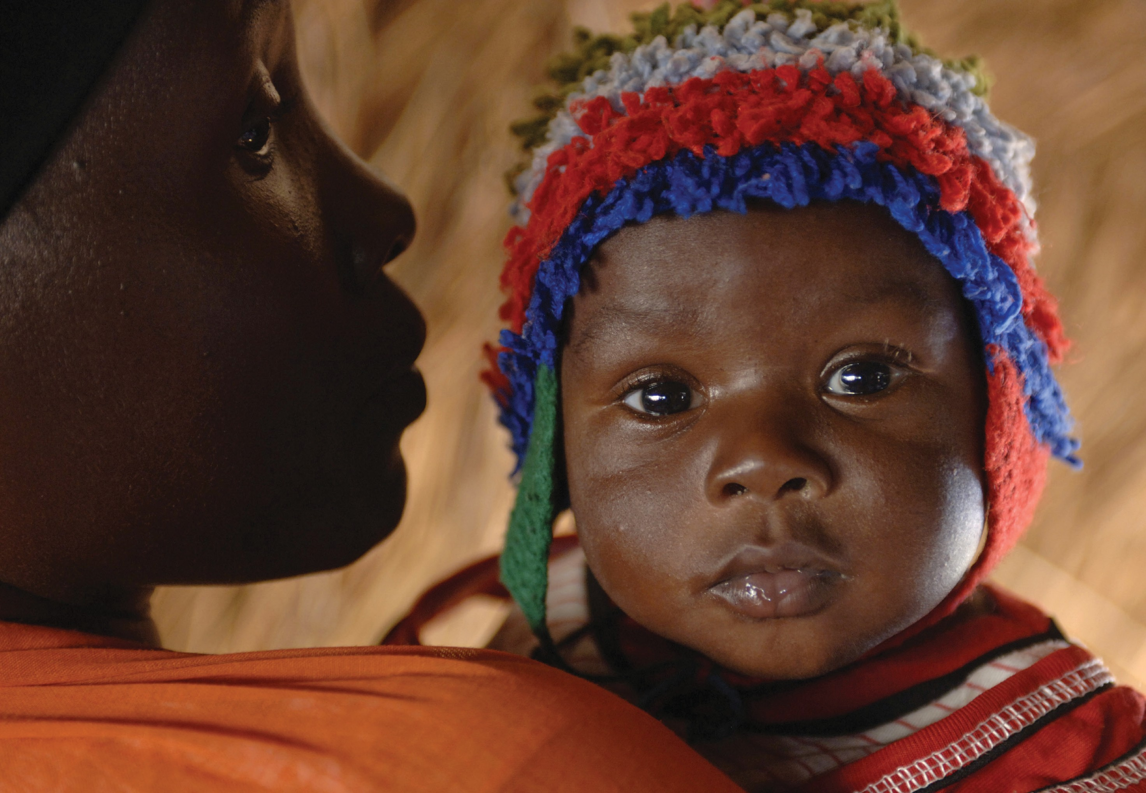

72 Supportive Supervision

©UNICEF/Cranston

