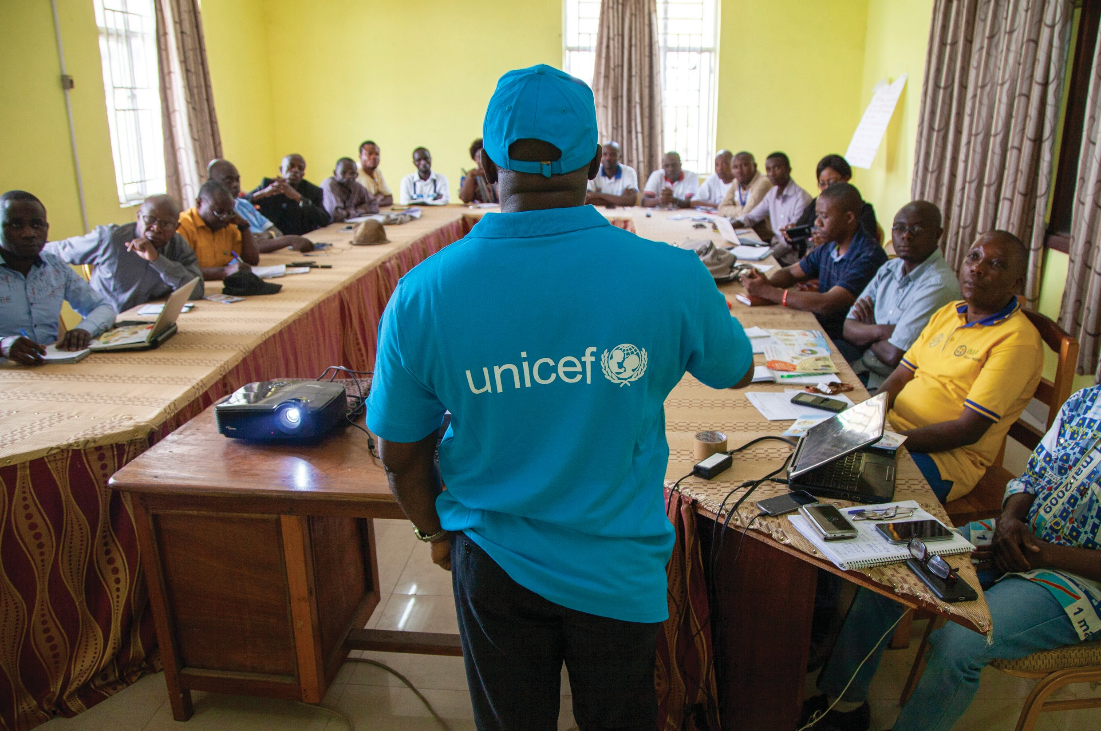

Trainers' Facilitation Guide - For Global IPCI

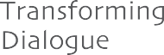Trainers' Facilitation Guide

Interpersonal Communication for Immunization Package

©UNICEF/Naftalin

Contents
Acknowledgements. iv
Photo Credits. iv
Abbreviations and Acronyms. v
Trainers' Facilitation Guide Overview vi
Glossary: Interpersonal Communication for Immunization Key Terms. x
Overview 1
Training Schedule. 4

MODULE 1
Principles Of Interpersonal Communication Beginning On Page 5

  - Opening Pg 6

  - Pretest Pg 8

  - Client-Centered Approach Pg 8

  - Interpersonal Communication and a Client-Centered Approach Pg 10

  - Interpersonal Communication Skills

Pg 12

  - Appreciating the Caregiver Pg 16
MODULE 2
Exploring Provider Perspectives And Barriers And Problem Solving Beginning On Page 18

2.1 | Respect and Equity | Pg 19
2.2 | Provider Barriers | Pg 20
2.3 | Problem Solving | Pg 21

i Trainers' Facilitation Guide - For Global IPCI

MODULE 3
Immunization And Vaccines Beginning On Page 25

  - Immunity Pg 26

  - Vaccines Pg 28

  - Vaccine-preventable Childhood Diseases
MODULE 4
Profiling Types Of Caregivers Beginning On Page 32
Pg 30

MODULE 5
Community Engagement Beginning On Page 44

4.1 | Understanding Vaccine Hesitancy | Pg 33
4.2 | Profiling Caregivers | Pg 35
4.3 | Communicating with caregivers | Pg 39

5.1 | Conducting a needs assessment | Pg 45
5.2 | Barrier Analysis | Pg 47
5.3 | Conducting a Community Conversation | Pg 50

Trainers' Facilitation Guide - For Global IPCI
ii
TABLE OF CONTENTS

6.1 | What can be done about a negative rumor | Pg 55
6.2 | Communicating Potential Adverse Events Following immunization | Pg 57
6.3 | Risk Communication | Pg 60

MODULE 7
Action Planning And Workshop Closing
Beginning On Page 63

  - Collecting and using community feedback
Pg 64

  - Mobilization Pg 66
  - Apply your skills Pg 69
  - Post-test and workshop evaluation Pg 70
  - Commitments and Certificates Pg 71

RESOURCES. 73
APPENDIX A. PRETEST AND POST-TEST 74
APPENDIX B. BARRIERS REVIEW IMAGE. 77
APPENDIX C. BARRIERS AND FACILITATORS TO EFFECTIVE COMMUNICATION. 78
APPENDIX D. JOB AID: COUNSELLING THE CAREGIVER. 79
APPENDIX E. STEPS TO COMMUNITY MEETINGS. 81
APPENDIX F. SAMPLE COMMUNITY CONVERSATION AGENDA 82
APPENDIX G. JOB AID: TIPS FOR USING IMMUNIZATION SUPPORT MATERIALS EFFECTIVELY 83
APPENDIX H. WORKSHOP EVALUATION QUESTIONS. 84
APPENDIX I. RECOMMENDATIONS FOR FOLLOW-UP AND SUPERVISION AFTER IPC/I TRAINING. 85
APPENDIX J. TRAINING SCHEDULE. 88
APPENDIX K. IPC/I Self-Assessment Checklist. 93
APPENDIX L. CERTIFICATES. 98

iii
MODULE 6
Addressing Negative Rumours, Myths, And Misconceptions Beginning On Page 54
Trainers' Facilitation Guide - For Global IPCI

This Resource
This resource is available on the Internet at: ipc.unicef.org
Copies of this document, as well as additional IPC materials on immunization, may be requested from UNICEF and partners:
UNICEF
3 United Nations Plaza New York, NY 10017 Tel: +1-212-326-7551
Email: IPC@unicef.org
© 2019 UNICEF
UNICEF and partners welcome requests for permission to use, reproduce or translate IPC for Immunization resources, in part or in full.
The content and the presentation of the material in this resource and the IPC package do not imply the expression of any opinion whatsoever on the part of UNICEF and partners.
Suggested citation: United Nations Children’s Fund, ‘IPC for Immunization Package’, UNICEF, New York, 2019.
For more information, or to provide feedback, please write to IPC@unicef.org

Trainers' Facilitation Guide - For Global IPCI
iv
THIS RESOURCE

Acknowledgments

The Interpersonal Communication for Immunization (IPC/I) Package is the result of strenuous hard work and collaborative efforts of many institutions and individuals, without whose help, guidance and support, this would not have been possible.
UNICEF wishes to recognize their contributions to this important initiative and expresses gratitude to all those who supported the development of the package through their time and expertise.
Special thanks to the global advisory group and the frontline workers From various parts of the world who contributed to develop the package.

Global IPC Advisory Group Members

Molly Abbruzzese, BMGF Hardeep Sandhu CDC Susan Mackay, GAVI
Lisa Menning, WHO Jhilmil Bahl, WHO
Mike Favin, The Manoff Group Lora Shimp, John Snow Inc. Bill Glass, CCP
Saad Omer, Emory University
Dr. Stephen Hodgins, University of Alberta, Canada Nathan Pienkowski, Bull City Learning
Dr. Naveen Thacker, IPA Benjamin Hickler, UNICEF Ketan Chitnis, UNICEF Tommi Laulajainen, UNICEF Claudia Vivas, UNICEF

JHU Project Team

Sanjanthi Velu, Jvani Cabiness, Caitlin Loehr, Amrita Gill Bailey, Ron Hess, Guy Chalk, Michael Craven, and Bill Glass. Others who contributed include Rupali Limaye, Anne Ballard, Mark Beisser, Missy Eusebio, and Carol Hooks.

Acknowledging and thanks to the CCP field offices and sister organizations in Nigeria, Pakistan, Uganda, Ethiopia, India and CHIP Pakistan for their support during the formative research and pretesting stages of the package.

UNICEF Team

Attiya Qazi, Chikondi Khangamwa, Anisur Rehman, Rufus Eshuchi, Kennedy Ongwae, Ayesha Durrani, Robb Butler, Violeta Cojocaru, Jonathan David Shadid, Johary Randimbivololona, Natalie Fol, Deepa Risal Pokharel, Helena Ballester Mario Mosquera, Svetlana Stefanet, Sergiu Tomsa, Daniel Ngemera, Fazal Ather, Vincent Petit, Carolina Ramirez, Alona Volinsky, Hannah Sarah Dini, Benjamin Schreiber, Rafael Obregon, Diane Summer, Robin Nandy, Luwei Pearson and Stefan Peterson.

Suleman Malik, Communication for Development Specialist, UNICEF Headquarters, New York, USA. UNICEF Team Lead

Trainers' Facilitation Guide - For Global IPCI
v
ACKNOWLEDGMENTS

Foreword

In recent decades, child mortality has dropped dramatically. Vaccines have been a major contributor to improvements in health by protecting children and adults against diseases that once maimed and killed. The scourge of smallpox has been eradicated, the last mile of polio eradication is close, as is the elimination of maternal and neonatal tetanus. Yet, despite the availability of vaccines, many countries face continuing constraints to achieving universal vaccination. One of the key challenges is ensuring sustainable demand for vaccination at family and community levels. The value that community members place on vaccination is a major contributor towards good health. The Global Vaccine Action Plan (2011–2020) acknowledges the importance of community attitudes and practices, as reflected in one of its six strategic results: “Individuals and communities understand the value of vaccines and demand immunization as both their right and responsibility.”
Although most children do receive the recommended vaccinations, too many still miss out: almost 20 million globally do not receive the full schedule of essential childhood vaccines. The reasons are complex. In some places, health services are not easily accessible – and when accessible, may not be convenient to users – and/or reliable. In some cases, health worker’s behaviors or attitudes may limit the uptake of vaccination services. Caregivers’ and children’s experiences with immunization services may be unpleasant for various reasons and this can explain why many children who receive the first dose of vaccines (e.g. BCG or DTP1), drop out. In other instances, children miss recommended vaccinations because their parents or guardians have concerns or misunderstandings about vaccines, lack information on the benefits of vaccines, or do not understand what they need to do to get their children vaccinated and protected.
Frontline Workers (FLWs), including facility-based professionals, community health workers (CHWs) and community volunteers (CVs), are a critical source of information about vaccination. Research shows that FLWs are the most influential source of information about vaccines for caregivers and families of children. Because of their critical role in providing essential information about vaccination services, FLWs must have effective interpersonal communication (IPC) skills. They also need positive attitudes towards the people they serve and their work, an understanding of the importance of communication, and an ability to operate in an environment that enables them to communicate effectively to build trust and confidence. When equipped with the relevant skills and supported by their supervisors, FLWs can be very effective in influencing attitudes and promoting uptake of vaccination services. Across countries, FLWs engage communities in dialogue, mobilize community leaders and provide communities with health services and knowledge about healthy practices. However, the limited IPC skills of FLWs remains
a challenge and requires focused efforts to enhance their capacity to communicate effectively with care givers and community members that they serve, and a system that supports and values the practice of these important competencies is vital.
UNICEF, together with Bill & Melinda Gates Foundation (BMGF), Centers for Disease Control and Prevention (CDC),
, Emory University, GAVI, the Vaccine Alliance (GAVI), International Pediatric Association (IPA), , John Snow Inc. (JSI), the United States Agency for International Development’s flagship Maternal and Child Survival Program, World Health Organization (WHO) and other partners, remain committed to closing the gap by facilitating a process of empowerment through the development and roll out of a comprehensive ‘IPC for Immunization’ package.
UNICEF and partners are pleased to introduce this IPC for Immunization package and invite national and sub- national programme managers, partners and FLWs to adapt it to their local context and use it to guide their work with caregivers and communities. A range of resources are in the package, including participant’s and facilitator’s manuals, an adaptation guide, a supportive supervision manual, FAQs, flash cards, videos, audio job aids, a mobile application, and a monitoring and evaluation (M&E) framework. These resources are available both online (IPC. UNICEF.Org) and offline in four global languages. It’s hoped that through this package and instructional-design approaches, FLWs will improve their capacity to effectively communicate and successfully promote demand for immunization and other health services; empathize with caregivers; address questions and concerns through counselling; and clearly communicate key messages regarding the timing and importance of further vaccinations and practical information on where and when they should be obtained.
UNICEF extends gratitude to partners, colleagues and the advisory group who contributed their time, expertise and experience to the preparation of this package. Special thanks to Johns Hopkins University Center for Communication Programs for helping to develop the package, to the UNICEF regional and country colleagues and the FLWs for their support, valuable feedback and collaboration in developing the package. Through this partnerships and support, UNICEF will continue to enhance the capacity of the immunization workforce,
institutions, and teams that will help communities to value, demand, trust and improved understanding to the right to immunization services.

Trainers' Facilitation Guide - For Global IPCI
vi
FOREWORD

Abbreviations And Acronyms

- AEFI adverse event following immunization

- FLW frontline workers

- IEC information, education, and communication

- IPC interpersonal communication

- IPC/I interpersonal communication for immunization

vii

Trainers' Facilitation Guide - For Global IPCI
ABBREVIATIONS AND ACRONYMS

Trainers' Facilitation Guide Overview

Module 1 - Principles Of Interpersonal Communication

Sessions
Key Concepts
Activities
Activity Session Module
Timing Timing Timing

1.1
Opening
Why interpersonal communication
is important to the immunization program
1.2 Pre-test
Testing current
knowledge
Pretest
20 min.
30 min.
Set ground rules

Learning expectation
5 min.

5 min.
15 min.
4 hr.

1.3 | Client- | Good customer | Client experience | 15 min. | 20 min.
 | centred approach | service in health  service | role play

1.5
1.4
Interpersonal
communication and a client- centred approach
Empathy
Persona exercise 45 min.
2 hr.
Journey mapping
the caregiver experience
1 hr.

Interpersonal communication skills

Nonverbal communication; creating a welcoming environment; asking questions sensitively

Double ‘blind’ communication

Photo review

10 min.

15 min.

20 min.

1.6 Appreciating the caregiver
Appreciating the
caregiver
Role play
25 min.
45 min.

Trainers' Facilitation Guide - For Global IPCI
TRAINERS' FACILITATION GUIDE OVERVIEW
viii

Module 2 - Exploring Provider Perspective And Barriers And Problem Solving
Sessions
Key Concepts
Activities
Activity Session Module
Timing Timing Timing

2.1 | Respect and | Discrimination, | Reflection on | 20 min. | 45 min. | 1 hr, 45
 | equity | diversity | experience |  |  | min.

Dimensions of diversity
15 min.
15 min.

2.3
2.2 Provider Experiences of Agree-disagree 10 min. 45 min. barriers frontline workers
impacting client services
Problem solving
Problem solving
Problem solving
25 min.

Module 3 - Immunization And Vaccines

Sessions
Key Concepts
Activities
Activity Session Module
Timing Timing Timing

3.1
Immunity
Active, passive, herd immunity
How vaccines work pop quiz
10 min.
45 min.
1 hr, 30 min.

3.2 Vaccines Types of vaccine Lecture 30 min. 30 min.

3.3
Vaccine- preventable childhood diseases
Vaccine- preventable diseases
Guess that vaccine- preventable disease
20 min.
45 min.

Trainers' Facilitation Guide - For Global IPCI
ix
TRAINERS' FACILITATION GUIDE OVERVIEW

Module 4 - Profiling Types Of Caregivers
Sessions
Key Concepts
Activities
Activity Session Module
Timing Timing Timing

4.1 | Understanding | Determinants of | Examples from | 15 min. | 45 min. | 1 hr, 30
 | vaccine  hesitancy | vaccine hesitancy; identifying parental concerns | the local context |  |  | min.

4.3
Communicating with caregivers
What to communicate during an immunization visit
Finding-the-right- message skits
10 min.
40 min.

Module 5 - Community Engagement

Sessions
Key Concepts
Activities
Activity Session Module
Timing Timing Timing

5.1
Conducting a needs assessment
Approaches for conducting a needs assessment
Lecture
45 min.
45 min.
2 hr, 15 min.

5.2 | Barrier | Common | Image review | 15 min. | 45 min.
 | analysis | caregiver barriers

5.3
Story and brainstorm 10 min.
45 min.

Conducting a community conversation

Communicating immunization messages to the community

Planning a community conversation

10 min.

4.2 Profiling
caregivers
Identifying parental
concerns; types of hesitant caregivers
Practice profiling
30 min.
1 hr.

Trainers' Facilitation Guide - For Global IPCI
x
TRAINERS' FACILITATION GUIDE OVERVIEW

Module 6 - Addressing Negative Rumors, Myths, And Misconceptions

Sessions
Key Concepts
Activities
Activity Session Module
Timing Timing Timing

6.1
What can be done about a negative rumor
Steps to addressing a negative rumor
Addressing rumors speed rounds
15 min.
30 min.
2 hr.

6.2
Communicating
potential adverse events following immunization
Causes of adverse
events following immunization (AEFI)
20 min.
45 min.
AEFI case study

6.3
Risk communication
Vaccine safety; essentials and techniques for risk communication

Practice with difficult
conversations
20 min.
45 min.

Module 7 - Action Planning And Workshop Closing
Sessions
Key Concepts
Activities
Activity Session Module
Timing Timing Timing

7.1 | Collecting | Why collect | Prototyping a | 1 hr. | 1 hr, 15 | 4 hr, 15
 | and using  community | community  feedback and how | feedback system |  | min. | min.
feedback

7.2
Mobilization
Advocating with
influencers
Communication
campaign
15 min.
30 min.

7.3
Apply your skills
Skills application and practice
Individual interactive immunization education session
1 hr, 30 min.
1 hr, 30 min.

7.4
Post-test and
workshop evaluation
Post-test,
workshop evaluation
Post-test
20 min. 40 min.
Workshop
evaluation

7.5
Commitments and certificates
Issue certificates
Post-training commitments
15 min.
25 min.

Trainers' Facilitation Guide - For Global IPCI
xi
TRAINERS' FACILITATION GUIDE OVERVIEW
Issue certificates
10 min.

Glossary - Interpersonal Communication For Immunization Key Terms

Advocacy
Refers to the ways of developing and implementing a strategy to enable you to gain the support and commitment of policymakers, community members, and other stakeholders and to successfully lobby for increasing immunization coverage.

Agency
Refers to the expression of choice, voice, and power. It is the ability to make and influence decisions that inform one’s life, the capacity to assert one’s interests and meaningfully participate in public and private decision making, and the capacity to influence behaviour or a course of action.

Caregiver
Someone who provides unpaid assistance and support to the physical, psychological, or developmental needs of a baby or child. They may be a parent or someone who acts as the secondary support to a parent, or as a primary guardian.

Client-centred approach
Means that the client’s needs, concerns, and experiences are the core focus during immunization communications and services.

Closed question
A query the caregiver answers with a simple ‘yes’ or ‘no’. A closed question does not allow you to check to make sure the caregiver or client has understood the question or really knows the answer.

Communication
The transmission of information or conveying thoughts or feelings from a source (sender) to a destination (receiver). Both sender and receiver have a responsibility to interpret the words, gestures, or symbols that are being exchanged and to provide feedback.

Community conversation
A process of discussion within a community group. This activity is used to identify issues that are causing problems locally and to find collective solutions to these problems.

Community mobilization
A process of gaining the involvement of key stakeholders in the community for an action towards a particular goal.

Counselling
A collaborative effort between a counsellor and client(s) that helps clients identify goals and potential solutions to barriers and promotes behaviour change.

Trainers' Facilitation Guide - For Global IPCI
GLOSSARY
xii

Empathy
An emotional identification with someone. It is the capacity to project a person’s thoughts and/or feelings despite not having those thoughts/feelings explicitly communicated.

Equity (in health)
Means that no one is denied the possibility of being healthy because they belong to a particular group or have an economic or social disadvantage.

Feedback
An audience’s response to a communication or experience either orally or nonverbally. Feedback enables a communicator to evaluate the effectiveness of their message. Giving an audience a chance to provide feedback is crucial for maintaining open communication.

Focus group discussion
A discussion with clear guidelines about the topic that the discussion should centre on. The ideal number of participants in a focus group is between six and 10. A facilitator keeps the discussion focused on the agreed upon topic and makes sure that everyone’s views are heard.

Frontline worker
A social worker or healthcare provider (facility- or community-based, professional or volunteer) tasked with delivering interpersonal communication (IPC) and counselling, immunization, or education and outreach to caregivers, clients, or community members.

Immunization
The process by which a person is made immune or resistant to an infectious disease, typically by the administration of a vaccine.

Interpersonal communication
The process of exchanging information, ideas, thoughts, and feelings between a group of two or more people using verbal and nonverbal messages. The exchange allows them to receive an immediate response or feedback that can lead to mutual understanding, agreement, and action. IPC can happen in a face-to-face/direct setting or in a mediated/indirect setting, such as video, audio, short message service (SMS) message, telephone, or internet exchange. IPC is related to and supports the following skills:

- Communication: Conveying ideas effectively through verbal and nonverbal means
- Empathy: Understanding individuals
- Mentoring: Coaching one or more people
- Problem solving: Resolving personal, group, and workplace challenges
- Negotiation: Coming to an agreement with others when opinions differ
- Teamwork: Working together with various people to achieve a single goal

xiii
Trainers' Facilitation Guide - For Global IPCI
GLOSSARY

Key message
A statement representing the general tone and main points to guide communication about vaccines or immunization.

Mobilization
An approach to engaging individuals, groups, or organizations to become their own agents of change in order to make improvements in the health and well-being of their families and communities.

Nonverbal communication
A method of transmitting information or conveying thoughts or feelings through actions such as body language, gestures, facial expressions, or sounds that are not quite words. These actions can strengthen or contradict what is expressed verbally.

Open-ended question
A question that encourages the caregiver to answer in their own way and share their concerns with you.

Respect
A positive feeling or action shown towards someone or something considered important. Respect conveys a sense of admiration for good or valuable qualities and honours someone by exhibiting care, concern, or consideration for their needs or feelings.

Social and behaviour change communication
Developing and implementing a communication strategy to promote a positive change in health-related behaviours in a community, informed by local values and priorities. This can only be done by sustained work with individuals and communities to explain the issues and implications involved and to support people as they try to understand them.

Sympathy
When you share the feelings of another. It is the act or capacity of entering into or sharing the feelings or interests of another.

Vaccination
The act of introducing a vaccine into the body to produce immunity to a specific disease.

Vaccines
A product that stimulates a person’s immune system to produce immunity to a specific disease and protect the person from that disease. A vaccine initiates the immunization process. Vaccines are usually administered through needle injections, however, some are administered by mouth or sprayed into the nose.

Trainers' Facilitation Guide - For Global IPCI
GLOSSARY
xiv

Overview
Background

There are many reasons for children not being fully vaccinated. Parents and caregivers have many reasons for delaying, refusing, or not fully completing childhood vaccination. Their reasons might include individual religious, ethical, and medical considerations; the influence of antivaccination information; fear of side effects or complications; undervaluing the benefits of vaccination; inconvenience of services (as perceived by caregivers); unreliability of services (sessions cancelled, vaccinator not available, stockouts of vaccine); poor communication by vaccinators regarding the return date, side effects, and so forth. They may also make poor decisions on whether to vaccinate or which vaccinations to give and fail to screen and referral of eligible children within health facilities.

Evidence shows that the quality of the interaction between frontline health workers (FLWs) and caregivers is a key factor in ensuring completion of the vaccination schedule. FLWs are among the most influential sources of information about immunization behaviour. The healthcare providers, social workers, community health workers, and community-based volunteers at the frontline of immunization programs provide a crucial bridge between the communities they serve and the immunization services they provide.

FLWs who routinely engage in positive and meaningful interpersonal communication (IPC) with caregivers and community members – such as asking relevant questions, encouraging participation, demonstrating empathy, emphasising the importance of timely vaccination, listening attentively, and responding to, showing respect for, and appreciating caregivers – are able to build trustful relationships and increase the likelihood that children will receive the recommended vaccines on time.

About This Resource

The Trainers' Facilitation Guide and participant’s manual on interpersonal communication for immunization (IPC/I) and its companion resources are designed to help FLWs acquire the knowledge, skills, and attitudes needed to communicate effectively with caregivers and communities about childhood immunization. The information and exercises these resources contain can be used for preservice training, training workshops, day-to-day supervision, supportive supervision visits, on-the- job training (including coaching, mentoring, and peer-to-peer mentoring), and self-study. The Trainers' Facilitation Guide was developed for group training and is supported by the participant’s manual, which can be used in group training settings or for self-study. The guide and manual were designed so that country offices can adapt them according to local context and needs. The modules incorporate several social and behaviour change theories and approaches. We recommend trainers familiarize themselves with basic principles of social and behaviour change or communication for development in preparation to deliver the training. A number of relevant resources and reference materials can be found at thecompassforsbc.org.

Trainers' Facilitation Guide - For Global IPCI
1
OVERVIEW

Training Philosophy

Intended to be participatory, this training includes learning-by-doing activities with a focus on adult learning methods that require participation through paired and small group exercises as well as large group discussions, brainstorming, role play, and practice. The training follows four guiding principles: clarity, engagement, reflection, and reinforcement.

Intended Audience

The intended audience is FLWs, broadly defined. An FLW is a social worker or healthcare provider
– facility- or community-based, professional or volunteer – who does or should deliver IPC and counselling, immunization, or education and outreach to caregivers, clients, or community members. An immunization program may be composed of several different types of FLWs whose key characteristics (such as education levels, training, competencies, and compensation levels), skills, roles, and jobs vary. Regardless of their differences, they all can play complementary roles in ensuring that communities achieve full vaccine coverage.

The resources within the IPC/I package are geared towards FLWs who serve in a health promotion and preventative care capacity. Their profiles vary by country and within individual countries. Those with more formal education tend to work in health facilities, where they vaccinate. They may have public health training of only a few months up to several years, in the case of registered nurses or medical technicians. FLWs may be minimally literate community volunteers or educated salaried employees. All FLWs are responsible for informing, counselling, and encouraging families to have their children fully immunized.

Training Objectives

The resources within the IPC/I package seek to help immunization programs address the following knowledge, attitudes, and practices among FLWs:

FLWs Will Gain Knowledge About:
- The principles of effective IPC
- How to effectively communicate with caregivers irrespective of their workload or the length of the caregiver interaction
- What steps are taken by regulatory authorities, vaccine manufacturers, and the health system to ensure vaccine safety
- How vaccines prevent disease

Flws Will Gain The Perspective That:
- All caregivers and community members deserve respect, empathy, equitable service, and to be heard regardless of religion, ethnicity, national origin, gender, education, or socioeconomic status.
- FLWs play a key role in enabling community health.
- Vaccines are safe and prevent disease.

Trainers' Facilitation Guide - For Global IPCI
2
OVERVIEW

FLWs Will Have The Skills To:

  - Explain the benefits of various vaccines, remind caregivers about subsequent vaccination, and describe possible side effects and actions caregivers can take to address them
  - Effectively communicate with caregivers and community members with various attitudes about vaccines or the health system at large
  - Encourage caregivers to ask questions and provide caregivers with clear and appropriate responses to these questions
  - Appropriately address rumours, concerns, or misconceptions
  - Plan and conduct community engagement and outreach activities

Layout/Content Of The Manual

The manual is divided into individual sessions, which include notes to help guide the trainer facilitate each session, including the:

  - Objectives of the session

  - Time required for the session

  - Materials/preparation needed for the session

  - Training methods used

  - Session content

Preparation For The Training

To make the best use of this manual and conduct effective training, trainers should:

- Read the manual carefully prior to use so they know the training agenda, objectives, methodology, materials, and time allocated for sessions and breaks
- Practice activities before conducting them, setting aside adequate time to plan and seek assistance from co-facilitators or translators
- Review each activity and gather or develop the necessary materials
- Know the characteristics of the training practice participants and prepare to accommodate different education levels, professional backgrounds, languages, cultural norms and customs, and learning styles
- Adhere to the suggested timing and try to conduct training sessions with fewer than 12 participants

Trainers' Facilitation Guide - For Global IPCI
3
OVERVIEW

Training Schedule

Sample schedules for a five-day training, three-day training, and one-day training are offered in Appendix J.

Preservice Training

Integration of this training package into preservice training will likely require a formal process that includes a stakeholder consultation to identify individuals or groups interested in supporting implementation, decide which modules and sessions should be added to the IPC/I curriculum, analyse the content of the program’s current IPC and IPC/I training resources, plan to adapt and introduce new content and prepare instructors, and develop a monitoring, evaluation, and learning plan.

In-Service Training

Prior to providing in-service training, assess participants’ training needs and modify the content of the training package to meet those needs. Consider adapting the objectives, sessions, steps, timing, activities, role play scenarios and character/place names, examples, vocabulary, key takeaways, and any other elements to make the training more closely aligned with the needs and policies of the immunization program, profile of the participants, and barriers within the community. Enhance the content with local examples and country-level data for better contextualization and modify the content according to the time available, focusing on the modules that align with the identified learning needs. In some health systems, it may be necessary to spread content over two or more mini-workshops of one to two days each or reduce the content to fit in a single workshop of one to three days. If these changes are necessary, make every effort to maintain the highly participatory, practice-oriented nature of the workshop as outlined. You will likely achieve the best result by covering a limited number of topics and sessions deeply.

On-The-Job Training

To use these modules for on-the-job training, focus on one or a few staff who you have identified as having the same training needs. Through supportive supervision and other needs assessments, focus the training on specific knowledge, attitudes, and skills. Allocate time to cover each competency on a schedule that will allow the FLWs to learn, practice, and independently apply the new skills or approaches.

Trainers' Facilitation Guide - For Global IPCI
4
TRAINING SCHEDULE

Principles Of Interpersonal Communication
Objectives

Identify the IPC techniques needed to enhance interactions with caregivers and clients

Analyse the barriers to IPC and the factors that promote effective interactions for increased immunization demand

Learn how to respond to caregiver/ client concerns to support informed decision making

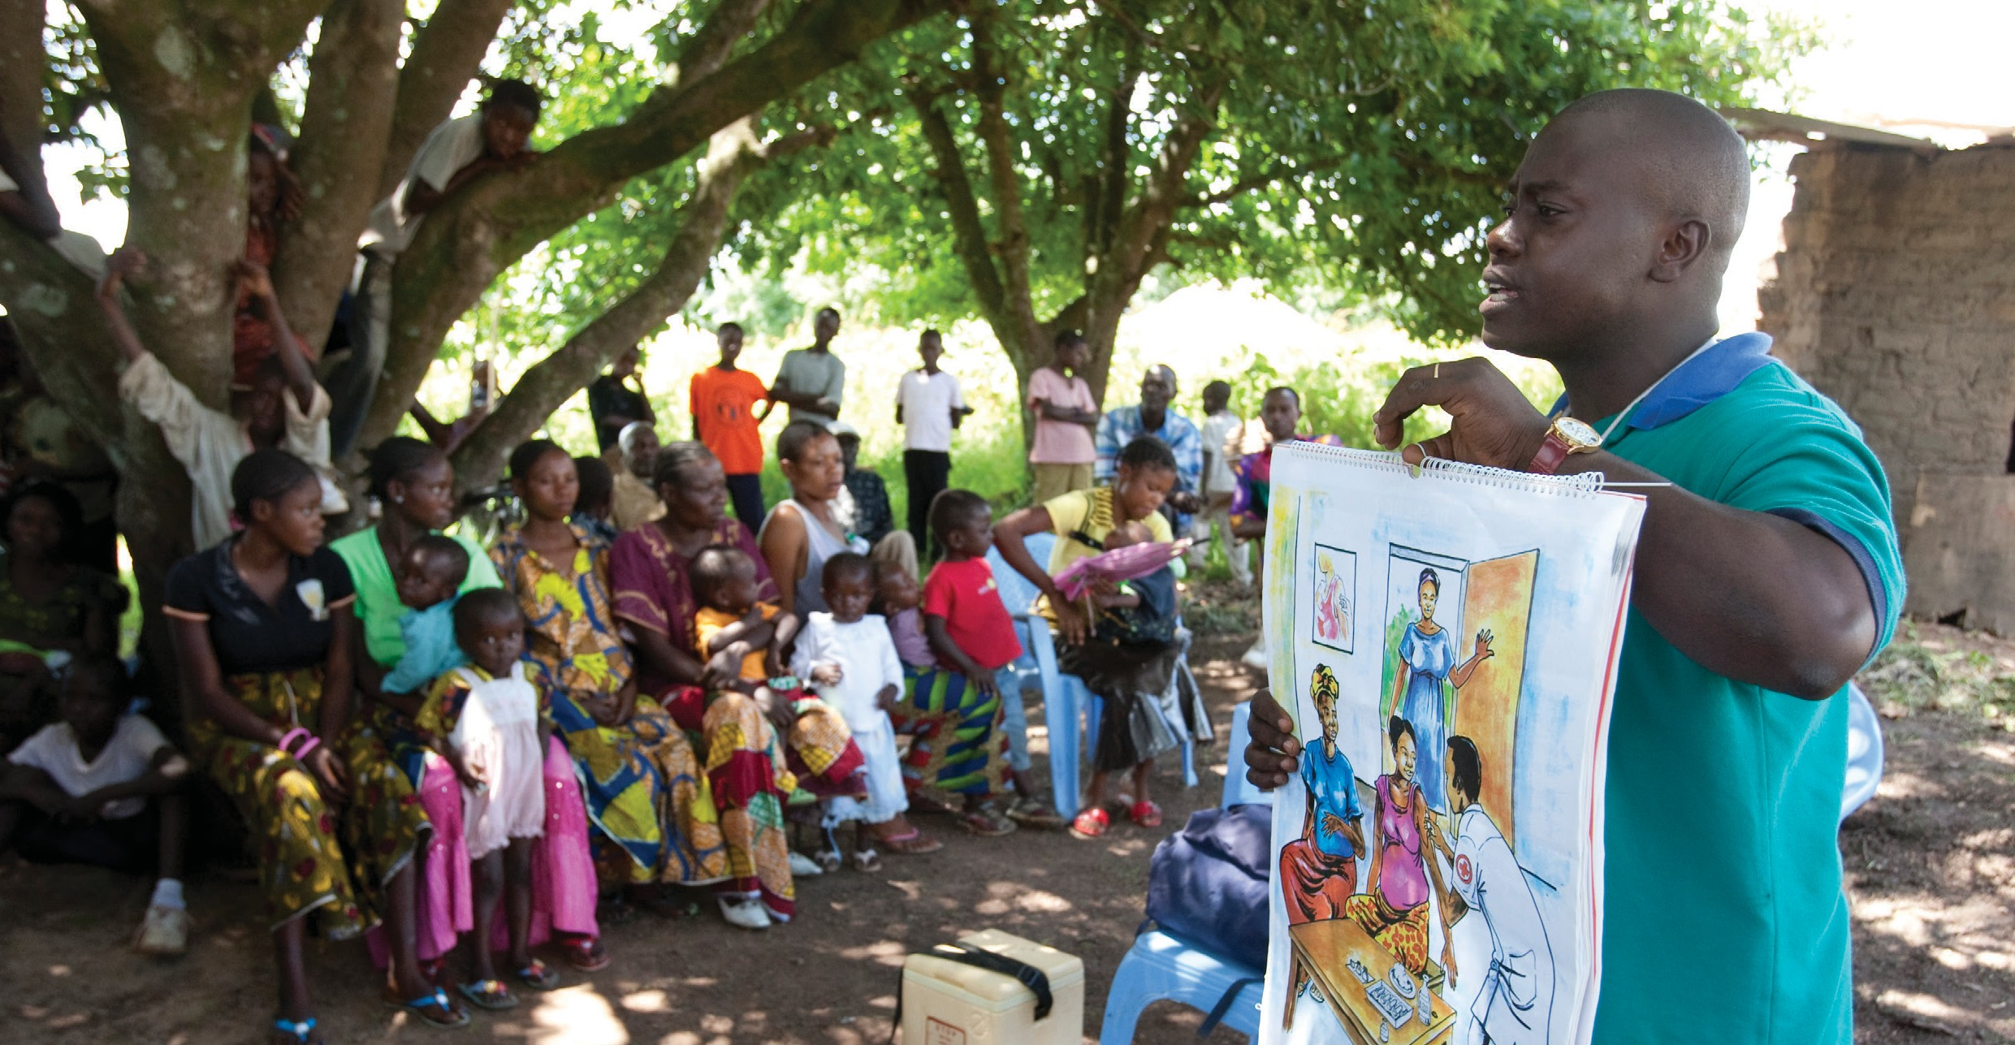Understand and be able to apply the principles of empathetic and active counselling with caregivers
MODULE 1

©UNICEF/Asselin

Session 1.1 Opening

Introduction: Why Is Communication Important To The Immunization Program?
The main task of IPC/I is to facilitate children receiving vaccinations as closely as possible to the recommended schedule. Achieving this goal requires access to reliable services, treating people respectfully, and clearly communicating essential practical information. Effective IPC fosters a positive relationship of respect and trust between FLWs, families and communities. This practice encourages and responds to caregivers’ questions and concerns, a task that is challenging when caregivers, religious leaders, political leaders, or cultural leaders reject vaccinations or some aspect of recommendations. Finally, it is used to inform communities and individuals about public health concepts related to immunization.

When you communicate with caregivers about vaccine-preventable diseases, vaccines, and immunization, it is important to understand their current attitudes, beliefs, and level of knowledge. You should always try to make sure that your points are memorable, made clearly, and respond directly to what the caregiver needs to understand or feel to accept vaccination. It is important to respond to the needs and concerns of the community, appreciating local challenges and showing respect for local customs and culture.

While completing the training exercises, it might be helpful to distinguish what kind of IPC is needed to address the concerns of caregivers bringing a child for the first vaccination(s) compared to the concerns of bringing a child for subsequent ones. Vaccine hesitancy and access issues most affect the former, while the service experience and quality of communication by the vaccinator most affect the latter.

Welcome Remarks
- Welcome participants
- Thank everyone for their participation and enthusiasm
- Use the “Why communication is important to the immunization program?” section above as speaking points to explain the workshop purpose

- Provide some background on the current status of the immunization program
Activity: Set Ground Rules
  - Ask participants to develop a set of ground rules to govern the workshop.
  - This can be done “popcorn-style” to get everyone to participate. Toss a ball to one participant. When they catch the ball, they have to name one ground rule and then toss the ball to another participant. Each person should catch the ball once and each person should come up with one rule.
  - Write the rules on a whiteboard, chalkboard, or flip chart paper.

Trainers' Facilitation Guide - For Global IPCI
6
MODULE 1 - PRINCIPLES OF INTERPERSONAL COMMUNICATION

Training Goals and Objectives
- To describe the training objectives outlined in the Overview section
- To develop and enhance the IPC skills of FLWs to provider quality care services
Activity: Learning Expectations
This activity will explore the barriers that affect the interactions with caregivers/clients.

  - Give each participant a full sheet of paper and a drawing or writing utensil (marker or pen).
  - Each participant should be given a few minutes to draw a picture illustrating a personal or professional challenge they face that they feel prevents them from ensuring that every caregiver has a high-quality immunization experience.
  - Each person should share their name, describe the meaning behind their illustration, and share one thing this workshop will help them to do better.

Note to Facilitator: Reiterate how the workshop objectives will help to address the challenges they face with caregivers, supervisors, and community members. Mention that the FLWs themselves are likely to get more satisfaction from their work if they improve their IPC.

IPC/I Video: FLWs Can Make a Difference
Despite the many barriers faced by FLWs, they are integral in preventing children from dying of vaccine-preventable illnesses. See the video ‘FLWs Can Make a Difference’, which shows the inspiring work of FLWs around the world.

This video establishes the importance of the role of FLWs in behaviour change for immunization. It highlights the key role FLWs play as trusted and influential actors in motivating vaccination uptake and increasing demand for immunization.

Reflection Questions
- What motivated you to be an FLW?
- What is one of your most memorable positive experiences with a caregiver?
- What is the most rewarding part of your work?

Trainers' Facilitation Guide - For Global IPCI
7
MODULE 1 - PRINCIPLES OF INTERPERSONAL COMMUNICATION

Session 1.2 Pretest
Pretest

- Distribute a copy of the pretest to each participant (see Appendix A).
- Instruct participants to write their name (or a unique identifier at the top; if they use an identifier, they should use the same one for the post-test).
- Allow 20 minutes to complete the test.
- Collect each test.

Session 1.3 Client-Centred Approach
Introduction: Interpersonal Communication And A Client-Centred Approach
Interpersonal skills are those pertaining to relationships with people and encompass many different important skills. The purpose of this session is to introduce how IPC can support a client-centred
health services experience.

Activity: Client Experience Role Play

Ask two participants to role play, one acting as a caregiver and the other acting as a receptionist who welcomes visitors the health facility.

A mother arrives late to the health facility with a newborn and a small child. The mother is flustered from her long journey and not sure whether to enter the facility. Before
she reaches the entrance to the clinic, the receptionist asks if she has come for a vaccination. She answers ‘yes’, and he asks whether she has brought the immunization card. She answers ‘no’. He tells her the nurse is very busy, and she should come back the next morning with her child’s immunization record.

Group Discussion

- How would you feel if you were the caregiver?
- What are some reasons the receptionist may have treated the caregiver this way?
- What could the receptionist have done differently?
- How would you interact with a caregiver who had an experience such as this?
- What would you (as the FLW) say to the receptionist to improve their behaviour?

Trainers' Facilitation Guide - For Global IPCI
8
MODULE 1 - PRINCIPLES OF INTERPERSONAL COMMUNICATION

Definition of a client-centred approach

A client-centred approach to immunization service means that the clients’ needs, concerns, and experiences are the core focus of communication and services.

A client-centred approach is important because it:

  - Improves the caregiver and client’s attitude towards FLWs
  - Improves the reputation of staff at the facility and community levels
  - Provides the caregiver and client with positive, memorable experiences
  - Satisfies the needs and expectations of the caregiver/client
  - Increases the number of caregivers/clients who continue to bring children for recommended immunizations (reducing dropout)
  - Increases the number of caregivers/clients demanding immunization

Reflection Questions
    - How would you define a client-cantered approach?
    - How can you demonstrate to caregivers/clients that they matter most? How can you improve on this?

Trainers' Facilitation Guide - For Global IPCI
9
MODULE 1 - PRINCIPLES OF INTERPERSONAL COMMUNICATION

Session 1.4 Interpersonal Communication And A Client-Centred Approach
IPC is vitally important to delivering a client-centred approach and supporting the behaviour change process. In particular, it is very good for:

- Informing individuals and target audiences about the value of the proposed behaviour change by explaining and responding to questions and doubts about immunization
- Addressing rumours about adverse effects of immunization
- Addressing any personal issues the caregivers may express
- Through advocacy efforts, helping to mobilize resources from the community to enhance the immunization program
- Building consensus, for example, to bring all eligible children for immunization
- Explaining to caregivers about the immunization status of the child
- Telling the caregivers about the next immunization(s) the child will need

Empathy

Before focusing on the principles of effective IPC in detail, it is important to try to understand how caregivers and clients experience immunization services. The more we can understand their experiences, the better we can empathize with the different types of caregivers and clients we encounter. Empathy gives us a sense of understanding and compassion for another person, based on our ability to imagine what an experience might be like for them.

Showing empathy is one of the most important communication skills for FLWs because it helps us to treat people with respect and kindness, regardless of their background, social position, or attitude. Showing empathy makes caregivers more likely to express themselves, allowing you to learn more about the caregiver, child, and issues or concerns that need to be addressed. When you show caregivers empathy, you are more likely to have positive interactions and they will feel more comfortable discussing vaccination concerns with you and following your guidance. It may be challenging to act empathetically under stressful working conditions, but it is important to try.
Activity: Journey Mapping the Caregiver Experience
The mapping exercise is intended to build empathy by helping participants imagine the experience of caregivers from the time they decide to bring their child to get a vaccination to the receipt of the vaccination.

Part 1: Understanding the Caregiver
  - Divide the participants into groups, with four participants per group.
  - Give each group two large pieces of flip chart paper, a marker, and s
  - Assign each group one of the following caregiver personas/characters:

Trainers' Facilitation Guide - For Global IPCI
10
MODULE 1 - PRINCIPLES OF INTERPERSONAL COMMUNICATION

    - A young (19 years old), married mother
    - An old grandmother unable to read or write
    - A recently widowed father
    - An educated, married couple

  - Allow each group 30 minutes to create the caregiver’s character. They can choose to imagine any backstory or personal history associated with the persona they have been assigned.
  - Draw an image of the caregiver and their family. Be prepared to discuss the points below.

Each group should be prepared to describe the following about their character:

  - Thinking and feeling: What are their worries and aspirations for themselves and their children?
  - Seeing: What does the person look like, what do they wear, what is their profession? What does their community, health facility, and environment look like? What resources does it offer?
  - Saying: What is their public attitude towards childhood immunization? Towards the health system in general?
  - Hearing: What are their peers, family members, and other influential people in their lives saying about immunization?

Note to Facilitator:

If feasible, consider inviting some caregivers from the community to observe the session and participate in the reflection questions. At the end of the role play, ask the caregivers how realistic the portrayals were and what changes or additions they believe should be included.

Part II: Mapping the Persona’s Experience through the Health System

Now you will ‘map’ the journey of your character’s experience using immunization services. Allow 30 to 45 minutes for the mapping. It may help to organize this as a chart with Step 1 on the horizontal axis and Step 2 on the vertical axis. Allow each group 10 to 15 minutes to present their persona and journey map.

Note to Facilitator:

There are a number of different ways to conduct a journey mapping exercise. The objective is to systematically think through a caregiver’s experience as they interact with health services. Understanding this then helps the FLW build empathy and develop solutions address any pain points. To familiarize yourself with journey mapping see this resource from IDEO.

Step 1: In the same groups, with the same caregiver character in mind, list the steps involved in receiving a vaccination for their child. Include: (1) the journey to reach the health facility; (2)
what happens once they arrive at the facility; and (3) what happens when their child receives the vaccination. Be as detailed as possible.

Step 2: Now, the groups will answer the following questions about the journey:

Trainers' Facilitation Guide - For Global IPCI
11
MODULE 1 - PRINCIPLES OF INTERPERSONAL COMMUNICATION

- Questions: What questions might the caregiver have as they move through the journey?
- Pain points: What are the problems, frustrations and annoyances, or potential barriers that may create a negative experience?
- Happy moments: What are the positive, enjoyable things that could improve the experience?
- Opportunities: What can you implement or do as an FLW to address any of the pain points identified?

Reflection Questions
  - Considering the entire caregiver/client journey, what might be the most difficult part of the immunization services experience?
  - Given the challenges a caregiver might experience, what might motivate them to bring their children to complete the immunization schedule on time?
  - What might a caregiver want to change about immunization services?
  - How would you expect caregivers to behave when they arrive at the facility, given the pain points they have experienced?

Session 1.5 Interpersonal Communication Skills
Activity: Double ‘Blind’ Communication
Through this activity, participants observe the importance of
nonverbal communication.

- Divide the participants into pairs. They should work with someone they do not know well, if possible.
- Each pair sits in chairs, one person directly behind the other, facing in the same direction – meaning that the second person should be staring at the back of the other person’s chair.
- Instruct the pairs that the person in front should not
turn around and the person behind them should not move towards the front of the other person.
- Ask them to have a two-minute conversation about why they each became an FLW.
- When finished, bring the participants together in the large group and discuss the exercise.

Trainers' Facilitation Guide - For Global IPCI
12
MODULE 1 - PRINCIPLES OF INTERPERSONAL COMMUNICATION

Reflection Questions
  - How did it feel to have a conversation without being able to look at the other person?
  - What was missing from the interaction?
  - What important attitudes does a caregiver/client express through their facial expression, eye contact (or lack of), posture, gestures, and so forth?
  - What kind of nonverbal communication supports positive interactions with caregivers?

Note to Facilitator:

Before reviewing the list of IPC skills below with the participants, invite participants to mention and describe skills they already know.

Interpersonal communication skills

Below are IPC practices important for immunization communication. These skills require practice and awareness until they become habit.

- Welcome the client warmly.
- Empathize with the caregiver by demonstrating that you understand their questions, concerns, and how they feel.
- Keep messages simple and clear.
- Speak in simple terms, using local and easy-to-understand language; give examples that the caregiver is likely to understand.
- Check for understanding. After explaining something, ask questions to find out whether you are understood.
- Motivate by praising the caregiver for bringing the child for immunization and encouraging them to return for the next dose.
- Listen actively. Active listening is very different from just hearing. It means listening to another person during a conversation in a way that shows your understanding and interest. This method encourages the other person to be more involved in the conversation.
- Use appropriate visual aids, such as posters, flip charts, counselling cards, and pamphlets, if available, to support the conversation. Any images you use should be relevant to the message you want to convey and appropriate to the local customs.
- Summarize what has been discussed at the end of the conversation. You should check and confirm understanding and request the caregiver’s commitment to bring the child back for the next vaccination(s) when scheduled, discuss a concern with her husband, and so forth.

Trainers' Facilitation Guide - For Global IPCI
13
MODULE 1 - PRINCIPLES OF INTERPERSONAL COMMUNICATION

You can demonstrate care and respect for caregivers and clients through the following actions:

- Being polite
- Being pleasant
- Encouraging caregivers to express their ideas by asking open-ended questions and pausing to allow them to respond
- Showing your appreciation for the caregivers’ knowledge and questions
- Avoiding interrupting caregivers when they speak
- Showing compassion if they share an issue or concern
- Using appropriate body language, including pleasant facial expressions, appropriate eye contact, and appropriate distance between you and the caregiver.
Note to Facilitator:
- After reviewing these skills, display them so participants can reference them throughout the training.

Asking Questions Sensitively
Asking questions sensitively means that, when you assess how much they understood and accepted what you have discussed, you are careful to not imply that the caregiver should have doubts about immunization. Ask them questions that enable you to assess their attitudes about and the likelihood of continuing to seek the recommended vaccinations, as scheduled.

Asking about a caregiver’s worries about immunization is an example of an open question, that is, it is a question that encourages the caregiver or client to answer in their own way and share their concerns with you. You should avoid asking closed questions that the caregiver or client can answer with a simple ‘yes’ or ‘no’. A closed question does not allow you to make sure that the client has really understood the question or knows the answer. When asking questions, always give the client time to think and answer. Let the client answer freely and do not interrupt while they are speaking.

An example of a closed question is: “Can we look together at your child’s immunization record to see which immunizations your child has been given and at what ages?”

Change this to an open question on the same topic by asking: ‘Which immunizations has your child been given, and at what age was your child when they got them?’

Trainers' Facilitation Guide - For Global IPCI
14
MODULE 1 - PRINCIPLES OF INTERPERSONAL COMMUNICATION

  - By putting yourself in your client’s position, you can understand and appreciate their challenges, fears, problems, and barriers better and empathize with their situation.
Key Takeaways
  - By using simple and genuine ways of demonstrating care and respect for the caregiver, you can increase the uptake of immunization.
  - By adopting a client-centred approach (focusing on the specific needs of the client), you can address their questions and concerns effectively.
IPC/I Self-Assessment Tool (see appendix K)
Complete the IPC/I Self-Assessment tool to evaluate whether you are currently practicing effective IPC. This tool is meant for participant’s personal use; however, they are encouraged to share it with a supervisor following the training.

IPC/I Video: Welcoming and communicating effectively

For an illustration of client-centred care, see the video ‘Welcoming and communicating effectively’.

This video focuses on a whole-site approach to creating a patient- friendly environment. It aims to equip everyone in the facility – from security to the administration, cleaners, and clinicians – with information on how to foster a positive immunization experience for the caregiver/client and the importance of doing so.
Reflection Questions
•

•

•
How was the caregiver’s
experience similar and different from caregivers you have encountered?
What are some of the skills the FLWs practiced to make sure the caregiver had a positive experience?
Do you think this caregiver is likely to return to the facility? Why or why not?

Trainers' Facilitation Guide - For Global IPCI
15
MODULE 1 - PRINCIPLES OF INTERPERSONAL COMMUNICATION

Session 1.6 Appreciating The Caregiver
Activity: Practice Appreciating the Caregiver – Photo Review
- Project or distribute copies of the photo (next page) of a caregiver (in red) and an FLW (in yellow).
- Allow participants five minutes to study the image and write down the positive things the photo is displaying. What is the caregiver doing well? What can we assume from the photo about her attitude towards vaccines? What is her behaviour towards the FLW? How is she caring for her child?
- In plenary, ask participants to share the reasons why they appreciated the caregiver.*

Note to Facilitator:

Before the session, please prepare at least 10 reasons to appreciate the caregiver. These may include, the fact that the caregiver brought the child in for immunization, the child is appropriately clothed, the caregiver appears to have a positive relationship with the
FLW, etc.

Activity: Practice Appreciating the Caregiver – Role Play
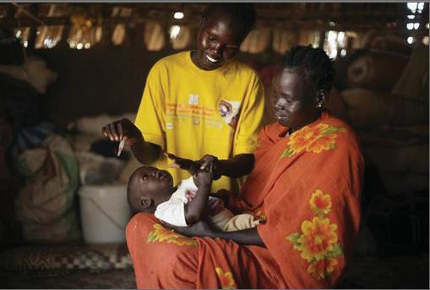
©UNICEF/Sokol
- Divide the participants into pairs.
- Assign each pair one of the following scenarios to role play. One participant should role play as the caregiver and the other as the FLW. The FLW should find at least one or two ways to appreciate the caregiver.
- Select two or three pairs to act out their role play scenario for the larger group.
- Ask the participants to share situations in which they might find it difficult to appreciate or praise a caregiver.
- Allow other participants to give suggestions on how to appreciate caregivers in those situations.

Trainers' Facilitation Guide - For Global IPCI
16
MODULE 1 - PRINCIPLES OF INTERPERSONAL COMMUNICATION

Appreciating the caregiver role play scenarios

A father brings his newborn in for her first immunizations since birth. | A very shy mother brings her child for immunization. She answers all the FLW’s questions with one-word answers and seems afraid (or not interested) in asking any questions.
An experienced mother has brought her child for every immunization session, so he is now fully vaccinated.  The young mother arrived just after the last | A mother brings her child for his second round of immunizations one month late.
child had been immunized and taken away by his father. You are tired and ready for lunch. She explains that her transport broke down, but she still wants her baby immunized. | A wife explains to her husband that she wants to vaccinate the child, but he refuses to allow it.
During the group discussion, a father asks why he should allow an FLW to vaccinate his child when other children have gotten a fever after vaccination. | After listening to the FLW explain the importance of vaccination during a home visit, the caregiver still refuses.
A mother brings her child for immunization but overwhelms you with questions. | A young father brings his child in for immunization. He says he cannot wait for the group discussion to finish because he must go to work.

Reflection Questions
  - Why is it important to appreciate a caregiver during an immunization visit?
  - How can appreciating caregivers motivate them to return for the next visit?
  - What are the positive and reaffirming statements a caregiver might like to hear?

Trainers' Facilitation Guide - For Global IPCI
17
MODULE 1 - PRINCIPLES OF INTERPERSONAL COMMUNICATION

Exploring Provider Perspectives And Barriers And Problem Solving
Objectives

To examine how providers’ attitudes and barriers impact the healthcare experience and access to immunization

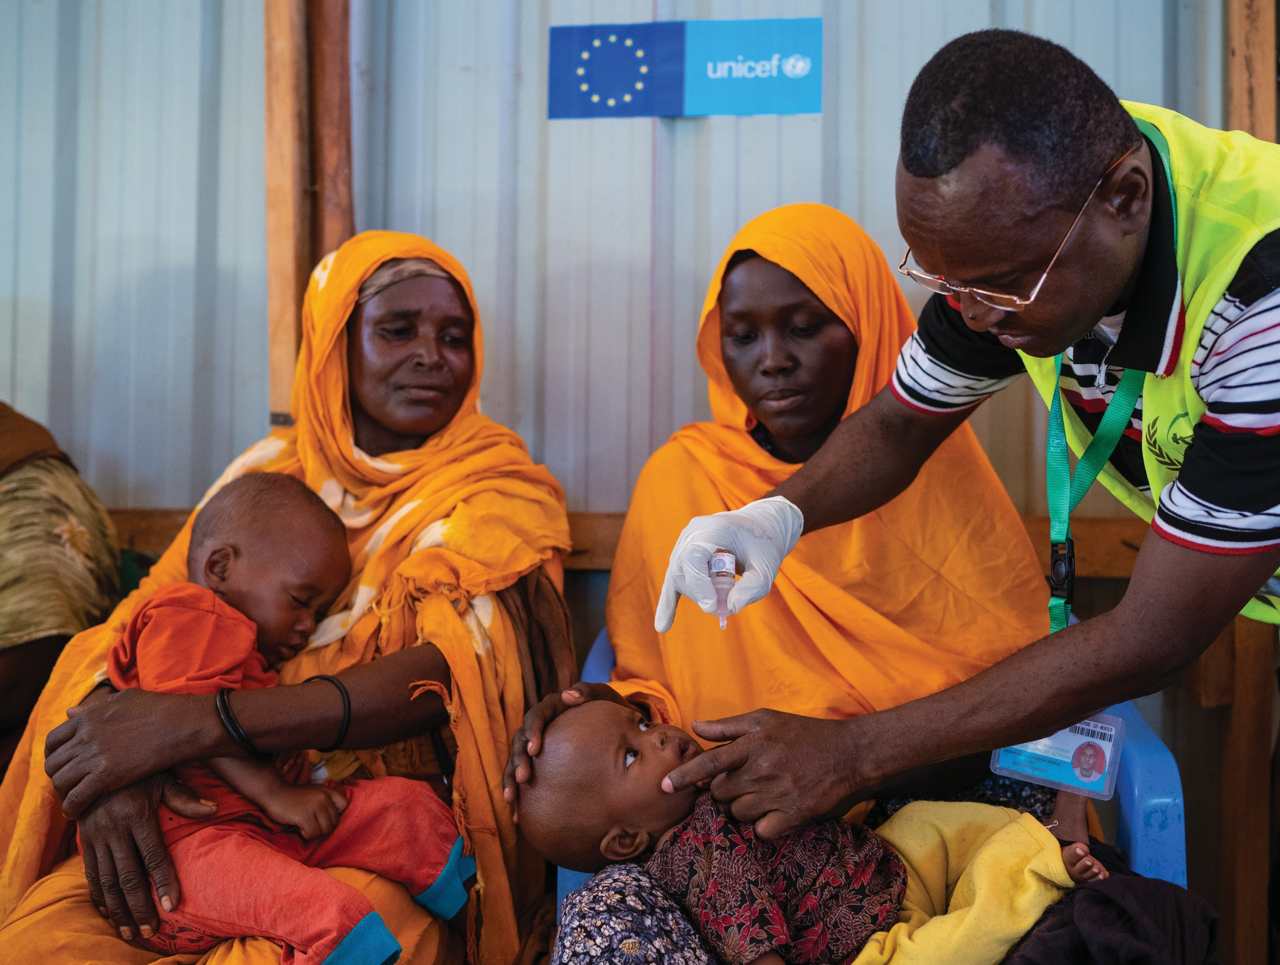To encourage FLWs to try strategic problem solving to overcome barriers
MODULE 2
©UNICEF/Knowles-Coursin

Session 2.1 Respect And Equity
It is the responsibility of everyone within the healthcare system to treat people with respect, regardless of any aspect of their identity. It is important for FLWs to demonstrate the following to all caregivers: empathy, interest, tolerance for values and beliefs, unbiased attitudes, patience, gentleness, friendliness, and willingness to support them.
Activity: Reflection on Experiences
- Distribute a piece of paper and writing utensil (marker or pen).

- Instruct participants that this activity will be silent.

- On the piece of paper, participants will record an incident when they felt they were treated unfairly.
  - They can record the incident in writing or as an image.
  - Give them 10 minutes to record the memory.
  - Next, in pairs, participants will share this memory with one another. Make sure partners ask one another:
    - Why this incident stands out?
    - How it made them feel?
    - Why do they feel they were being treated unfairly?
Each person should listen carefully to their partner as they may be asked to relate the story back to the group.
  - Request a few volunteers to share the stories that they heard. Volunteers should ask for their partner’s permission before sharing their story with the larger group.
Activity: Dimensions of Diversity
- In the large group, ask participants to brainstorm reasons that people might be treated differently or unfairly; examples include race, ethnicity, nationality, gender, disability, age, education, income, and religion.
- The participants should return to their pairs. Each pair should discuss the ways in which a particular dimension of diversity might positively and negatively affect the healthcare experience of and access to immunization. Assign each pair one of the ‘dimensions of diversity’ below:

Dimensions of Diversity:

Internal dimensions: age, gender, race, ethnicity, physical ability, and sexual orientation

External dimensions: geographic location, marital status, parental status, appearance, work experience, educational background, religion and spirituality, income, and personal habits

- Next, they should discuss how they, as an FLW, can help to address and lessen any negative healthcare experiences that are rooted in a caregiver/client’s identity.
- Depending on the amount of time remaining, select a few pairs to share what they discussed.

Trainers' Facilitation Guide - For Global IPCI
19
MODULE 2 - EXPLORING PROVIDER PERSPECTIVES AND BARRIERS AND PROBLEM SOLVING

Reflection Questions

  - How might your own biases affect your interactions with caregivers/clients?
  - What can you do to ensure you treat all caregivers/client equitably, regardless of their identity?
  - How can your personal beliefs help you become a more empathetic service provider?

Session 2.2 Provider Barriers
Multiple factors have been linked to the underutilization of services. One commonly noted factor is that a provider’s barriers may translate to access barriers for their clients. Service providers are among the most influential sources of information in community settings and serve as crucial facilitators in reducing client barriers to services.1 However, FLWs have their own experiences, perspectives, and biases that can challenge their ability to adequately deliver immunization services. They may be faced with a number of personal and professional barriers that contribute to poor quality or insufficient service. A provider’s personal opinions and biases, attitudes and behaviours, capacity and skills, and working conditions may all impact their ability or motivation to deliver quality services. It is important for FLWs to understand their barriers, so they can work with their supervisors, the health system, and interested citizens to address how those barriers and perspectives negatively impact interactions with caregivers and clients.

Note to facilitator:

Before the session, please prepare a few discussion points or key messages to conclude the activity. You may consider giving the participants to stand between agree or disagree in a “middle ground”.
Activity: Agree-Disagree
Place a sign that reads ‘Agree’ on one side of the room. Place another sign that reads ‘Disagree’ on the other side of the room. As you read aloud the following statements, ask participants to stand next to the ‘Agree’ sign if they agree and next to the ‘Disagree’ sign if they disagree with the statement. After the participants are comfortably settled next to the sign of their choice, have one person from each side provide an example of a time when they felt this way. You may choose to add more issues related to how the health system treats FLWs. This set of statements is a good place to start:

(Continued on next page)
AGREE DISAGREE

Trainers' Facilitation Guide - For Global IPCI
20
MODULE 2 - EXPLORING PROVIDER PERSPECTIVES AND BARRIERS AND PROBLEM SOLVING

- On most days, I enjoy my job.
- I feel motivated to do whatever it takes to protect the health of the community I serve.
- I feel respected and supported.
- Seeing a child complete their immunization schedule gives me personal satisfaction.
- I am always patient, respectful, and kind when dealing with caregivers.
- Sometimes my facility runs out of vaccines and I have to turn caregivers away.
- I often find it difficult to provide good IPC because I need to rush due to so many caregivers and children waiting for vaccination.
- Some caregivers do not deserve to be treated with kindness.
- I sometimes get angry at caregivers who forget their child’s immunization card or come late for vaccinations.
- I feel confident confronting a coworker who is treating caregivers/clients poorly.
- I feel like I have the training and information I need to respond to caregivers’ questions on immunization, vaccines, and vaccine-preventable diseases.
- I receive support from my supervisors that enables me to improve my performance.
- I have opportunities to expand my skills and move to more responsible and better compensated positions in the health system.

Session 2.3 Problem Solving
FLWs cannot solve all of their problems alone. For example, the common problem of overcrowded vaccination sessions can be addressed by, for example, expanding vaccination hours or days, working with community leaders to encourage caregivers to bring children during less crowded times (usually afternoons), and setting up a counselling table at the facility exit. More essential information could be given during community health talks, so less time is needed for individual sessions.

Open this session by asking the participants who are their supervisors and what type of support they currently receive.

Trainers' Facilitation Guide - For Global IPCI
21
MODULE 2 - EXPLORING PROVIDER PERSPECTIVES AND BARRIERS AND PROBLEM SOLVING

Problem solving is a constructive process focused on how to adapt, be flexible, and effectively deal with an immediate or long-term problem or obstacle. The steps are as follows:

Step 1
Identify the problem.

Step 2
Brainstorm possible strategies to address it

Step 3
Engage others to generate possible solutions

Step 4
Examine the advantages and disadvantages of each

Step 5
Determine which strategy might be the most effective
and select the best solution

Step 6
Develop a plan of how to carry out the solution

Step 7
Take action using the plan

Step 8
Evaluate how well the solution addressed the problem

Activity: Problem Solving

Now that participants have shared the types of barriers they experience in their work, they should brainstorm solutions for dealing with these barriers. Divide the participants into groups of four people each. Allow each group to select one of the barriers mentioned in the agree–disagree exercise (e.g., time constraints, low motivation, difficult caregivers, lack of support, or low technical knowledge). Give them 15 to 20 minutes to brainstorm a skit (short play) that demonstrates the challenge and a communication-based solution for addressing it.

Trainers' Facilitation Guide - For Global IPCI
22
MODULE 2 - EXPLORING PROVIDER PERSPECTIVES AND BARRIERS AND PROBLEM SOLVING

Reflection Questions
  - What were the similarities and differences in the solutions and approaches the groups proposed?
  - How does this eight-step process differ from how you normally approach solving problems?
  - How do you see yourself using the problem-solving process in your workplace? Your community? Your household?
- How can this process be applied to resolving challenges for caregivers?

IPC/I Video: Supportive supervision and problem solving

The problem-solving process does not need to be an independent exercise. Look to supervisors and other FLWs for additional support to address the challenges you and your clients face. See the video ‘Supportive Supervision and Problem Solving’ for an illustration of how supervisors can help to support problem solving.

This video illustrates the process of guiding and coaching FLWs to promote compliance with standards of practice and assure the delivery of quality health services. It focuses on strengthening communication, identifying and solving problems, facilitating teamwork, and providing leadership and support to empower healthcare providers to monitor and improve their own performance.

Reflection Questions

  - What kinds of issues can a supervisor help you address?
  - What kind of issues can a fellow coworker help you address?
  - What can you do to strengthen the relationship with your supervisor?

Trainers' Facilitation Guide - For Global IPCI
23
MODULE 2 - EXPLORING PROVIDER PERSPECTIVES AND BARRIERS AND PROBLEM SOLVING

Key Takeaways

- Problem solving is a practical and helpful process that focuses on brainstorming and evaluating possible solutions then taking action.
- Learn to seek help from supervisors, coworkers, and others to address problems and barriers at work that will ultimately impact caregivers and uptake of immunization.
- Realize that biases and attitudes of FLWs play a crucial role in the counselling experience.

Trainers' Facilitation Guide - For Global IPCI
24
MODULE 2 - EXPLORING PROVIDER PERSPECTIVES AND BARRIERS AND PROBLEM SOLVING

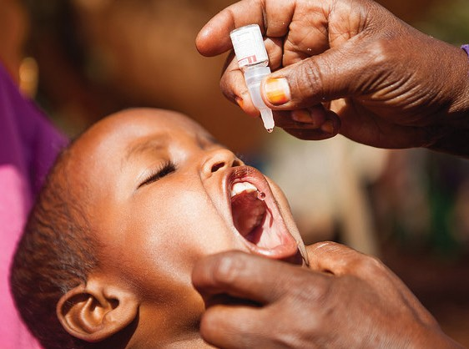Immunization And Vaccines
MODULE 3

Objectives

Understand the mechanisms of immunity and the immunization schedule

Describe the cause of infections

Explain how the body develops immunity

Know the various types of vaccines ©UNICEF/Sewunet

Note to Facilitator:

Before conducting this session, probe into what participants already known about immunization and vaccines and focus on what is not known or well-understood.

Session 3.1 Immunity
Immunity is the ability of the human body to tolerate the presence of materials indigenous to the body and resist materials foreign to the body. This discriminatory ability provides protection from infectious disease, since most microbes are identified as foreign by the immune system. Immunity is generally specific to a particular organism or group of closely related organisms and is usually indicated by the presence of an antibody to that organism. There are two basic ways to acquire immunity against infections – active immunity and passive immunity.

Active Immunity

Active immunity is acquired when a person’s own immune system is stimulated to produce antigen- specific antibodies and immune cells. This type of immunity often lasts for many years and, in some cases, may be lifelong. Active immunity can be divided into natural and artificial active immunity.

Natural active immunity: This type of immunity is acquired after an individual has survived an infection with the disease-causing form of the organism.

Artificial active immunity: This type of immunity is acquired through vaccine administration.

Passive Immunity

Passive immunity occurs when antibodies are transferred from one person and/or animal to another. Passive immunity disappears over time, usually within weeks or months. It is divided into natural passive immunity and artificial passive immunity.

Natural passive immunity: Passively acquired antibodies are responsible for the protection of newborns and young infants against certain diseases. The transfer of antibodies from mother to fetus across the placenta during the last two to three months of pregnancy provides the newborn with a portion of the mother’s immunological experience.

Artificial passive immunity: ‘Borrowed’ antibodies can protect a person temporarily. These borrowed and prepared antibodies are from the serum (antiserum) of a person or animal that has been exposed to an antigen and has produced antibodies that are then purified and directly

injected to the person at the site of infection to immediately counteract the offending antigen. Sources of passive artificial immunity include blood and blood products, immune or *hyperimmune globulin, and animal antitoxins.

- Hyperimmune globulin is prepared from the plasma of donors with high titers of antibody against a specific antigen. Some agents against which hyperimmune globulins are available include hepatitis B, rabies, tetanus toxin, and varicella-zoster.

Trainers' Facilitation Guide - For Global IPCI
26
MODULE 3 - IMMUNIZATION AND VACCINES

Herd Immunity

This is the protective effect given to the few unimmunized individuals in a community that has a high proportion of its population immunized. Herd immunity usually is strongest when a high percentage of individuals are immunized and evenly distributed in a given area. A community becomes susceptible to the disease if a large number of nonimmune people – either by birth or immigration – enter the area. There are two ways of developing herd immunity:

  - High natural infection rate in the community
  - Artificial immunization

Activity: How Vaccines Work - Pop Quiz
Ask the following questions aloud. Read each answer choice. Ask participants to raise their hand based on the answer choice they think is correct. Whoever raised their hand to the correct answer can be provided a small treat (such a piece of chocolate). Be sure to share the correct answer (highlighted) and explain why it is true.

Question 1. Which of the following is true about the immune system?

- The immune system is an infection that harms the body.

- Skin and mucous membranes are not part of the immune system.

- The immune system does not help the body fight disease.

- Vaccines help the immune system fight disease

Question 2. Which of the following is true about vaccines?

- Giving an infant multiple vaccines can overwhelm its immune system.

- Vaccines are made from adjuvant, stabilizers, and preservatives.

- Natural immunity works better than vaccines.

- Ingredients in vaccines are harmful.

Question 3. Which of the following diseases mainly affects children under five years of age and remains endemic in only two countries?

- Rubella

- Polio

- Measles

- Tetanus

Trainers' Facilitation Guide - For Global IPCI
27
MODULE 3 - IMMUNIZATION AND VACCINES

Question 4. Which of the following is NOT a vaccine-preventable disease?

- Cervical cancer

- Polio

- Hepatitis B

- Asthma

Question 5. How many infants worldwide are still missing out on basic vaccines?

- 1.4 million

- 5.9 million

- 6.8 million

- 18.7 million

IPC/I Audio Job Aid: Can vaccines help to eradicate or eliminate certain diseases?

This audio job aid provides an overview of how a disease can be eradicated and the role that vaccines play in increasing immunity, with the aim of ultimately eradicating diseases. The audio job aid also explains why some diseases, particularly those with environmental reservoirs, may never be eradicated, pointing to the importance of widespread vaccination against those diseases.

Reflection Questions
- What are some of the challenges in achieving high levels of population immunity for all diseases?
- How would you simply explain the importance of population immunity to a caregiver?
- What IPC skills were used in the audio?

Session 3.2 Vaccines
Vaccines are produced and distributed with the principal goal of preventing and protecting against serious diseases. The efficacy of vaccines has been shown all over the world. Many diseases that were once common, such as polio, measles, mumps, and tetanus, are now rare and under control.

Vaccines are proven safe and effective. They are held to high safety standards and carefully monitored from the start of the development process to the time they reach the child. A quality assurance system is in place to ensure that vaccines are as safe as possible and are closely monitored throughout the immunization production and delivery system. The vaccine safety system starts from quality control at the level of the manufacturer and continues through the supply chain and cold chain to the delivery point where the vaccines are administered. Manufacturers make sure to they maintain a high level of quality control throughout the manufacturing and transportation of the vaccines to the health facilities. In [country], there is a quality assurance system in place to ensure that vaccines are as safe
as possible and are closely monitored throughout the immunization delivery system.

Trainers' Facilitation Guide - For Global IPCI
28
MODULE 3 - IMMUNIZATION AND VACCINES

Quality and Safety

The World Health Organization works closely with national experts and authorities to ensure and support the quality, safety, and effectiveness of all vaccines. They, along with partner countries and coordinating bodies, establish a set of safety standards to ensure vaccine safety, including:
  - Conducting a thorough review of the evidence on the efficacy and safety of the vaccine
  - Establishing quality standards for specific vaccines
  - Testing every batch for potency (to ensure it works effectively to protect against the specific disease), purity (to ensure that certain ingredients used during production have been removed), and sterility (to ensure that it does not contain any outside germs).

  - Establishing a vaccine monitoring system for detecting and investigating AEFIs

Types of Vaccines

There are three types of vaccine: live attenuated, inactivated (either whole cell or cell fractions), and recombinant (genetically engineered) vaccines. In communities that are sceptical about the make-up of vaccines, effective communication may need to focus on providing assurances about vaccine safety and side effects.

Live Attenuated Vaccines

Live attenuated vaccines are derived from disease-causing viruses or bacteria that have been weakened under laboratory conditions. Examples of live attenuated vaccines include:

- Viral: Oral polio vaccine (OPV), measles, and yellow fever
- Bacteria: Bacillus Calmette-Guerin (BCG), oral typhoid (Salmonella typhi), and oral cholera

Inactivated Vaccines

Inactivated vaccines are produced by growing viruses or bacteria and then inactivating them with heat or chemicals. Because they are not alive, they cannot grow in a vaccinated individual and, therefore, cannot cause the disease. Multiple doses are required for full protection. Booster doses are needed to maintain immunity because protection by these vaccines diminishes over time.
Examples of inactivated vaccines include:

- Viral: Injectable polio vaccine (IPV) (Salk), hepatitis A, influenza, and rabies
- Bacterial: Whole-cell pertussis, inactivated cholera, and anthrax

Recombinant Vaccines

Recombinant vaccines are produced by inserting genetic material from a disease-causing organism into a cell, which replicates the proteins of the disease-causing organism. The proteins are then

Trainers' Facilitation Guide - For Global IPCI
29
MODULE 3 - IMMUNIZATION AND VACCINES

purified and used as vaccine. Examples of inactivated vaccines include:

  - Hepatitis B and human papillomavirus (HPV)

Session 3.3 Vaccine-Preventable Childhood DisYeEasSes

IPC/I Audio Job Aid: The importance of immunizations and new vaccines
This audio job aid reviews key reasons why it is important that all children are fully vaccinated, including the benefits to the individual child, family, and community. The audio job aid also explains why it is beneficial that new vaccines are being developed and introduced to protect us from even more diseases.

Reflection Questions
- How would you use IPC skills to convince a caregiver that their child should follow the recommended vaccination schedule so they can be fully vaccinated?
- Why do you think a caregiver may be hesitant to have their child receive a newly introduced vaccine? What could you say to convince them to allow their child to receive the vaccine?
Activity: Guess that Vaccine-Preventable Disease NO

Instructions
Note to facilitator: You will need to prepare a PowerPoint presentation/slide deck ahead of time for this activity with 16 slides. On each slide include You can use the IPC/I Reference Cards as a reference. The slides should present key facts about each vaccine-preventable disease featured in the Reference Cards, one disease per slide. If you do not have access to a projector, copy a few key facts about each vaccine-preventable disease onto flip chart paper. Use one piece of paper per vaccine-preventable disease.

- Invite a volunteer to stand in the front of the room and face the rest of the participants.
- Display either one of the vaccine slides or flip chart paper, so that it can be seen by the workshop participants but not the volunteer.
- The task of the volunteer is to identify what vaccine-preventable disease is on the slide using only ‘yes’ or ‘no’ questions.
- When the volunteer asks a question, the audience can only answer with a ‘yes’ or ‘no’, providing no additional information.
- The volunteer may ask up to 15 ‘yes’ or ‘no’ questions.
- They can only guess the disease once. The game is over once they either reach 15 questions or guess the disease correctly.
- Alternate volunteers, using a different slide for each volunteer as time allows.

Trainers' Facilitation Guide - For Global IPCI
30
MODULE 3 - IMMUNIZATION AND VACCINES

IPC/I Quick Reference Cards

See the IPC/I Quick Reference Card Deck for more information on immunization and vaccines.

The cards are split into four decks: (1) general IPC/I guidance, (2) key immunization messages and FAQs, (3) common vaccine-preventable diseases, and (4) review questions. For Decks 1 and 2, each card has focus questions related to the topic of the card that are explicitly answered. Deck 3 answers key questions about a specific vaccine-preventable disease and its corresponding vaccine. Deck 4 provides review questions and answers.

Trainers' Facilitation Guide - For Global IPCI
31
MODULE 3 - IMMUNIZATION AND VACCINES

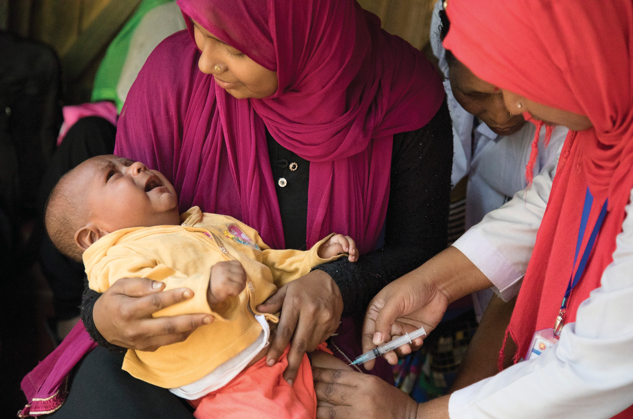Profiling Types Of Caregivers
MODULE 4
Objectives

Discuss parental concerns and categories of hesitant parents

Review specific case examples to illustrate types of concerns that caregivers have

Discuss how to address specific and general concerns of caregivers

©UNICEF/Krishan

Session 4.1 Understanding Vaccine Hesitancy
Vaccine hesitancy refers to people’s negative attitudes and perceptions (primarily fears and lack of trust) of vaccination. These perceptions may lead people to accept all vaccinations (but with concerns), no vaccinations, some vaccinations, the recommended schedule, or an alternative schedule. Addressing vaccine hesitancy is not a simple task as a multitude of factors can potentially influence a person’s decision to seek out or accept vaccination for themselves or their child. The specific factors leading to hesitancy need to be identified so that the most appropriate communication can be applied. The information needed to address hesitancy will differ by subgroup, context, setting, vaccine, and amount time available for a discussion.

Understanding The Situation

There are many reasons why a caregiver might hesitate to have their child receive some or all vaccinations. Caregivers make decisions based on their knowledge and available information; their own experiences with the diseases and vaccinations; and what they hear from the media, family, friends, and service providers. What makes discussion about vaccination complicated, is that a caregiver’s decisions and attitudes may vary depending on the type of vaccine or their experience with health services.

It is important to remember that immunization is a process that includes many points of contact with the health system and providers. Once a caregiver brings a child for their first vaccinations, the service experience becomes at least as important as the caregiver’s perceptions when they came to that first visit. The service experience includes caregivers’ perceptions of how long and how comfortably they waited, how well they felt they were treated, whether their child received all of the vaccinations due (or did not because of stockouts), whether the FLW clearly communicated essential practical information such as the return date, and whether the child developed worrying side effects that the FLW did not prepare the family for. Second, few caregivers totally reject any vaccination (some do, of course). Rather, most have specific concerns, such as injection pain or side effects, perceived dangers of a child getting too many vaccinations at too young an age or in the same visit, and concern over certain ingredients in vaccines. Some caregivers may be members of a religious group whose leadership rejects vaccination. All of these concerns need to be discussed.

The table that follows outlines common determinants that contribute to attitudes and beliefs towards vaccines.

Trainers' Facilitation Guide - For Global IPCI
33
MODULE 4 - PROFILING TYPES OF CAREGIVERS

Table 1. Working Group Determinants of Vaccine Hesitancy Matrix

CONTEXTUAL INFLUENCES
Influences arising due to historic, sociocultural, environmental, health system/institutional, or economic or political factors
- Communication and media environment
- Influential leaders, immunization program gatekeepers and antivaccination or provaccination lobbies
- Historical influences
- Religion, culture, gender, and socioeconomic factors
- Politics/policies
- Geographic barriers
- Perception of the pharmaceutical industry

INDIVIDUAL AND GROUP INFLUENCES
Influences arising from personal perceptions of the vaccine or the social/peer environment
  - Personal, family, and community members’ experience with vaccination, including pain
  - Beliefs and attitudes about health and prevention
  - Knowledge and awareness
  - Health system and providers – trust and personal experience
  - Risk/benefit (perceived and learned)
  - Immunization as a social norm vs. not needed/harmful

VACCINE/VACCINATION- SPECIFIC ISSUES
Directly related to vaccine or vaccination
- Risk/benefit (epidemiological and scientific evidence)
- Introduction of a new vaccine, formulation, or recommendation for an existing vaccine
- Mode of administration
- Design of vaccination program/mode of delivery (e.g., routine program or mass vaccination campaign)
- Reliability and source of vaccine supply or vaccination equipment
- Vaccination schedule
- Costs
- The strength of the recommendation, knowledge base, or attitude of healthcare professionals

Source: SAGE working group, 2014.
Activity: Examples from the local context
During this exercise, participants will independently reflect on interactions with caregivers that demonstrated any of the reasons for hesitancy. They can either write out or illustrate their three examples.

- After presenting the table above, instruct the participants to brainstorm three examples of interactions with caregivers, one from each row, that demonstrated these concerns.
  - What did the caregiver say? Be specific.
  - How did you determine whether their concern was a contextual influence, individual/group influence, or vaccine-specific issue? What was the question they asked or comment they made?
  - How did you respond to the caregiver?
- Select a few participants to share their examples with the larger group.

Trainers' Facilitation Guide - For Global IPCI
34
MODULE 4 - PROFILING TYPES OF CAREGIVERS

Session 4.2 Profiling Caregivers
Identifying parental concerns

The profiling tools below can help you determine whether a caregiver might be hesitant to vaccinate their child. If caregivers answer ‘yes’ to any of these questions, then they may be hesitant to accept some or all vaccinations. The extended tool can be used during longer caregiver interactions, while the modified tool can be used during brief interactions. The questions do not need to be read directly to the caregiver, the information can be interpreted through conversation. This tool may be useful where vaccine hesitancy is a known problem that blocks higher coverage; however, it is not recommended in countries or regions where vaccine hesitancy is not a major factor limiting coverage.

Extended Profiling Tool
1.
2.
3.
4.
5.
6.
7.
8.
9.
10.
11.
12.
13.
14.
15.

Have you ever intentionally delayed having your child get a vaccine for
reasons other than illness or allergy? Yes / No
Do you have any cultural, religious, or personal belief
regarding immunization? Yes / No
Have you ever decided not to have your child get a vaccine for reasons
other than illness or allergy? Yes / No
Are you certain that following the recommended vaccine schedule is
a good idea for your child? Yes / No
Has your child or any child you know become seriously ill or injured after
an immunization? Yes / No
Are you concerned that your child might get a serious side effect from
a vaccine? Yes / No

Are you concerned that any of the vaccines might not be safe? Yes / No

Do you feel that children get more vaccines than is good for them? Yes / No

Do you feel that it is better for children to get fewer vaccines at the
same time? Yes / No
Do you feel that many of the illnesses that vaccines prevent are severe
or deadly? Yes / No

Are you concerned that a vaccine might not prevent the disease? Yes / No

Do you feel that it is best for a child to develop immunity by getting sick
(natural immunity) rather than to get a vaccine? Yes / No
Do you feel that you have all the information you need to immunize
your child? Yes / No

Do you trust the information you receive about vaccines? Yes / No

Overall, are you confident about immunization for your child? Yes / No

Modified from the Parent Attitudes about Childhood Vaccines Survey Tool, University of Washington School of Medicine Seattle, WA, USA

Trainers' Facilitation Guide - For Global IPCI 35

MODULE 4 - PROFILING TYPES OF CAREGIVERS

Modified Profiling Tool

Yes / No
1. | Do you feel that children get more vaccines than is good for them?
2. | Do you feel that it is better for children to get fewer vaccines at the same time?
3. | Do you feel that it is best for a child to develop immunity by getting sick (natural immunity) rather than to get a vaccine?
4. | Do you feel that you have all the information you need to immunize your child?
5. | Do you trust the information you receive about vaccines?
6. | Are you confident about immunization for your child?

Yes / No Yes / No Yes / No
Yes / No

Yes / No

Some Types Of Hesitant Caregivers

Uninformed But Want More Information

These caregivers are uninformed about vaccination and are turning to you, because of your expertise as a healthcare professional, and they want you to assure them that vaccines are safe and effective.
- Listen to their concerns.
- Answer their questions.
- Explain basic facts in easily understood terms.
- Share experiences that demonstrate the benefits of vaccines.
- It may be helpful to tell them about how your child(ren) are fully vaccinated and that vaccination is something you strongly recommend.

Misinformed But Open To Correction

These caregivers have inaccurate information about vaccines and the diseases they prevent. They may believe misinformation, myths, or rumours about immunization.

- Listen to their beliefs.
- Provide them with relevant information or experiences to disprove myths and misinformation.
- Discuss the strong benefits of vaccines.

In addition: Discover the sources of misinformation because they may be ongoing and can negatively affect current efforts.

Trainers' Facilitation Guide - For Global IPCI
36
MODULE 4 - PROFILING TYPES OF CAREGIVERS

Well-Informed And Open-Minded
These caregivers are aware of arguments for and against vaccination. They will have many questions and concerns that they want resolved.
  - Help them to assess the merits of each argument by placing them in a proper context.
  - Discuss each concern and be prepared to have validated evidence to counter any antivaccination points.
  - Discuss the strong benefits of vaccines.
  - Point them to appropriate fact-based resources from well-respected sources.
  - Offer to follow up with them to dispel any further worry or doubt.
In addition: Encourage them to be advocates and spokespersons in the community

Informed And Refusing
These caregivers, whether well-informed, uninformed, or misinformed, are convinced that they do not want their child(ren) to be vaccinated.
  - Ask the caregiver to describe their concerns about vaccines.
  - Ask the caregiver what it is about vaccines that makes them concerned.
  - Acknowledge their concerns.
  - Address any misinformation with evidence and experiences.
  - Discuss the strong benefits of vaccines.
  - Point them to appropriate fact-based resources from well- respected sources.
In addition: Identify their influencers and work with them as allies.

Anti-Vaccine Champion
These caregivers not only refuse to vaccinate their child(ren) but try to convert others to their position.
  - Establish trust with these caregivers by listening to their perspective.
  - While it is important to respect their opinion, it is necessary to explain the importance of vaccines for the overall health of their child.
  - Correct any antivaccine myths and misinformation.
  - Refocus the conversation onto the positive effects of vaccines.
  - Explain the risks and responsibilities of not vaccinating their child.
  - In addition: Commit to continuing the dialogue about vaccines.
Some members of this group will never be convinced, but the FLW nevertheless needs to try.

Trainers' Facilitation Guide - For Global IPCI
37
MODULE 4 - PROFILING TYPES OF CAREGIVERS

Note to Facilitator:

For the activity below, you may need to limit the number of questions per group (e.g. half of the first profiling tool could be asked by one group).

Activity: Practice Profiling
During this exercise, participants will practice using the expanded or modified profiling tool to identify a caregiver’s level of knowledge and comfort with vaccination.

- Review the profiling tool and types of hesitant caregivers in the large group.
- Divide the participants into pairs: one person will play a caregiver and the other will play an FLW.
- The participant playing the caregiver should select one of the types of hesitant caregivers to role play. They should NOT tell their partner which type of caregiver they are role playing.
- Relying on the questions from the expanded or modified profiling tool, the FLW should guess the type of caregiver they are interacting with and respond to them accordingly.
- Give the group two minutes to act out this immunization session. Try to make the dialogue as natural as possible.
- At the end of the two minutes, the FLW should check with the caregiver to see whether they guessed correctly.
- Now the partners should switch places in the role play and repeat the exercise.
- Select a few participants to share their reflections on the activity. What was difficult? Is this how we typically assess and counsel caregivers?

Reflection Questions

  - What are other ways to assess a caregiver’s level of comfort with vaccination? Are there nonverbal cues?

  - What are some other useful ways to categorize types of caregivers that will help us determine how to communicate with that caregiver type during discussion and counselling sessions?

IPC/I Audio Job Aid: What to do if a caregiver refuses immunization

This audio job aid outlines some key reminders to give caregivers who refuse to immunize their child, including the risks involved and the additional responsibilities they have to protect their children and to protect others.

Reflection Questions
- What type of hesitant caregiver is the one in the audio job aid?
- Do you think that the key points presented in the audio job aid would be convincing to a hesitant caregiver?
- How would you use IPC skills to achieve a balance between communicating the danger of not immunizing a child but not scaring a caregiver or making them feel like they do not have a choice about immunizing their child?

Trainers' Facilitation Guide - For Global IPCI
38
MODULE 4 - PROFILING TYPES OF CAREGIVERS

Session 4.3 Communicating With Caregivers
Communicating effectively about vaccines with caregivers and communities is a key issue for the public health community to address. In addition to national campaigns, FLWs play a very important role in this communication. Building trust with caregivers is perhaps one of the most important things an FLW can do to promote vaccination. There are many approaches to communicating with caregivers. An atmosphere of caring, two-way dialogue and clear messages that address information gaps and concerns supports trust between caregivers and FLWs. Although many factors influence the decision to vaccinate, some studies have shown that the outcome of an immunization session can differ based on how a provider begins a conversation with a caregiver.

The Presumptive Approach

The presumptive approach assumes parents are fine with the vaccines that the FLW recommends. Using this approach, the FLW tells the caregiver which vaccine(s) the child will be given that day and states the reason for the vaccine and the potential side effects. If the caregiver consents to vaccination and has no objections or questions, then the vaccinator proceeds with vaccination. If the caregiver objects or has questions or concerns, then those questions and concerns are answered by using medical evidence or stories to convey the safety, effectiveness, and necessity of the recommended vaccine(s).

The Participatory Approach

The participatory approach focuses on addressing concerns and helping caregivers understand the importance and necessity of vaccines. Using this approach, the FLW asks the caregiver about their vaccination preferences and emphasizes the importance of shared decision making. However, some within the research and medical community feel that shared decision making is not appropriate for vaccination.

Regardless of the approach you use, have some tested and proven effective key messages on hand when you talk with the caregiver(s). A key message is a statement containing the main points of information you want to communicate to caregivers to address their concerns and promote the benefits of vaccines. A well-designed key message is simple, memorable, easily understood, culturally appropriate, and meaningful to the caregiver.

Sample Key Messages

- Vaccination is the most effective way to protect your child from life-threatening illnesses.
- Communities with towns that have lower vaccination rates have higher rates of life-threatening diseases.
- I am a parent, too, and I vaccinated my children. I also received vaccinations myself.

It is important to carefully consider which of the above communication approaches and messages are most successful with caregivers in your community. For example, some caregivers may respond effectively to the presumptive approach; some might need to hear negatively-framed messages to

Trainers' Facilitation Guide - For Global IPCI
39
MODULE 4 - PROFILING TYPES OF CAREGIVERS

be moved while others may prefer stories over scientific data.

Communicating With Caregivers

Regardless of the type of caregivers you meet, it is important to remember that they want their child to be healthy, they would like to be heard and respected by the provider, and they want credible information and the power to make an informed decision. Following these four practices will help you communicate with parents:

- Take time to listen

  - Let the parent finish speaking.

  - Resist the urge to multitask during conversation.

- Solicit and welcome questions

  - Ask for questions.

  - Convey that you have time to answer them.

  - Give concise answers to allow time for more questions.

- Acknowledge risks and benefits

  - While severe side effects do happen, they are extremely rare.

  - Non-vaccination is much more risky.

- Have both science and stories available

  - Parents will appreciate experiences you can share.

- Identify a safe and private space to discuss concerns

  - It is important to have these conversations in private so the caregivers feel safe and

Trainers' Facilitation Guide - For Global IPCI
40
MODULE 4 - PROFILING TYPES OF CAREGIVERS

you reduce the risk of influencing other caregivers.

What To Communicate During An Immunization Visit

The following issues may need to be covered, depending on individual needs and understanding:

- Why vaccination is important for children’s health
- Your child needs some vaccinations more than once to gain maximum protection from the specific disease.
- The number and timing of doses
- The importance of completing the series
- The importance of being aware of and complying with the due date(s) to return for the next dose(s)
- Potential discomforts after vaccination and what to do if they occur
- Explanation and reassurance in response to inaccurate information
- Importance of immunization cards and the need to keep them in a safe place and always bring them when bringing a child to health services
- Immunization session locations and times, especially for the next visit
- Which diseases are vaccine-preventable
- Vaccines schedules and the diseases vaccines prevent

In most circumstances, it will be more feasible to discuss the last two topics with groups of caregivers, rather than individually.

Reminders

There are many ways to remind caregivers when the next vaccination(s) is due, most involving IPC. Studies in the last few years have found that use of reminders can reduce dropout and improve timeliness. Some methods:

- Ensure the vaccinators write the date of the next vaccination(s) on the home-based record. This may require supervision and monitoring to reinforce instructions.
- The health facility can maintain a tickler system (manual or electronic) and remind the caregivers of upcoming vaccination dates by: SMSs, phone calls, or giving the list to a community-based person or group to make home visits to remind
- Assist communities to establish a method of monitoring each local child’s vaccinations, and remind caregivers’ in home visits of upcoming or missed vaccinations.
- Where there is a community vaccination focal person, as recommended in the RED/REC strategies, these persons can remind caregivers.

Trainers' Facilitation Guide - For Global IPCI
41
MODULE 4 - PROFILING TYPES OF CAREGIVERS

IPC/I Audio Job Aid: Sticking to the immunization schedule (including even when a child is sick)

This audio job aid describes how the immunization schedule has been developed and why it is important for it to be followed. The audio job aid also states that it is safe to bring a child for immunization even when they are mildly unwell and explains what to do if a child misses a
scheduled immunization.

Reflection Questions
  - What are some techniques you use to remind caregivers of the immunization schedule and ensure that they bring their children
on time?
  - What would you say to a caregiver who has stopped bringing their child for their scheduled immunizations and how would you help them get back on schedule?

IPC/I Video: Welcoming and communicating effectively For an illustration of client-centred care, see the video ‘Welcoming and communicating effectively’.

The video illustrates how to acknowledge caregiver and client perspectives and concerns. It focuses on helping caregivers understand their feelings about immunization and then addresses
their specific personal concerns and barriers.

Reflection Questions

  - What are some ways that the FLW encouraged the caregiver to freely voice their questions and concerns about vaccinating their children?
  - Other than what you saw in the video, what are some of verbal and nonverbal IPC skills you have adopted to make caregivers feel welcome and heard?

Facilitator’s Note:

Rather the conducting the activity below as skits, you may instead opt to divide participants into discussion pairs. These pairs should then develop key messages to be used in dialogue with each
of the four categories of caregiver outlined in the profiling section.

Activity: Finding-the-Right-Message Skits

- Divide the participants into small teams of four to six people.

Trainers' Facilitation Guide - For Global IPCI
42
MODULE 4 - PROFILING TYPES OF CAREGIVERS

- Assign each team one of the four types of caregivers (uninformed but want more information; misinformed but open to correction; convinced and refusing; or antivaccine champion).

- Allow the teams 15 minutes to prepare a skit illustrating what the caregiver believes about vaccines and an FLW communicating with that caregiver. The skit can show a facility-based interaction, home visit, community encounter, or a combination.

- The skit should be no longer that five minutes and involve all members of the team in some way.

- After each presentation, ask the audience to brainstorm as a group the key messages (no fewer than five) that would support an effective communication with that type of caregiver.

- Write the key messages on flip chart paper and encourage the participants to note the audience-specific messages.

Reflection Questions

  - What types of caregivers do we most often encounter in our work?
  - How can we best prepare to effectively communicate with them?

Trainers' Facilitation Guide - For Global IPCI
IPC/I Frequently Asked Questions
See the ‘Frequently Asked Questions’
resource for detailed guidance on how to respond to questions you are likely to encounter while interacting with caregivers. The resource provides key messages and supporting messages. This tool can be adapted to provide the most contextually relevant responses to common questions.
43
MODULE 4 - PROFILING TYPES OF CAREGIVERS

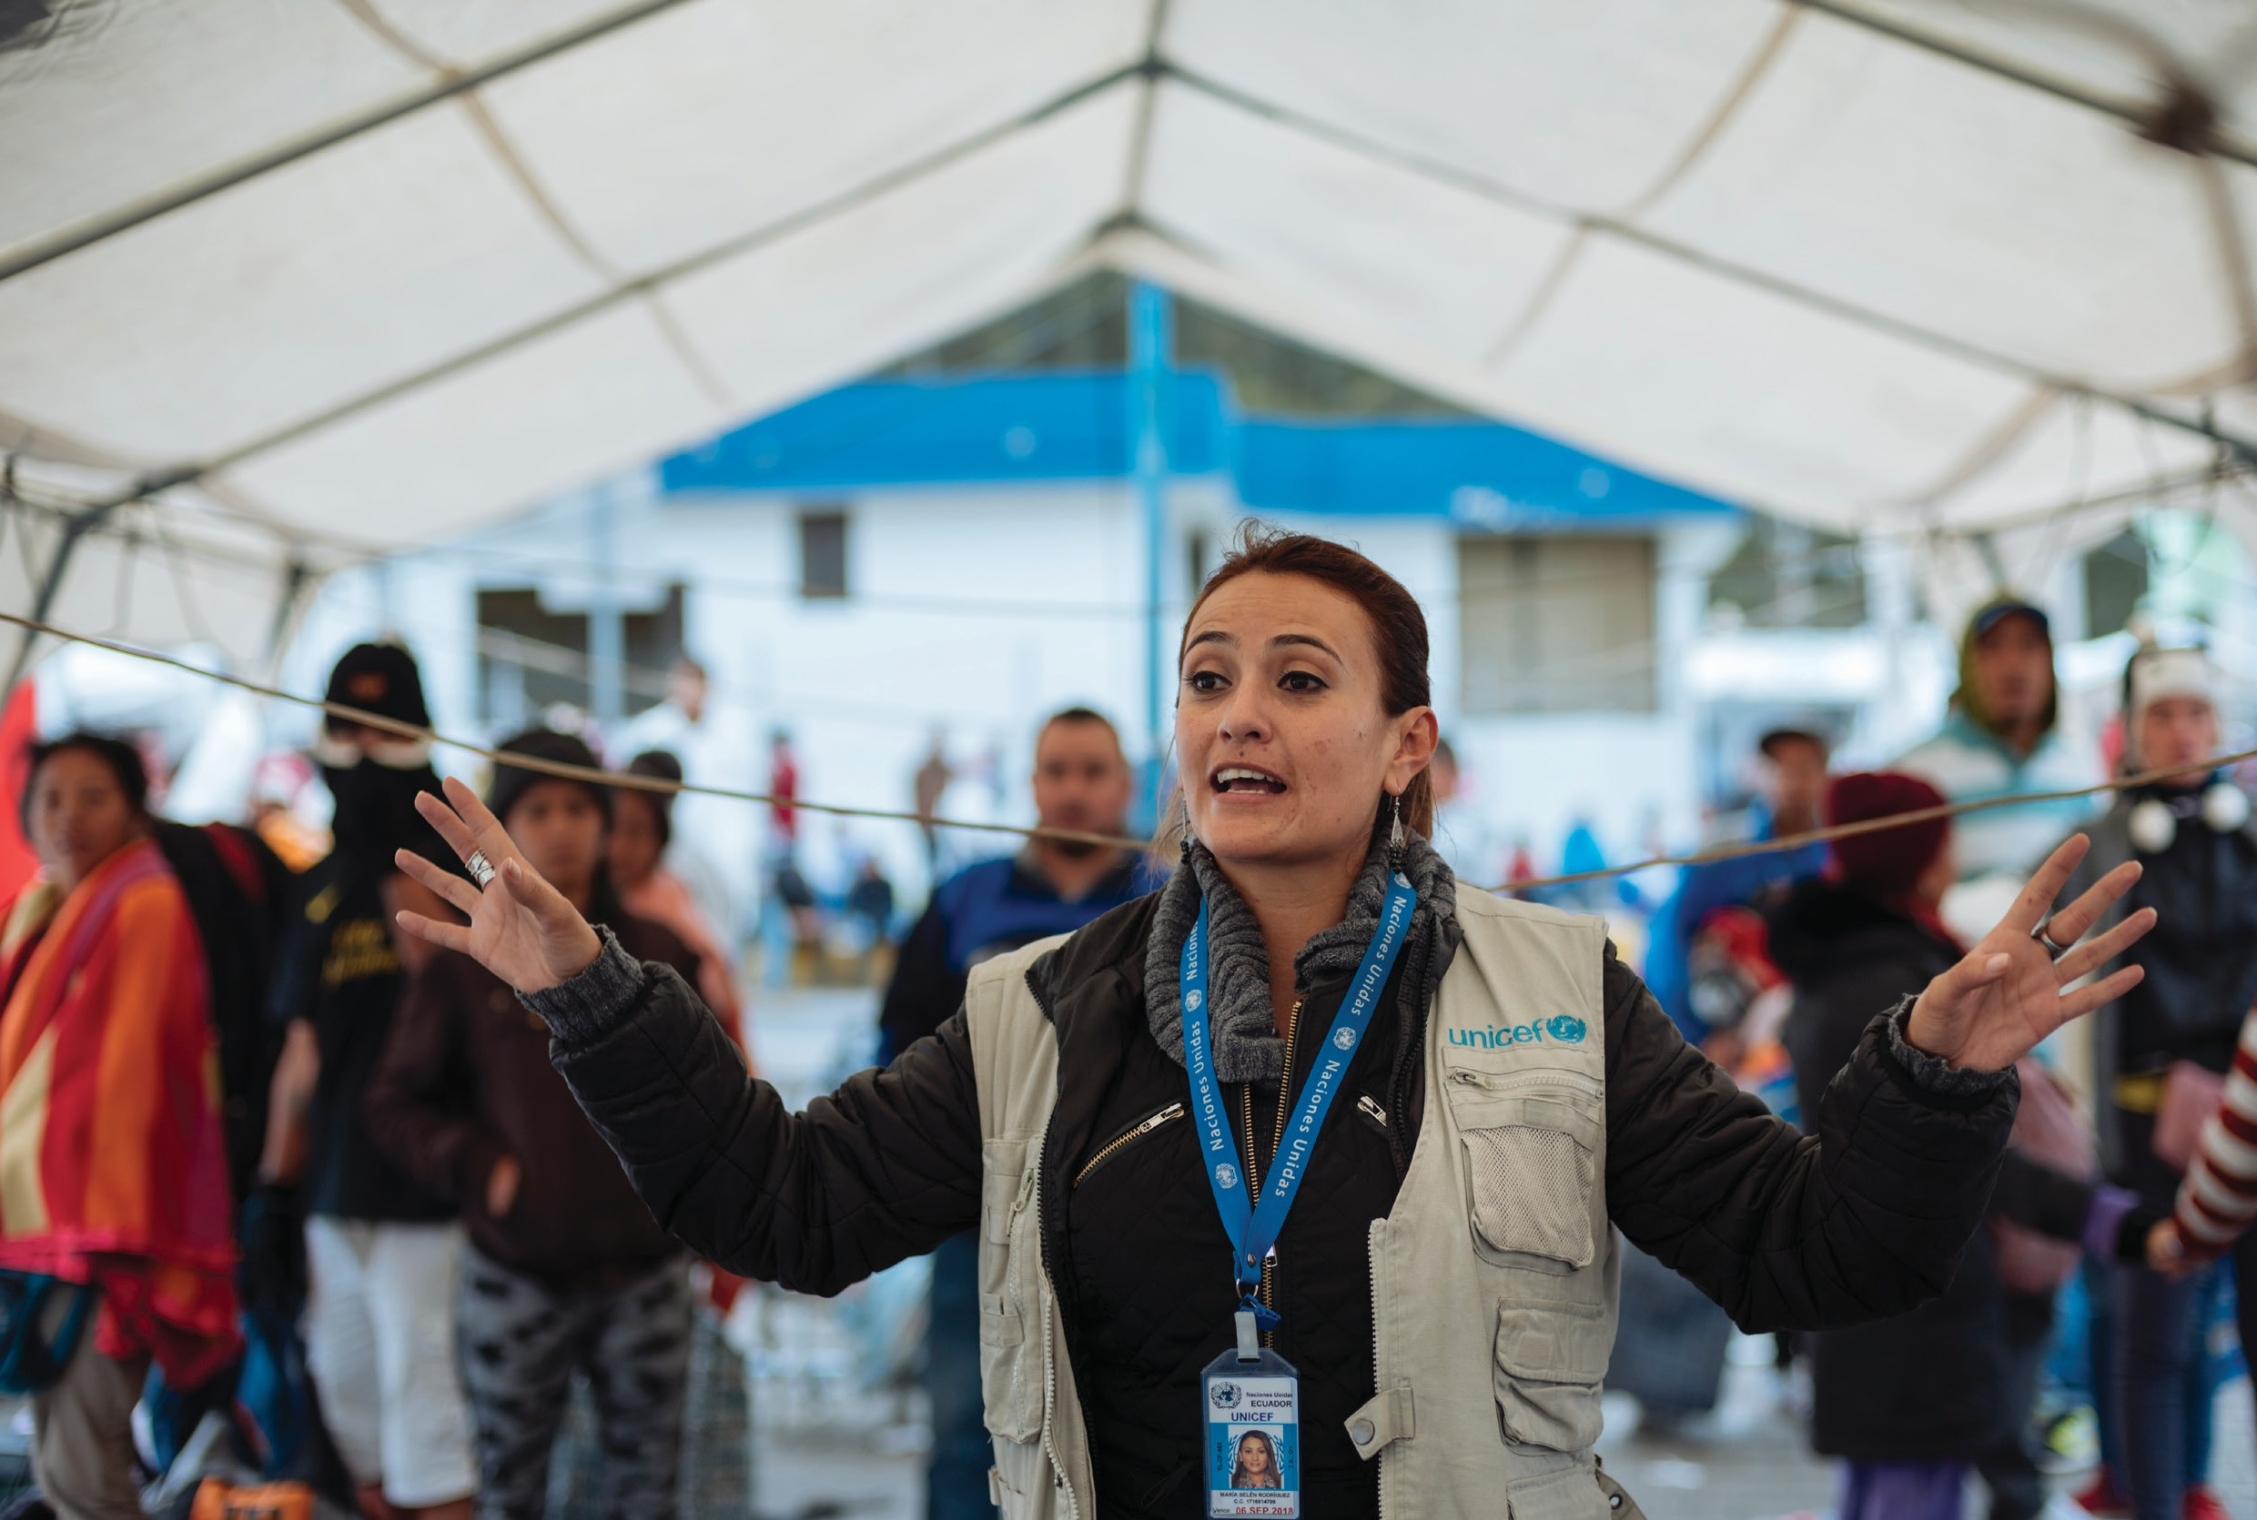Community Engagement

44 Trainers' Facilitation Guide - For Global IPCI
MODULE 5
Objectives

Describe reasons why engaging communities in immunization dialogues is important

Outline the steps to organize a community conversation or meeting

Develop appropriate content for a community meeting

Engaging the community in immunization issues can help to create awareness of services, stimulate demand for services, help motivate those who may be hesitant, and encourage community participation to reach difficult-to-reach or neglected (those who are left out of services) populations. Meeting with the community also provides an important opportunity to get people’s feedback and suggestions on improving health services.

Strategies to engage the community:

- Build alliances with community leaders.
- Use existing community structures for communication about immunizations and identify partners to collaborate with.
- Hold regular community meetings, share progress, and use community feedback to improve activities.
- Leverage community events/activities to literally ‘meet people where they are’.
- Arrange for selected community representatives to participate in microplanning (including outreach planning), development of communication campaigns, and data review meetings.
Note to Facilitator:
Throughout this section it is important to discuss how participants practice community engagement. They may be very familiar with the approaches outlined below; therefore, you made decide to spend the session discussing community engagement challenges and effective way to address them.
This section may also used to address defaulter tracing strategies, including management of the immunization register.

Session 5.1 Conducting A Needs Assessment
Approaches For Conducting A Needs Assessment

First, it is important to talk to people to learn about attitudes to immunization in the community, in particular whether there is opposition to it. If there is some resistance to immunization, you need to ask why this has occurred. Discussion with members of women’s groups and youth groups in your community may help you to find answers. In some cases, you may also want to speak to community leaders (traditional, elected, or religious) who are influential and can be allies or impediments, depending on how they are involved in these processes. You may be able to identify specific behaviours or attitudes that are creating a barrier to immunization in the community.

Consider organizing a committee to assess why people do not come to be vaccinated or do not complete their vaccinations. This would help to:

- Improve relations between you as an FLW and the community
- Promote participatory decision making to improve community involvement in the Expanded Programme on Immunization
- Support the community to develop strategies for identifying and tracing immunization defaulters
- Improve the quality of the immunization service
- Encourage the community to identify and report outbreaks of communicable diseases

Trainers' Facilitation Guide - For Global IPCI
45
MODULE 5 - COMMUNITY ENGAGEMENT

Focus Group Discussions

One of the most effective ways to quickly get a range of opinions is to arrange small focus groups, that have clear guidelines from you about the topic that the discussion should centre on. The ideal number of participants in a focus group is between six and 10. A facilitator keeps the discussion focused on the agreed topic (in this case, immunization) and makes sure that everyone’s views are heard. You could select particular participants, such as caregivers you think may not bring their children for immunization. In group interviews, if one participant starts sharing, others are more likely to join in with honest opinions and stories.

Sample questions to explore in the assessment:

  - Why are children not being brought for immunization?
  - Has there been an adverse incident in the past that has worried parents?
  - Is there an opinion leader in the community who is opposed to immunization and has persuaded others to resist it?
  - What, if anything, do they think they (or other community members) need to do to raise the communities’ use of immunization services or to otherwise improve or support those services?

One-on-One Meetings with Caregivers

You may also talk to caregivers one-to-one when they visit the facility or health post to learn about their good and bad experiences with the immunization services provided. However, if you ask caregivers about their service experience while they are still in the health facility, you are less likely to receive honest answers about how they felt, as they are unlikely to say anything negative even if they had a miserable experience. Try to reach caregivers in the community who, for one reason or another, do not visit the facility or health post. However, interview the caregivers who do visit the facility first, since they are readily accessible and are often willing to talk about their experience of the services. They may also suggest ways of reaching those who do not use facilities.

There are many things you might want to learn from caregivers, for example:

  - How close their child is to getting vaccinated on schedule
  - Any barriers to accessing existing services
  - If the times and locations of immunization sessions are appropriate for them
  - What they think about the quality of the service provided
  - How they think the service could be improved
  - What they already know about immunization
  - What concerns they may have about immunization
  - Their traditional beliefs about disease or immunization

Trainers' Facilitation Guide - For Global IPCI
46
MODULE 5 - COMMUNITY ENGAGEMENT

Meeting with Nongovernmental Organizations and Other Partners

Try to meet with any other partners or institutions that you think might be able to help improve the immunization service. Who these are will depend on your community, but may include traditional birth attendants, traditional healers, private health practitioners, volunteer groups, and representatives of nongovernmental organizations that focus on health, particularly the health of children.

Meetings with Special Groups

In your community, you may be aware of special groups that have been largely unreached by immunization services or have chosen not to participate in them. You should try to include these people or groups in your meetings and planning process from the start. Some examples of special groups include:

    - Pastoralist groups
    - Migrant populations
    - Ethnic or other minority groups
    - Groups in geographically remote areas who may find it difficult to reach the site of the immunization services
    - People who are injured, sick, or disabled who may find it difficult to get to where immunizations are taking place
    - Religious or traditional sects
    - Refugees
    - Homeless families

Session 5.2 Barrier Analysis
We need to use empathy when we learn the reasons a child is behind on vaccinations. In many cases, a caregiver may have sought vaccinations that the health facility could not provide due to, for example, stockouts, vaccinator absent, or the session ended before it was supposed to. The reason for falling behind needs to be clarified since it could be related to the family – such as the husband being angry at side effects and refused further vaccinations – or the service experience. A system should be in place for health facility staff to identify these children, whose families should be visited at home to understand the issue, and to try to resolve any impediments to continuing the vaccination schedule.

Trainers' Facilitation Guide - For Global IPCI
47
MODULE 5 - COMMUNITY ENGAGEMENT

Activity: Barriers Image Review
- Divide participants into small groups

- Distribute or display the image (see appendix B)

- Assign each group one of the characters in the image

- Next, ask each group to develop a profile or description of that individual. The profile should include:

  - What are this person’s thoughts, feelings, or beliefs about vaccination?

  - Why does person think/feel/believe those things about vaccination?

  - What has been their experience with vaccination?

- What barriers might they experience in trying to vaccinate a child or support vaccination?

- Each group will then share the character profiles and barriers to the larger group.
Reflection Questions
      - Which barriers were similar across the characters, which were different?
      - Imagine that all of these characters live in the same community. How do their thoughts/feelings/beliefs in regard to communication affect each other?
      - Who in the photo appears to have the most agency/power?
      - How might a woman’s barriers differ from her husband’s?
      - Who has the right to make the ultimate decisions about a child’s health?

Trainers' Facilitation Guide - For Global IPCI
48
MODULE 5 - COMMUNITY ENGAGEMENT

Barrier Analysis

If you can identify specific barriers to immunization, you will need to decide which barriers might be targeted in order to find a solution. Which barriers could be removed? How might their removal help to increase immunization coverage and decrease dropout rates?

Common reasons reported by caregivers to explain why their children were not fully immunized include:

    - Caregiver was unaware of the need for immunization
    - Caregiver feared adverse effects following immunization
    - Caregiver was unaware of need to return for next dose
    - Vaccine was not available
    - Vaccinator was absent
    - Family was having problems and/or the caregiver was ill
    - Place and time of immunization was unknown
    - Immunization site was too far away
    - Time of session was not convenient due to caregivers’ other responsibilities
    - Caregiver was unhappy about how they were treated in the health facility
    - Essential information, such as the return date, was not provided to caregiver by vaccinator

Reflection Questions
      - Which of the reasons listed do you think could be best addressed by improved communication?
      - How might you hope to address these barriers for an effective immunization service?
Key Takeaways
- Barriers to seeking immunization service include issues that can be resolved by better communication. These barriers include lack of knowledge about the need for immunization, the need to return for further doses, or the time and location of immunization sessions.
- Fear of adverse reactions is another barrier that good communication can overcome.

Trainers' Facilitation Guide - For Global IPCI
49
MODULE 5 - COMMUNITY ENGAGEMENT

Session 5.3 Conducting A Community Conversation
IPC/I Audio Job Aid: Barriers to vaccines – cost, time, and spousal refusal

This audio job aid addresses some of the most common barriers faced by caregivers in immunizing their children and provides examples of how an FLW might respond to a caregiver facing these barriers.

Reflection Questions
•

•
In addition to what you heard in the audio job aid, what other suggestions or
arguments would you give to a caregiver facing these common barriers?
What is another common barrier faced by caregivers and how would you help a caregiver overcome this barrier?

Activity: Story and Brainstorm
Ask a volunteer to read the following:
A health worker glances at the calendar and realises they have scheduled a community outreach meeting for the following day. The next day, they arrive at the venue and find no one there.

Ask participants:
- What are the possible reasons no one showed up to attend the immunization meeting?
- How could this have been avoided?

Discussing Immunization With Communities

Our job is to identify and arrange communication opportunities to exchange information with community members. During these opportunities, FLWs can share technical information about vaccinations, the importance of vaccination, and practical information about using health services. Meanwhile, community members can teach FLWs how they feel about services, how services can become more convenient and friendlier, how services can reach families who are not currently being reached, and how they can mobilize their neighbours more effectively.

Trainers' Facilitation Guide - For Global IPCI
50
MODULE 5 - COMMUNITY ENGAGEMENT

Many approaches or activities can be used to exchange information between health services and communities about immunization. Which one you choose will depend on the specific community audience you want to engage and the most appropriate way to reach them. Communication approaches might include a community conversation, community mobilization, or advocacy campaign. You will need to plan what you want to do, when you hope to do it, how many people you will need to help you, and who these people might be.
Your interactions may take place in community meetings, religious places, market places, and so forth. You may need to use written materials, such as posters and leaflets, to communicate your messages.
Dramatic television shows, plays, and local community radio broadcasts may also help your communication messages to be heard and understood.

Community Conversation

Community conversations are successful when everyone is given the opportunity to be heard. Because many will not participate fully in a meeting unless they feel at ease and believe their opinions will be heard, to organize a successful community conversation, you should consider the following points:

    - Decide on the purpose of the conversation and advertise it widely.
    - Decide who should attend or be invited based on your intended audience.
    - Prepare an agenda for the meeting.
    - Decide on the date and time and make sure that everyone you want to attend is informed about the meeting’s time and location.
    - Choose a meeting place that allows everyone to hear one another’s views.
    - Facilitate the conversation in an open and non-judgmental way, so everyone feels included and respected.

When to Arrange a Community Conversation

There are many situations where you might decide to arrange a community conversation about your immunization program, for example:

    - If you have large numbers of families who do not bring their children for immunization
    - If you have a high dropout rate
    - If any children have had serious adverse reactions after immunization
    - If you believe there are negative rumours circulating in the community about immunization

Trainers' Facilitation Guide - For Global IPCI
51
MODULE 5 - COMMUNITY ENGAGEMENT

Who to Involve in a Community Conversation

The appropriate people to invite will depend on the context and situation:

  - If you have large numbers of families who do not bring their children for immunization, you could invite representatives of those families and any neighbours who do bring their children for immunization.
  - If you have a high dropout rate from the immunization program in areas of your community, you could invite parents from families whose children started their vaccinations but did not complete them.
  - If children have had serious adverse reactions after immunization, you might invite the parents of those particular children, along with other parents whose children were not
adversely affected.
  - If you believe there are negative rumours circulating in the community about immunization, you might invite those you believe are being influenced by the rumours, along with community leaders and other influential people in your local community who support immunization.

Assessment, Monitoring, And Evaluation

You will need to find ways to assess whether your strategy or activity is working. Here are ways you might try to evaluate the effectiveness of your activities:

  - You could record how many people attended the meeting or community conversation and who they were.
  - You could see if these people brought their children for immunization or brought them more regularly than before.
  - If someone who is not known to you brings their children for immunization for the first time, you could ask how they knew that immunization services were available. This could help you establish whether those who were present at the meeting or community conversation informed others.
Activity: Planning a Community Conversation
4
3
2
1
*You will need the “Steps to Community Meetings” worksheet (Appendix E).

- Divide the participants into teams with four participants in each group.
- Distribute one ‘Steps to Community Meetings’ handout to each group. The handout should be pre-cut into tiles along the dotted lines.
- Instruct each group to organize the tiles in the proper order.
- The group that organizes the cards in the correct order the quickest wins a prize or recognition.
- Read the correct answer to the entire training group and ask if they have any questions.
- Ask the group to share any tips they have for hosting effective community conversations.

Trainers' Facilitation Guide - For Global IPCI
52
MODULE 5 - COMMUNITY ENGAGEMENT

A sample community conversation agenda can be found in Appendix F.
Reflection Question
  - How could you evaluate whether your message was understood and whether it has made a difference to people’s behaviour?

Key Takeaway

- Carefully plan community meeting to address the specific attitudinal, informational, or behavioural barrier the community is facing.

IPC/I Video: Engaging communities and community leaders in dialogue
The video takes you through the process of identifying and engaging community leaders to increase vaccine acceptance.

Reflection Questions
  - How can engaging community leaders help to strengthen immunization communication?
  - Who should be involved in educating and mobilizing community members?

IPC/I Video: Engaging communities and community leaders in dialogue
The video takes you through the process of identifying and engaging community leaders to increase vaccine acceptance.

Reflection Questions
- How can engaging community leaders help to strengthen immunization communication?
- Who should be involved in educating and mobilizing community members?

Trainers' Facilitation Guide - For Global IPCI
53
MODULE 5 - COMMUNITY ENGAGEMENT

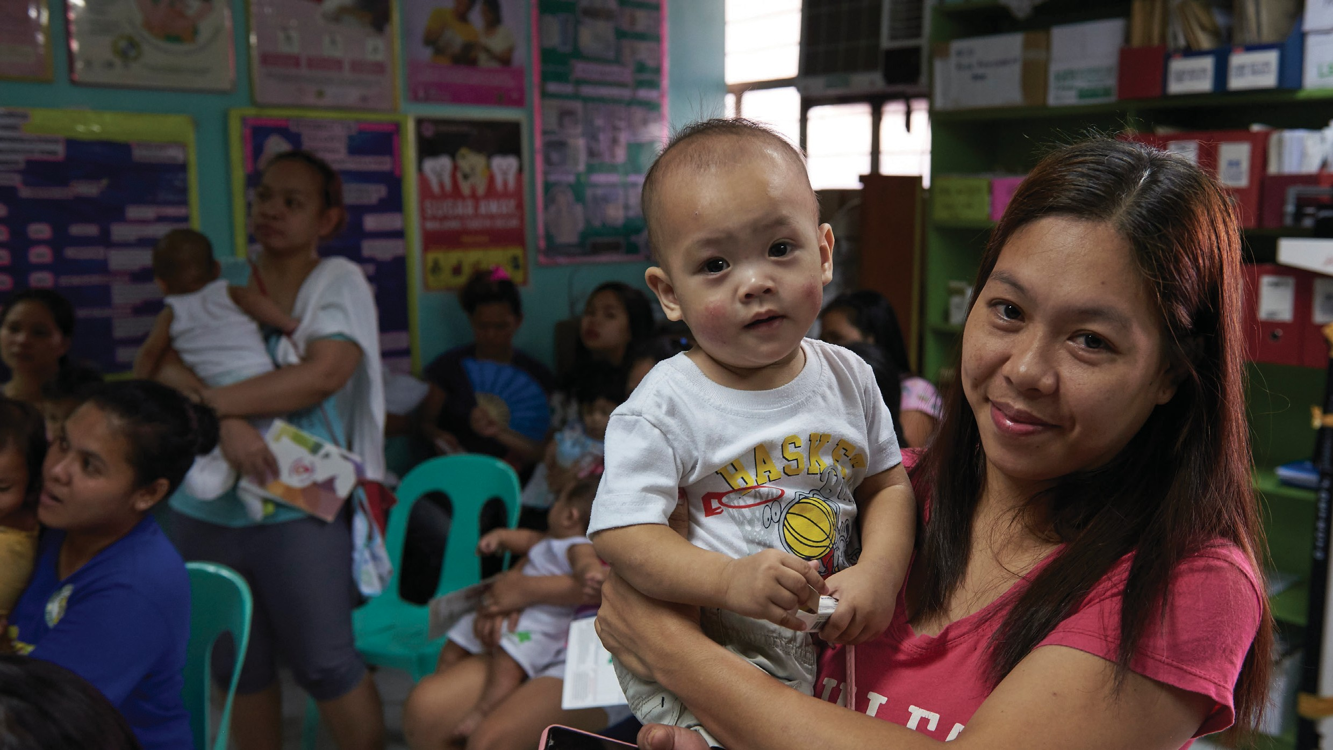Addressing Negative Rumours, Myths, And Misconceptions

54 Trainers' Facilitation Guide - For Global IPCI
MODULE 6

©UNICEF/Noorani

Rumours about bad consequences of immunization may circulate in communities and, increasingly, on the internet. If such negative rumours are not dealt with appropriately, they can have a serious effect on demand for immunization services. Any negative rumours about immunization that you hear circulating should be communicated to your supervisor as soon as possible. The following suggested actions cannot be carried out by you alone. Immediate reporting is important, and advice should be sought before you take action.

Before you conduct these activities, it is important to invest in building trust within the community. To gain trust from the community, it is critical to maintain caregiver and client confidentiality; act in a responsible manner during interactions with the community, possess good knowledge on the health topics you deliver and be available when the community needs you.

Communicate and demonstrate that you are acting in their child’s best interests and are committed to their health.

Session 6.1 What Can Be Done About A Negative Rumor
What can you do about negative rumours?

- First, try to find out what the rumour is, who started the rumour, and who is spreading the rumour now. Try to establish whether there is any reason for the rumour – there might be a political or religious reason, or the rumour may have simply arisen from a lack of information or incorrect information about the immunization program.
- Once you have gathered this information, arrange a meeting with opinion leaders, such as local government officials, traditional and religious leaders, community leaders, and other health workers. In the meeting, begin by providing information about the immunization program and the diseases it can prevent. Try to ensure that the individuals present are free to ask questions and express concerns. Discuss and reach agreement on the ways they can collectively use to correct negative rumours and incorrect information about the immunization service.
- Identify the correct information about vaccines and how to deal with the rumour.
- Disseminate the correct information about immunization to the public. This can be done through communication materials, regional or national campaigns, radio programming, community education and so forth.

Strategies that can be used to reach people who are hard to convince, including the following:
- Identify the groups that are involved in perpetuating the rumours/misinformation.
- Engage key informants to find out the nature and reasons for rumours/misinformation.
- Visit influential people/leaders for one-on-one discussions.
- If relevant, meet with media representatives, such as radio and television or internet contributors.
- Hold discussions with leaders and community members to address the rumours/ misconceptions.
- Seek endorsement statements from credible authorities, such as members of government, church leaders, and medical professionals.
- Invite respected/trusted authorities to participate and discuss the issues with community members.

Trainers' Facilitation Guide - For Global IPCI
55
MODULE 6 - ADDRESSING NEGATIVE RUMOURS, MYTHS, AND MISCONCEPTIONS

Activity: Addressing Rumours Speed Rounds
IPC/I Video: Addressing rumours or myths and health workers’ role in vaccine
safety events

Rumours can be fuelled by inadequate/inaccurate knowledge, mistrust of the government, past experiences of poor treatment by health workers, or other personal, social, or political reasons. The video illustrates strategies to address rumours, myths, and misconceptions, particularly about vaccine safety.
Reflection Questions
- What are some specific strategies that the protagonists in the video employed to address rumours, myths, and misconceptions in the community?
- Thinking back about your own experience or the experience of someone you know, was there a time when a successful strategy was used to stop a rumour or myth? If so, how was it done?

  - In the large group, brainstorm a list of rumours/myths/ misconceptions.
  - Record these ideas so that everyone in the training can see them.
  - Assign half of the participants to play caregivers and the other half to play FLWs in a facility setting.
  - Assign each of the caregivers one of the rumours/
myths/misconceptions. They will role play a caregiver who believes the rumour/myth/ misconception to be true.
  - Match one FLW with one caregiver. The caregiver will maintain the same character for the first half of this activity.
  - The FLW will have 60 seconds to practice responding to and effectively addressing the caregiver’s beliefs.
  - They should pretend that this is a real visit with a caregiver and use the skills they have learned throughout the day.
  - The FLW should rotate after 60 seconds and conduct another mock visit with another caregiver character.
  - Each FLW should practice with at least five different caregiver characters.
  - Now repeat Steps 3 through 9. The participants who played caregivers in the first round will now play FLWs and vice versa.
  - After the activity, bring the group back together in plenary to develop messages that respond to each of the rumours (scenarios) that were brainstormed and role-played in step 1.

Trainers' Facilitation Guide - For Global IPCI
56
MODULE 6 - ADDRESSING NEGATIVE RUMOURS, MYTHS, AND MISCONCEPTIONS

Note to Facilitator:

Encourage participants to record the responses to rumours so that they can reference them later when conducting IPC with caregivers.

Reflection Questions
    - What was challenging about this exercise?
    - How effectively did you remember to address each of the points within the ‘What to
    - communicate during an immunization visit’ list?
    - Do you feel you adequately addressed the caregiver’s beliefs? If not, what other strategies could you have tried?

Session 6.2 Communicating Potential Adverse Events Following Immunization
An adverse event following immunization (AEFI) is any unexpected medical occurrence that follows immunization; it may or may not have a causal relationship to the vaccination. AEFIs consist of both common mild side effects that go away quickly and very rare more serious symptoms or illnesses, most of which just happen to occur at that time and would have occurred with or without the vaccination. The adverse event may be any unfavourable or unintended sign, abnormal laboratory finding, symptom, or disease. AEFIs can either be the result of the vaccine or immunization process, or coincidental events that are not due to the vaccine or immunization process but happened to occur after immunization. If an AEFI occurs, the most important thing to do is to communicate correct and reassuring information as quickly as possible. People need to know that their concerns are shared by health services, the situation is being investigated and will be addressed, and they will be kept informed.

Causes Of Adverse Events Following Immunization

The majority of AEFIs are actually not due to the vaccine itself – many are coincidental events, while others are due to human or program error.

Vaccine product-related reaction: An AEFI that is caused or precipitated by a vaccine due to one or more of the inherent properties of the vaccine product.

Vaccine quality defect-related reaction: An AEFI that is caused or precipitated by a vaccine because of one or more quality defects of the vaccine product, including its administration device, as provided by the manufacturer.

Immunization error-related reaction: An AEFI that is caused by inappropriate vaccine handling, prescribing, or administering, and by its nature is preventable.

Trainers' Facilitation Guide - For Global IPCI
57
MODULE 6 - ADDRESSING NEGATIVE RUMOURS, MYTHS, AND MISCONCEPTIONS

Immunization Error-Related
Reaction Possible Adverse Event

Non-sterile injection
  - Reuse of disposable syringe or needle
  - Improperly sterilized syringe or needle
  - Contaminated vaccine or diluents
  - Reuse of reconstituted vaccine at subsequent session

Vaccine prepared incorrectly
  - Vaccine reconstituted with incorrect drugs or other substance substituted for vaccine or diluent.
Immunization injected in wrong site
  - Subcutaneous instead of intradermal for BCG
  - Too superficial for toxoid vaccine (diphtheria,
  - pertussis, and tetanus [DPT]; diphtheria and
  - pertussis [DT]; or tetanus toxoid [TT])
  - Buttocks
Infection
- Local suppuration at injection site
- Abscess
- Cellulitis
- Systemic infection
- Sepsis
- Toxic shock syndrome
- Transmission of blood-borne virus like HIV, hepatitis B, or hepatitis C

- Effect of incorrect diluent or drugs

- Local reaction or injection site abscess
- Sciatic nerve damage (and ineffective vaccine)

Vaccine transported or stored incorrectly • Increase local reaction
  - Ineffective vaccine

Contraindications ignored • Avoidable severe reaction such as anaphylaxis
Citation: United Nations Children’s Fund (UNICEF) Regional Office for South Asia. (2005). Building trust and responding to adverse events following immunization in South Asia: Using strategic communication. Working paper. Kathmandu, Nepal: UNICEF Regional Office for South Asia.

Immunization anxiety-related reaction: An AEFI arising from anxiety about the immunization.

Coincidental event: An AEFI that is caused by something other than the vaccine product, immunization error, or immunization anxiety.

The following points are important to communicate when discussing potential AEFIs:

- Adverse side effects following vaccination are very rare.
- The occurrence of adverse events does not mean that vaccines are unsafe.
- If a child has high fever or becomes severely sick immediately following vaccination, the child should be brought to a health worker for advice and/or treatment.
- If a child experiences an adverse event, the caregiver should write down what happened and the date and time it happened and report it to the FLW immediately. The doctor, nurse, or health
department should file a ‘Vaccine Adverse Event Report’.

Trainers' Facilitation Guide - For Global IPCI
58
MODULE 6 - ADDRESSING NEGATIVE RUMOURS, MYTHS, AND MISCONCEPTIONS

Activity: Adverse Events Following Immunization Case Study

- Ask a volunteer to read the following case study aloud.
- Divide the participants into groups of four.
- Ask the groups to discuss for 15 minutes how and what the FLW could do to restore trust in immunization in the community where an AEFI has occurred.
- Ask each group to share with the larger group their top two ideas for restoring trust.

The Kivanjititis Campaign in Chimorgia

Chimorgia (a fictional country) implemented a nationwide mass Kivanjititis (a fictional vaccine-preventable childhood bacterial disease) campaign in August 2018. Two weeks after the start of the campaign, FLWs in Sanjimania District started to hear that several families were saying that their children developed symptoms including diarrhoea, high fever, and injection-site abscesses after receiving the Kivanjititis vaccination. Five children were admitted to the district hospital. Tragically, two of these children died in the hospital a few days after being admitted. One week after the deaths of the children, admissions of children citing similar symptoms increased to 13. However, the condition of most admitted children improved quickly. According to some caregivers at the hospital, another young two-year-old boy with similar symptoms in the nearby district of Loehria seemed to have died on the way to the hospital within around the same time that the two other children died. The investigation team attributed the incidents to immunization error-related reactions and action is being taken to correct the cause of the error.

Caregivers are demanding an explanation, saying:

  - ‘It is your fault, why are you doing this to us? Why did you kill our children? What is your motive?’
  - ‘We do not even know whether the vaccines are safe. We will never vaccinate again.’

Case study adapted from: United Nations Children’s Fund (UNICEF), & World Health Organization. (n.d.).
AEFI and IPC skills: A four-hour training course for health workers. New York: UNICEF.

Note to Facilitator

Before initiating the communication response, first, an analysis of how many sick children were and were not recently vaccinated should be conducted, followed by an investigation of the cases to try
to determine the cause(s).

Trainers' Facilitation Guide - For Global IPCI
59
MODULE 6 - ADDRESSING NEGATIVE RUMOURS, MYTHS, AND MISCONCEPTIONS

Reflection Questions

- What would it take to restore trust between FLWs and the communities across Chimorgia?
- What should be said to caregivers whose children suffer from an AEFI?
- What could have been done before the incident to reduce its impact on people’s confidence in vaccination?

IPC/I Audio Job Aid: Side effects of immunization

This audio job aid explains common side effects from immunizations and what can be done to reduce the severity of common reactions to immunizations. The audio job aid also illustrates how side effects can fuel rumours about the safety of immunization.

Reflection Question
- How would you use IPC skills to address a caregiver who is concerned about vaccine safety due to a misunderstanding about side effects?

Session 6.3 Risk Communication

Risk Communication Essentials

Listen to what the public is saying.

Understand local perceptions of the disease, injections, and the vaccine.

Make sure everyone is giving out the same information, tailored to the specific situation and audience.

Enlist trusted spokespersons to provide information. Make sure to communicate the benefits of vaccination. Avoid technical terms and long words or phrases.
Anticipate counterpoints and prepare effective responses.

Trainers' Facilitation Guide - For Global IPCI
60
MODULE 6 - ADDRESSING NEGATIVE RUMOURS, MYTHS, AND MISCONCEPTIONS

Techniques For Handling Difficult Communications

- Respond to negative questions with a positive answer.
  - Example Question: ‘How many children have died from vaccination?’ Answer: ‘Since our immunization program began, XX children have been vaccinated and very few (or none) have died from vaccination itself. Without vaccination, children’s risk of getting a potentially life- threatening disease is far greater than the risk of the vaccine.’

- When responding to a difficult point or question, respond to the comment but add something positive.
  - Example Comment: ‘One person died shortly after receiving the vaccine! How can you explain this?’ Response: ‘Immunization saves lives. The death was related to an allergic reaction and not the safety of the vaccine.’

- Immediately correct information that is wrong.
  - Example Comment: ‘Many children tested positive for HIV shortly after receiving the vaccine.’ Response: ‘One child in this community tested positive for HIV when they received their health screening and vaccination. This was their first vaccine. The positive HIV test result is not linked to the vaccination.’

- Be assertive but not aggressive and state the facts simply, factually, and in a friendly way.

- Do not repeat any negative questions/statements in your answers:
  - Example Comment: ‘Some children have become ill from vaccines. Why do we have immunization?’ Response: ‘Vaccines save children’s lives.’
Activity: Practice with difficult conversations
During this exercise, participants will practice using the risk communication essentials and techniques for Difficult Communications listed above to respond to community members’ aggressive and difficult questions and comments following rumours of an AEFI.

- Review the two lists mentioned above.
- Ask each participant to work with the person sitting next to them.
- Together the pair should brainstorm a few rumours they have heard. These can be actual rumours in their community or rumours borrowed from other contexts.
- Then, go to each pair and ask them to name one of the rumours they have heard.
- Write the rumour on the board or a flip chart paper.
- Keep going around the room until you have a list of at least 10 rumours.
- Then ask for volunteer pairs to role play a community member and an FLW discussing the rumour.
- They should select one of the rumours from the list the group generated.
- Give the pair two to three minutes to act out a dialogue. They should try to make the dialogue as realistic as possible.

Trainers' Facilitation Guide - For Global IPCI
61
MODULE 6 - ADDRESSING NEGATIVE RUMOURS, MYTHS, AND MISCONCEPTIONS

- At the end of the dialogue, ask the group to provide feedback on how well the FLW addressed the rumour.
- Repeat the exercise with a few more pairs or the entire participant group.
- Select a few participants to share their reflections on the activity. What was difficult? Is this how we typically address rumours? What other tips and recommendations should be added to the essentials and techniques lists?

Key Takeaways

- Be sure to inform your supervisor and other health staff if negative rumours about immunization are circulating in your community.
- While discussing a potential AEFI, it is important to communicate about the safety of the vaccine, things to be done in case a child becomes sick immediately following immunization, and the fact that adverse events following vaccination are very rare.
- Make sure that accurate knowledge about immunization services is widely circulated. You can do this by posting notices where they will easily be seen, telling all your clients when you see them at the facility, in their homes, at the market, and so forth.
- Ongoing health education sessions in the facility and community are key to preventing the spread of rumours.

Trainers' Facilitation Guide - For Global IPCI
62
MODULE 6 - ADDRESSING NEGATIVE RUMOURS, MYTHS, AND MISCONCEPTIONS

Action Planning And Workshop Closing
Objectives

Understand the benefit of receiving community feedback and using it to improve services

Learn strategies to gather feedback from community members in an open and honest manner

Learn to work with influential

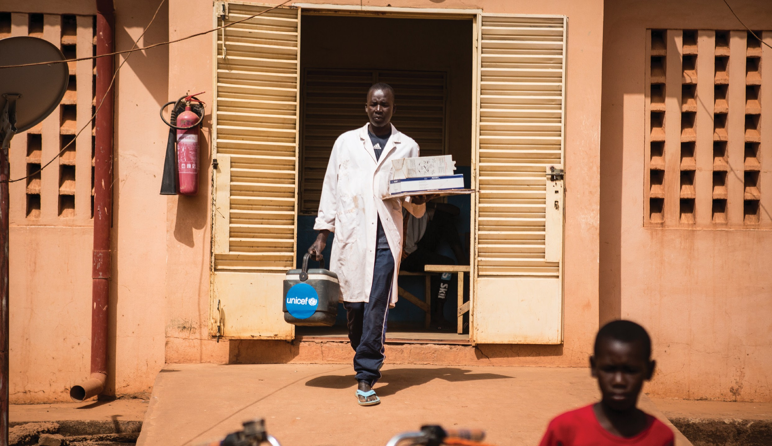members of the community who can advocate for immunization

Trainers' Facilitation Guide - For Global IPCI 63
MODULE 7

©UNICEF/Keïta

Session 7.1 Collecting And Using Community Feedback
Community feedback is an essential component of an effective immunization program. Listening to community feedback can alert FLWs to problems and guide actions to address them. To ensure that you are continuing to provide the best possible service, you must listen to what caregivers and communities are telling you. Doing this will give you the information you need to improve your interactions with communities and caregivers and to help managers make better decisions about immunization services, which should, in turn, improve caregiver satisfaction and increase the number of children within your community who receive timely vaccinations.

Why Collect Community Feedback

Actionable feedback guides better decision making. Communities know what does and what does not work for them. Given the opportunity in a safe environment, they will tell you if what you are doing is unsatisfactory and praise you if you are doing it right. If people feel afraid of giving honest but critical opinions – for example, being asked in a health facility about services or being asked by a health worker who typically gets angry when people ask questions – they will simply give you the answers they think you want to hear, which will not be useful. Providing a safe environment means letting them know you really value and want to use their feedback and will not use anything they say against them. This is crucial; otherwise, people will only tell you what they think you want to hear. Community and individual feedback is useful because it can:

  - Identify caregivers at risk of not fully utilizing immunization services
  - Identify caregivers who are not happy with immunization services or have problems using them (e.g., because of the service hours)
  - Identify and help you stop recurring problems
  - Help quickly and proactively solve the problems that are causing caregivers to not return for services
  - By listening, show caregivers and communities that you care and help build mutual understanding and respect, which goes a long way to building a positive relationship
  - Identify potential immunization advocates

Strategies For Getting Community Feedback

Four actionable strategies to get community feedback.

Caregiver Interviews or Surveys

These can be as simple as brief exit interviews where you ask caregivers a few questions. Exit interviews are useful for learning how well FLWs communicated and caregivers understood key information, such as the return date. However, exit interviews are not good for learning opinions on services, as caregivers may be reluctant to say anything critical while they are in or near the health facility. Consider what locations are appropriate as you decide where and how to conduct interviews.

Trainers' Facilitation Guide - For Global IPCI
64
MODULE 7 - ACTION PLANNING AND WORKSHOP CLOSING

Short Message Service Surveys

Although surveys conducted via mobile phone through an SMS or digital messaging service can help you reach a large number of caregivers quickly and relatively inexpensively, it is crucial to carefully interpret study findings to consider what were the characteristics of people who did and did not respond (e.g., gender, age, or family income).

Suggestion Boxes

Make sure the box is easily accessible. Attach a pen or pencil to the box and put a small stack of blank paper or brief questionnaires next to it. Keep questions simple (e.g., ‘How was the service today?’). Ask for the FLW’s name and the service provided (immunization or other), so you can follow up accordingly. To ensure that low-literate caregivers can respond, suggest in the health talk that they ask someone in their community or health facility to write their message.

Focus Groups and Group Discussions

A focus group is a discussion among a group of people who are asked about their perceptions, opinions, beliefs, and attitudes about a topic or service. To be effective, this type of discussion requires an experienced facilitator to guide the participants. Group discussions, on the other hand, are less formal; FLWs can lead them even if they do not have a lot of group facilitation experience. To lead a group discussion, begin with general questions and then ask deeper, more specific questions to get a better understanding of what the community thinks and identify ways to make the caregiver experience better.

To organize your own focus group or group discussion, invite six to 10 people who are similar in a relevant way to come in for a couple of hours. You will want to have separate groups for:

  - Caregivers (male and female) who are following the immunization schedule for their child

  - Caregivers (male and female) who are not having their children immunized

  - Caregivers (male and female) who are not following the immunization schedule

  - Mothers-in-law

  - Young parents

If few children are not receiving vaccinations, you can combine groups 2 and 3.

Using And Reporting On Community Feedback

Be sure to act on community feedback and report on how it is used – or how you would like to use it, if you need support to make changes. At a minimum, reports should summarize who provided the feedback (respondent type), how and when it was collected, the findings from the collected feedback, and recommendations for changes or continuation based on the feedback. Share the report with colleagues, managers, supervisors, and communities.

Trainers' Facilitation Guide - For Global IPCI
65
MODULE 7 - ACTION PLANNING AND WORKSHOP CLOSING

Activity: Prototyping a Feedback System
In this exercise, the participants will develop a model for a community feedback system
that they can implement when they return to their facility. Allow 30 minutes to develop a ‘quick’ feedback system model. The groups can choose to present their model however they choose (e.g., a skit, a role play, a song, a poster, a video, or radio drama).

- Divide the participants into teams with four participants in each group.
- Each group should develop a single model of a community feedback system. They should consider the following:
  - Should the feedback system be community or facility based?
  - Who can provide the feedback and how?
  - Is the feedback tied to individual performance or overall facility performance?
  - What are the categories for feedback?

- The model should be something that can be easily implemented by an FLW.
- Give each group 10 minutes to present their model.
- Each group should be prepared to answer the following questions:
  - How would they implement this in their own context?
  - How would they promote the system to the community?
  - How would they monitor and incorporate the feedback on a regular basis?
  - How should FLWs be rewarded or recognized based on the feedback they receive?
  - What can supervisors do to support any areas the community determines require quality improvement?

- Once all the groups have presented, ask the participants to decide which of the feedback systems seem most effective and feasible.

Session 7.2 Mobilization
In your efforts to increase immunization coverage and decrease dropout rates, you are likely to come across various interested groups of people and organizations. These may include health staff at various levels, politicians and policymakers, community leaders, representatives from the private sector and nongovernmental organizations (such as UNICEF and the African Medical and Research Foundation), caregivers, and journalists. You may also want to meet with small groups of people who have been minimally reached by the immunization program.

Communities can support the immunization program in several ways. Mobilization activities will help you work with the community and influence stakeholders to generate community-level action to strengthen the immunization program.

Trainers' Facilitation Guide - For Global IPCI
66
MODULE 7 - ACTION PLANNING AND WORKSHOP CLOSING

Six Basic Ways Community Members Can Support Immunization:

Using services
1
2
3
4
5
6

discussing any concerns and barriers to use, and helping people problem solve how to overcome them

Collaborating with health services by participating in microplanning

Assisting in outreach by, for example, recording in the tally sheet or register and alerting the community when the outreach is about to begin

Giving feedback on services

privacy screens or, in an emergency, picking up a vaccine at the district store and bringing it to the local health facility

Meeting With Community Leaders

Community leaders may include traditional village heads, religious leaders, elders, school leaders, and the leaders of women’s and youth groups. You should try to gather information about the community you are working in before you meet such community leaders. To increase the effectiveness of your meeting, you should identify who the relevant participants will be, decide on an agenda with them (and what issues to discuss), and make sure that all the people you want to attend the meeting are aware of the agenda and the time and location of the meeting. To gain the maximum benefit from the meeting, try to find out in advance what the participants already know about immunization. Based on what you learn, you can introduce the topic and build up useful discussions.

Some possible issues you may want to discuss with religious leaders:

- Any concerns the leaders and families may have about immunization
- Any religious or traditional beliefs about disease or immunization
- Barriers that may prevent people from accessing immunization services, such as distance, seasonal work commitments, traditional festivals or customs, lack of money for transport, and inconvenient days, times, or sites for immunization sessions
- The most appropriate times and locations for immunization sessions
- Possible ways of reaching more children in the community
- Whether immunization could be promoted by being mentioned regularly at religious or other gatherings

Trainers' Facilitation Guide - For Global IPCI
67
MODULE 7 - ACTION PLANNING AND WORKSHOP CLOSING

  - Preparing for dialogue: key messages

As you have a better understanding of the concerns and priorities of community members, you can begin to craft key messages that will help you have productive and effective discussions about immunization. In social and behavior change communication (SBCC), a key message is a statement containing key points of information that help motivate behavior change. In order to be effectively received and understood in the way you intended, a message needs to include a clear call to action and address the behavior or attitude you want to influence. A helpful guideline to effective communication is given by 7 C’s. These seven communication principles provide a checklist for making sure that your
messages are effective.

7’s of Communication

  - Clear: be clear about your purpose in communicating with another person
  - Concise: stick to your main point
  - Concrete: be specific about the benefit of the action you are encouraging
  - Correct: be sure that the information you are communicating is accurate
  - Considerate: respond to your receiver/audience’s needs, their requirements, and emotions
  - Complete: include all of the necessary information for the reaction you desire
  - Courteous: take into consideration relevant viewpoints, the feelings of the receiver/audience, and engender a feeling of trust

Activity: Communication Campaign

are:
In this exercise, the participants will individually identify an influential person whose support and action could strengthen the immunization program and improve coverage in their community. They will then develop messages to discuss with that person. The key steps

- First brainstorm with the individuals in the community who can influence immunization coverage.
- Think about their current level of support for vaccination. Your target audience for advocacy will be the influencers who can either mobilize resources towards the immunization program or motivate caregivers and other community members to demand and utilize immunization services.
- Select two target audiences.
- Develop one message for each audience that can be used to reach that individual or group of individuals.
- Determine how you would reach the audience with that message through, for example, a community drama, poster, song, or radio drama.

Trainers' Facilitation Guide - For Global IPCI
68
MODULE 7 - ACTION PLANNING AND WORKSHOP CLOSING

  - Community feedback is an essential component of an effective immunization program. Collecting feedback from the community can help you to identify core issues, make better decisions, and build a positive relationship between you and the community.
6. Make a plan to share the message with the influencer within the next few weeks.
Key Takeaways
  - Immunization coverage rates can be increased and dropout rates reduced through effective advocacy and communication activities; inadequate communication with local people, in particular caregivers, can seriously affect the success of the immunization program.
  - Community or religious leaders can be asked to announce information about immunization to gain support and help dispel myths and misconceptions.

Reflection Questions

  - What are some of the effective messages you have used in the past to discuss immunization with caregiver and community members?
  - How can you improve those messages based on 7c’s of communication?
  - What can be done to integrate more community outreach and education into your current work?

Session 7.3 Apply Your Skills
Activity: Individual Interactive Immunization Education Session

This final learning session will challenge participants to apply what they have learned throughout the day to plan a community discussion for a mixed (varying literacy, hesitancy, and vaccine-knowledge levels) community audience. The presentations will be delivered individually but presented to a small group of three other training participants.

- Divide the participants into groups of four.
- Instruct each person to select a topic to present for 10 minutes. They can choose any topic relevant to caregivers in their community. For example, they can attempt to address a specific rumour, address an AEFI, or explain how vaccines work. Encourage participants to choose a topic that will challenge them and help them do their work better.
- Give them 45 minutes to prepare their presentation. They can use their prior experiences, the skills gained in the workshop, or the knowledge of their fellow group members to develop their lesson.
- They can use the 45 minutes to develop and outline key

Trainers' Facilitation Guide - For Global IPCI
69
MODULE 7 - ACTION PLANNING AND WORKSHOP CLOSING

messages; information, education, and communication support materials; or creative dramas, skits, songs, or poems that can be used to inform and motivate caregivers.
Presentation Flow

- Each person will have 10 minutes to deliver their interactive immunization education session, which should include a brief question and answer period.
- Two group members should act as ‘community members’ during the ‘community discussion’, asking questions and sharing information and stories as community members would.
- One group member will be the observer. The workshop facilitators will also serve as observers during the presentations.
- At the beginning of the presentation, the presenter should describe the community member audience participating in the discussion.
- The community members are free to ask questions as they would during a real session.
- Following the presentation, the observer should provide constructive feedback.
- Repeat this process until each participant has delivered their 10-minute education session.
Note to Facilitator:
If you are training a large group, consider creating larger groups to reduce the number of presentations.
After each presenter has presented:

- Ask for positive and constructive feedback about how group members can improve their capacity to deliver high-quality IPC.
- Refer to the appropriate section in the manual and conduct a quick recap of relevant points
- Ask participants what was challenging about the exercise.
- Thank and congratulate the participants.
- Summarize and draw lessons from the discussion.

Session 7.4 Post-Test And Workshop Evaluation

Post-test

- Distribute a copy of the post-test to each participant (see Appendix A).
- Allow 20 minutes for the participants to complete the post-test
- Collect each post-test.
- Score each post-test.

Trainers' Facilitation Guide - For Global IPCI
70
MODULE 7 - ACTION PLANNING AND WORKSHOP CLOSING

- Review the results as a group.

Evaluation

- Ask participants if they have any questions or final concerns to discuss; respond to any outstanding questions or concerns.
- Provide each participant with the workshop evaluations worksheet and a writing utensil (see Appendix H).
- Request that each participant complete the workshop evaluation sheet.
- Encourage participants to share any feedback or thoughts they would like with the group or facilitator.

Session 7.5 Commitments And Certificates
Please find sample certificates in Appendix L.
  - Congratulate the participants on a job well done.

Activity: Commitments

Ask each participant to write down three commitments for continuing to improve their
interpersonal interactions with caregivers and clients. They may choose to share.
Activity: Certificates (in appendix L)

- Distribute certificates to each participant

Trainers' Facilitation Guide - For Global IPCI
71
MODULE 7 - ACTION PLANNING AND WORKSHOP CLOSING

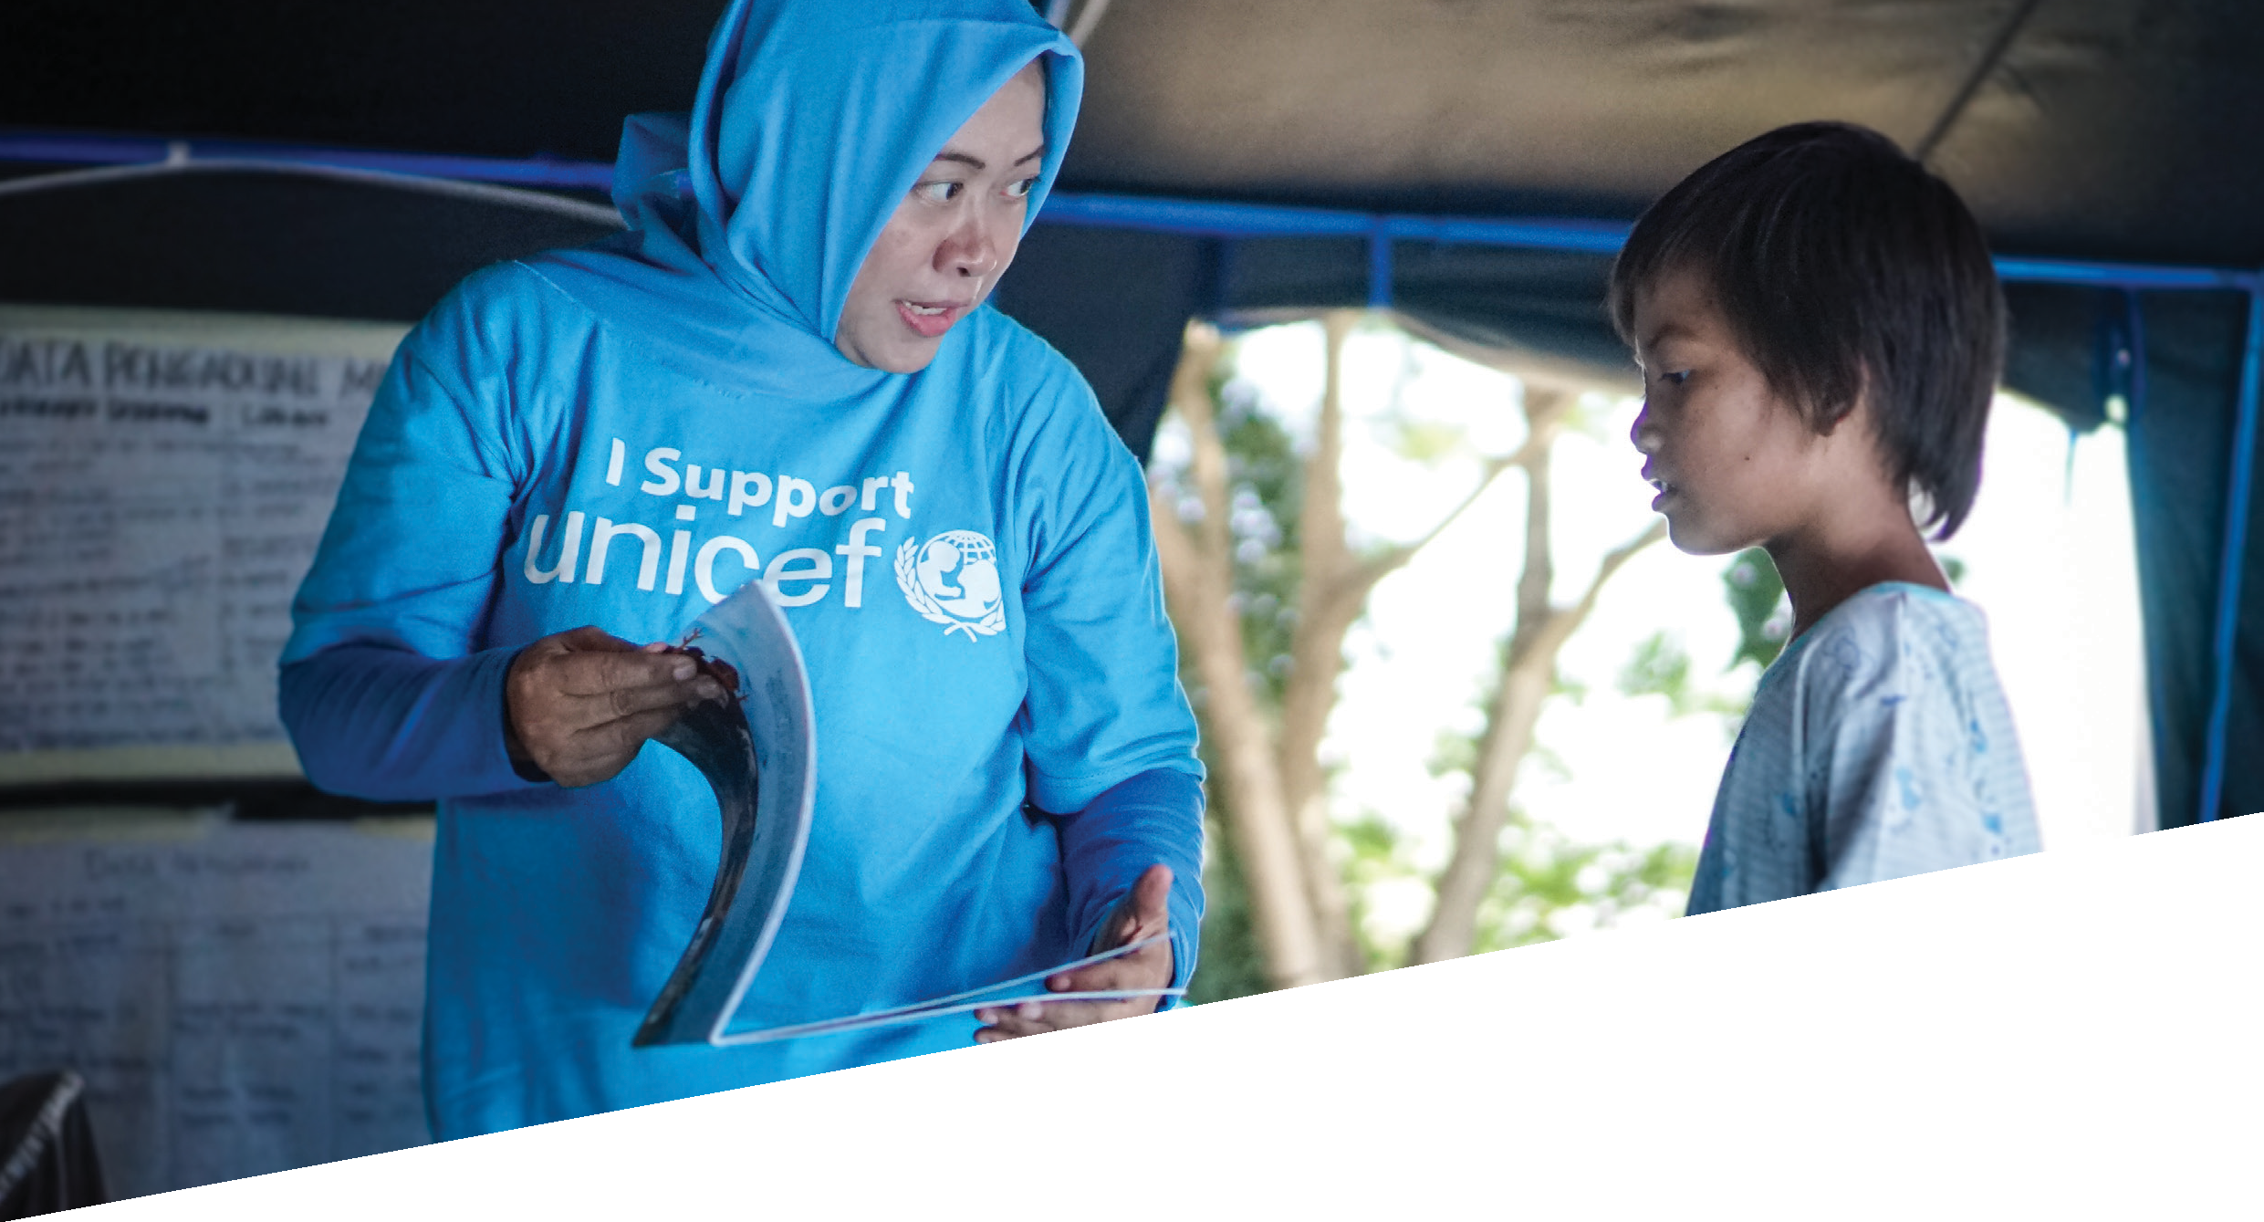©UNICEF/Veska

72 Trainers' Facilitation Guide - For Global IPCI

END OF TRAINING

RESOURCES

American Academy of Pediatrics. (2018). Common immunization myths and misconceptions: Talking points and resources for busy healthcare professionals. Presentation to the Immunization Action Coalition. Available from: http://www.immunize.org/catg.d/s8035.pdf

Federal Democratic Republic of Ethiopia Ministry of Health. (n.d.). Immunization care module: Ethiopian Federal Ministry of Health. Available from: http://www.open.edu/openlearncreate/mod/oucontent/view.php?id=53349

Ministry of Health (MOH). (n.d.). Immunization manual for health workers. Nairobi, Kenya: MOH. Available from: https://www.mchip.net/sites/default/files/mchipfiles/Immunization%20Manual%20for%20 Health%20Workers_updated.pdf

PSI (formerly Population Services International). (2013). Interpersonal communication toolkit. Available from:
http://sbccimplementationkits.org/provider-behavior-change/wp-content/uploads/sites/10/2015/11/ IPC-toolkit-English.pdf

United Nations Children’s Fund (UNICEF). (2014). Training curriculum: Increasing interpersonal communication skills for the introduction of inactivated polio vaccine (IPV). Available from: http://www.wpro.who.int/immunization/documents/polioendgame/curriculum_manual_ipc_unicef. pdf?ua=1

United Nations Children’s Fund (UNICEF), & World Health Organization. (2012). Strengthening interpersonal communication skills of health workers for the Expanded Program on Immunization: Facilitator’s guide. Islamabad, Pakistan: UNICEF. Available from:

https://www.unicef.org/cbsc/files/UNICEF_3-hr Introduction-23-08-12.pdf
IPC_Session_FacilGuide_for_PAK_TOT-PCV10_

United Nations Children’s Fund (UNICEF), & World Health Organization. (n.d.). AEFI and IPC Skills: A Four-Hour Training Course for Health Workers. New York: UNICEF.

United Nations Children’s Fund (UNICEF) Regional Office for South Asia. (2005). Building trust and responding to adverse events following immunization in South Asia: Using strategic communication. Working paper. Kathmandu, Nepal: UNICEF Regional Office for South Asia.

This content is adaptable for in-service, pre-service and periodic capacity building initiatives.
All the materials highlighted in this guide are also available and can be downloaded in English, French and Arabic at: (ipc.unicef.org). You are encouraged to share your experiences on this website and if you need additional guidance, feel free to contact UNICEF via email: smalik@unicef.org

Trainers' Facilitation Guide - For Global IPCI
73
RESOURCES

Appendix A.
Pretest And Post-Test

Pretest/post-test with answers highlighted
- Which of the following can be frontline workers (FLWs) in the context of immunization?

  - Physicians/doctors
  - Nurse and midwives
  - Community health workers
  - Community outreach workers and mobilizers
  - Community volunteers

f) All of the above

- Which of the following is not a desirable practice of an FLW in immunization communication?

  - Building trust with caregivers and clients

  - Educating and informing caregivers, community members, and influential leaders

c) Speaking harshly to caregivers

- Addressing fears and misconceptions at the community level

- Sensitizing, mobilizing, and generating demand for immunization

- Which of the following statements is most generally true about behaviour change communication?

a) It is important to understand a person’s current level of knowledge and their attitudes and beliefs to successfully motivate behaviour change.

- Providing someone with new information is enough to change their behaviour.
- Behaviours are easy to change.
- People make decisions independent of peer, community, and media influence.

Trainers' Facilitation Guide - For Global IPCI
74
APPENDIX A - PRETEST AND POST-TEST

- Which are reasons to use a client-centred approach to immunization communication and services?

  - Improve the reputation of staff at the facility and community levels

  - Provide the caregiver/client with positive memorable experiences

  - Satisfy the needs and expectations of the caregiver/client

  - Decrease the number of caregivers/clients who discontinue immunization services

e) All of the Above

- Which of the following is an example of an FLW demonstrating empathy?

  - A mother expresses uncertainty about the safety of vaccines and the FLW dismisses her concerns.

  - A baby begins to cry after receiving a vaccination so the FLW asks the mother to quiet the baby.

  - A father forgot to bring the child’s immunization card, so he is refused service.

d) A caregiver is concerned the injection will hurt the child so the FLW explains that she understands her concern and reassures her the pain will quickly pass.

e) A grandmother arrives late for the child’s vaccination appointment after traveling a long distance to the clinic, and the FLW tells her that he also has a long journey to the clinic but is never late.

- Which of the following does not demonstrate respect for a caregiver (or client)?

  - Encouraging the caregiver to express their ideas

  - Showing your appreciation for the caregiver’s knowledge and questions

c) Interrupting the caregiver when they speak

- Showing compassion if they share an issue or concern

- Using appropriate body language, including pleasant facial expressions and appropriate eye contact

- Place these problem-solving steps into the correct sequence:

  - Brainstorm strategies to address the problem (2)

  - Select the best solution (4)

  - Develop a plan of how carry out the solution (5)

  - Identify the problem (1)

  - Take action using the plan (6)

  - Determine which strategy might be the most effective (3)

Trainers' Facilitation Guide - For Global IPCI
75
APPENDIX A - PRETEST AND POST-TEST

- Which of the following is true about the immune system?

  - The immune system is an infection that harms the body.
  - Skin and mucous membranes are not part of the immune system.
  - The immune system does not help the body fight disease.

d) Vaccines help the immune system fight disease.

- Which of the following are reasons a caregiver might be hesitant to vaccinate their child?

  - Their own experience with vaccine-preventable diseases.
  - Their own experience with vaccination.
  - Information they gather from the media, family, and friends
  - Bad experiences with service providers

e) All of the above

- Which of the following is most unlikely to be an effective technique for community engagement?

  - Holding focus group discussions caregivers

b) Placing a stack of information pamphlets in the clinic

- Organizing community meetings or conversations

- Conducting home visits to discuss immunization

- Which of the following is not a reason to hold a community conversation?

a) If you feel that you are not appreciated by the community and want recognition

- If you have large numbers of families who do not bring their children for immunization
- If you have a high dropout rate
- If any children have had serious adverse reactions after immunization
- If you believe there are negative rumours circulating in the community about immunization

- Which of the following are systematic ways to collect community feedback?

  - Interviews or surveys with caregivers
  - SMS surveys
  - Suggestion boxes
  - Focus group discussions

e) All of the above

Trainers' Facilitation Guide - For Global IPCI
76
APPENDIX A - PRETEST AND POST-TEST

Appendix B.
Barriers Review Image

Trainers' Facilitation Guide - For Global IPCI
77
APPENDIX B - BARRIERS REVIEW IMAGE

Appendix C.
Barriers And Facilitators To Effective Communication

Barriers to Effective
Communication Facilitators of Improved Communication

Language differences (caregiver and frontline workers [FLWs] speak different mother tongues)
Vocabulary – use of technical
- Learn key words and phrases in the local language
- Use an experienced translator
- Use images

terms, jargon, and difficult words • Use words the caregiver is likely to understand
Poor clarity of speech • Speak clearly
  - Give clear, understandable responses
  - Limit the information and provide cues to help the

Too much technical information
caregiver remember
- Ask yourself: ‘Am I giving too much information?’

Lack of focus on the caregiver • Become sincerely interested in the other person

Different assumptions

Different points of view
  - Listen well and check your own understanding of what the other person said
  - Check the caregiver’s understanding.
  - Try to see things from the other person’s point of view
  - Think: ‘How is it possible for someone to misunderstand my message?’

Cultural differences • Seek to understand and accept the culture

Lack of trust • Be honest
    - Reassure the caregiver
    - Take a few seconds to control your emotions

Emotions
  - Comfort the caregiver and give them a few moments to control their emotions

Conflicting body language • Be honest
    - Practice noticing and adjusting your body language

Sending discouraging feedback • Use encouraging nonverbal communication

The rush to serve many people waiting
Caregivers’ fear of speaking and
- Smile and be polite anyway
- Tell the caregiver who can provide more information

asking questions • Compliment the caregiver and encourage questions
Lack of respect for clients
and caregivers • Treat everyone with respect

Trainers' Facilitation Guide - For Global IPCI
78
APPENDIX C - BARRIERS AND FACILITATORS TO EFFECTIVE COMMUNICATION

Appendix D.
Job Aid: Counselling The Caregiver

Skill/Technique Example
Explore caregiver’s understanding of childhood immunization. Ask caregiver if

they have any questions about what will happen during this immunization session. If this is the child’s first session, ask what the caregiver understands about immunization.

Correct misconception and rumours and provide information and education about important related issues.

Use appropriate vocabulary and assess the caregiver’s level of understanding. Explain what caregiver should know to have a basic
understanding of immunization (in small pieces, do not give them everything at once). Tailor the information to the caregiver based on their experience, knowledge, concerns, and what they need to know today. Use short sentences that will be remembered easily. Pause
frequently and repeat the key details. Avoid overloading the caregiver with information they do not need and will not remember.
Check caregiver’s understanding after each chunk of information, and correct misunderstandings. Pause every so often to check the caregiver’s understanding.
Only the caregiver can confirm what is understood. This is best done with open- ended questions.
Gently correct misunderstandings. Take responsibility for not communicating well and explain the misunderstood information in another way.

Encourage the caregiver to voice questions, fears, and concerns. Reassure the caregiver that any question, fear, or concern that they have is worth discussing.
‘I am happy to see you here today. What
questions do you have about your child’s immunizations today?’

[In response to the statement: ‘That malaria vaccine didn’t work. My baby has had malaria twice since the last immunization.’] ‘We don’t have a vaccine against malaria here yet, but the four vaccines your baby gets today will protect him against several other very dangerous diseases.’

‘One of the vaccines protects against several diseases. These are a type of pneumonia, a serious type of diarrhoea, diphtheria, pertussis, tetanus/lockjaw, and hepatitis.’ [Use the local term for each disease.]

‘I would like to make sure that I have made everything clear. Would you tell me what you will do if the baby gets a slight fever tonight?’

‘I think I did not explain X very well. What I am trying to say is…’

‘Please ask any questions you have. I am here to help you, and any question you have is a
good one.’

Trainers' Facilitation Guide - For Global IPCI
79
APPENDIX D - JOB AID: COUNSELING THE CAREGIVER

Skill/Technique Example

Address the caregiver’s fears and concerns.
Try to understand the cause of the caregiver’s fears and concerns.

Discuss/give concrete behaviours that the caregiver can accomplish. Do not ask the caregiver to do something that he or she will find impossible to do.

Summarize key information. Deliver the four key messages and make sure that the main points are clear to
the caregiver.

Motivate the caregiver. Explain to the caregiver that if they continue to bring the child in for immunization, the child will
be safe from certain diseases.
Check on acceptability/mutuality of decision making. Make sure that the caregiver understood the decisions taken and agreed. If the caregiver feels
unhappy with or does not seem to own the decision, address whatever is making them hesitant.
Closing. Ask the caregiver if there is anything else they would like to know. Praise them for being honest about their concerns and for making the best decision for their child.
‘Every vaccine we are giving has been given to millions of children without hurting them. Even my own children are fully vaccinated because I want to protect them from disease whenever possible.’

‘According to what we discussed, you will keep this immunization card in a safe place and bring it when you come back, right?’

‘I’d like to remind you about three things that we talked about: (1) the vaccines your baby got today will protect him from several illnesses; (2) the baby might get fever or get pain where the needle went in – if that happens, give them half a tablet of paracetamol for the fever; (3) please keep the yellow card somewhere safe and bring
it with you next time; and (4) bring the baby back in four weeks for the next round of vaccines.’

‘Your baby will have a better chance at life if you bring him for all his vaccines.’

‘We will work together to make sure your child stays as healthy as possible.’

‘Is there anything else you would like to know? I’ll see you in four weeks. Thank you for coming.’

Trainers' Facilitation Guide - For Global IPCI
80
APPENDIX D - JOB AID: COUNSELING THE CAREGIVER

Appendix E.
Steps To Community Meetings

The table should be read from top to bottom, then left to right. Cut out into tiles and distribute to teams for an ordering activity.

Decide on the purpose of the conversation | Discuss the meeting with local leaders and influences; invite them to attend, as appropriate | Facilitate the conversation, allowing time for questions
Determine the target audience | Research the topic to be covered | Document questions, concerns, and necessary follow-up actions
Determine which attitudes, beliefs, behaviours, and perceptions need to be addressed | Prepare the key talking points, meeting agenda, and  relevant materials | Develop an action plan to address on any issues raised during the meeting
Select a date, time, and venue | Promote the meeting through relevant communication channels | Follow up with meeting attendees

Trainers' Facilitation Guide - For Global IPCI
81
APPENDIX E - STEPS TO COMMUNITY MEETINGS

Appendix F.
Sample Community Conversation Agenda

- Introduce yourself and the team to the community or group. If possible, let the group introduce themselves, too.
- Give a brief introductory talk.
- In the introduction, explain the objective to the community and create an environment conducive to learning and sharing. You can tell the community that you and your team have come to work with the community to help improve their well-being.
- Tell participants you would like to focus today’s discussion on childhood immunization to prevent some of those health problems, and that you want them to participate fully in the discussion, sharing their ideas, experiences, and opinions.
- Ask the participants if they have seen children with vaccine-preventable illnesses in their community. Ask participants how they can protect their children from such illnesses. Direct the discussion to a point where the participants themselves decide that something has to be done to protect the children in their community.
- Show participants a picture of healthy, happy children with their parents. Allow the participants to comment on what they see in the happy picture and let them discuss if they see many such families in their community.
- Ask participants what they feel are the benefits of childhood immunization. Discuss, helping them to think of more benefits or adding to their ideas as necessary.
- Divide them into groups of six to eight and ask them to think of steps they can take to ensure all the children in their community are fully immunized. Let them write each suggestion down on a paper or choose a group member to remember and report to the full group.
- Have everyone come together again to present their ideas.
- Ask the whole group the following questions:
  - Who are likely the most influential people they can work with to bring about the desired change?
  - What will happen if we do not achieve the desired change?

- Wrap up by sharing key immunization messages that are relevant to participants, such as childhood vaccines and the diseases they prevent, the need to bring children back for all their vaccine doses on time to best protect them, the value of the health card and the need to bring it to each visit, and the ways to convince hold-out families to get their children vaccinated.
- Ask participants they have any questions. For questions that you believe some community members can answer, ask for answers from the community members before adding any additional points. Commit to following up with answers to the questions that you cannot respond to at the meeting.

Trainers' Facilitation Guide - For Global IPCI
82
APPENDIX F - SAMPLE COMMUNITY CONVERSATION AGENDA

Appendix G.
Job Aid: Tips For Using Immunization Support Materials Effectively

IEC (information, education, and communication) materials are visual or audio aids that help providers and caregivers better understand and remember information about diseases, prevention, treatment, health behaviours, and other health topics. The visual and audio aids and materials can be used during group discussions or during one-to-one IPC sessions.

IEC materials improve communication by:

- Helping explain complex information
- Serving as a talking points reminder
- Simplifying complex information
- Generating discussion
- Reinforcing key points and messages

How to Use IEC Materials

Become familiar with the materials provided during this workshop and take a new look at materials you already have. Make sure they are they up to date and that the visuals and language are culturally appropriate. Practice using any materials before meeting with caregivers and communities so that you are sure you know what is in them and where to find the information you want.

Tips for Using Flip Charts

When using a flip chart, always face the group members. Hold the flip chart so that everyone in the group can see it. If the group is large, move around the room with the flip chart to give everyone a chance to see each picture. Memorize the main points but explain them in your own words. After discussing the flip chart, summarize (or have participants summarize) the key messages – what they really need to remember.

Tips for Using Video or Audio

Know what you want to achieve by using the video or audio – what is your objective? If the video or audio will not help you achieve your objective, find one that will. If the video or audio is long, decide which segments to play and where to pause for discussion. Introduce the video or audio, then play it. Watch for audience reactions to give you clues about what to discuss after playing. Pause the video or audio in appropriate places for discussion or to take questions. When discussing the video or audio, ask questions about what the audience saw/heard, felt, liked, and could relate to. You can use or adapt any discussion guide that accompanied the video or audio.

Trainers' Facilitation Guide - For Global IPCI
83
APPENDIX G - JOB AID: TIPS FOR USING IMMUNIZATION SUPPORT MATERIALS EFFECTIVELY

Tips for Using Booklets, Discussion Cards, Brochures, and Posters

If you are using a pictorial source, ask the caregiver what is happening in the pictures. Build on what the caregiver has said to further explain each page of the material to the caregiver. Point to the picture as it is discussed. Observe caregivers to see if they look puzzled or worried. If they do, encourage them to ask questions and discuss any concerns.

When possible, give materials to the caregivers and suggest that they share the materials with others, even if they decide against the health practice discussed.

Appendix H.
Workshop Evaluation Questions

- Which topics covered in the training did you find most relevant?

- Which activities did you like the most?

- What did you like the least about the training?

- What could be done to improve the sessions?

- On which topics would you have preferred additional time?

- Do you feel you confident about applying what you learned in the training to your work?

- In what ways has the workshop inspired you to change or introduce new ideas into your work? Please explain.
- Who do you think would benefit most from this training course?

- Any other comments and suggestions?

Trainers' Facilitation Guide - For Global IPCI
84
APPENDIX H - WORKSHOP EVALUATION QUESTIONS

Appendix I.
Recommendations For Follow-Up And Supervision After Ipc/I Training

Managers and supervisors of FLWs should cofacilitate, observe, or participate in at least part of the IPC/I training. This will help inform their IPC/I follow-up and supervision approach. Managers and supervisors may also attend sessions of particular relevance, such as new competencies,
competencies needing the most improvement, or competencies the managers or supervisors want to develop themselves.

Facilitators, managers, and/or supervisors should provide follow-up assessment and support of IPC/I training. Follow-up should be conducted no later than one month following the training.

Key objectives of follow-up after IPC/I training are to:

  - Reinforce the knowledge learned in the training (e.g., vaccine information, responses to frequently asked and difficult questions)
  - Reinforce the interpersonal skills learned in the training (e.g., active listening, group facilitation)
  - Reinforce the attitudes the training sought to develop (e.g., respect, equity)
  - Identify and, if possible, help mitigate reduce problems faced by participants in their work situation that affect consistent use of good IPC/I
  - Assess participants’ use of good IPC/I skills in their routine immunization duties in order to provide them with constructive feedback, coaching, and on-the-job or refresher training
  - Obtain feedback useful in improving and advocating for future IPC/I training

Scheduling post-training follow-up

Plan to assess training participants for the first time about one month later, giving participants time to practice IPC/I competencies with caregivers and communities in real-life circumstances. Try to follow up before three months at the latest to help FLWs maintain the positive changes they have made. Follow-up can take four hours or more, depending on the number of FLWs being followed up and the number, type, and location of activities to be observed.

Assessment of IPC/I competencies

It is important to emphasize to participants that this is not an examination, but rather a way for facilitators to assess the training, help reinforce the competencies learned, and help with situations that participants have found difficult to manage since the training. If assessing a group of FLWs, begin the day with a welcome and introduction that includes expectations for the visit. Give the FLWs time to describe their experiences – successes, benefits, challenges, wishes – trying to implement IPC/I.

Trainers' Facilitation Guide - For Global IPCI
85
APPENDIX I - RECOMMENDATIONS FOR FOLLOW-UP AND SUPERVISION AFTER IPC/I TRAINING

If you are a facilitator conducting a follow-up visit, briefly meet with facility in-charge and staff to explain the visit’s purpose and the activities expected to take place that day. Identify the FLWs you will assess. Ask staff if they have observed any differences in the way those trained in IPC/I are interacting with caregivers. Establish a friendly atmosphere for the visit.

Ask to see where immunization, group discussions, and counselling take place. Identify a quiet area to conduct the ‘classroom’ parts of the follow-up (conversations with participants, quiz, and training). If the training included community outreach, ensure that plans have been made and confirmed with community leaders and members to conduct home visits and/or a
community meeting.

Conduct the assessments in a similar way to the training’s field practice sessions. Observe, remaining silent and not interrupting interactions. Give feedback to the FLW immediately afterward, starting with praise for things done well. Having the whole group present will make it feel more
like the training and enable all participants to gain from watching others interact with caregivers and community members. This step is not essential, as it might embarrass some participants. Ask each participant how they felt they did. Then ask other participants to give feedback – starting with praise, followed by suggestions for improvement. You also may wish to ask the participants some knowledge questions as well.

An alternative is to ask the participants which competencies they feel unsure of and to spend time on these skills. If identified before the follow-up (e.g., by phone, SMS, or email), plans can be made ahead of time as needed. This might include, for example, scheduling an immunization discussion, community meeting, or a home visit with caregivers whose children are behind on
their immunizations.

Explain your purpose to anyone included in such a session. Also explain how the assessment will be conducted and reassure them that they are not being judged.

An extremely effective way to improve counselling is to videotape/record a person counselling a few people. Then, the facilitator should ask the counsellor to assess his or her own performance, what he or she did well and could have done better. Then the facilitator can add his or her own observations. This can be done in training and/or in follow-up and supervision visits. This will not be possible in all settings, but it should be considered where feasible.

Trainers' Facilitation Guide - For Global IPCI
86
APPENDIX I - RECOMMENDATIONS FOR FOLLOW-UP AND SUPERVISION AFTER IPC/I TRAINING

Training Follow-up Checklists

Use the IPC/I supportive supervision checklist or FLW self-assessment checklist to help assess participants’ on-the-job IPC/I. The FLW self-assessment checklist is more detailed than the supportive supervision checklist. Alternatively, develop a checklist tailored to the training conducted and job expectations. Be sure to photocopy enough forms before leaving for the follow-up.

Avoid treating the checklists as a test. Checklists serve as a reminder of what to look for when assessing each FLW’s use of IPC/I. They outline the way that FLWs should counsel and include the key information they should communicate. They also reflect the attitudes FLWs should exhibit.

Supportive Supervision of Interpersonal Communication for Immunization: A Manual for Supervisors of Frontline Workers provides specific guidance for enabling and supervising good IPC/I.

Centralized group follow-up

If individual follow-up is not feasible, for example, if all training participants come from different areas, one alternative would be to convene participants for a group follow-up session that uses role playing to assess competencies or allows FLWs from different sites to provide routine immunization services in a designated facility and community. This could be combined with a refresher training.

Distance follow-up

If in-person follow-up is not possible, plan to follow up with participants by telephone or video conference. Telephone conversations can be relatively brief but should have a structure for asking how easily the FLW has been able to use what was learned, what is going well, what has been difficult, and include time for problem solving and coaching. Video conferences can be longer and include role playing (if the video conference involves two or more participants) or observation of immunization services.

Trainers' Facilitation Guide - For Global IPCI
87
APPENDIX I - RECOMMENDATIONS FOR FOLLOW-UP AND SUPERVISION AFTER IPC/I TRAINING

Appendix J.
Training Schedule
Annex A 5-Day Training

Day 1 Training Schedule

Greeting Announcements
9:00
9:15 - | Session 1.1
9:30
9:45 | Session 1.2
10:00 | Tea Break
10:15 | Session 1.3
10:30 - | Session 1.4 Part 1
11:00
11:15 | Energizer
11:30 -
12:15

12:30 - | Lunch
13:00
13:15 - | Session 1.5
13:30
13:45 - | Session 1.6
14:15
14:30 | Afternoon Break
14:45 - | Session 2.1
15:15
15:30 -
15:45

Session 1.4 Part 2

Closing and Feedback

Day 2 Training Schedule

Greeting Announcements
9:00
9:15 | Energizer
9:30 - | Session 2.2
9:45
10:00 | Tea Break
10:15 - | Session 2.3
10:45
11:00 | Energizer
11:15 - | Session 3.1
11:45
12:00 - | Lunch
12:15

12:30 | Lunch
12:45 - | Group Bonding Activity
13:00
13:15 - | Session 3.2
13:30
13:45 - | Session 3.3
14:15
14:30 | Afternoon Break
14:45 - | Session 4.1
15:15
15:30 -
15:45

Closing and Feedback

Trainers' Facilitation Guide - For Global IPCI
88
ANNEX A

Day 3 Training Schedule

Greeting Announcements
9:00
9:15 | Energizer
9:30 - | Session 4.2
10:15
10:30 | Tea Break
10:45 - | Session 4.3
11:15
11:30 | Energizer
11:45 -
12:15

12:30 - | Lunch
13:00
13:15 - | Group Bonding Activity
13:30
13:45 - | Session 5.2
14:15
14:30 | Afternoon Break
14:45 - | Session 5.3
15:15
15:30 -
15:45

Session 5.1

Closing and Feedback

Day 4 Training Schedule

Greeting Announcements
9:00
9:15 | Energizer
9:30 - | Session 6.1
10:00
10:15 | Tea Break
10:30 - | Session 6.2
11:15
11:30 | Energizer
11:45
12:15

12:30 - | Lunch
13:00
13:15 - | Group Bonding Activity
13:30
13:45 - | Session 7.1
14:45
15:00 | Afternoon Break
15:15 - | Session 7.2
15:30
15:45

Session 6.3

Closing and Feedback

Trainers' Facilitation Guide - For Global IPCI
89
ANNEX A

Annex A Continued

Day 5 Training Schedule

Greeting Announcements
9:00
9:15 | Energizer
9:30 - | Session 7.3 Part 1
9:45
10:00 | Tea Break
10:15 -
10:45

11:00
11:15 - | Session 7.4
11:45
12:00 - | Lunch
12:15
12:30 -
12:45

Session 7.3 Part 2

Session 7.3 Part 2

Session 7.5

Trainers' Facilitation Guide - For Global IPCI
90
ANNEX A

Annex B 3-Day Training

Day 1 Training Schedule

Greeting Announcements
9:00
9:15 | Session 1.1
9:30 - | Session 1.2
9:45
10:00 | Tea Break
10:15 | Session 1.3
10:30 - | Session 1.4 Part 1
11:00
11:15 | Energizer
11:30 -
12:15

12:30 - | Lunch
13:00
13:15 - | Session 1.5
13:30
13:45 - | Session 1.6
14:15
14:30 | Afternoon Break
14:45 - | Session 2.1
15:15
15:30 -
15:45

Session 1.4 Part 2

Closing/Feedback

Day 2 Training Schedule

Greeting Announcements
9:00
9:15 | Energizer
9:30 - | Session 2.2
9:45
10:00 | Tea Break
10:15 - | Session 2.3
10:45
11:00 | Energizer
11:15 - | Session 3.3
11:45
12:00 - | Lunch
12:15

12:30 | Lunch
12:45 - | Session 4.1
13:15
13:30 - | Group Bonding Activity
13:45
14:00 - | Session 4.2
14:45
15:00 | Afternoon Break
15:15 -
15:45

Session 4.3

Trainers' Facilitation Guide - For Global IPCI
91
ANNEX B

Day 3 Training Schedule

Greeting Announcements
9:00
9:15 - | Session 5.1
9:45
10:00 | Tea Break
10:15 - | Session 5.2
10:45
11:00 | Energizer
11:15 - | Session 5.3
11:45
12:00 - | Lunch
12:15

12:30 | Lunch
12:45 - | Session 6.1
13:15
13:30 | Group Activity
13:45 - | Session 6.2
14:15
14:30 | Afternoon Break
14:45 - | Session 7.4
15:15
15:30 -
15:45

Session 7.5

ANNEX C 1-DAY TRAINING

Day 1 Training Schedule

Session 1.1
9:00
9:15 - | Session 1.2
9:30
9:45 | Session 1.3
10:00 | Tea Break
10:15 - | Session 1.4
11:00
11:15 | Session 1.5
11:30 - | Session 2.1
11:45
12:00 - | Lunch
12:15

Session 2.2

Session 7.5

Trainers' Facilitation Guide - For Global IPCI
92
12:30
12:45 - | Session 2.3
13:00
13:15 - | Session 4.1
13:30
13:45 - | Session 4.2
14:15
14:30 | Afternoon Break
14:45 - | Session 4.3
15:00
15:15 - | Session 7.4
15:45
16:00

ANNEX B, C

Appendix K.
IPC/I Self-Assessment Checklist

Purpose
This checklist is designed to help you:

- Honestly assess how often you are using good interpersonal communication skills during immunization sessions and outreach/education
- Identify areas for improvement
- Set goals and develop plans for improving your use of effective IPC skills
How to use this checklist
Use this checklist periodically (perhaps daily at first, then weekly or monthly. Your supervisor might choose to make this checklist part of the formal supportive supervision process. In this case, you would, for example, share a monthly or quarterly self-assessment with the supervisor. Whether part of the formal supportive supervision process or not, you can share all or parts of your findings with supervisors to make them aware of your improvements, to seek help in setting goals, and to get on-the-job coaching or training.
Give yourself credit for any improvement, no matter how small, and for maintaining good IPC practices despite challenges you face. Also give yourself credit for recognizing areas where you need to improve. These are important steps to making good IPC as routine as any of your immunization activities.
Consider sharing all or parts of your findings with colleagues to get encouragement, advice, or support, or even to help them make similar changes.
Instructions for use
Date of this assessment: Date of next assessment: Date of next supportive supervision visit:

My Goals for this period were to:
1.
2.
3.

Effective IPC | I did this |  | Recent Example | Challenge/Goal
 | Never/Seldom | Often
IPC Process
Welcome the caregiver
Sincerely praise caregivers for bringing their babies for immunization
Ask the appropriate routine immunization questions
Use relevant support materials, including health card, to explain to caregivers

Trainers' Facilitation Guide - For Global IPCI
93
APPENDIX K - IPC/I SELF-ASSESSMENT CHECKLIST

Effective IPC | I did this |  | Recent Example | Challenge/Goal
 | Never/Seldom | Often
Communicate the key immunization messages:
o The vaccines being given during the visit
o The possible side effects and what to do
o To safeguard and return with the health card
o The day and time for the child’s next doses
Check caregivers’ understanding by asking them to repeat what was covered
Ask caregivers for any immunization questions or concerns they may have
Respond truthfully, understandably, and reassuringly to caregivers’ questions and concerns
Ask caregivers to repeat what they need to do
Encourage caregivers
Summarize key information, including the key immu- nization messages
IPC Skills
Avoid judging or scolding the caregivers
Avoid rushing the caregivers (exercise patience)
Show respect by listening attentively
Show respect through tone of voice
Give credible, evidence-based vaccine and disease information
Use simple language the caregivers understand
Avoid overloading caregivers with information
Make eye contact (if appropriate) while listening
& talking
Show empathy nonverbally and by reflecting caregivers’ feelings
Reflect back caregiver statements and feelings to show or check understanding and encourage dia- logue
Use open-ended questions to seek more information about concerns or practices as needed
Use gestures and short responses to encourage dialogue
Sit or stand at the same level as caregivers
Ensure there are no physical barriers (such as a desk) between me and caregivers
Discuss and try to correct caregivers’ immunization misconceptions/rumors
Other:
IPC in Immunization Group Discussions
Before the session, find out what participants likely know, think, and do about the proposed topic
Opening
Begin on time
Greet participants warmly
Introduce yourself
If appropriate, have participants introduce themselves
Clearly state the purpose of the session
Say how long you expect the session to last
Facilitation
Put the participants at ease
Ask participants what they already know about the topic
Seek participant input early and often
Communicate information in a lively fashion

Trainers' Facilitation Guide - For Global IPCI
94
APPENDIX K - IPC/I SELF-ASSESSMENT CHECKLIST

Effective IPC | I did this |  | Recent Example | Challenge/Goal
 | Never/Seldom | Often
Use visual aids, including props
Ask participants what they see in the visual aids
Use appropriate language and relatable concepts
Encourage the exchange of ideas among participants
Reassure caregivers
Respond to caregivers’ questions, concerns, barriers
Highlight links between the topic and issues of concern to caregivers
Include ample time for Q&A
Include positive reinforcement of immunization behaviors
Solicit group consensus
Manage challenging behaviors well
Content
Use story, video, interactive exercises
Invite participants to share what they already know
Engage participants in discussion of immunization key benefits such as:
- Saves millions of lives every year
- Prevents serious illness and permanent dam- age
- Saves time and money (clinic visits, medicines, hospitalization)
- Protects those who can’t be immunized for health reasons
- Is safe, effective, free
- Where and when immunization is available
- Complete in 1st year of life for best protection
Provide information that is easily understandable and relevant for the entire group
Seek positive examples from participants
Use positive examples from community
Engage participants in discussion of key immuniza- tion messages:
- Vaccines and the diseases they prevent
- Possible side effects and what to do
- Importance of safeguarding, referring to, and returning with the health card
- The immunization schedule (number and timing of visits)
Encourage full participation
Ask participants for examples
Encourage participants to respond to each other as appropriate
Ask participants to restate what you said in their own words or language (if session is in a different language)
Solve a problem together (for example, how to keep track of the health card)
Don’t scold or embarrass participants
Balance eye contact around the group when speaking
Ask shy participants easy questions, then praise them
Reinforce participation with verbal and non-verbal communication
Sing a song together, preferably related to the topic
Closing
Summarize key points from the discussion
Have participants summarize key points

Trainers' Facilitation Guide - For Global IPCI
95
APPENDIX K - IPC/I SELF-ASSESSMENT CHECKLIST

Effective IPC | I did this |  | Recent Example | Challenge/Goal
 | Never/Seldom | Often
Suggest or review actions agreed upon by partici- pants
Ask participants to raise their hands to show they commit to the full immunization of their children
Thank and encourage participants for their efforts to protect their children
Thank and praise participants for their participation
Inform participants about the next session
Ask participants for feedback on the session
Other IPC/I Activities
Review the IPC/I participant handbook
Review the IPC/I FAQs
Identify or create useful materials and visual aids
Conduct community meetings
Conduct home visits
Reach out to community leaders and encouraged them to support immunization
Follow-up with caregivers who had questions or concerns
Follow-up with caregivers whose children have missed a scheduled immunization
Help caregivers overcome obstacles to complete and timely immunization
Problem-solve alone
Problem-solve with colleagues
Seek the guidance of my supervisor to overcome a challenge
Share successful practices with colleagues

Changes I see from using good IPC skills

How using good IPC skills is affecting my work:

How using good IPC skills is affecting caregivers/my clients: How using good IPC skills is affecting my life/outlook: Other:
Things/challenges that made it difficult to practice good IPC: Ideas for overcoming these challenges:

Trainers' Facilitation Guide - For Global IPCI
96
APPENDIX K - IPC/I SELF-ASSESSMENT CHECKLIST

Challenges to practicing effective IPC | What would solve the problem | Whose help I need | Timeframe

My IPC goals for the next month/quarter (circle one): 1.
2.

3.

Trainers' Facilitation Guide - For Global IPCI
97
APPENDIX K - IPC/I SELF-ASSESSMENT CHECKLIST

Appendix L.
Certificates

Certificate on next page

Trainers' Facilitation Guide - For Global IPCI
98
APPENDIX L - CERTIFICATES

ll'IUf'penOnel <ommunll:a'don . .
:rt
For lmmunlz.adon ·
Transforming Immunization • · ' • •
Dlalogllt'

Certifica te of Comp let ion

In recognition of your commitment to transforming immunization dialogue

through interpersonal communication and completion of the Interpersonal Communicationfor Immunization Training.

--i
iil
:;­
<.1,>_
TI
).>... Q"£"'.;
m.... er
z "
C C>
s.
r-
(") TI

:no
;::; g­
)> -
=u
(I) Q
c.o
c.o
Name of Issuer Date of Issue

Notes

100
Trainers' Facilitation Guide - For Global IPCI
NOTES

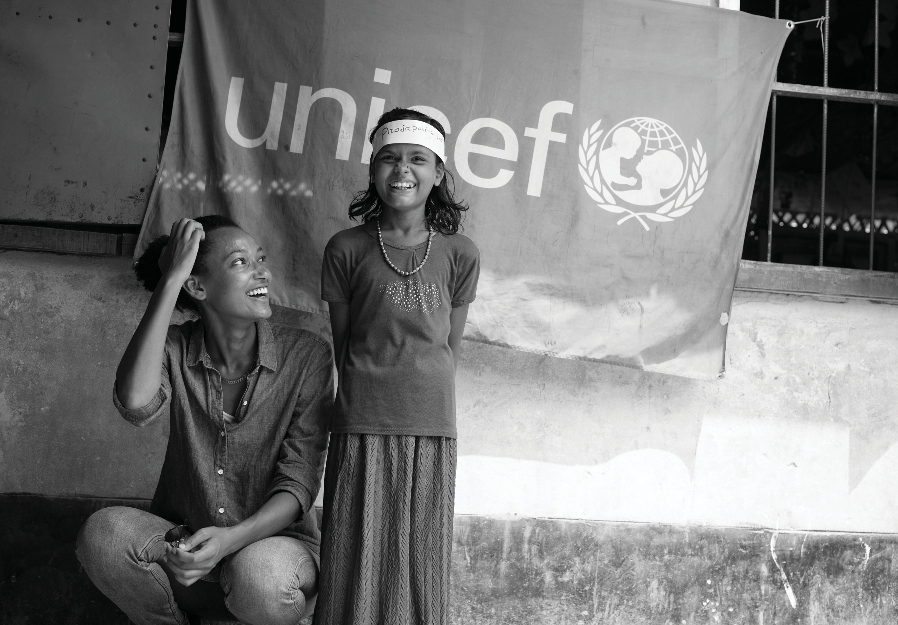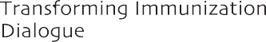

Trainers' Facilitation Guide - For Global IPCI 101

©UNICEF/Sokol

